**吴洪**

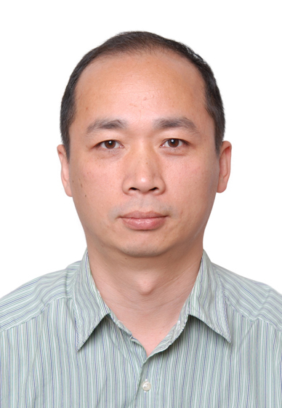

**吴洪副教授， 1993年在中国科技大学获计算机科学学士学位； 2004年在中国科学院自动化所获博士学位。2004年到2006年任NEC中国研究院副研究员。2006年5月开始在电子科技大学计算机学院任副教授。2013年至2014年在美国新泽西州立罗格斯大学计算生物医学影像建模中心(CBIM)访问一年。当前研究兴趣为图像分析、模式识别、机器学习及它们在医学影像分析与检索、计算机辅助诊断、多媒体等方面的应用。**

**主要学术成果和学术贡献：**

参加Image CLEF 的医学检索国际比赛获得了成绩：

1. 2010年在医学图像模式分类中获视觉方法第2名；
2. 2011年在医学病案的检索任务中获第1名；
3. 2012年在医学图像模式分类中获视觉方法第2名。

2011 年第12 届环太平洋多媒体会议(PCM 2011) 获得最佳论文第二名（Best Paper Runner-up）。

**代表论文：**

[1] Hong Wu, Lele He. Combining visual and textual features for medical image modality classification with LP norm multiple kernel learning, Neurocomputing 147 (2015) 387-394

[2] Hewei Cheng, Hong Wu, Yong Fan. Optimizing affinity measures for parcellating brain structures based on resting state fMRI data: A validation on medial superior frontal cortex. Journal of Neuroscience Methods Volume 237, 30 November 2014, Pages 90–102

[3] Hong Wu, Kuangkai Sun, Asymmetric Semantic Similarity for Biomedical Information Retrieval, The 7th Asia-Pacific Association for Medical Informatics Conference (APAMI), Beijing, China, October 22-25, 2012.

[4] Hong Wu, Kuangkai Sun, Zhongliu Zhuo, Improving Context-Based Medical Image Retrieval by Incorporating Semantic-Based Retrieval, The 4nd International Conference on Internet Multimedia Computing and Service (ICIMCS), Wuhan, China, September 9-11, 2012.

[5] Hong Wu, Chengbo Tian. Thesaurus-Assistant Query Expansion for Context-Based Medical Image Retrieval. the 12th Pacific-Rim Conference on Multimedia, (PCM), Dec. 20-22, 2011. (Best Paper Runner-up)

[6] Yong Fan, Yong Liu, Hong Wu, Yihui Hao, Haihong Liu, Zhening Liu, Tianzi Jiang. Discriminant analysis of functional connectivity patterns on Grassmann manifold. Neuroimage, 2011, 56(4):2058-2067.

[7] Hong Wu, Hao Zhang, Chao Li. Medical Image Classification with Multiple Kernel Learning, The 2nd International Conference on Internet Multimedia Computing and Service (ICIMCS), Dec. 30-31, 2010.

[8] Hong Wu, Hanqing Lu and Songde Ma. A Survey of Relevance Feedback Techniques in Content-Based Image Retrieval. (Chinese version) Chinese Journal of Computers, 2005, 28(12):1969-1979.

[9] Hong Wu, Hanqing Lu and Songde Ma. Ordinal Regression in Content-Based Image Retrieval. (Chinese version) Journal of Software, 2004,15(9):1336-1344.

[10] Hong Wu, Hanqing Lu, Songde Ma, WillHunter: A CBIR System with Refined Relevance Measurement. 17th Intl. Conference on Pattern Recognition (ICPR), 2004, Cambridge, UK.

[11] Hong Wu, Hanqing Lu, Songde Ma, A Practical SVM-Based Algorithm for Ordinal Regression in Image Retrieval. ACM Multimedia (ACM MM), 2003, Berkeley, USA.

[12] Hong Wu, Hanqing Lu, Songde Ma, Multilevel Relevance Judgment, Loss Function, and Performance Measure in Image Retrieval, International Conference on Image and Video Retrieval (CIVR), 2003, July 24-25, Urbana, IL, USA

[13] Hong Wu, Hanqing Lu, Songde Ma, The Role of Sample Distribution in Relevance Feedback for Content-Based Image Retrieval, IEEE International Conference on Multimedia and Expo (ICME) 2002,August 26-29, Lausanne, Switzerland

[14] Hong Wu, Hanqing Lu, Songde Ma, Incorporating negative examples in One-class SVM for relevance feedback in image retrieval, The 2nd International Conference on Image and Graphics (ICIG), August 16-18, 2002, Hefei, China.

[15] Xianfeng Ding, Hong Wu, Hongjiang Zhang, Songde Ma, Review on Shape Matching. (Chinese version) ACTA AUTOMATICA SINICA，9，2001

**科研项目**

1.国家自然基金面上项目:“跨媒体语义医学图像检索中关键技术研究”；

2.电子科大青年科技基金重点项目：“基于知识的智能医学图像检索”；

3.国家重点实验室开放课题基金：“可视媒体自动标注中多示例多标签学习算法研究”。