

课程名称：Java应用技术 指导老师：翁恺 学生姓名：尹嘉权

实验名称：TechSupport 实验类型：编程实现 学生学号：3120000419

1. 实验目的和要求

目的：

了解 Java 基本语法，熟悉输入输出流和容器的常用方法。

要求：

*TechSupport* is a program intended to provide technical support for customers of the fictitious DodgySoft company. Some time ago, DodgySoft had a technical support department with people sitting at telephone where customers could call to get advice and help with their technical problems with the DodgySoft products. Recently, though, business has not been going so well, and DodgySoft decided to get rid of the technical support department to save money. They now want to develop the *TechSupport* system to give the impression that support is still provided. The system is supposed to mimic the responses a technical support person might give. Customers can communicate with the technical support system online.

The plan is that we shall have a set of words that are likely to occur in typical questions and we will associate these words with particular responses. If the input from the user contains one of our known words we can generate a related response. To make it more nature, one word may be associated with several different answers which will be randomly picked when the word encountered.

The user interface is quite straightforward: The user inputs a sentence and the program answers. Your program should be able to split the user input into words and find "key words" inside them. Then for every key word, try to decide a "suitable" (random) answer and print it out. For a sentence with more than one key word, you may have your own way to deal with it, like to print only one or all of them.

1. 实验内容和原理

内容：

自定义命令行形式的用户交互界面，支持新增关键字和对应回答内容、模拟用户来输入关键字，获取相对应的应答、以及退出系统的功能。

原理：

利用Serializable 和输入输出流 FileInputStream, FileOutputStream, ObjectInputStream, ObjectOutputStream 的使用，利用HashSet和ArrayList来读入当前数据库、更新数据库，和对用户给出相对应的回答。

1. 主要仪器设备

MacBook Pro, MacOSX 10.10, 2.6GHz Intel Core i5, 8G RAM

JSE: JavaSE-1.8

JDK: oracle-java8-jdk

1. 操作方法和实验步骤

分析题目，然后打开Eclipse建立相对应的工程文件，输入代码，进行初步的调试运行之后打开terminal，找到相对应的程序目录，用javac通过JDK编译得到相对应的class文件，然后用java命令运行调试。

具体的代码可以参见第二节里面的实验原理，另外注意对于用户输入的关键字，给出的应答是匹配用户输入关键字数量最多的。

另外，对于输入给出约定，当更新数据库的时候，第一行所有输入，根据空格分隔来摘取关键字，然后第二行的输入作为第一行所有关键字的匹配输出。

对于数据文件data.txt给出约定，目录为Eclipse工程文件TechSupport下src/TechSupport/data.txt

1. 实验数据记录和处理

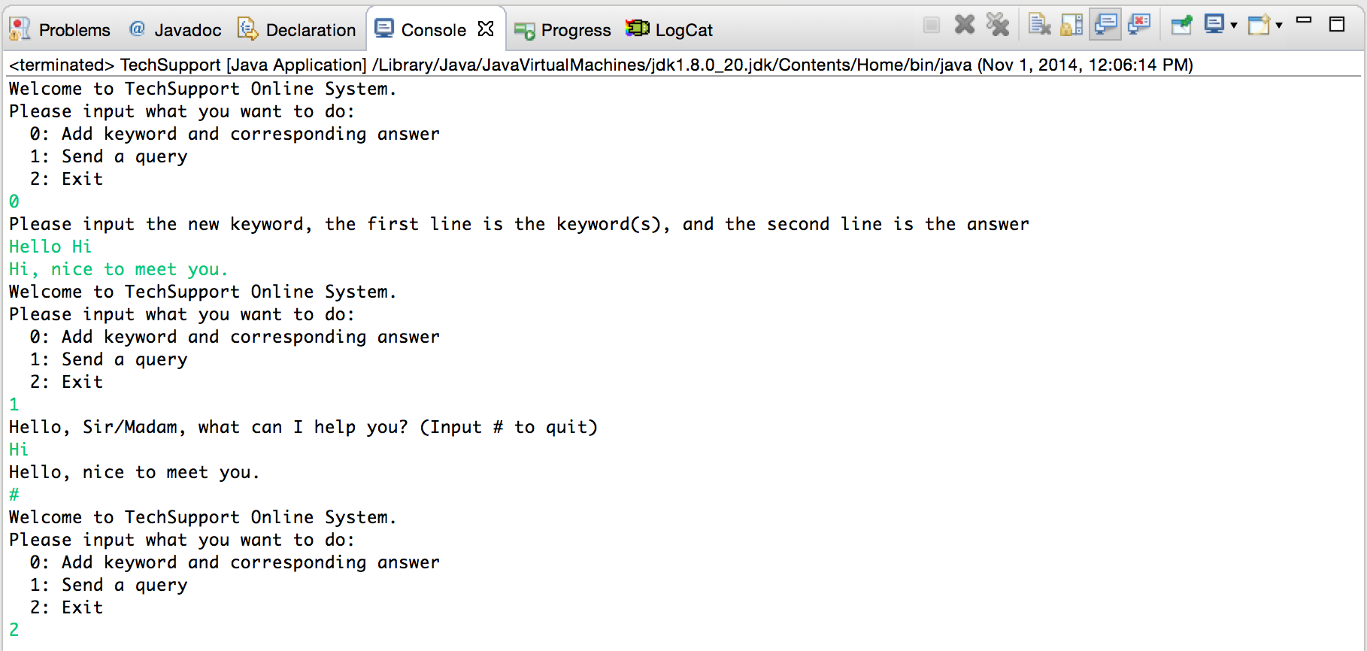

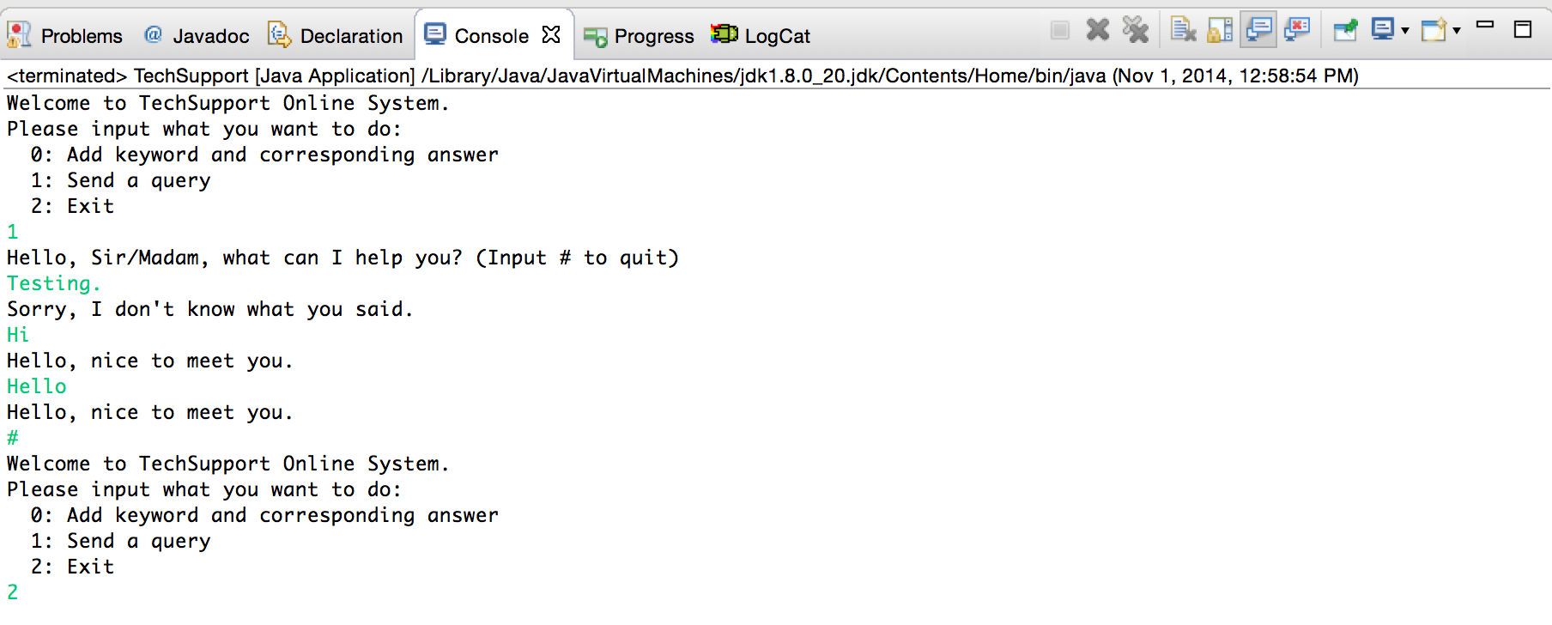

1. 实验结果与分析

实验结果正确，给出友好的用户交互界面。支持新增关键字及其应答、以及模拟用户输入，来获取相对应的应答，如果没有在数据文件中找到相对应的关键字应答，则输出Sorry, I don’t know what you said.

1. 讨论心得

在整个实验中，对于Java的关于文件IO有了初步了解，同时类比C++的STL容器来学习Java中的HashSet和ArrayList. 另外在文件IO中，通过使用try catch的异常抛出让程序显得更加OOP，能有效避免退栈造成的错误。