**Screenshot**

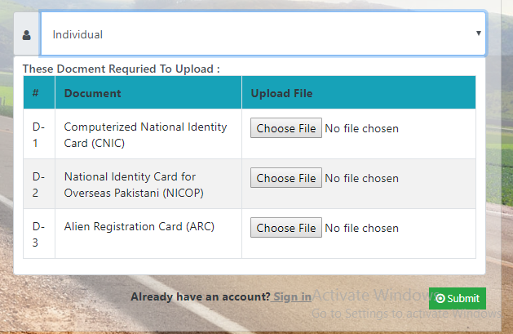 **Category: Individual**

*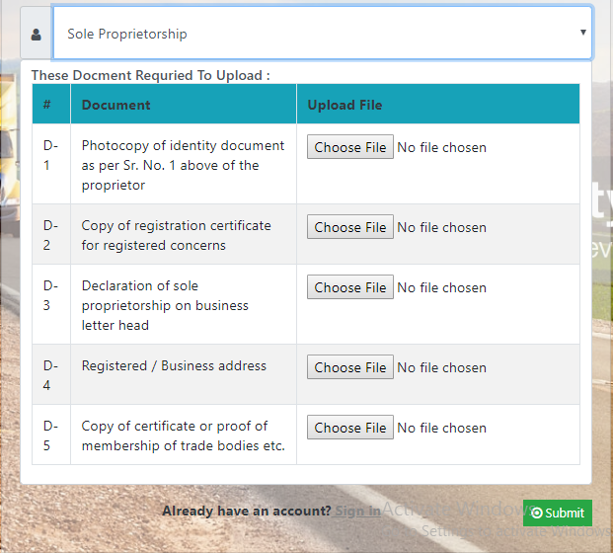***Category: Sole Proprietorship**

**Category: Partnership**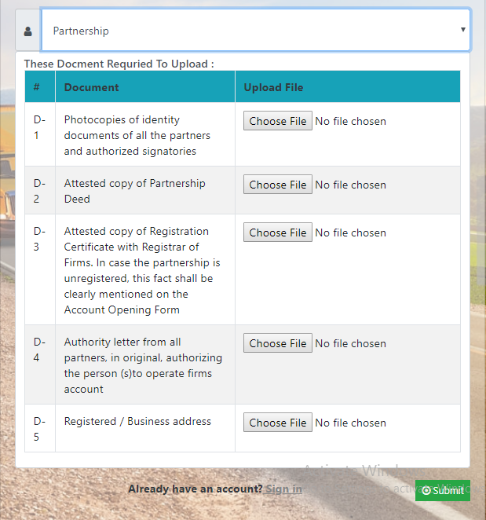

**Category: Corporate Public** 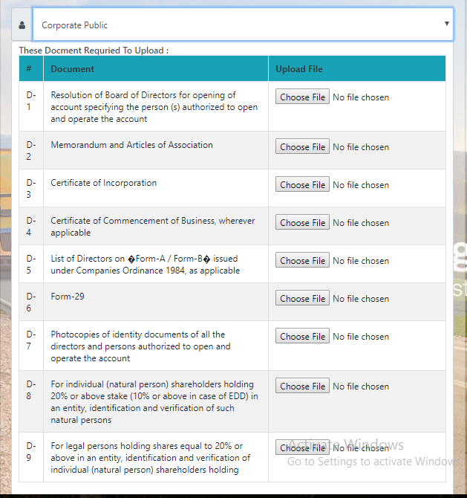

**Category: Corporate Private**

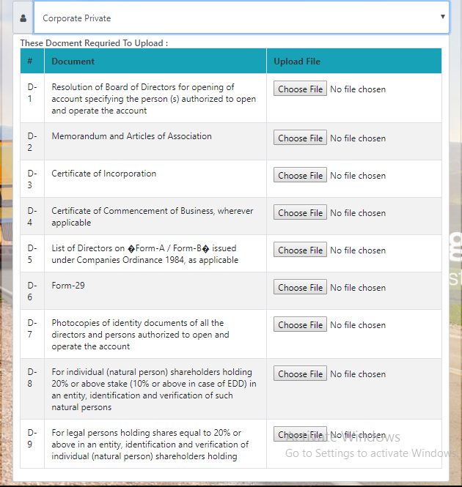

**Category: Liaison Office of Foreign Companies**

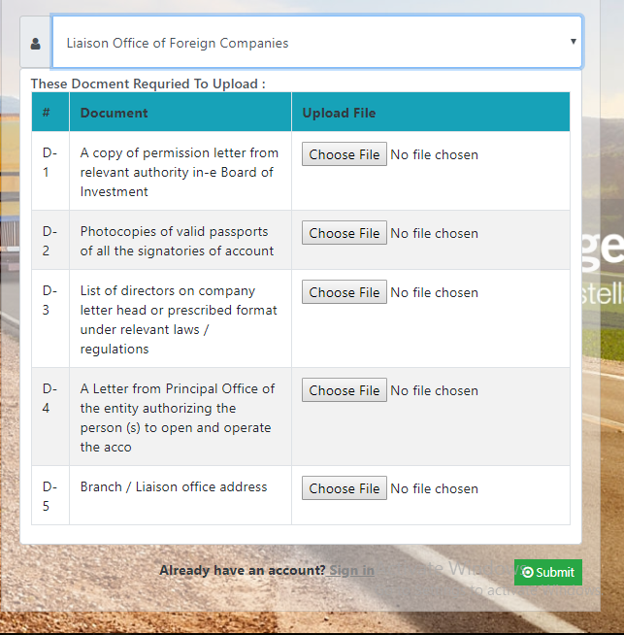

**Category: Trust/ Clubs/ Societies/ Associations**

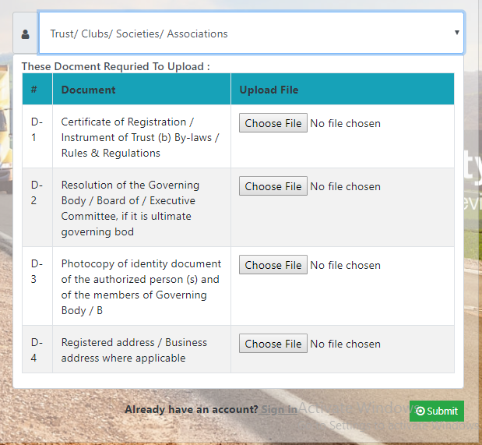

**Category: NGOs/ NPOs / Charities**

