# Prerequisite

1. Android Studio should be installed.
2. A Virtual Device with API between 15 and 26 should be ready.

*Remark: System requirements – Even if Android Studio requires 4GB RAM minimum, the recommendation is 8GB RAM for executing with virtual devices.*

# How to run

1. Download project from github <https://bit.ly/31263sD>
   1. From github page, you can download it as zip file by clicking **Clone or download** button. Then selecting **Download ZIP.**

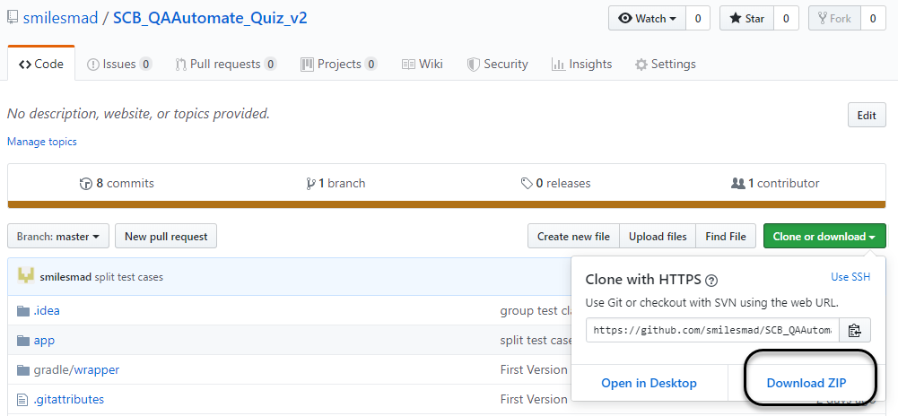

1. After download zip file and extract, open Android Studio and select **open an existing Android Studio project**

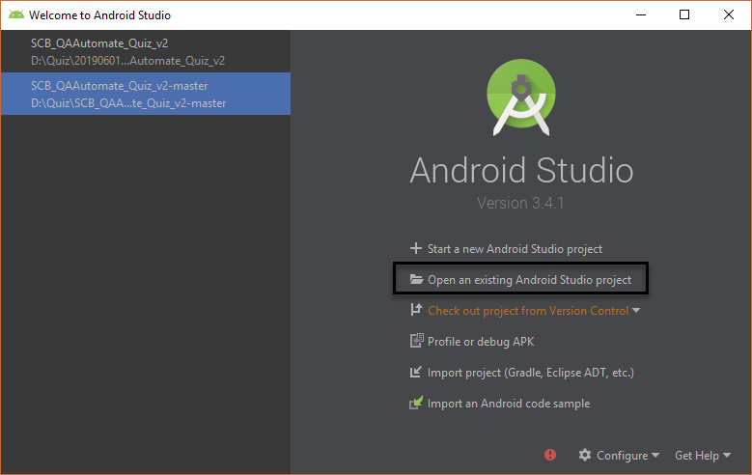

1. After opening project, go to the test script folder in project.
   1. If the project is opened as project view, the path is app/src/andriodTest/java/com.sourcey.materiallogindemo

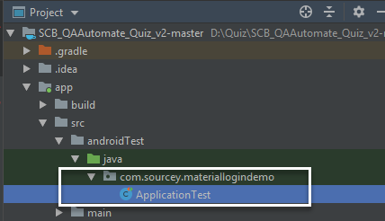

* 1. If the project is opened as Android view, the path is app/java/ com.sourcey.materiallogindemo (andriodTest)

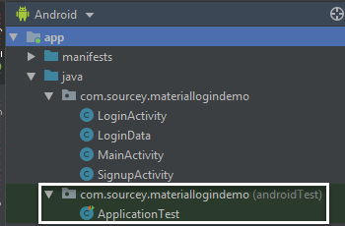

1. Right-click at the test script folder folder, then select **Run ‘Test’ in ‘…’**

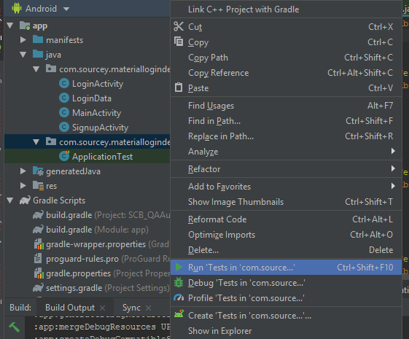

1. You will be asked to select a virtual device. Select one and click **OK**

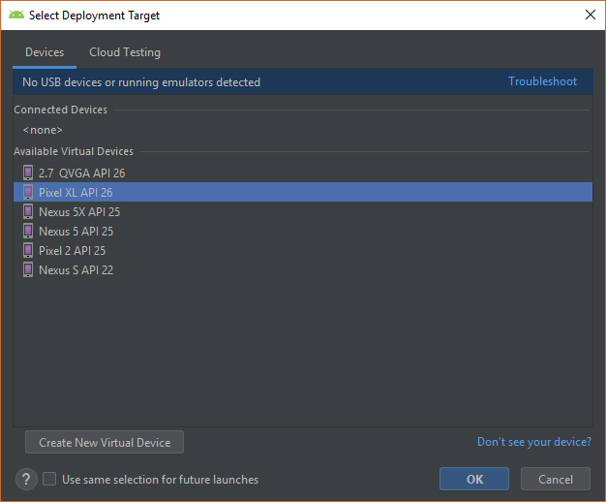

1. After that it will build for a while and start running test by launching emulator you have chosen.

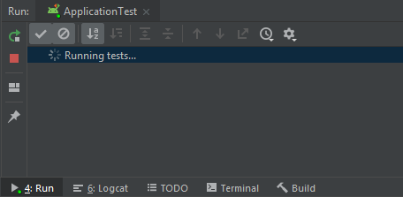

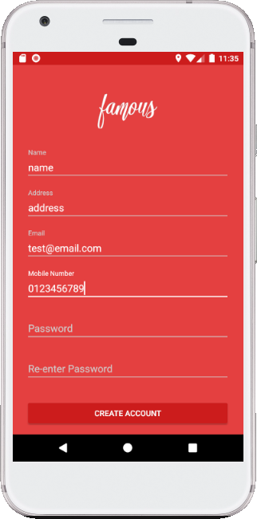

1. When it finishes, the result summary is in ‘Run’ panel and it will summarize all of Test results at the right top

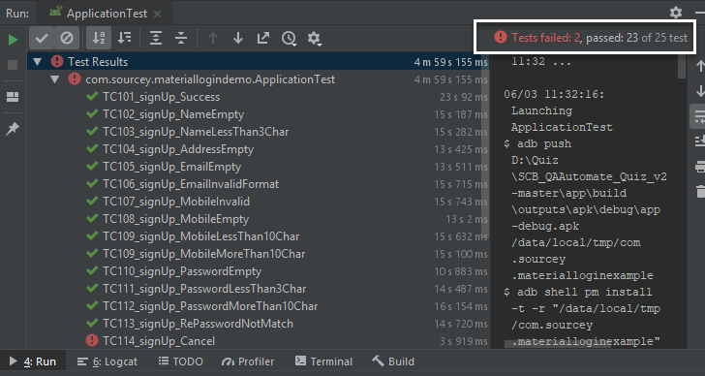

You can see the error log from Logcat panel, by filter emuluator, class, and type of log is error.

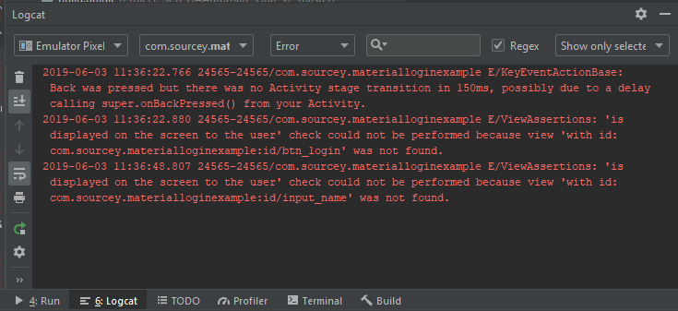

# Test cases



# Improvement

1. Currently, the test data is fixed in the test script. Next phase, it should load from file/configuration or database.
2. Emulators require to setup properly such as no animation interrupt.
3. It should have mock process/value to shorten execution. Because it could access into the middle of process, no need to start from the beginning.
4. Recycle-view should be used for some tests.
5. It should run without emulator to reduce time.
6. The method to manually execute should be improved to execute via command/gradle to have more efficient to integrate test and DevOps.
7. Test Report should be better to make user easier to read, understanding and analysis.