sortApp Code Walk Through

June 19, 2017

Ismail Pathan

Contents

Contents 2
1 Introduction 4
2 Tools & Technologies 4
3 Project Directory Structure 5
4 Project Dependencies 6
5 Spring boot 8
6 Application.properties file 9
7 Table Entity 10
8 Repository 11
9 Bubble Sort 11
10 MVC Controller 13
11 AOP Logging(Aspect) 14
12 AngularJS Based UI 15

Revision History
Version | Date | Name | Description
1 | 06/19/17 | Ismail Pathan | Initial Document

Introduction
The sortApp application takes random numbers provided by end user. And provide sorted number with required statistical data. This document will provide details of technologies used and code explanation.

Tools & Technologies

- Java 8
- Maven 3
- Eclipse Jave EE IDE(Mars Release)
- MySQL 5.5
- Spring Boot 1.5.1.RELEASE
- AOP,JPA,Aspects
- AngularJS Version 1.6.1
- Jquery Version 3.1.1
- Bootstrap Version 3.3.7
- RequireJS 2.3.2

Project Directory
The sortApp application follows structured coding layer like Controller, Service, DAO etc.

- src/main/java contains controller,service, dao, model, util logic.
- src/main/resources/static contains UI logic in angular,bootstrap.
- src/main/resources contains application properties configuration and database intialization

Project Dependencies
The sortApp application takes random numbers provided by end user. And provide sorted number with required statistical data. This document will provide details of technologies used and code explanation.

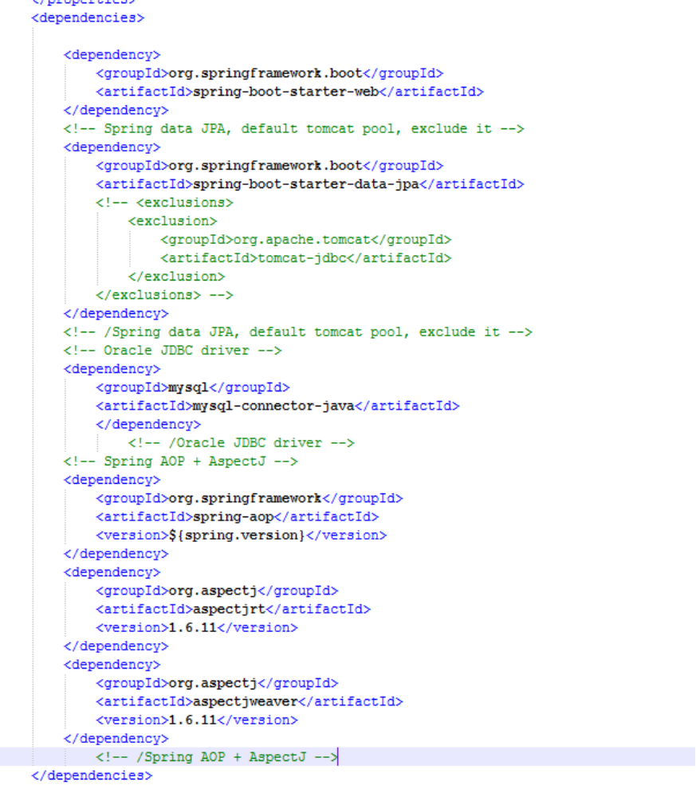

Spring Boot
Spring boot provide Rapid Development Application approach.
With the help of Java Annotation. sortApp initializes and autowired objects accordingly.

Application.properties File
Spring boot takes application.properties file residing in classpath and takes application level parameters. It initializes beans required for application.

Server.contextpath property use to set context path of application.
Spring.datasource set used to initialize data source bean.
Database related information need to be filled.
Based on this Schema.sql/import.sql will be executed in specified databse.
sorted_array_info Table used to store sorted numbers data.
Schema.sql load tabled ddl if not exists in database at the time of application load.

Table Entity

SortedArrayInfo is table entity specified in java annotation. ID is primary key with auto increment value.

Repository

Corresponding to SortedArrayInfo entity, is SortedArrayInfoRepository CRUD repository which helps to operate many operation over table.

Bubble Sort Algorithm

Bubble sort Algorithm has been implemented in this POC.

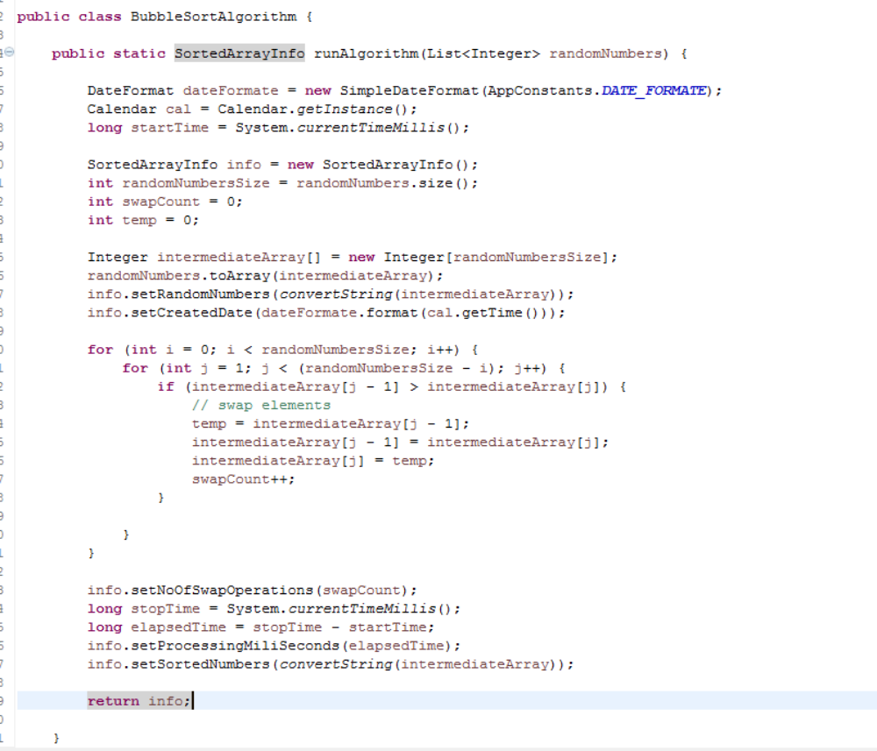

MVC Controller

SortArrayController is Rest API Controller . With help of RequestMapping annotation, request name, method type and response content can be specified.

In below controller.
- sortArray is responsible for sorting API
- sortHistory is responsible for providing history of sorted numbers.

AOP for Logging

Aspect is used to create logging functionality ( LoggingAspect) which logged required information across various level.

AngularJS based UI.

AngularJS used to create UI logic for taking random numbers from user and provide statistical data of sorting.
It also provide history for the same.
Single Page Application is created to achieve tasks.
JSON is used for objects response.
RequireJS used to achieve lazy lading in application.
Bootstrap is used to have good look & feel.

Single Page Application Routing.

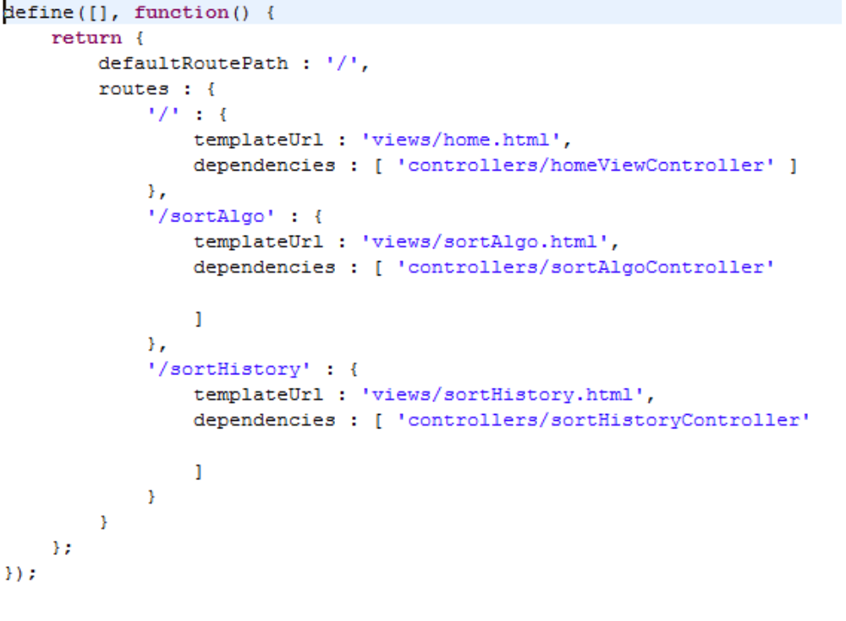

Lazy Loading

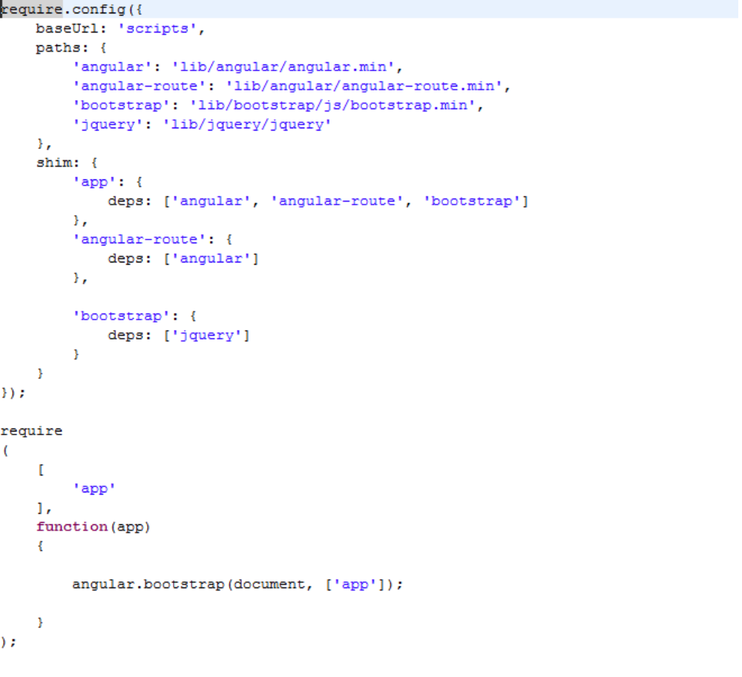

View & Controllers

