**NAME – KHUSHI PANWAR, khushipanwar26@gmail.com**

**ROLL NO – 2021334**

**C++ PRACTICAL ASSIGNMENT – 20 JAN 2022**

1. **Write a program that performs addition, subtraction, multiplication and transpose using 2D arrays:**

#include <iostream>

#include <iomanip>

using namespace std;

int inputMatrix(int m[][3]){

    for (int i=0; i<3; i++){

        cout<<"Enter the elements for row "<<i+1<<" : ";

        for (int j=0; j<3; j++)

        cin>>m[i][j];

    }

}

int addition(int m1[][3], int m2[][3], int sum[][3]){

    for (int i=0; i<3; i++){

        for (int j=0; j<3; j++)

            sum[i][j]=m1[i][j]+m2[i][j];

    }

}

int subtraction(int m1[][3], int m2[][3], int difference[][3]){

    for (int i=0; i<3; i++){

        for (int j=0; j<3; j++)

            difference[i][j]=m1[i][j]-m2[i][j];

    }

}

int multiplication(int m1[][3], int m2[][3], int prod[][3]){

    for (int i=0; i<3; i++){

        for (int j=0; j<3; j++)

            prod[i][j]=m1[i][j]*m2[i][j];

    }

}

int transpose(int m[][3], int trans[][3]){

    for (int i=0; i<3; i++){

        for (int j=0; j<3; j++){

            trans[j][i]=m[i][j];

        }

    }

}

int displayMatrix(int m[][3]){

    cout<<endl<<"============================="<<endl<<endl;

    for (int i=0; i<3; i++){

        for (int j=0; j<3; j++)

        cout<<setw(5)<<m[i][j];

        cout<<endl;

    }

    cout<<endl<<"============================="<<endl<<endl;

}

int main(){

    cout<<"\t * MATRIX OPERATIONS (3x3) *" <<endl<<endl;

    cout<<"========================"<<endl;

    cout<<"\t SELECT : "<<endl<<endl;

    cout<<" 1. MATRIX ADDITION "<<endl;

    cout<<" 2. MATRIX SUBTRACTION "<<endl;

    cout<<" 3. MATRIX MULTIPLICATION "<<endl;

    cout<<" 4. MATRIX TRANSPOSE "<<endl;

    cout<<"========================"<<endl;

    int choice, size;

    int matrix1[3][3];

    int matrix2[3][3];

    int difference[3][3];

    int sum[3][3];

    int prod[3][3];

    int trans[3][3];

    char ch='y';

    while (ch=='y'){

        cout<<"What operation do you want to perform (1,2,3 or 4)?? ";

        cin>>choice;

        cout<<endl<<"\t * ENTER ELEMENTS FOR MATRIX 1 *"<<endl;

        inputMatrix(matrix1);

        cout<<endl<<"\t * ENTER ELEMENTS FOR MATRIX 2 *"<<endl;

        inputMatrix(matrix2);

    switch(choice){

        case 1: addition(matrix1, matrix2, sum);

                cout<<endl<<setw(20)<<"* SUM OF MATRIX *";

                displayMatrix(sum);

                break;

        case 2: subtraction(matrix1, matrix2, difference);

                cout<<endl<<setw(20)<<" * DIFFERENCE OF MATRIX *";

                displayMatrix(difference);

                break;

        case 3: multiplication(matrix1, matrix2, prod);

                cout<<endl<<setw(20)<<" * PRODUCT OF MATRIX *";

                displayMatrix(prod);

                break;

        case 4: transpose(matrix1, trans);

                cout<<endl<<setw(20)<<" * TRANSPOSE OF MATRIX 1 *";

                displayMatrix(trans);

                transpose(matrix2, trans);

                cout<<endl<<setw(20)<<" * TRANSPOSE OF MATRIX 2 *";

                displayMatrix(trans);

                break;

        default : cout<<"INVALID CHOICE! "<<endl;

    }

    cout<<"Do you want to continue(y/n)? ";

    cin>>ch;

    }

    return 0;

}

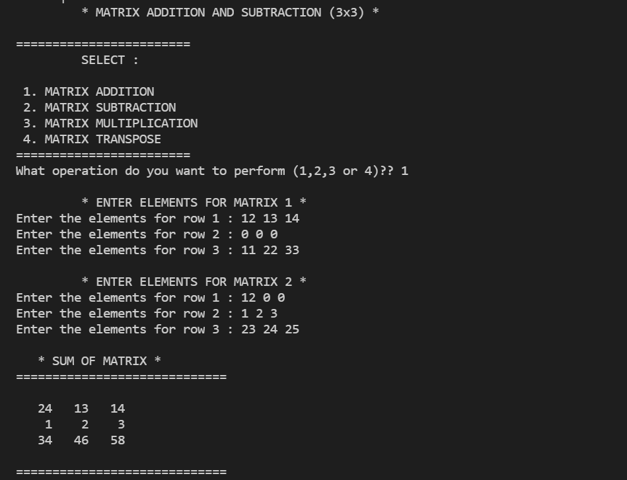

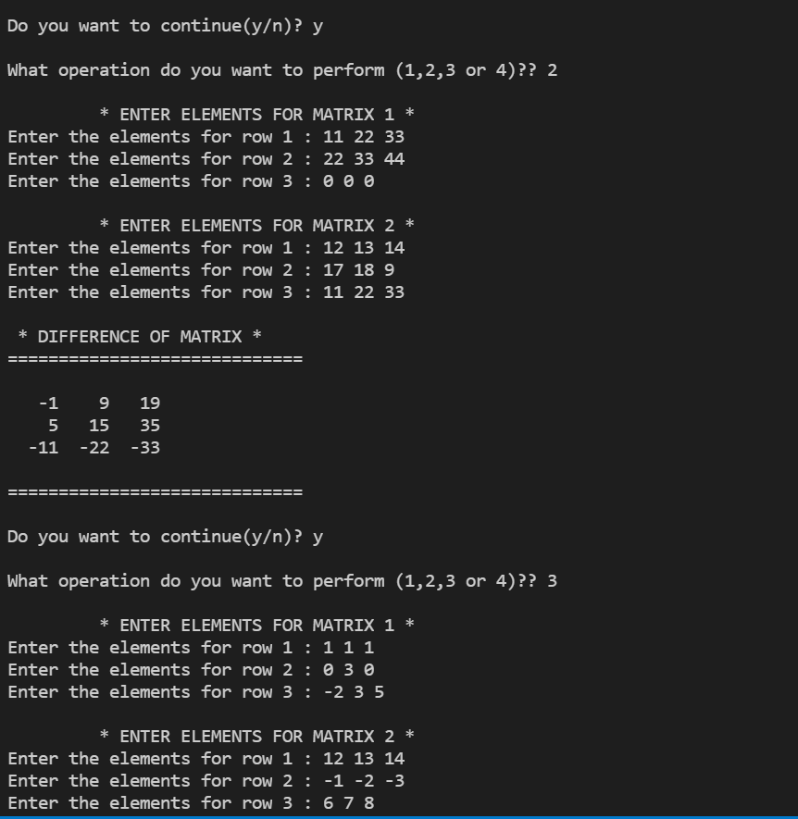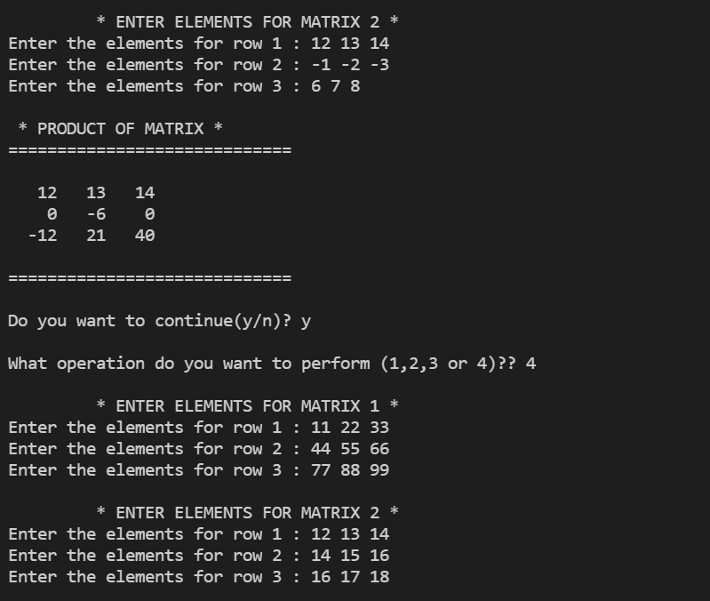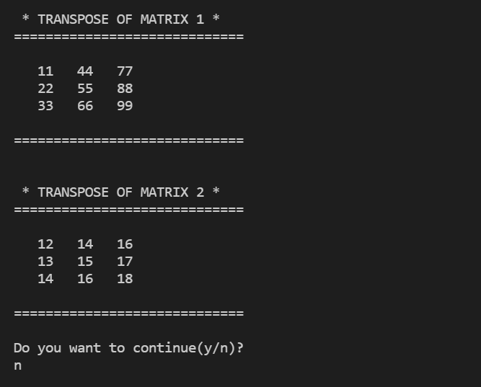

1. **Write a program that prints a table indicating the number of occurrences of each alphabet in the text entered as command line arguments.**

#include<iostream>

#include<iomanip>

#include<string.h>

using namespace std;

int main(){

    char array[20];

    int count;

    cout<<endl;

    cout<<"\t *DISPLAY OCCURENCES OF THE ALPHABETS* "<<endl<<endl;

    //take input string and display

    cout<<"Enter the string : ";

    cin>>array;

    cout<<endl<<"\t -> The input string is : "<<array<<endl;

    cout<<endl<<"\t -> The length of string is : "<<strlen(array)<<endl;

    //finding occurences of alphabets

    cout<<endl;

    cout<<"============================"<<endl;

    for(char j='A'; j<='z';j++){

        count=0;

        for (int i=0; i<strlen(array); i++){

            if (array[i]==j){

                count+=1;

            }

        }

        if (count!=0)

        cout<<setw(5)<<j<<setw(5)<<" occurs "<<setw(5)<<count<<" times"<<endl;

    }

    cout<<"============================"<<endl;

    cout<<endl<<endl;

    return 0;

}

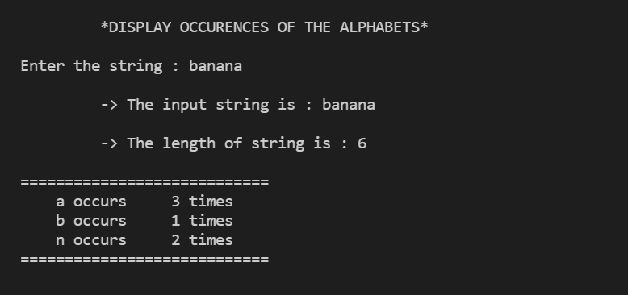

1. **Write a menu driven program to perform following operations on strings (without using inbuilt string functions):**
2. **Show address of each character in string**

#include<iostream>

#include<iomanip>

#include<string.h>

using namespace std;

int main(){

    char array[20];

    int count;

    cout<<endl;

    cout<<"\t *DISPLAY ADDRESS OF THE STRING CHARACTERS* "<<endl<<endl;

    //take input string and display

    cout<<"Enter the string : ";

    cin>>array;

    cout<<endl<<setw(20)<<" -> The input string is : "<<array<<endl;

    cout<<endl<<setw(20)<<" -> The length of string is : "<<strlen(array)<<endl;

    //printing address of alphabets

    cout<<endl;

    cout<<"\t============================"<<endl;

    cout<<setw(15)<<"*APHABET*"<<setw(15)<<"*ADDRESS*"<<endl;

    void *p;

    for (int i=0; i<strlen(array); i++){

        cout<<"\t"<<array[i];

        p=&array[i];

        cout<<"\t \t"<<p<<endl;

    }

    cout<<"\t============================"<<endl;

    cout<<endl<<endl;

    return 0;

}

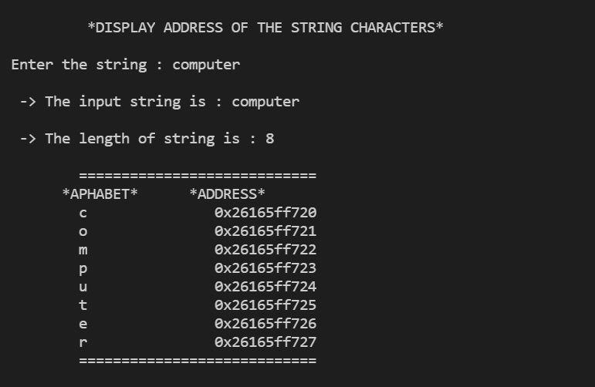

1. **Calculate length of the string (use pointers)**

#include<iostream>

#include<iomanip>

#include<string.h>

using namespace std;

int length(char*p){

    int i=0;

    while (*p){

        i++;

        p=p+1;

    }

return i;

}//function to find string length

int main(){

    char array[20];

    int count;

    cout<<"\t *DISPLAY LENGTH OF STRING USING POINTERS* "<<endl<<endl;

    //take input string and display

    cout<<"Enter the string : ";

    cin>>array;

    int len=length(array);

    cout<<endl<<"\t -> The input string is : "<<array<<endl;

    cout<<endl<<"\t -> The length of string is : "<<len<<endl;

    return 0;

}

