**1 – Complete Graph matrix question :**

#include <iostream>

#include <iomanip>

using namespace std;

void createMatrix(int A[10][10], int size)

{

cout<<"\n-> INPUT THE MATRIX/GRAPH VALUES"<<endl<<endl;

int n=1;

for (int i=0; i<size; i++)

{

cout<<"Enter the "<<n<<"th row : ";

for (int j=0; j<size; j++)

{

cin>>A[i][j];

}

n++;

}

}

void displayMatrix(int A[10][10], int size)

{

cout<<"\n-> DISPLAYING THE MATRIX "<<endl<<endl;

for (int i=0; i<size; i++)

{

for (int j=0; j<size; j++)

{

cout<<setw(3)<<A[i][j];

}

cout<<endl;

}

}

int completeGraphTest(int A[10][10], int size)

{

int flag=0;

int flag2=0;

for (int i=0; i<size; i++)

{

for (int j=0; j<size; j++)

{

if (i==j)

{

if (A[i][j]==0)

{

flag++;

}

else

flag=0;

}

else

{

if (A[i][j]==1)

{

flag2++;

}

else

flag2=0;

}

}

if (flag>0 && flag2>0)

return 1;

else

return 0;

}

}

int main()

{

cout<<"\t ** COMPLETE GRAPH MATRIX **"<<endl;

int size, result;

char ch='y';

while(ch=='y')

{

cout<<"\n-> Enter the number of elements in graph/size of matrix : ";

cin>>size;

int matrix[10][10];

createMatrix(matrix, size);

displayMatrix(matrix, size);

result=completeGraphTest(matrix, size);

if (result==1)

cout<<"\n-> The above matrix belongs to complete graph! "<<endl<<endl;

else

cout<<"\n-> The above matrix does not belong to complete graph! "<<endl<<endl;

cout<<"Do you want to continue(y/n): ";

cin>>ch;

cout<<"------------------------------------"<<endl<<endl;

}

cout<<endl<<"Program ends here!"<<endl;

return 0;

}

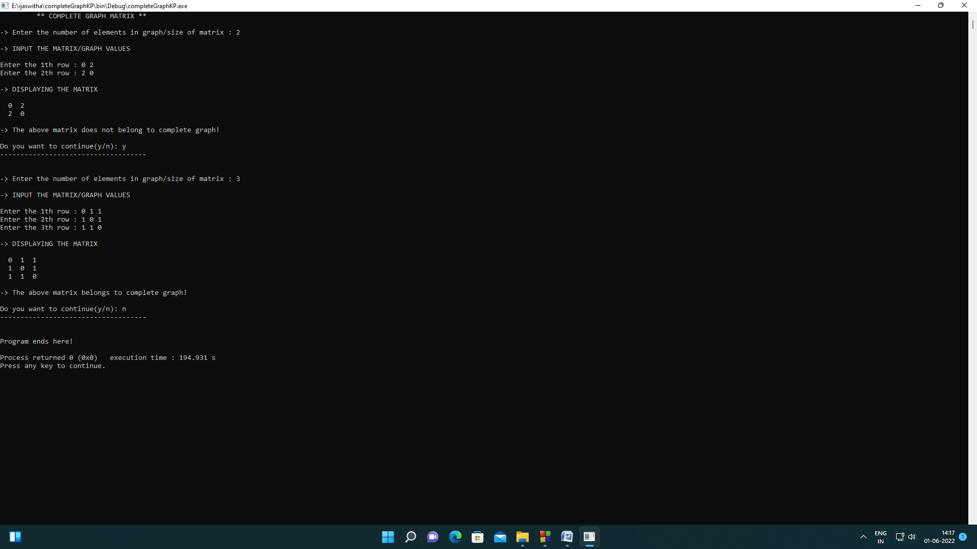

**2- tower of hanoi question :**

#include <iostream>

#include <iostream>

#include <iomanip>

using namespace std;

void towerOfHanoi(int disc, char start, char temp, char dest)

{

if (disc==1)

{

cout<<"Disc "<<disc<<" moved from "<<start<<" to "<<dest<<endl;

return;

}

towerOfHanoi(disc-1, start, dest, temp);

cout<<"Disc "<<disc<<" moved from "<<start<<" to "<<dest<<endl;

towerOfHanoi(disc-1, temp, start, dest);

}

void towerOfHanoiDesign(int nums){

int h=3*nums+2;

int i=0;

while(i<=h){

cout<<setw(18)<<"|"<<endl;

if (i==nums*3){

cout<<setw(10);

for (int i=0; i<h; i++){

cout<<"__";

}

cout<<endl;

for (int i=0; i<3; i++){

cout<<setw(9)<<"|"<<endl;

}

}

i++;

}

return ;

}

int main()

{

cout<<"Tower of Hanoi"<<endl;

// towerOfHanoiDesign(3);

int disc;

double swaps;

cout<<endl<<"-> Enter the number of discs : ";

cin>>disc;

cout<<endl<<"THE STEPS INVOLVED IN MOVING THE DISCS -> "<<endl<<endl;

towerOfHanoi(disc, 'A', 'B', 'C');

return 0;

}

