**Dehradun & Mussoorie – Hill stations you just can’t miss!**

The capital of Uttarakhand, Dehradun has a picturesque location with a beautiful view of the Himalayan ranges and river Ganga flowing on the either sides of the city. Mussoorie is located at a distance of about 38 km from Dehradun. It is touted to be the ‘Queen of Hills’ and attracts many tourists every year.

**Why**: ‘Coz there are only a few amazing weekend getaways like Dehradun and Mussoorie

**Ideal for**: Peace lovers, honeymooners, family and friends

**Best time to visit**: All round the year except monsoons.

**Ideal duration**: 2 to 3 days

**How to reach**: It takes around 5 hours to reach Dehradun from Delhi via road. From Dehradun, Mussoorie is just an hour journey away. The nearest airport is in Dehradun – Jolly Grant Airport.

**Things to do**: Visit the National Parks, Lakes, Kempty Falls, Benog Hill & Jwalaji Temple. Monastery, Resorts and Forest research institute in Dehradun

**Nainital & Ranikhet – A mix of bustle and quietude**

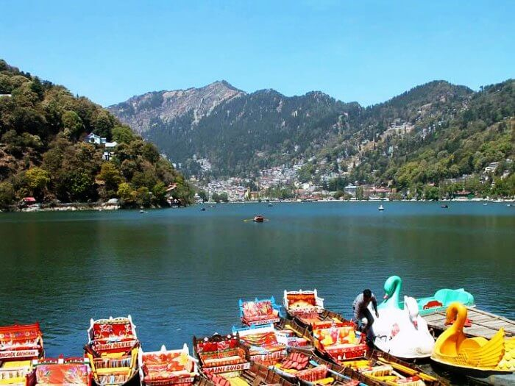

[Image Source](http://www.esamskriti.com/photograph/35jim-nainital-jim-corbett-photo.jpg)

One of the best places to visit in Uttarakhand and a popular getaway for couples and families, is Nainital. Located by the famous Naini Lake in the valley, surrounded by mountains on all sides where one can enjoy majestic vistas of nature here. Plus, there is plenty to explore with some interesting [tourist places in Nanital](https://traveltriangle.com/blog/best-places-to-visit-in-nainital/).

**Why**: The lush green sight of Nainital offers an exotic view of the Himalayan ranges. Enjoy the trekking trails in Ranikhet and go camping in the main sight of the location.

**Ideal for**: Honeymoon couples, office goers, couples and families

**Best time to visit**: April – June

**Ideal duration**: 4 to 5 days

**How to reach**: Nainital does not have direct access to the air connectivity. The nearest railwway station is located at a distance of 34 km at Kathgodham. It takes about 7 hours from Delhi to reach Nainital.

**Things to do**: Visit the host of temples at Ranikhet, go trekking, and visit the Nainital zoo and Naini Lake. Enjoy the wildlife sanctuary and the wonderful climate of the hill station.

**Must Read:** [Your Search Ends Here: 10 Hotels in Nainital on Mall Road](https://traveltriangle.com/blog/best-hotels-in-nainital-on-mall-road/)

**4. Rishikesh and Haridwar – To the spiritual destinations in Uttarakhand**

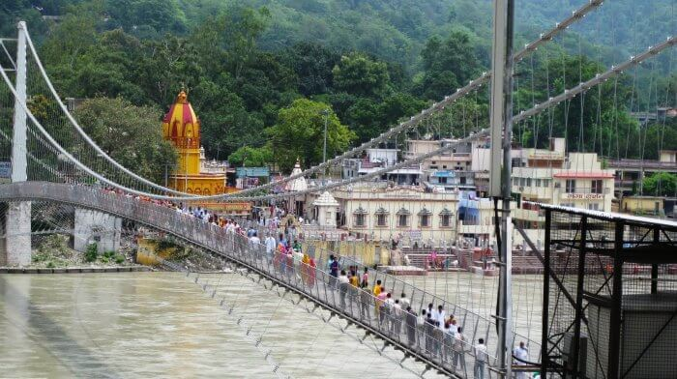

[Image Source](http://www.transtechpackersandmovers.com/images/Transtech-Packers-and-Movers-in-Rishikesh.jpg)

Another place you definitely [must visit in Uttarakhand](https://traveltriangle.com/uttarakhand-tourism/places-to-visit) is the adventure capital–Rishikesh and pilgrim capital–Haridwar. Haridwar is a place where tourists get enchanted by rustic touch and spiritual energy of the place and its surroundings.

**Why**: Rishikesh as it is the adventure capital of India; Haridwar for the tranquility and religion.

**Ideal for**: Everyone – friends, couples and families.

**Best time to visit**: Anytime of the year is good except monsoons.

**Ideal duration**: 3 to 4 days

**How to reach**: Nearest airport is in Dehradun. Trains connect both Rishikesh and Haridwar.

**Things to do**: Take part in the Ganga aarti in Haridwar, a holy dip in the river Ganga, go for a boat ride, eat the local delicacies and talk to the spiritual gurus. Visit the *ashrams* in Rishikesh; go for water sports adventures and trekking up in the hills.

**5. Chamoli – An ideal vacation spots in the mountains**

[Image Source](http://www.dreammountain.net/wp-content/uploads/2013/04/front.jpg)  
Chamoli is populary known as the ‘adobe of Gods’. Famous for its shrines, temples and connections with Hindu mythology and stories — Chamoli is also the town that sparked off the famous [Chipko movement](https://en.wikipedia.org/wiki/Chipko_movement" \t "_blank). The place is frequented by tourists for its villages and rich Garhwali traditions.  
**Why**: Chamoli is that ideal vacation spot with something for everyone. It is an ideal blend of pilgrimage, adventure and natural serenity.

**Best time to visit**: Across the year except heavy monsoon

**Ideal for**: Peace lovers, photographers, pilgrims, adventure junkies

**Ideal Duration**: 3 to 4 days

**How to reach**: The nearest airport Jolly Grant is at a distance of 222 km. The nearest railhead is Rishikesh at a distance of 202 km. It is well connected by road from all the major cities like Rishikesh, Rudraprayag, Srinagar,and Pauri.

**Things to do**: Trekking, sightseeing, photography, skiing, and cable car rides

**Suggested Read:** [6 National Parks In Uttarakhand That Would Please Your Eyes & Calm Your Adventurous Side](https://traveltriangle.com/blog/national-parks-in-uttarakhand/)

**6. Binsar – Nature’s bounty, untouched!**

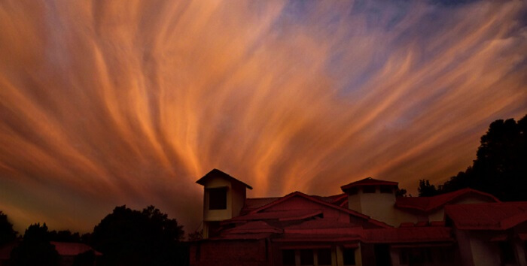

[Image Source](https://upload.wikimedia.org/wikipedia/commons/a/aa/Cloudscape_in_sky_at_Binsar,_Almora,_Uttarakhand,_India.jpg)  
Binsar is located amidst an entire wildlife sanctuary. At an elevation of some 2,400 m, it is a slightly cut off travel destination offering majestic views of Nanda Devi, Nanda Kot, Kedarnath and Chaukhambha. Like several others, even binsar has a mythological connect as the local gods Golu devta had a fight with the king of Binsar.  Homestays in Binsar are among the [best homestays in the Himalayan region](https://traveltriangle.com/blog/secret-homestays-in-himalayas/).

**Why**: If you are looking for a break from the noise of the city life, this is the place to be.

**Best time to visit**: Summer months; October & November

**Ideal for**: Writers, nature lovers, peace seekers

**Ideal duration**: 3 to 4 days

**How to reach**: The nearest airport is Pant Nagar airport at a distance of 143 km from Binsar. Kathgodam is the nearest railway station (110 km) and is well connected to major cities. If travelling on personal vehicle, the town charges INR 50 as entry charge.

**Things to do**: Sightseeing, photography, lazing around, trekking, safaris to the wildlife sanctuary

**Must Read:** [35 Hill Stations Near Delhi For A Peaceful Getaway](https://traveltriangle.com/blog/hill-stations-near-delhi/)

**7. Jim Corbett – Where wildlife never fails to amuse**

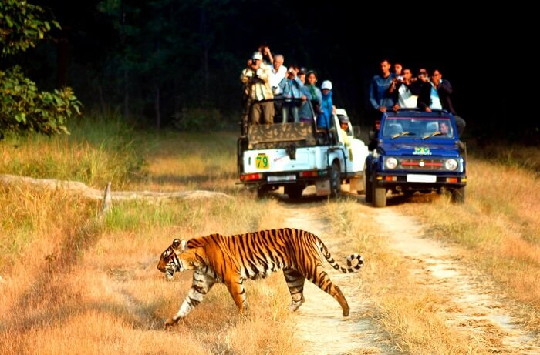

[Image Source](http://www.tripcrafters.com/agent/trip_photos/tiger-jim-national-park-tour.jpg)  
Formely known as Haley’s National Park, Jim Corbett was established in 1938 and attracts visitors for its Royal Bengal Tigers. The park is home to some 600 species of birds, an equal number of animals and around 488 different types of plants and trees. Jim corbett organises safaris and hiking trails through the dense forest’s buffer zones all through the year.

**Why**: ‘Coz this is the place you can’t miss if you are a wildlife enthusiast, photographer and nature lover.

**Best time to visit**: December to February

**Ideal for**: Nature enthusiast, photographers, excursionists

**Ideal duration**: 2 to 3 days

**How to reach**: Ramnagar is the nearest railway staion while Pant Nagar provides air connectivity. It is well connecetd by road and there are regular bus services from Ramnagar and Delhi.

**Things to do**: Elephant rides, elephant safaris, Jeep safaris, photography, and unplanned excursions

**Must Read:** [15 Amazing Hill Stations In Uttarakhand: From The Most Popular Hill Towns To The Unexplored Ones](https://traveltriangle.com/blog/hill-stations-in-uttarakhand/)