Simple Area Correction for Reflectivity

Detlef-M. Smilgies

In an ideal world the incident slit would provide a box-shaped intensity distribution

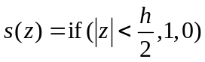

where “if” is the case function if(condition, value if true, value if false). The integrated intensity of such a slit is simply

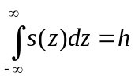

with h being the vertical gap of the slit. If we illuminate a sample under a small incident angle q with the radiation passing through the slit, the sample of finite length L will act like another slit of width w with

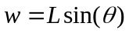

thus limiting the maximum reflected beam to

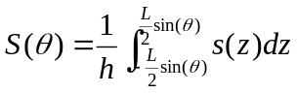

Often the incident intensity does not have a simple box shape, but resembles more a Gaussian. If we assume that the incident x-ray beam is given by a Gaussian curve with a maximum intensity of 1 and the same integrated intensity, we have

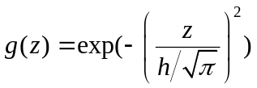

The FWHM of this Gaussian is

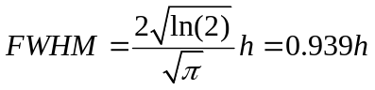

The sample acts again like an effective slit of size and the area effect can now be expressed as

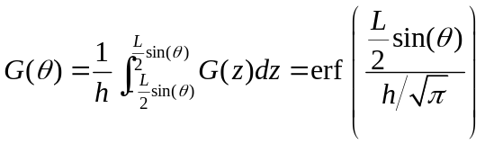

f(w) describes the fraction of the intensity accepted by the sample and erf(x) is the error function.

Both types of slit acceptance functions s(z) and g(z) are plotted below, as well as the fraction of intensity accepted by the surface S(z) and G(z), respectively.

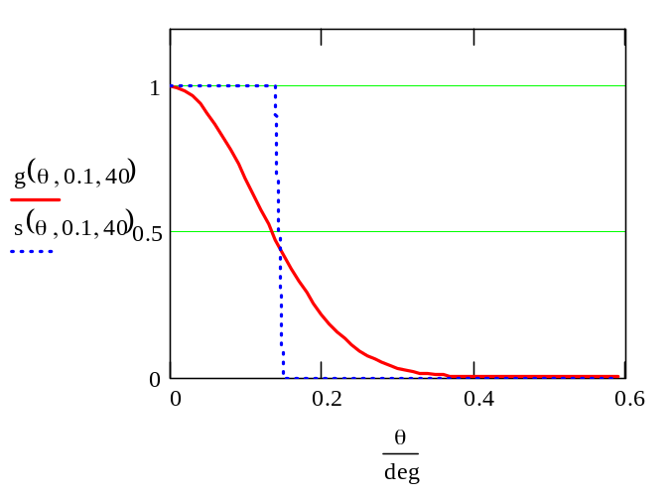

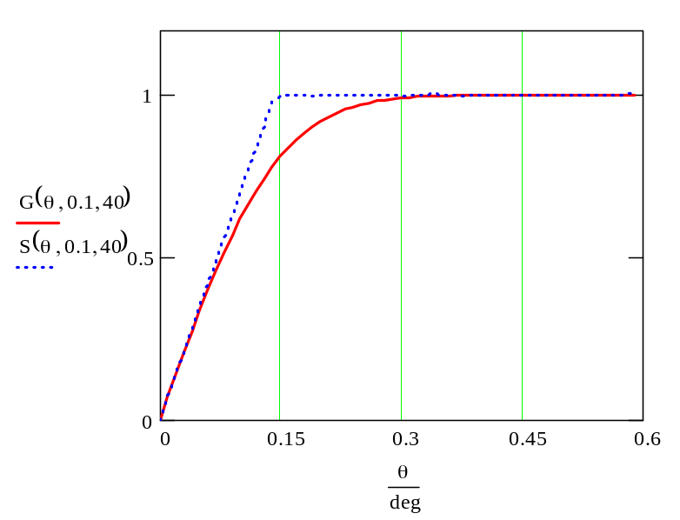

Note that with our choice of Gaussian from above the initial slope of the two curves is identical.

Although it may seem that the chosen condition of beam height h=0.1 mm and sample length L=40 mm are sufficient to reach saturation at θ=0.2deg (the critical angle of silicon), as in the idealized case, in the Gaussian case the full intensity is still not impinging on the surface. So even at the critical angle a significant correction for the absolute reflectivity remains.

Finally we show the effect of the sample length, while keeping the beam height h fixed at 0.1 mm:

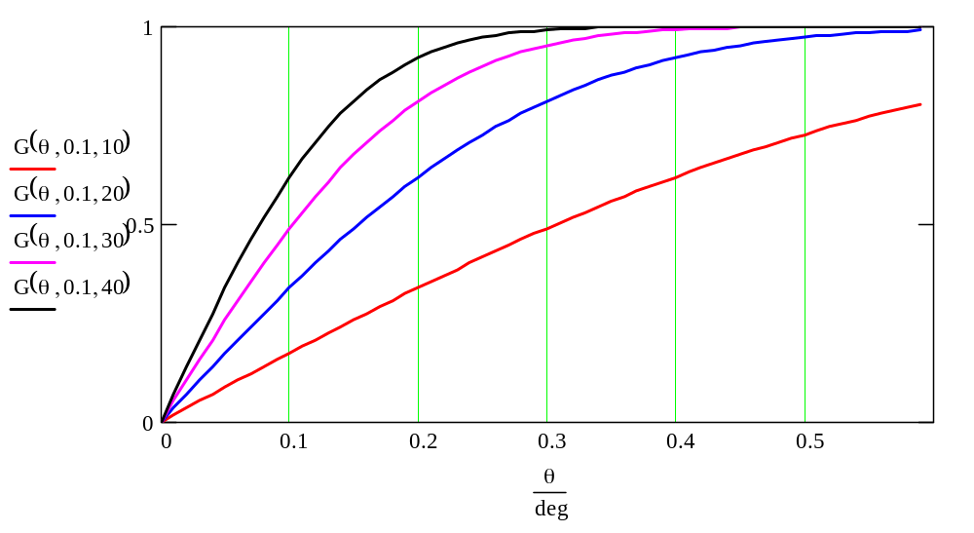

Probably the shape of the beam passing through the incident slit system will be inbetween these two cases, like a box function smeared out by a Gaussian:

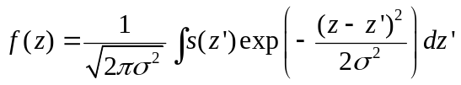

where σ is a smearing parameter. For σ<<h, f(z) will resemble s(z), for σ>>h, g(z).

Unfortunately the expression for f(z) is quite involved and with σ we introduced another unknown parameter, which would have to be determined from an independent measurement (Actually, a zsam scan provides information on the incident beam profile at the sample position!). So G(θ) is probably still the best ad hoc choice for the area correction.

How do we go about now to correct our reflectivity data from the area effect? Again, there are several possible ways.

First of all we do all the usual correction: subtract the constant offset from the V/f converter, normalize to monitor counts, correct for remaining θ offset by a linear fit to the initial slope. Then we have the following options:

- We take the theory as is, and measure slit gap and sample length. If this works – great. Otherwise we may need to look into the vertical beam profile at the sample position and into the effective sample length (if the sample is not flat, edge effects, or an inhomogeneous reflectivity).
- We assume that the error function provides the correct shape for the area effect. We measure the direct beam intensity I_{dir} and then fit the error function such that it reproduces the initial slope: I(θ) = I_{dir} erf(a θ). This should give a pretty good fit. From the fit we can determine either an effective vertical gap or an effective sample length and see whether these make sense. Let’s keep in mind that any deviation from the expected values is usually a combination of these two effects.
- We determine the incident beam profile from a knife edge scan at the sample position (the next best scan would be a zsam scan). The derivation yields the beam profile, and its width can be determined from a fit to the error function or a Gauss fit to the derivative. We use this information to determine the a-parameter of the error function. Then we make a fitting model: I(θ) = I_{fit} erf(a θ) and fit I_{fit}. The deviation of I_{fit} from I_{dir} is then ascribed to imperfections of the sample.

Whichever way works out, we are now in shape to correct our reflectivity curve by dividing over the fitted error function. Note, this yields an approximation to the absolute reflectivity!

What we learn from all these conniptions:

It is always best, to slit down and measure the real thing.

However, stability issues (beam position, mechanical stability of the set-up) may dictate to relax the beam size somewhat and then we can use the approximations outlined above to recover the reflectivity at small angles.

