**Holly Olson**

**Cit 230**

**Brother Blazzard**

**3-28-18**

**Website Planning Document**

***The Mountain Spoke***

**Author: Holly Olson**

**Site Purpose**

**The purpose of this site is to let the world know of the amazing company, The Mountain Spoke. The site will have 7 different pages that will be easy to navigate to. Each page will have the company logo and name at the top of the page and will have a navigation bar to direct you to the other pages. Upon clicking into The Mountain Spoke website you will see various pictures of things you can do with your bike. These pictures will not only be exciting to look at, they will also make the visitor want to explore the site a little more. The other 5 main pages are the Adventure Tour Page, The Event Page, The Sales Page, The Service page, and The Contact Us Page. The event page will have another page linked to it called the Thank You Page.**

**In the Adventure Tour Page,. you are shown different adventures you can take with your bicycle. Because people of many ages ride on bikes and they all seem to love adventure, there will be adventures geared toward young children and families with young children. Some adventures will make your teenage heart soar as you ride through more advanced adventures. Then for the experienced rider, you will find adventures that fit right in to your style. And The Mountain Spoke has not forgotten those of the older generation who just want an adventure that takes you back to a time when biking was the only way to travel.**

**On the events page you find information about the “Cycle the Continental Divide”, the dates and the form to register to go. There will be another page linked to the events page called the thank you page that will thank you for filling out the form and to let you know that you have filled it out completely and that it is being processed.**

**The sales page speaks for itself. It will show the bicycles that are for sale from The Mountain Spoke Company.**

**The service page will offer everyone, not just owners of bicycles bought from The Mountain Spoke, a place that they can go to find things they can do to make their bikes in top condition, but if needed they can bring their bikes in to be serviced.**

**The contact us page will give you not only the phone number, email, and address, but it will have a section of map to show you the general position of the store.**

**The Mountain Spoke site is going to receive a lot of visitors and will become one of the top bicycle sites around, not only because it will offer tours and events, but also because it will allow you to purchase bicycles that are well made. And to better help you with the up keep of your bike, they offer a service site. They will not leave you in the dark if you are having questions, they are always quick to answer all questions you might have on the contact page.**

**Their goal is to help people realize that riding a bike can be an adventure, not just drudgery or another way to get around. We want the viewer to leave the site excited and willing to share its URL with others.**

**Target Audience**

**Those at The Mountain Spoke want everyone to find joy in the site because they offer things for anyone who can ride a bike and wants to have fun. They offer adventures for many different skill levels and ages. The owners of The Mountain Spoke know that not every cyclist is the same in skill and age and do their best to account for that, not only in the adventures they offer, but also in the bikes they sale. The viewer can be assured that their experience with bikes is well rounded as The Mountain Spoke is a close family business.**

**Site Map**

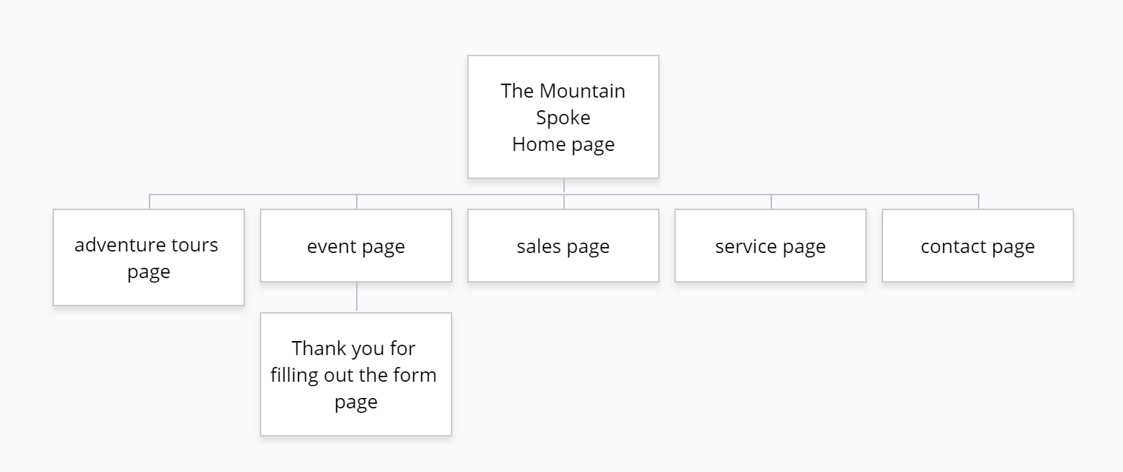

**Color Scheme**

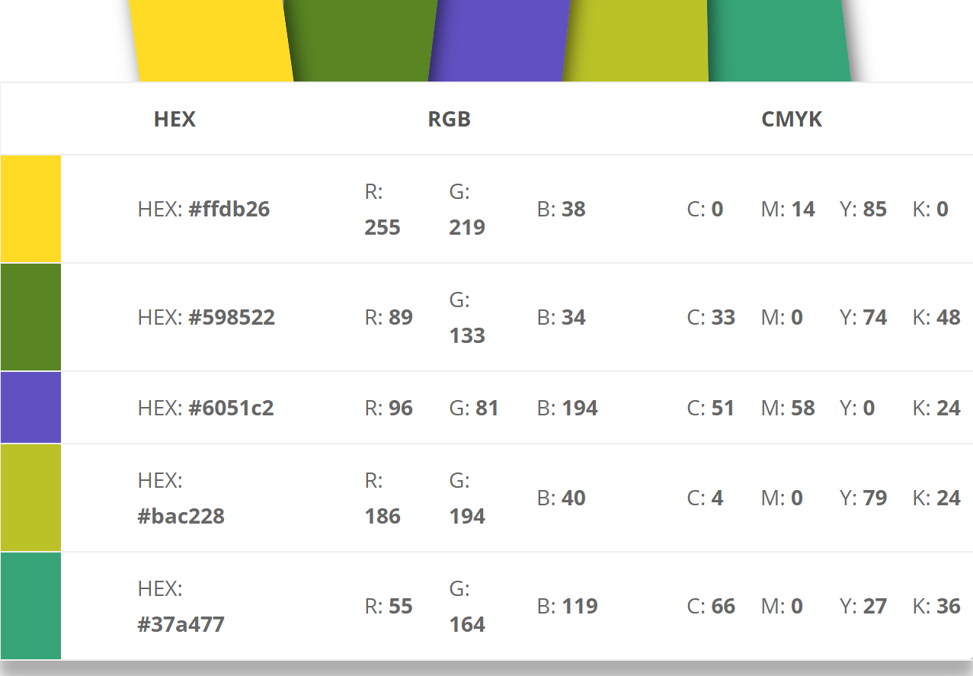

**These colors will make the site pop but not be too overbearing. The h1-h6 elements will be the color #bac228, allowing them to draw the attention but not to be to overpowering. The header and footer background color will be #598522, this allows them to draw your attention but not over power the rest of the page. The navigation bar will be color #6051c2 with the words being white. Color #ffdb26 will be the color used as you go over the navigation bar. Color #37a477 will let you know what site you have visited. All these colors will be used throughout each page in a way to help people enjoy the experience.**

**Typography**

**I picked three fonts for the website. One is for the h1-h6, another for the headers, and the last for the basic text.**

1. 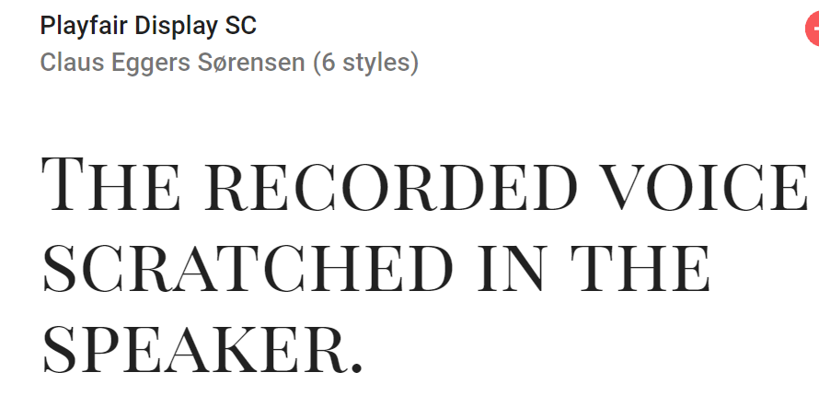

**This font shows style but also is easy to read. It will be a great h1-h6 font.**

1. 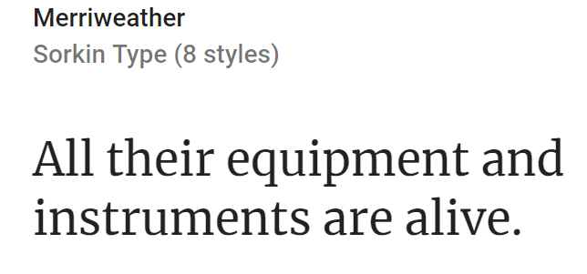

**This font will be used for the headers and the titles. It is also easy to read with some style.**

1. 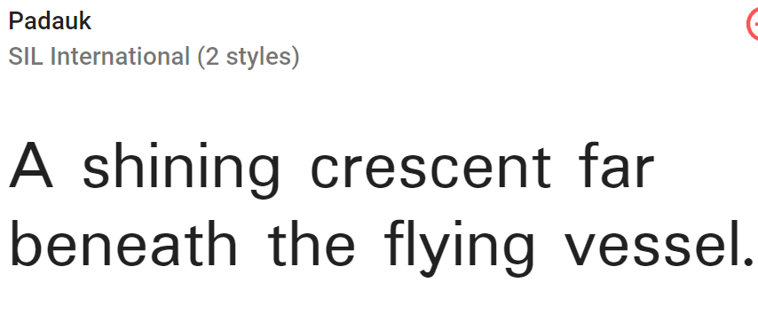

**This is a good font for the basic text of the site.**

**Wire-frames Sketches**

**I made these wire frames for the Monitor, Tablet, and Phone for the home page.**

**Monitor**

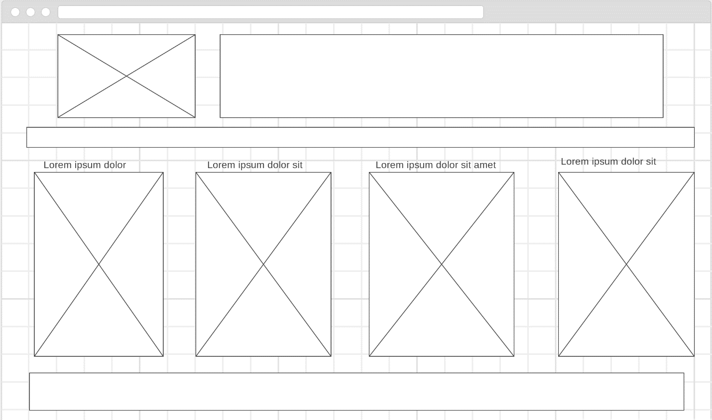

**Tablet**

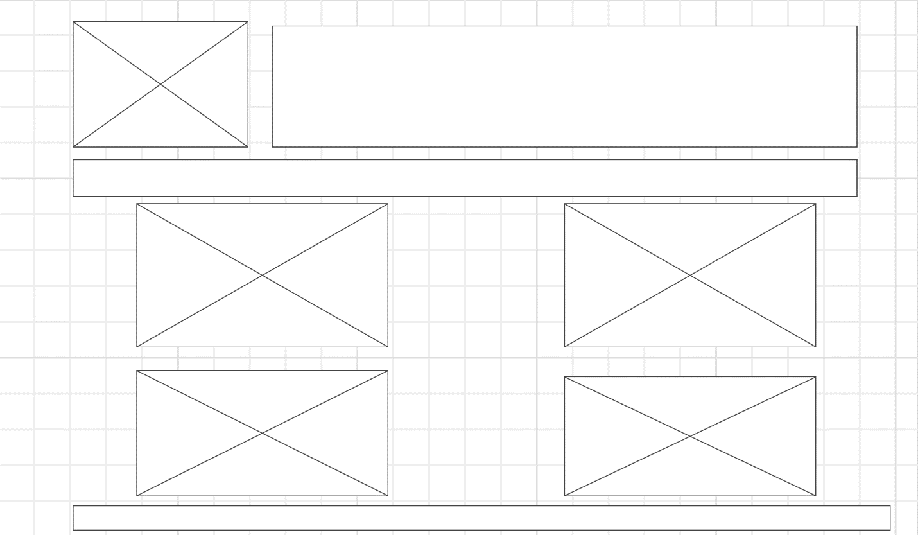

**Phone**

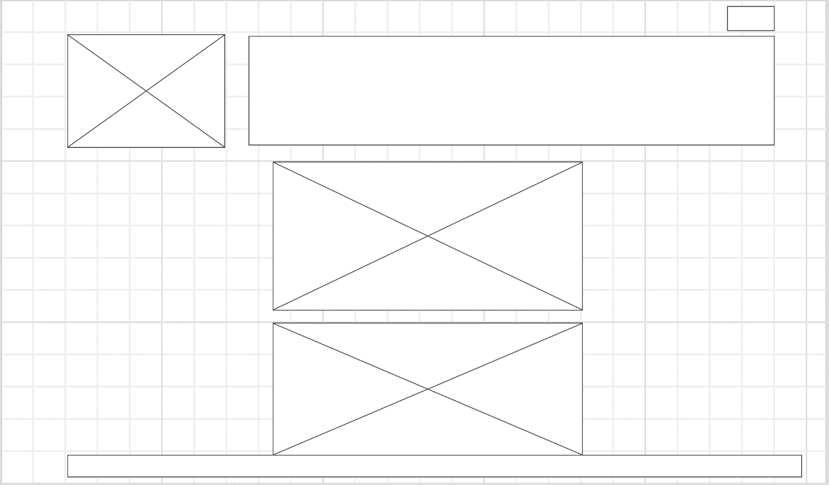

**Not all of the pictures are showing as you have to scroll down to see them. It also has the hamburger button for the navigation bar at the top.**