Question 1:
Longest Common Subsequence (LCS)
Given two sequences:
X = "COMPUTER" and Y = "PROGRAMMER"
a) Design an algorithm to compute the Longest Common Subsequence (LCS) of X and Y using
Dynamic Programming.
b) Draw the DP table step by step.
c) State the time and space complexity of your solution.
CO Alignment: CO2 (Apply algorithmic paradigms for problem-solving)
Answer :
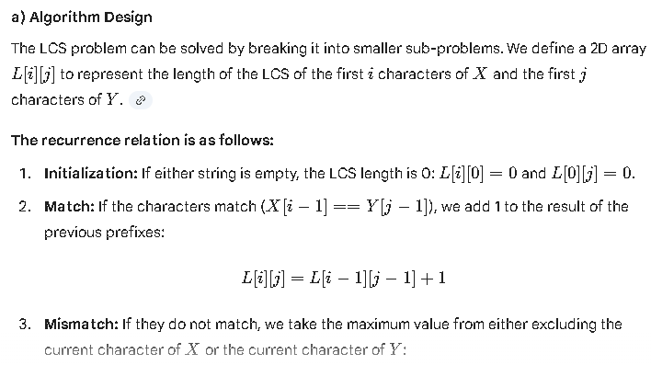

b) DP Table Step-by-Step
We construct the table by comparing each character of "COMPUTER" (rows) against "PROGRAMMER" (columns).
 | ∅ | P | R | O | G | R | A | M | M | E | R
$\emptyset$ | 0 | 0 | 0 | 0 | 0 | 0 | 0 | 0 | 0 | 0 | 0
C | 0 | 0 | 0 | 0 | 0 | 0 | 0 | 0 | 0 | 0 | 0
O | 0 | 0 | 0 | 1 | 1 | 1 | 1 | 1 | 1 | 1 | 1
M | 0 | 0 | 0 | 1 | 1 | 1 | 1 | 2 | 2 | 2 | 2
P | 0 | 1 | 1 | 1 | 1 | 1 | 1 | 2 | 2 | 2 | 2
U | 0 | 1 | 1 | 1 | 1 | 1 | 1 | 2 | 2 | 2 | 2
T | 0 | 1 | 1 | 1 | 1 | 1 | 1 | 2 | 2 | 2 | 2
E | 0 | 1 | 1 | 1 | 1 | 1 | 1 | 2 | 2 | 3 | 3
R | 0 | 1 | 2 | 2 | 2 | 2 | 2 | 2 | 2 | 3 | 4

Result
- Length of LCS = 4
- One possible LCS: “OMER”

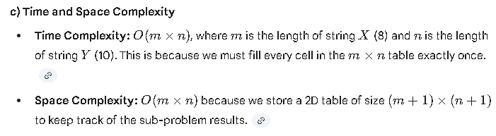
Question 2:
0-1 Knapsack Problem
You are given the following items:

Item Weight Value
1 4 40
2 3 35
3 5 60
4 2 25
5 1 15

Knapsack capacity: 8
a) Formulate the 0-1 Knapsack problem.
b) Solve the problem using a Dynamic Programming approach with tabulation.
c) State the optimal solution and explain its correctness.
CO Alignment: CO3 (Analyze performance and justify correctness)

