README
Functionality
The required functionality of this project is to enable a user to connect to a MongoDB database as an authenticated user with read permissions and see the records on the database on a frontend with a list, a pie chart, and a map. Not only this, but the user needs to be able to filter the data by specific categories, and filtering the data should update the pie chart and the table to display the selected information filter. Along with this, the company logo needs to take the user to the SNHU website when clicked.

Below you will see the default landing page for the application. This has the filter set to “Reset” which returns all of the data in the database table.
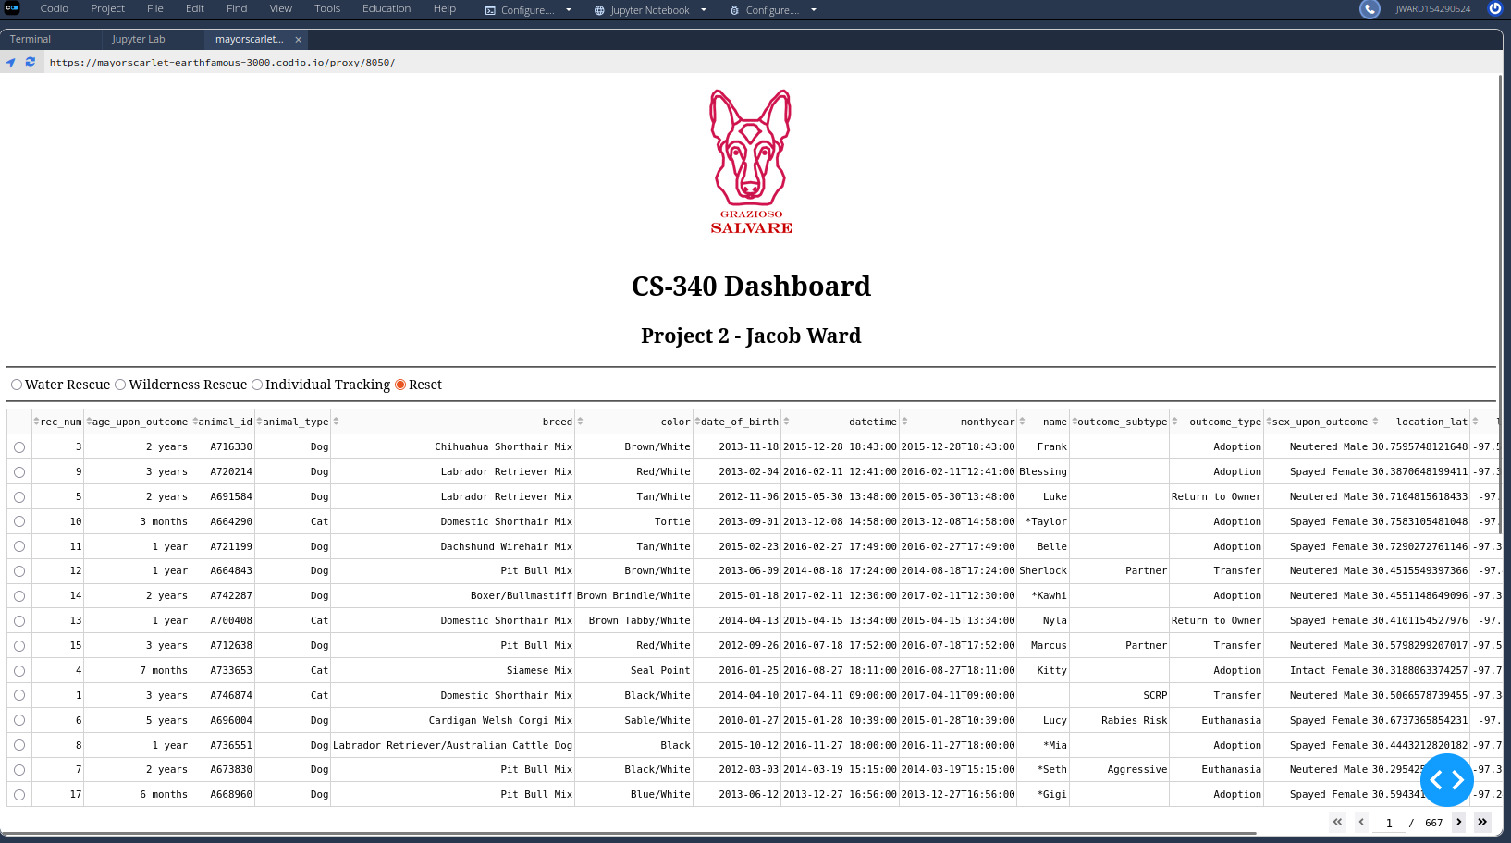
Next you will see the rest of the same page with the filter still set to “Reset”. This will show you the Map (displaying a selected entry from the table) and the Pie Chart (showing all animal breeds).
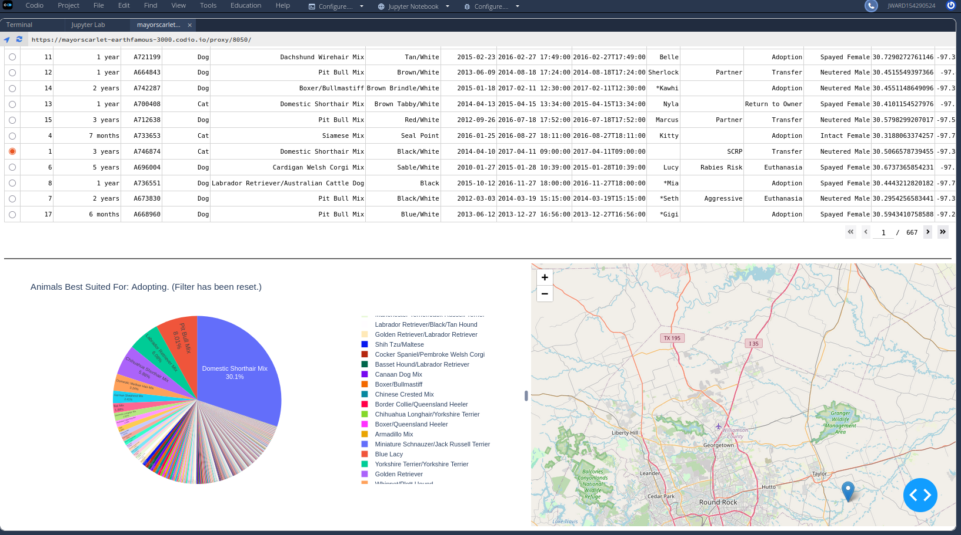
Next, we will see the two images with the filter set to “Water Rescue”. This filters the database to animals best suited for this type of rescue.
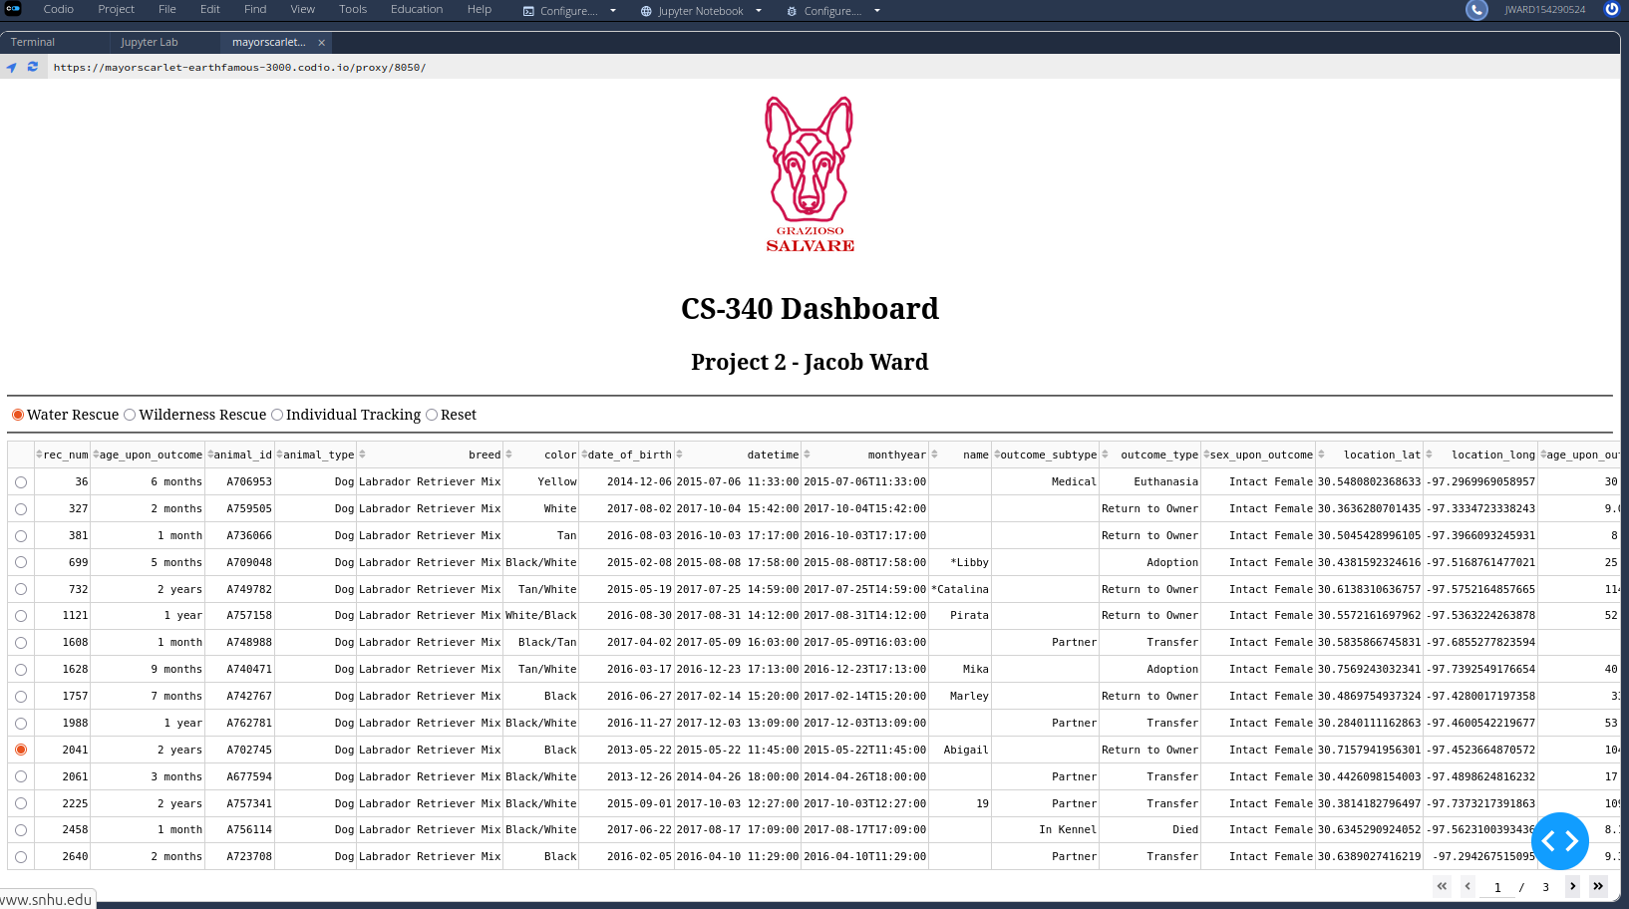
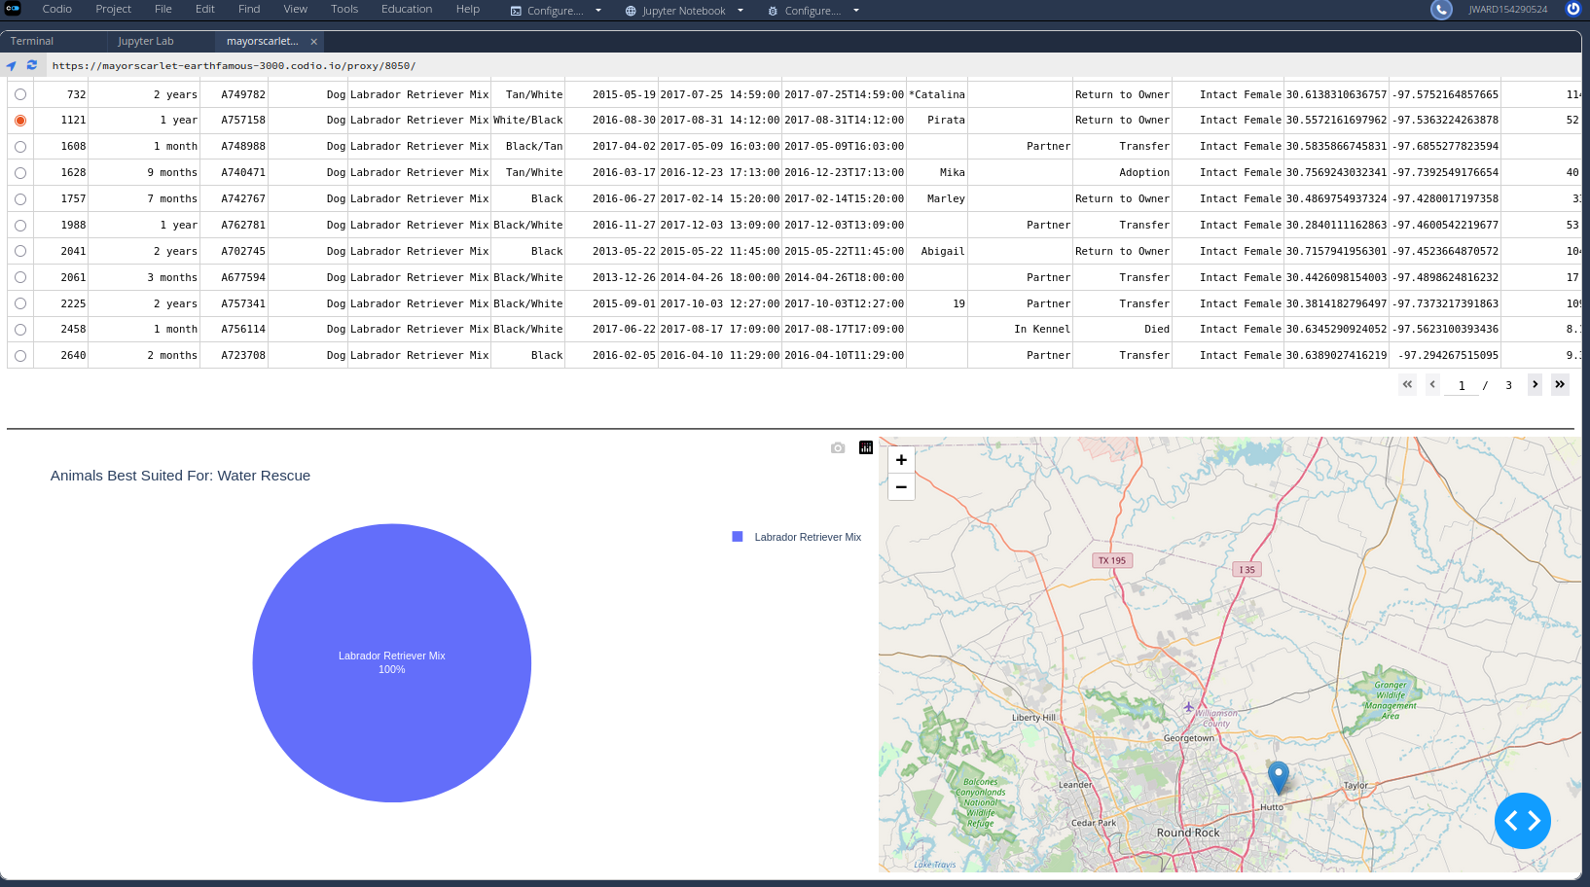

The next image shows the whole screen with the “Wilderness Rescue” filter set. It is only one image because this filter does not return as many entries.
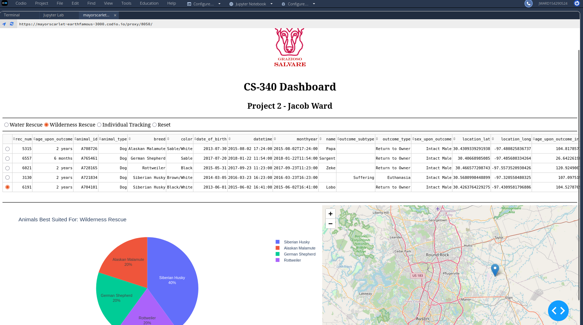
Now the following image will be the whole page with the filter set to “Individual Tracking”. Similarly not many results are returned.
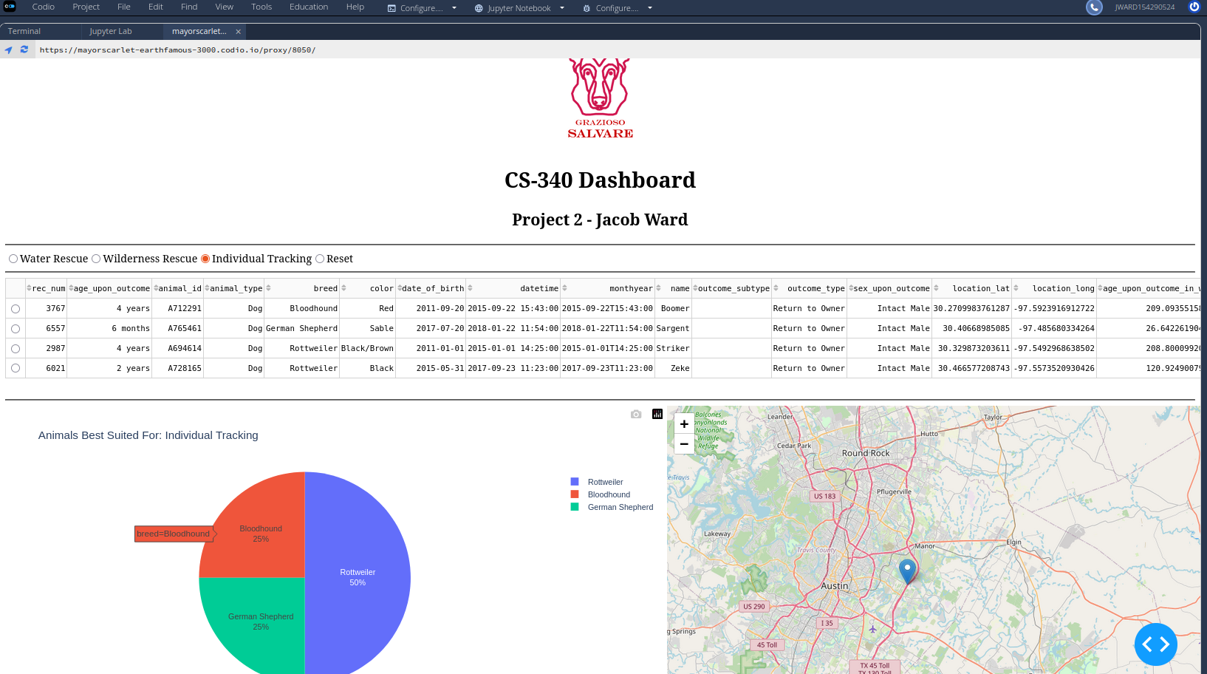
The tools used to achieve this functionality:
MongoDB was used as the model component of the development because of a few reasons. Since the queries that we are using to filter data and return results are not overly complicated, we can take advantage of MongoDB’s simpler learning curve. It also interfaces very nicely with Python and Dash, as well as some of the other tools that we used to create this application. Along with a shallower learning curve, MongoDB stores documents in BSON objects. BSON objects are a very similar format to Python dictionaries so this almost 1 to 1 structure makes communicating with the database extremely intuitive.
The Dash framework provided the view and the controller in our MVC (Model View Controller) application. This enabled us to connect to the MongoDB as an authorized user (aacuser), on a specific collection (animals), within a specific database (aac). It also provided us with the tools to create the HTML elements that would contain our Plotly.express graph, map, and data table. Dash is the tool that enables the user to interact with the database through a graphical user interface or GUI.
Useful links to the Docs:
- https://plotly.com/python/pie-charts/
- https://dash.plotly.com/datatable

The steps taken to complete the project:
- Importing the database
- Creating the authorized user
- Creating the CRUD api to implement Creating, Reading, Updating, and Deleting functionality. This is the backbone of the application that enables a user to view all the animals in the database collection and to filter them.
- Creating the HTML elements to contain all of the Plotly graphs and charts
- Creating the Dash frontend.
  - Connecting the Data Table
  - Connecting the Pie Chart
  - Connecting the Map
Challenges:
- The biggest challenges that were overcome in this project revolved around getting used to the callbacks that are used to update the Dash GUI components. Most of my time spent debugging revolved around the table, graph, and chart not updating. This was resolved once i figured out how to add parameters to the callbacks to support the filter-type that i incorporated in the radio button component.

