**Module 3.2 – Building Trust**

By: Skyler Millburn

April 3, 2021

Deliverable:

1. Link to your GitHub repository.
   1. <https://github.com/smillburn/csd-310>
2. Screenshot of your GitHub repository.

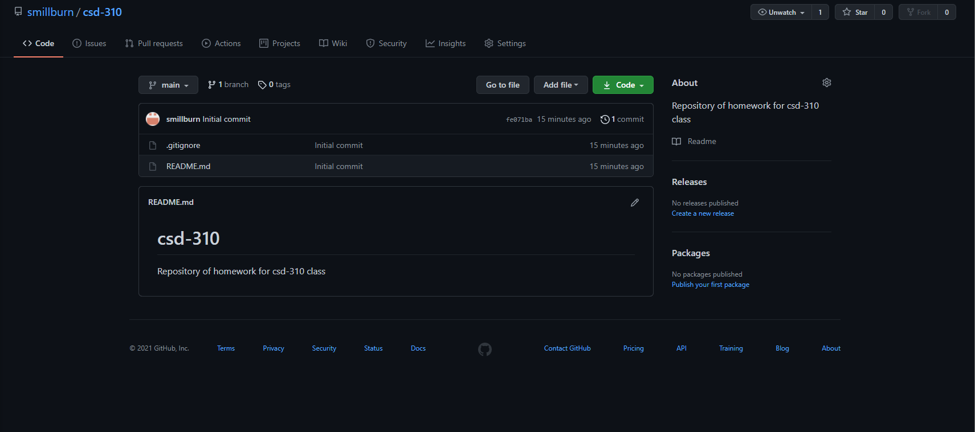

1. Screenshot of your local directory (properly formatted).

