**Module 1.3 – UMLet Installation**

By: Skyler Millburn

May 30, 2021

Deliverable:

1. Take a screenshot of UMLet running on your desktop.

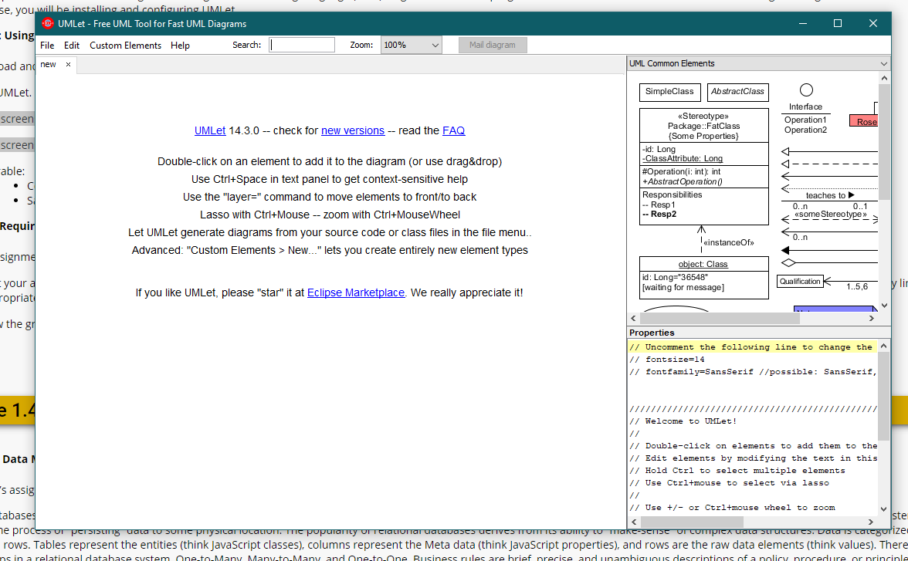

1. Take a screenshot of the directory where UMLet was installed.

