**Module 1.4 – Data Models**

By: Skyler Millburn

May 30, 2021

UMLET:

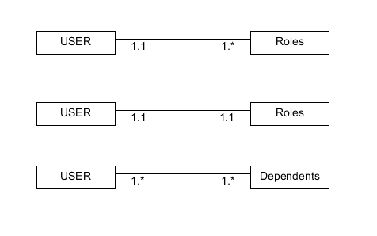

NoSQL:

