**Module 2.2 – PyTech**

By: Skyler Millburn

June 6, 2021

UMLET:

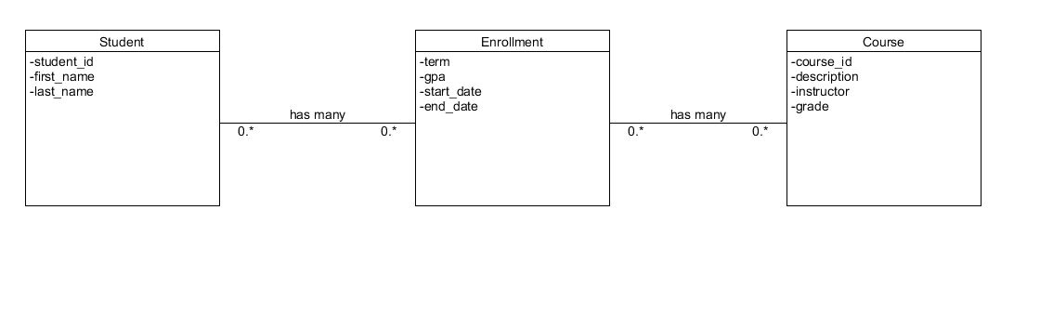

NoSQL:

