**Module 3.2 - PyBookCo**

By: Skyler Millburn

June 13, 2021

UMLET:

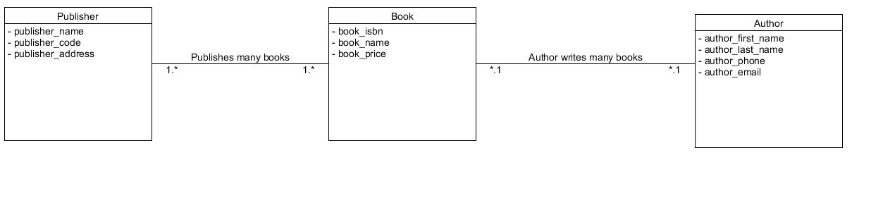

NoSQL:

