**Module 4.2 – MongoDB Atlas Setup**

By: Skyler Millburn

June 20, 2021

2. Cluster Setup:

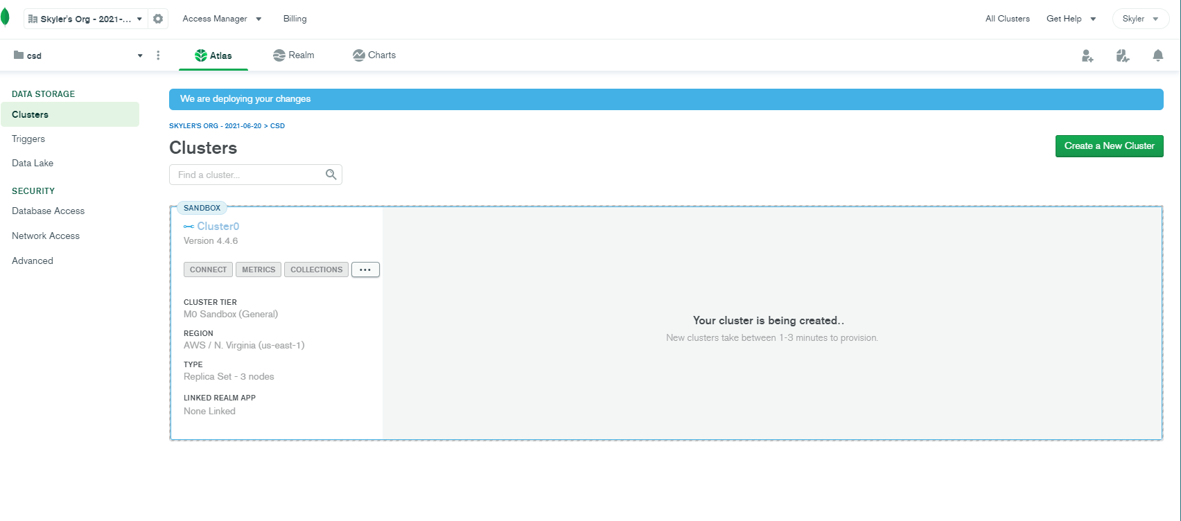3. Organization/Project Setup:

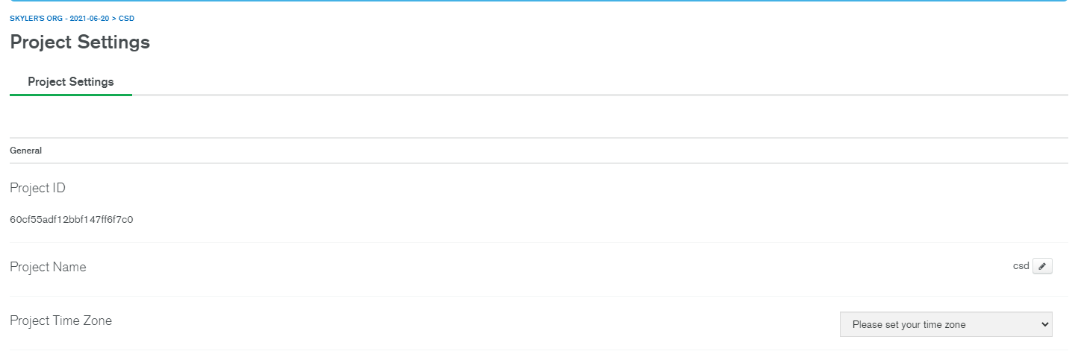

4. Security Provisions

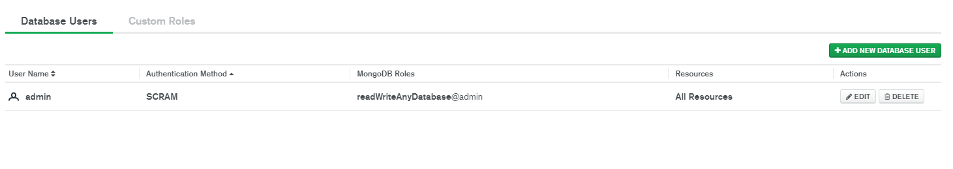

5. Whitelist IP Addresses

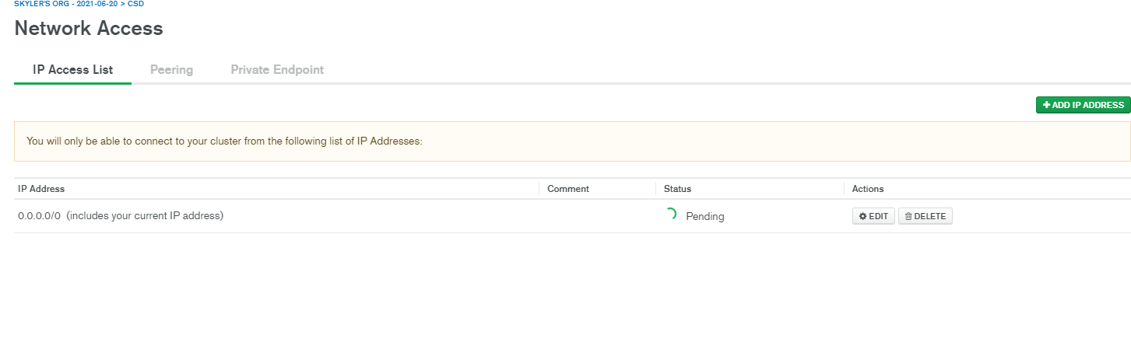

6. Access the Cluster

