**Module 4.3 – PyTech Part Deux**

By: Skyler Millburn

June 20, 2021

UMLET:

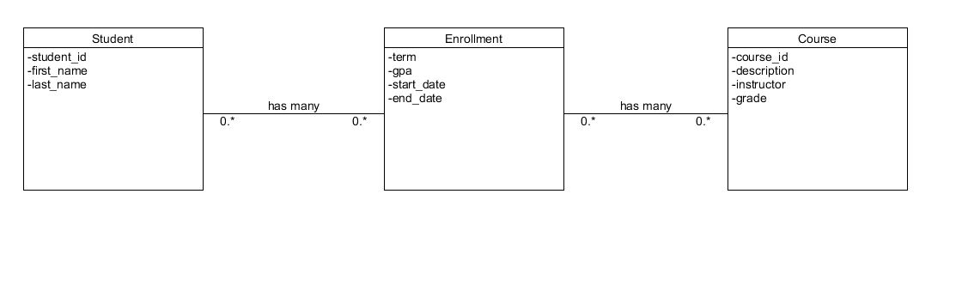

NoSQL:

