**Module7.2– MySQL Installation and setup**

By: Skyler Millburn

July 4, 2021

Step 1:

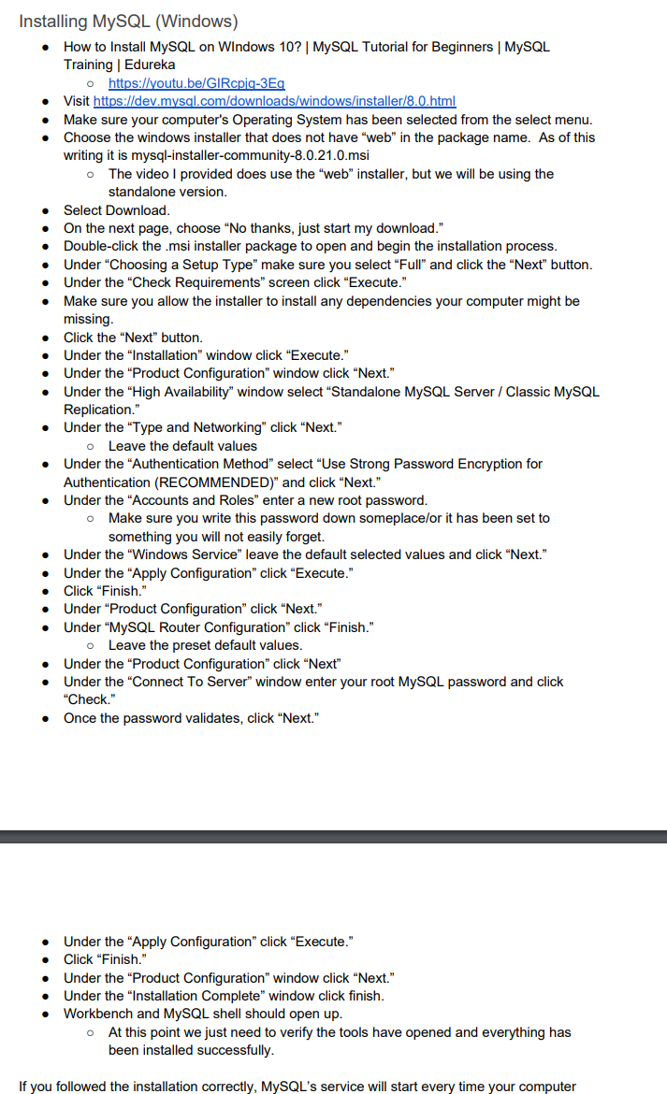

Step 2:

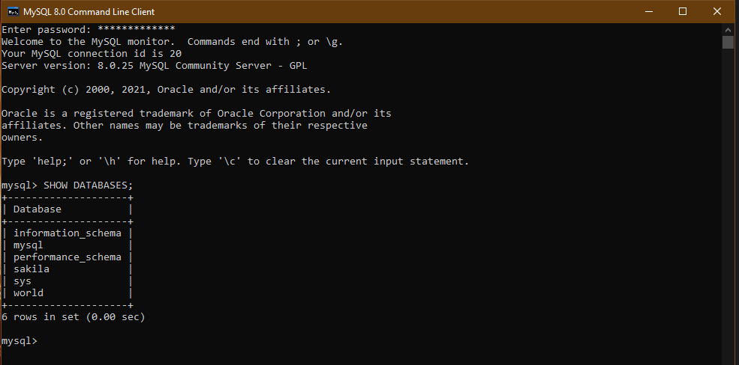

Step 3:

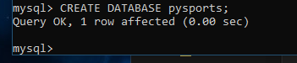

Step 4:

