**Module8.2– PySports: Setup**

By: Skyler Millburn

July 4, 2021

Github Repo:

* https://github.com/smillburn/csd-310

Sql Script run output:

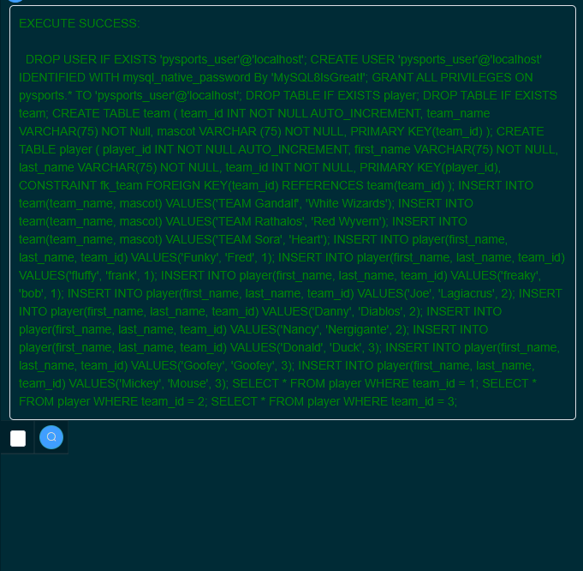

Show Tables Output:

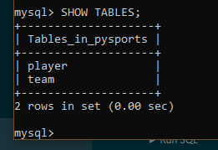

Mysql_test output:

