**Module 1.2 – Repo Setup**

By: Skyler Millburn

August 15, 2021

Deliverable:

1. Link to your GitHub repository.
   1. <https://github.com/smillburn/csd-340>
2. Screenshot of your GitHub repository.

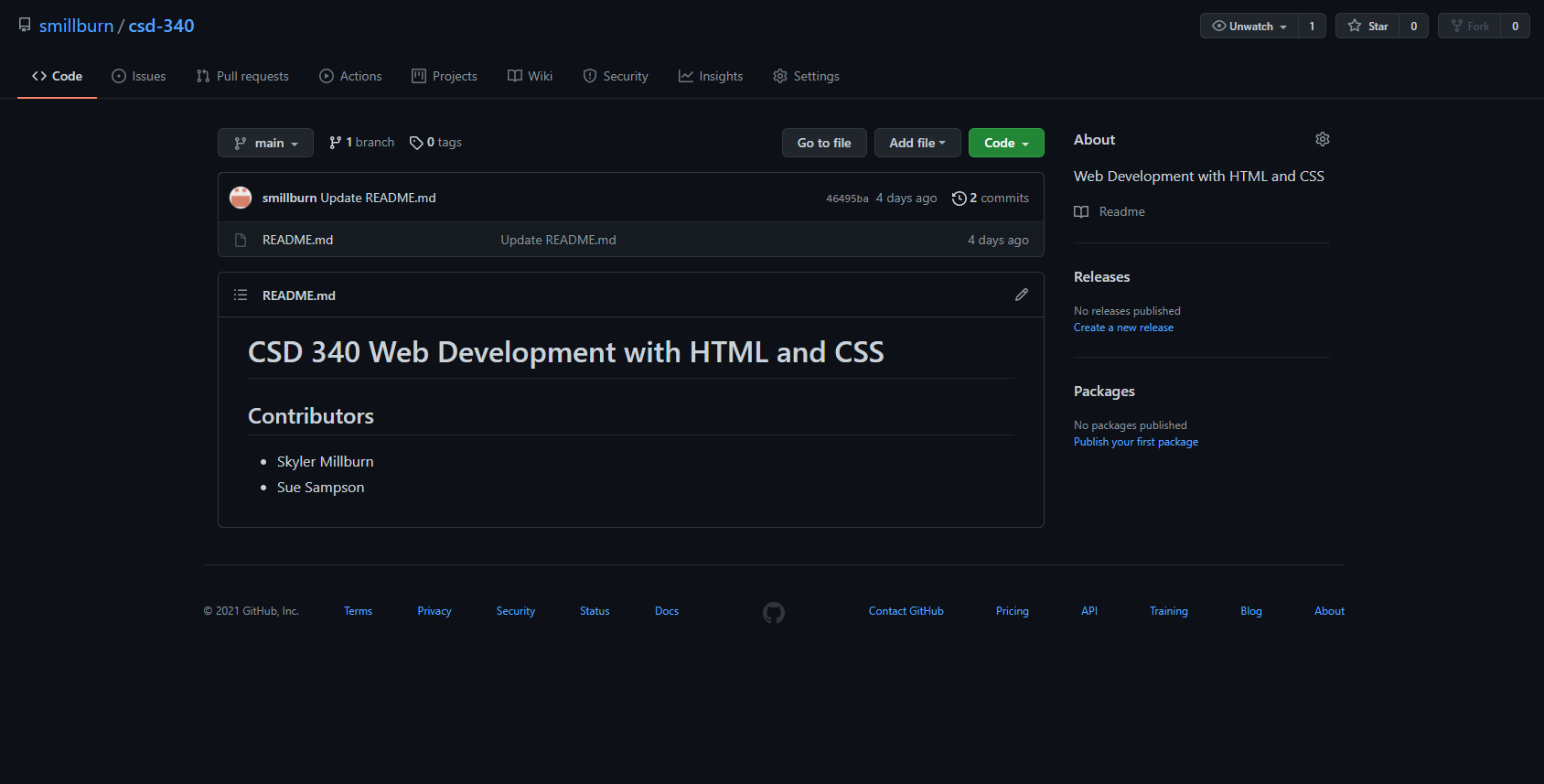

1. Screenshot of your local directory (properly formatted).

