**Module 11.2 – Web Browser Development Tools**

By: Skyler Millburn

October 03, 2021

Deliverable:

Image after devTools:

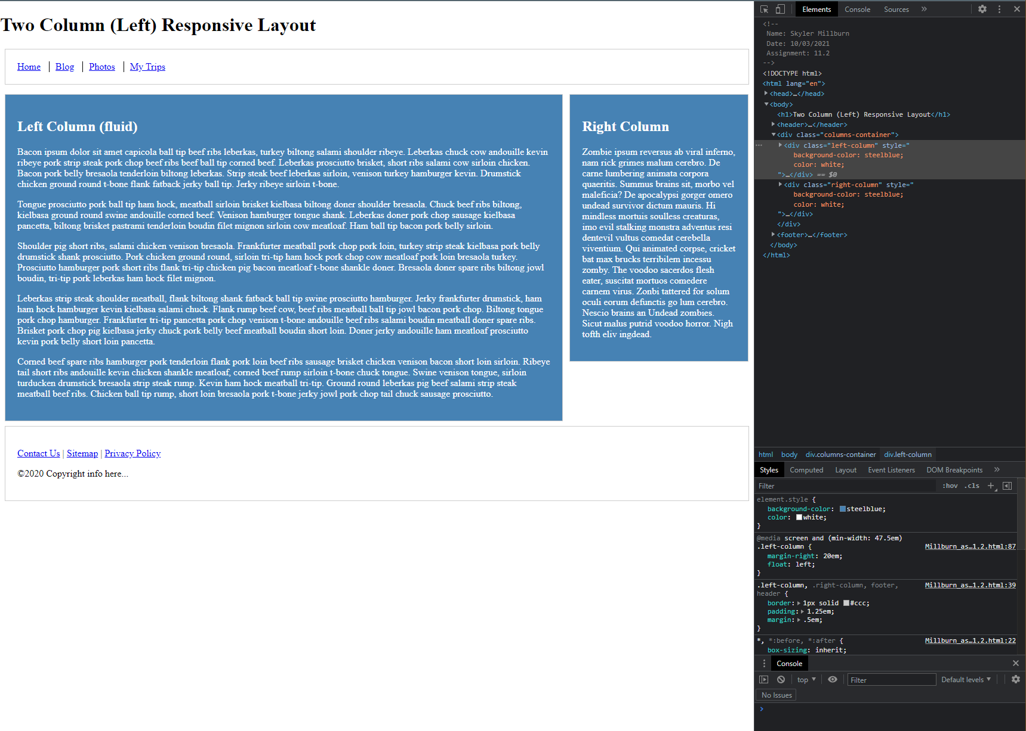

Repository:

https://github.com/smillburn/csd-340

Landing Page:

https://smillburn.github.io/csd-340/