**Module 2.2 – Building a webpage**

By: Skyler Millburn

August 15, 2021

Deliverable:

1. Starting validation

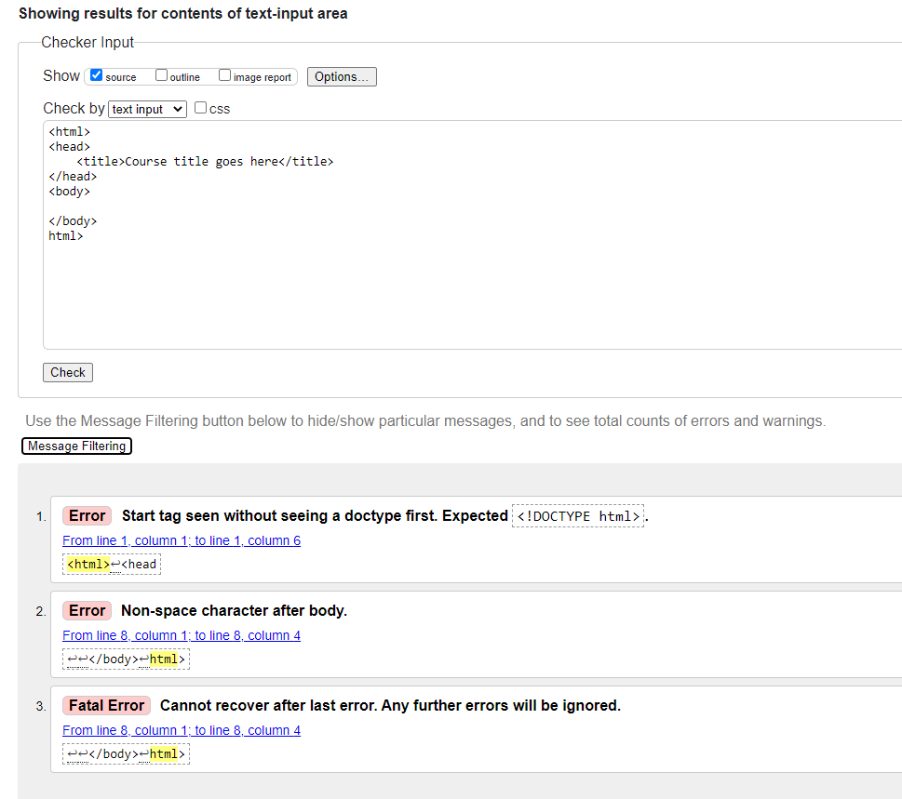

1. Screenshot after corrections

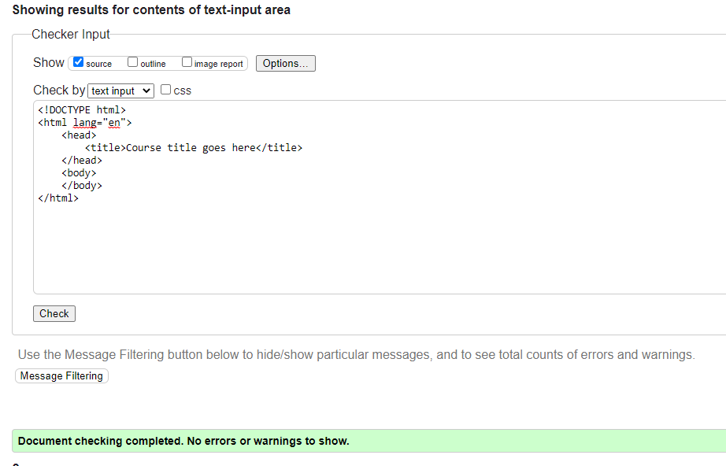

1. Screenshot with field updates

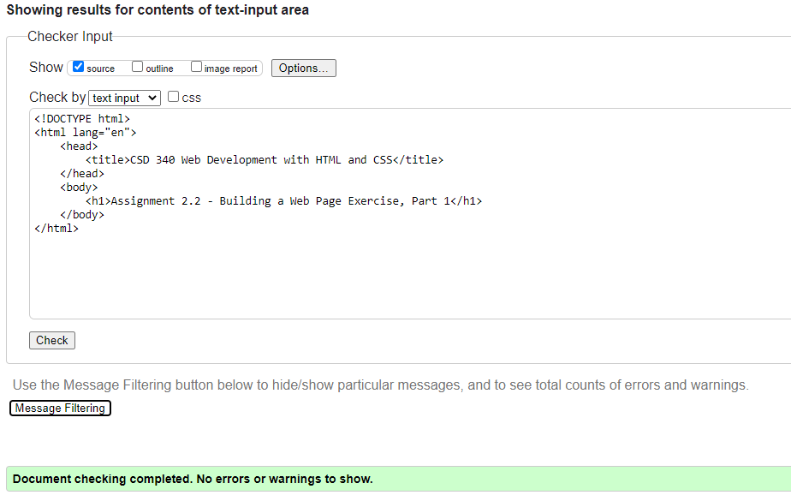

1. Webpage

