**Module 4.2 – GitHub Pages**

By: Skyler Millburn

August 29, 2021

Deliverable:

1. Validate HTML

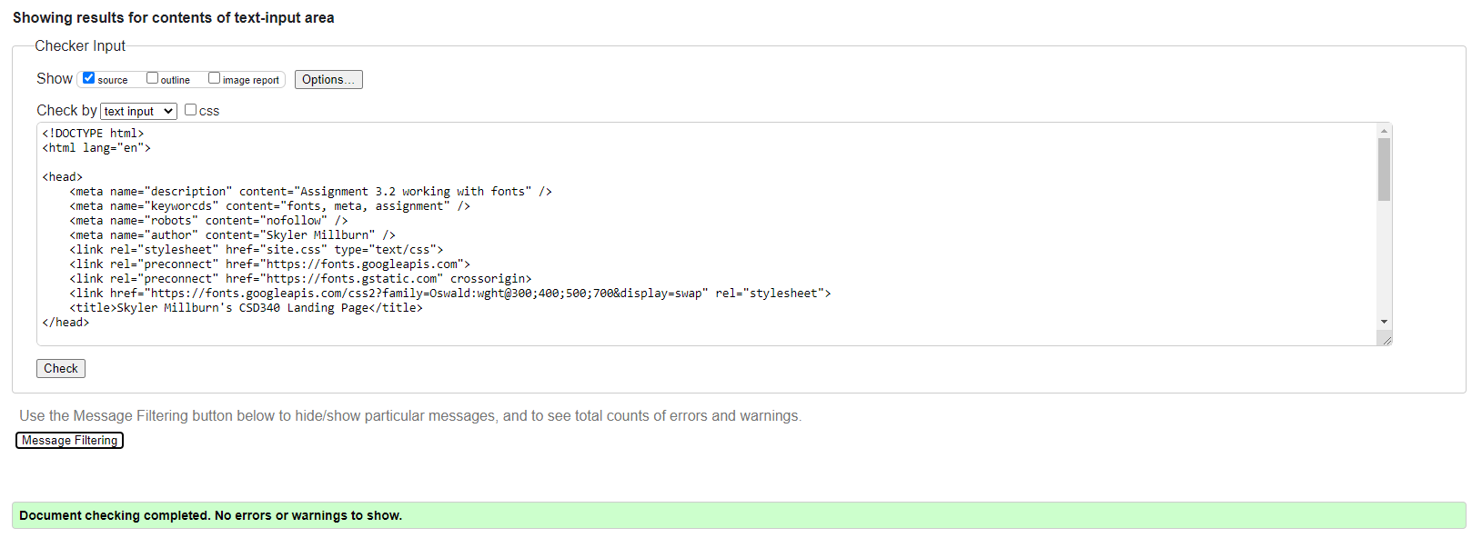

1. Validate CSS



1. Index.html Screenshot

