**Module 6.2 – bioSite**

By: Skyler Millburn

September 12, 2021

Deliverable:

* Who: Ashley Millburn
* Color Palette
  + 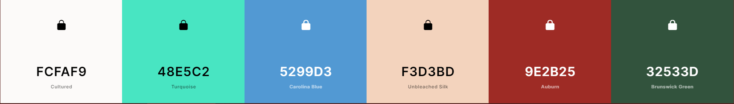
* Fonts:
  + Noto Sans 400, Oswald 400, Verdana, Arial, sans-seif
* Wireframes
* 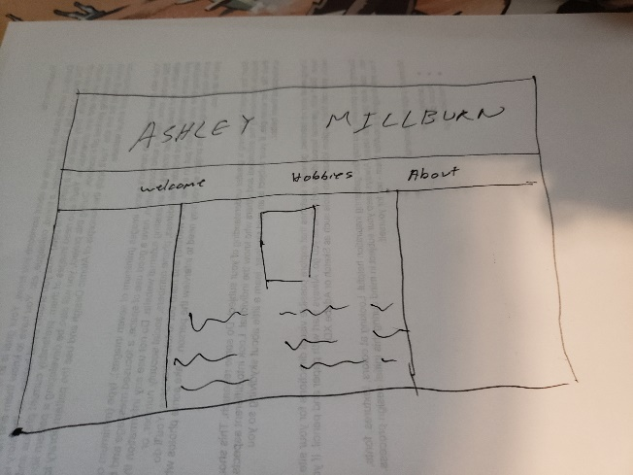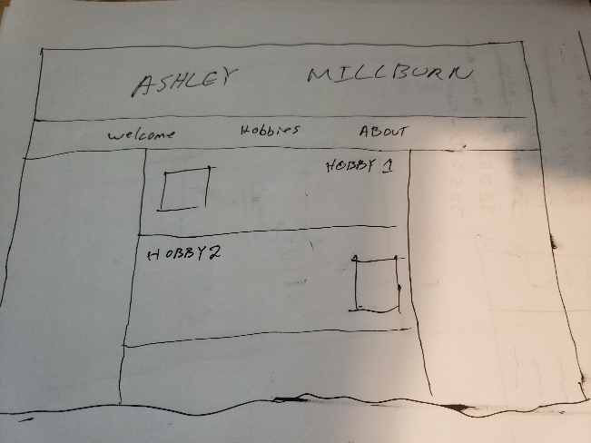
* 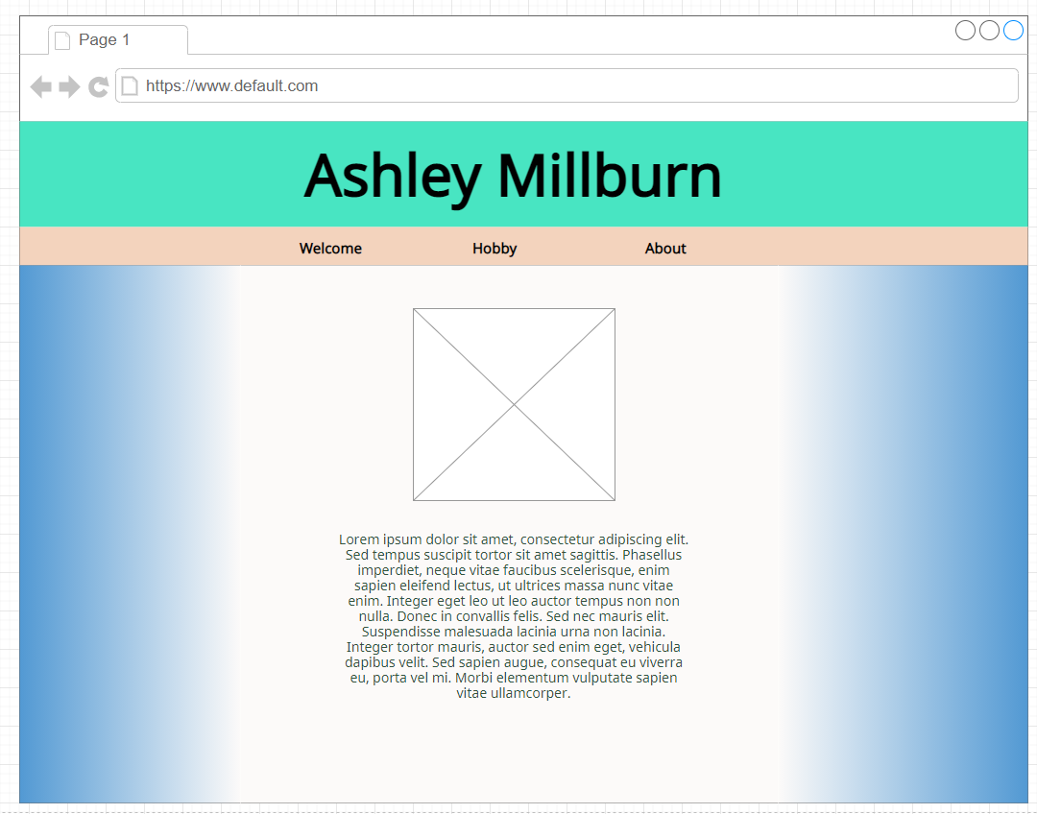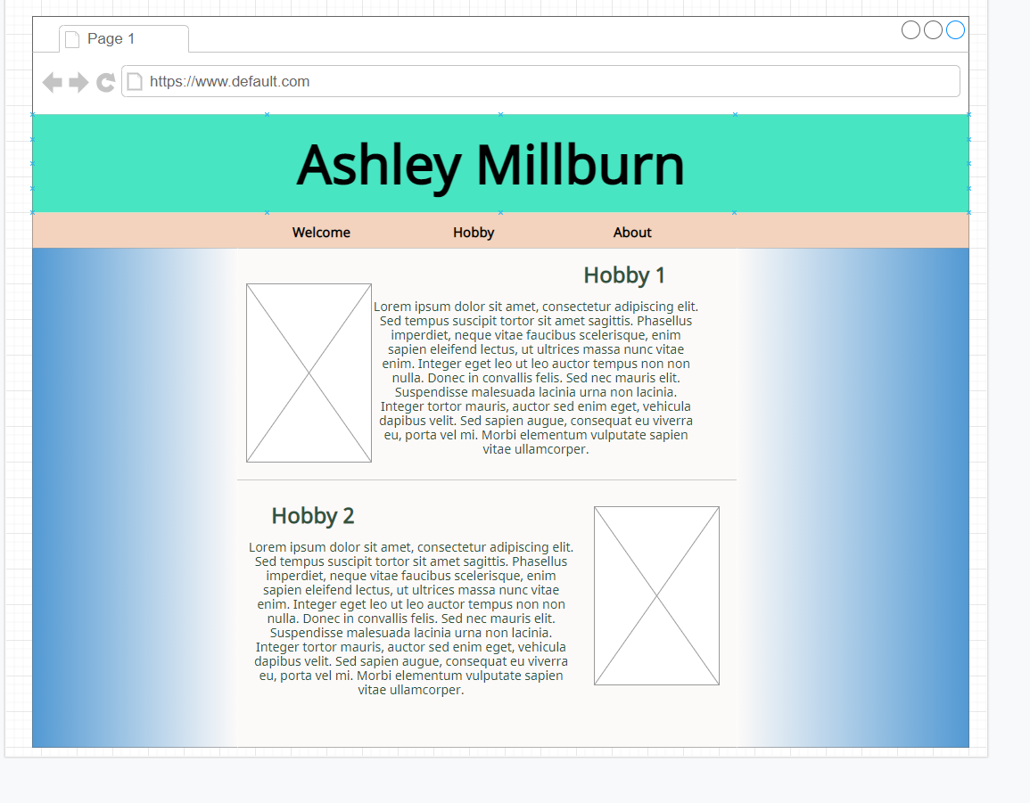
* About: Picture of Ashley and Bio
* Hobby: Picture per hobby, Hobby information
* Landing Page: Couple pictures of Ashley
* 
* Interview

1. What is your favorite class in Dungeons and Dragons?
   1. I enjoy the Cleric class.
2. What are some of your favorite video games?
   1. Borderlands 2, Valheim, Garry’s Mod.
3. Who are your favorite artists for Music?
   1. Coldplay, Imagine Dragons, and One Republic
4. What is one of your goals?
   1. I want to continue my college education
5. How many states have you lived in?
   1. Three, Utah, Illinois, and Nebraska
6. How many siblings do you have?
   1. four, I am the second oldest.
7. What is your favorite snack/candy?
   1. starbursts
8. What do you think about when you’re alone in your car?
   1. 90% of the time I am blasting my music and singing along. Only on my bad days would I be quietly listening.
9. What’s your favorite ’90s jam?
   1. Bye Bye Bye, NSYNC
10. What got you into Drawing/Art?
    1. Cartoons and comic books, I wanted to copy that style.
11. What is your favorite activity to do when you are bored?
    1. play video games.
12. Where do you see yourself in 5 years?
    1. At home with my Husband and maybe more cats.
13. How long have you been playing Dungeons and Dragons?
    1. 5 years
14. How many concerts have you been to? And What was your favorite? A: two. First one I went to was a John Mayor concert in Chicago. Second one was a Coldplay concert in Chicago at Soldier field.

* Inspiration Document on subject and hobbies
  + Dungeons and dragons:
    - Dungeons and dragons is the oldest fantasy game. Dungeons and Dragons is a tabletop role playing game. The setting for the game is usually pretty close to medieval. So players run around the world with swords, axes, and spells to take on mythical beasts like dragons, hydras, and goblins. Playing in a game purely fueled by imagination is engaging and presents itself with unique challenges. Banding together in the basement of your friend's home with pizza and soda at 1am at night trying to figure out how to get past a trap door in a world of make believe. Roll the dice and wait and see if you succeed or fail.
  + Video games:
    - Ashley has had a history of growing up near video games. Her father often played games and they had several game consoles at their house. She typically plays casually for fun rather than in a competitive role. She has not tied herself down to a single console/brand. Playing games on the Wii, Xbox, pc, and ps4. Lately her favorite games have been Borderlands, Conan Exiles, Garry’s Mod, and Valheim. Borderlands is a 1st person shooter that encourages people to play with friends. The game is primarily player vs environment meaning it is her/her friends against the game not player against player. Both Conan Exiles and Valheim are survival games where you try to keep your avatar alive. The game mimics some different real-life mechanics like food, water, sleeping and building shelters. Garry’s mod is a suite of games. Her typical favorite is called prop hunt which is kind of like hide and seek except the ones hiding are trying to hide as everyday objects like a cup, fridge, shelf, and even a hotdog.
  + Drawing:
    - cave drawings one thousand years old to a digital portfolio of photoshopped content. Art has branched into many mediums, but has had the same core purpose; To portray the world the artist sees. For her, she uses my talents to process my emotions and express myself through my art. Ashley’s favorite medium to work with is charcoal. she is also proficient with ink pens, graphite pencils, and colored pens/markers. The majority of Ashley’s work is done with pencil/pen and paper. However, as of recently, I am gravitating to ink pens again. Ashley’s work has been described as experimental; she try’s new techniques and styles often. Switching mediums and emphasis. Ashley’s work definitely reflects my frame of mind at the time. She can see the difference in my work on the days she was inspired and focused versus the days that she was drained and tired. But she does not look at the work she did on those days as ‘bad’, it is what it is. She never throws away her work. She has the tools and means to correct mistakes and make embellishments, but more often than not she will leave the piece be. It captured how she was in that moment in time and she see that as a frame of reference for her personally; a personal portfolio of her and her progression as an artist.
  + Music:
    - For Ashley, music is a very personal experience. Everything from the lyrics to the key change at the second chorus. Ashley believes each song in an album is one chapter in a book. The singer/songwriters write the lyrics to say a message or portray an emotion; they choose the key and tempo to carry that message. The album is a book and should be listened to in order because that's the way the artists intended it. You wouldn't read a book out of order, skipping every other chapter, why listen to an album out of order. With that being said, not all artists have a story or intention with their music. She does not resonate with every song she hears. Music has such a wide range of genres and artists; it is impossible to hold every artist to the same standard. she believes music is an art form and art are interpreted by the beholder. Ashley’s fondest memory related to music is the 2016 live Coldplay concert she and her husband attended in Chicago. Vivid colors flashing all around the crowd and the waves of hands and arms looked like a field of grass moving with the breeze. Everything felt alive. She keeps the ticket stubs on a memory board in her art studio.
    - “I cringe at someone who listens to their music playlist on shuffle. Too much chaos” Ashley Millburn.
* Bio
  + Ashley Millburn, The wife of Skyler Millburn. She has 2 cats named Neptune and Tigress. She is the second eldest of four siblings. Ashley grew up around games. Both board games and video games. Her father got her started into Dungeons and Dragons where she prefers to play a cleric or paladin. She enjoys playing video games like Borderlands 2, Valheim, and Garry’s Mod with her friends and family. She got into both music and art at a young age. During middle school she played the trumpet in the school band. When she started high school, she changed things up and joined the choir as a soprano. Her senior year of high school she joined the honors choir and competed in some local competitions. She has always enjoyed art. From the classes she took to creating doodles in her free time. In her junior year of high school, she was recognized as part of the school’s district art fair. Ashley spent most of her life growing up in Illinois before moving to Nebraska at the start of her senior year. After high school she spent some time in Utah with her grandma working to save up for college. After moving back home she started college to work on a digital arts degree at metropolitan community college. While going to college she was invited to join Phi Theta Kappa Honor Society. A few months later after moving back to Nebraska she met her husband. The following summer they were married. Ashley looks forward to a future filled with concerts, art exhibits, and games with her friends and family.

Pictures: Landing/Welcome Page

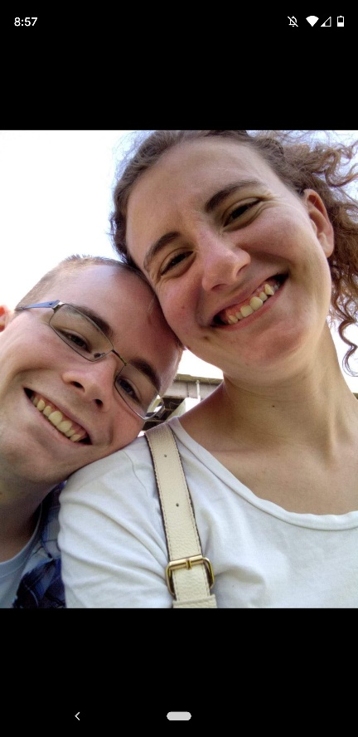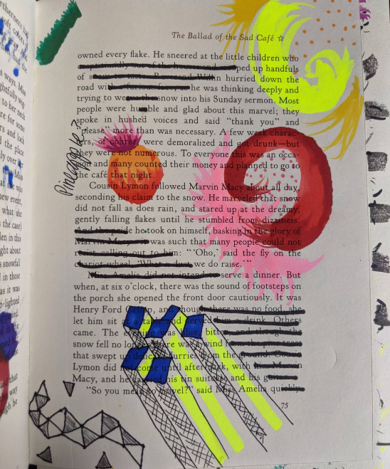



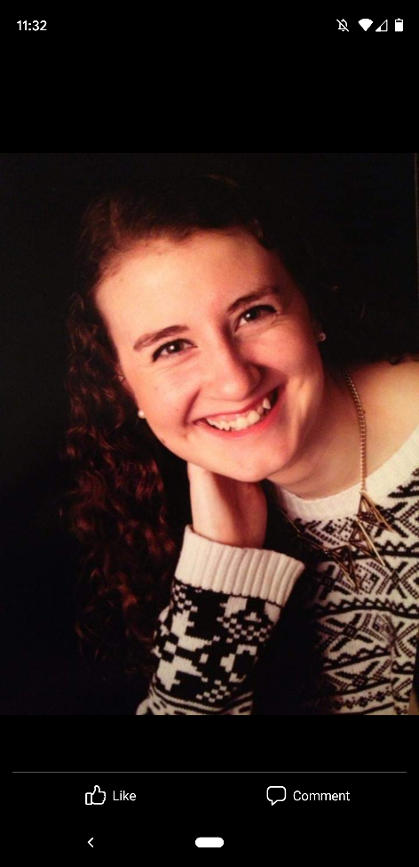Pictures: About Page

Pictures: Hobby Page

