**Smily Dawra’s Portfolio Website**

**By**

**SD Technologies**

**PREPARED FOR**

**Brent Scott**

**Steve George**

**PREPARED BY**

**Smily Dawra**

**Table of Contents**

**I. PHASE 1: BACKGROUND** 3

**II. Goals And Objectives** 4

**III. Project Requirements And Deliverables** 5

**IV. About Us** 5

**VII. Major Assumptions** 8

**VIII. Concluions** 8

**X. Sitemap** 9

**XI. Photoshop Mockups** 10

**XII. Creative Brief** 15

**XIII. Workback Schedule** 16

**XIV. Invoice** 17

**XV. PHASE 2: Description/Background** 18

**XVI. Data Collected and How It Is Being Used** 18

**XVII. Interaction by Users** 19

**XVIII. Security Considerations** 19

**XIX. Phases of Development** 20

**XX. Timelines/Budget** 22

**XXI. Data Models and ERD** 22

**XXII. Front End Dynamic Pages Design/Screenshots** 24

**XXIII. Backend Design/Screenshots** 29

**XXVI. Sitemaps** 34

**XXV. Conclusion** 35

**XXVI. Invoice: Phase II** 36

**PHASE 1: Frontend**

|  |  |  |  |
| --- | --- | --- | --- |
| **PROJECT TITLE** | Smily Dawra’s Portfolio Website - SD Technologies | | |
| **SUBMITTED BY** | Smily Dawra | **Submitted To** | Brent Scott |
| **EMAIL** | [Dawra-s@webmail.uwinnipeg.ca](mailto:Dawra-s@webmail.uwinnipeg.ca) | **Email** | edu@brentscott.com |

# **I. PHASE 1: BACKGROUND**

**Portfolio Website – Smily Dawra**

In today’s digital world, your website is often the first impression on potential customers. In fact, more than 60% of today’s purchases start online, and nearly all consumers state that company websites factor into their purchasing decisions. A reliable, well-designed website exposes your products and services to those who seek them and makes it easier for you to compete in a crowded marketplace. This is a proposal for a portfolio website, which will be targeting primarily to people who are looking for IT solutions.

SD Technologies has fast become a dynamic and fast-moving company in Client Solution Management in Information Technology in Canada and has proven itself to be one of the market leaders. We strive to provide you with the best solutions for your business needs. We have had the pleasure of working with many brands around the world to build successful business websites. We have strong web design background, augmented by an understanding of what makes any website a profitable marketing tool.  
In this proposal, you’ll find a wealth of information related to the web design services that we offer. We’ve included visual snapshots of the website along with testimonials from previous clients. You’ll also find information regarding my approach to web design project, and the costs associated with your website’s design and creation.

**Primary Audience:**

The targeted primary audience would be startups, small businesses and medium level enterprises which either do not have an online presence or are not maximizing online platform to their potential.

**Secondary Audience:**

My targeted secondary audience would include businesses who already have online presence and are looking for maintenance and changes to their websites to keep up with the technological advancement. Also, some of these businesses might be looking to develop and launch mobile applications which can indirectly be beneficial for us. This portfolio will also help in future employment opportunities.

**Tertiary Audience:**

My tertiary audience would be family and friends, who are looking to develop their personal and business websites. My portfolio website will also encourage young bloggers and developers to follow their passion.

# **II. GOALS and OBJECTIVES**

In creating my portfolio website, I want to showcase my work in the best possible way for the viewer. I want my site to be an experience with both my work and the design of the site.

1. Excellent Customer Service: Good customer service would help us to retain customers and generate repetitive revenue. Keeping the customers happy is the primary objective for our organization.
2. Getting and Staying Profitable: Maintaining profitability means making sure that revenue stays ahead of the costs of doing business. Focus on controlling cost in both production and operation while maintaining the profit margin.
3. Sustainable Growth: Growth is planned based on historical data and future projections. Growth requires the careful use of companies resources such as finances and personnel.

# **III. PROJECT REQUIREMENTS AND DELIVERABLES**

SD technologies has following deliverables:

* To create a new website to reflect current look & feel and branding of their portfolio website.
* User friendly Navigations.
* Website will be compatible with all the browsers and operating systems.
* Strategically put “Get Quote” button on each page.

Proposed Solution:

Designing the portfolio website with HTML5/CSS3. Also, streamline the content and user-friendly navigation along with a new portfolio website with an emphasis put on getting new work as a web developer.

# **IV. ABOUT US**

**WHY WE’RE THE BEST FIT**

For over 25 years, SD Technologies has helped companies communicate with confidence and deliver transformative IT business results by enabling powerful experiences that engage customers across multiple touchpoints, all strengthened by our technology expertise. Our service capabilities include strategic consulting, web design and development, and digital marketing and branding.

We Specialize in a few of content management systems such as:

* WordPress
* Drupal

And, we work with the newest and most widely used technology such as:

* HTML
* CSS
* PHP
* MYSQL
* React JS
* Angular JS

**V. OUR TEAM**

|  |  |  |
| --- | --- | --- |
| **Name** | **Role** | **Qualifications/Experience** |
| Smily Dawra | Web Developer | 3 years of experience as Business Analyst at AT&T |
| Apoorve Mongia | Web Designer | 7 Years of experience in graphical designing at Techmahindra Ltd. |
| Daniel R. | Automation Test Engineer | 5 Years of experience as Testing Engineer at Apple. |
| Paul Larson | Account Manager | 11 Years of Industry Experience as Client Manager |

**VI. TIMELINES/BUDGET**

|  |  |  |
| --- | --- | --- |
| **Phases** | **No. of hours** | **Budget** |
| Planning/Exploration | 8 hours | CAD $320 |
| Design/Content | 12 hours | CAD $480 |
| Coding/Testing | 28 hours | CAD $1680 |
| Launch/Maintenance | 4 hours | CAD $200 |
|  | **Total: 42 hours** | **Total: CAD $2680** |

**Planning/Exploration**

Project Definition Meeting with Smily Dawra to determine precise details concerning the scope of the project and develop an accurate and detailed timeline outlining the development and delivery of the project, including deliverables for the developer, and Scott-Media.

**Design/Content**

Web Designer begins design development. Designer presents sample designs for review by SD Technologies. Scott-Media will have to either approve one of the design samples or provide feedback for revisions and adjustments to design. Scott-Media provides any relevant graphics and content.

**Coding/Testing**

Developer develop the website. During this time there will be deliverables for development and periodic sign-off by SD Technologies.

**Launch/Maintenance**

SD Technologies will register domain. The website will be posted live on the server and any final testing and tweaking will be completed. The project will be signed off by Smily at the completion.

# **VII. MAJOR ASSUMPTIONS**

The developer will:

* Use regular e-commerce security standards with proper authentication system.

Targeting business from most IT companies and private users as the total load on the site.

# **VIII. CONCLUIONS**

To conclude, I would like to thank you for giving the opportunity to participate in the project. This document has proposed research to redevelop the website of Portfolio Website - Smily Dawra as a detailed information on our approach to build newly, user friendly web platform.

# **X. SITEMAP**

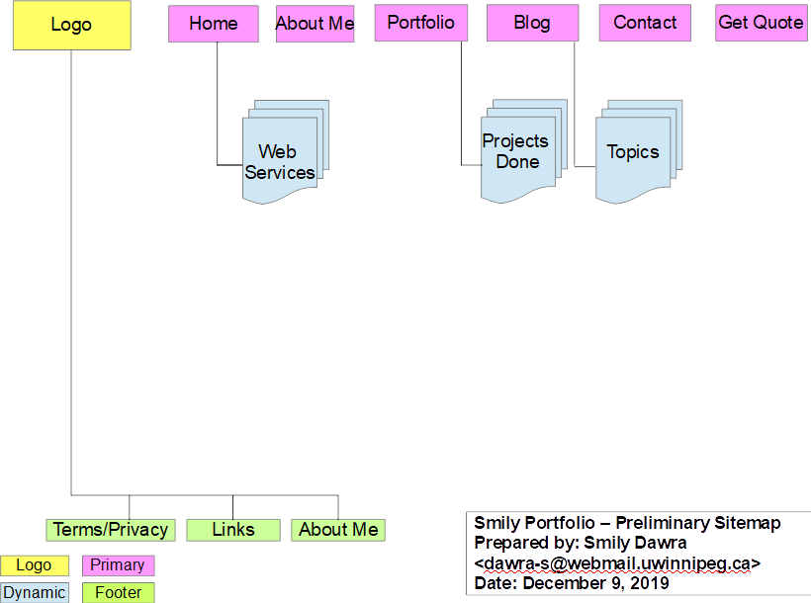

# **XI. Photoshop Mockups**

**Home:**

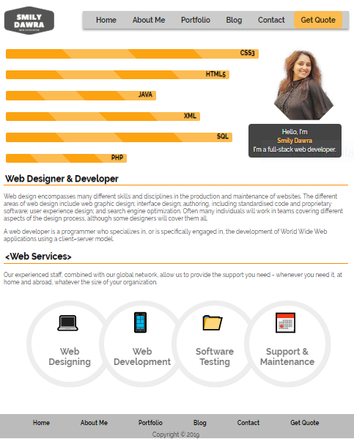

**About-Me:**

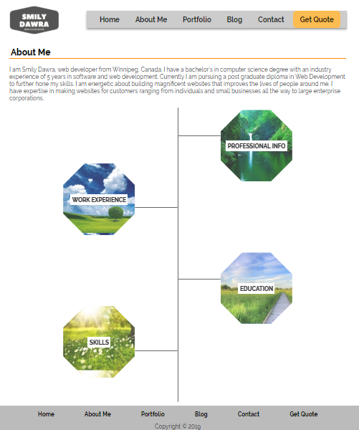

**Portfolio:**

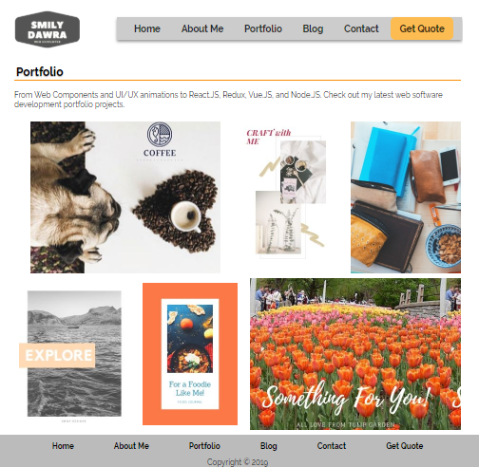

**Blog:**

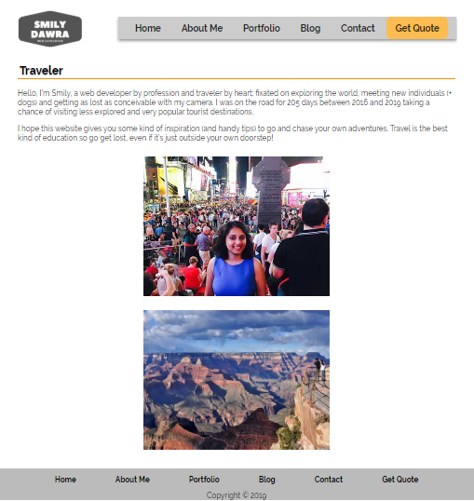

**Contact:**

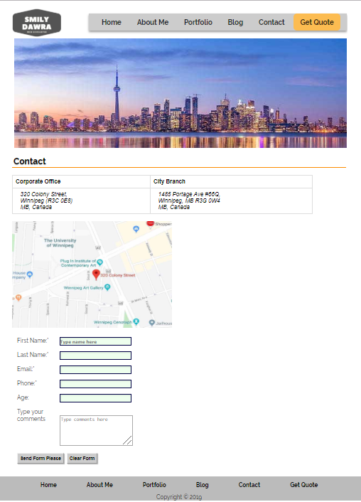

# **XII. CREATIVE BRIEF**

What does the client wish to accomplish with this project?

Clients wishes to create a portfolio website to show her work.

What is it?

It is a portfolio Website.

How will it be used in the marketplace?

Client’s Portfolio and her contact information.

Who will it be seen by?

Potential Employers/Clients.

What are the most important calls to action?

Get Work.

What should the personality of the project be?

To design a portfolio website to enjoy the experience of visiting client’s website..

What are the mandatory inclusions?

Client’s projects and experience in web development.

# **XIII. WORKBACK SCHEDULE**

From: Smily Dawra, SD Technologies

To: Brent Scott

Re: Workback Schedule for Website Development

Date: December 4, 2019

|  |  |  |
| --- | --- | --- |
| **Task** | **Responsible** | **Date** |
| Work Starts (Product Requirement) | SD Tech. | 4-Dec-19 |
| Project Clarifications | Client | 4-Dec-19 |
| Project Specification | SD Tech. | 4-Dec-19 |
| Content Acquisition | Client | 4-Dec-19 |
| Data Integration | SD Tech. | 4-Dec-19 |
| Customization/Design | SD Tech. | 4-Dec-19 |
| Take Original Photograph | SD Tech. | 5-Dec-19 |
| Source Stock Photograph | SD Tech. | 6-Dec-19 |
| Web Optimization | SD Tech. | 6-Dec-19 |
| SEO Optimization | SD Tech. | 7-Dec-19 |
| Design Approval | Client | 8-Dec-19 |
| Design Mockups | SD Tech. | 9-Dec-19 |
| Coding/Programming | SD Tech. | 10-Dec-19 |
| Website review before testing | Client | 14-Dec-19 |
| Testing Approval | Client | 14-Dec-19 |
| Unit Testing | SD Tech. | 16-Dec-19 |
| Functional Testing | SD Tech. | 16-Dec-19 |
| Load/Performance Testing | SD Tech. | 16-Dec-19 |
| Site Review before Activation | Client | 16-Dec-19 |
| Website Live Approval | Client | 16-Dec-19 |
| Server Testing before live | SD Tech. | 17-Dec-19 |
| Website goes live | SD Tech. | 18-Dec-19 |
| UAT Testing | SD Tech. | 18-Dec-19 |
| Client-Side Testing | Client | 18-Dec-19 |
| Project Review | Client | 19-Dec-19 |

# **XIV. INVOICE**

INVOICE 

From

Smily Dawra

SD Technologies

320 Colony Street,

Winnipeg R3C 0E8

MB, Canada

|  |  |  |  |
| --- | --- | --- | --- |
| BILL TO | SHIP TO | INVOICE # | US-OOI |
| Scott-Media | Scott-Media | INVOICE DATE | 12/19/2019 |
| 460 Portage Ave,  Winnipeg, MB  R3C 0E8 | 460 Portage Ave,  Winnipeg, MB  R3C 0E8 |  |  |
|  |  |  | 2312/2019 |
|  |  | DUE DATE | 01/20/2020 |

QTY DESCRIPTION UNIT PRICE AMOUNT

8 Hours Planning/Exploration $40/hr. $320.00

12 Hours Design/Content $40/hr. $480.00

28 Hours Coding/Testing $60/hr. $1,680.00

5 Hours Launch/Maintenance $40/hr. $200.00

Subtotal $2,680.00 SalesTax (6.25%) $214.04 TOTAL $2,894.04

**PHASE 2: Backend**

|  |  |  |  |
| --- | --- | --- | --- |
| **PROJECT TITLE** | Smily Dawra’s Portfolio Website(Database Driven) - SD Technologies | | |
| **SUBMITTED BY** | Smily Dawra | **Submitted To** | Steve George |
| **EMAIL** | [Dawra-s@webmail.uwinnipeg.ca](mailto:Dawra-s@webmail.uwinnipeg.ca) | **Email** | edu@pagerange.com |

# **XV. PHASE 2: Description/Background**

This is phase two for Portfolio Website of Smily Dawra which will show the web development work being done during the school program. Project work offers a bridge to independent learning for students. This website offers various projects and assignments done by Smily using different languages such as HTML5, CSS3, JavaScript, XML, SQL, Java, PHP etc., all details will be stored in the database(MySQL). In addition to the project’s details, information about courses, instructors will also be accumulated in the DB. Also, details for new users who can register at the website on the registration page and can enjoy interacting with Smily’s work by giving comments/suggestions on the projects done. The comments will be stored in the database using user information. The website will be deployed on the server using a registered domain name. Furthermore, users can ask for more details on the project done and can hire Smily for web development services.

Also, there will be an admin portal which is a CRUD Application to handle all the backend operations such creating, editing, updating, deleting and search on primary entity(projects). There will be a list view for all the tables directly retrieved from database.

# **XVI. Data Collected and How It Is Being Used**

MySQL is being used for data storing. There is one primary entity(Projects) along with secondary and tertiary entities. All data related t projects will be stored in project table with primary key and foreign key(if required).

Upon registration, User data will be directly stored into user table in database containing all the personal information of a user along with encrypted password.

Data from all these tables, will be used for user interaction. Once user registers on the website, he/she will be directed to their profile page, displaying all their information retrieved from database using OOPHP(by creating objects for classes and calling their functions). Furthermore, PHP Session will be used to store information (in variables) to be used across multiple pages.

# **XVII. Interaction by Users**

1. **Unauthenticated:** User can view projects and other primary navigation but cannot access comments module on projects detail page. In other words, user cannot interact with the website being unauthenticated.
2. **Authenticated:** To access comments module, user must be an authenticated user. For that, user needs to register with valid information and will be authenticated through php session.
3. **Administrators:** Admin portal can only be accessed by verified users which must have given permission to be admin.

# **XVIII. Security Considerations**

1. **Password encryption:** This Website is password encrypted which means when user register with the unique password and unique email, password is being hashed using a strong one-way hashing algorithm **password_hash()** and bycrypt algorithm **PASSWORD_DEFAULT** before saving into the database, it is best way to store password which is private to user.
2. **SQL Injection:** As we want to protect our data from SQL Injection, we must take care of binding the values to the named parameter. This way the user information passed will be safe to interact with the database. For binding, refer to following steps:

* Escaping the data
* Sanitize the data before it inserted to DB – to protect our data from attacks.

1. **XSS Protection:** Smily’s Portfolio Website is all protected with inputting and outputting the information to prevent cross-site scripting.

# **XIX. Phases of Development**

**Planning/Exploration**  **8 Hours**

Project Definition Meeting with Smily Dawra to determine precise details concerning the scope of the project and develop an accurate and detailed timeline outlining the development and delivery of the project, including deliverables for the developer, and Pagerange. Following are the main tasks for planning:

* Sitemap
* Wireframes
* Data Models
* ERD
* Mockups

**Design/Content** **12 Hours**

Web Designer begins design development using HTML/CSS3, JavaScript. Designer presents sample designs for review by SD Technologies. Pagerange will have to either approve one of the design samples or provide feedback for revisions and adjustments to design. Pagerange provides any relevant graphics and content. Major design areas of phase 2:

* Registration page for new users
* Login page
* Profile page
* Project list view
* Project detail view

**Coding/Testing 24 Hours**

Developer develop the website using php as backend language and it will be fully database driven and user interaction with login authentication. During this time there will be deliverables for development and periodic sign-off by SD Technologies.

* **Frontend Coding:** This involves registration functionality in which a new user will provide information, is validated using Validator Class. Upon Validation, user will be directed to profile page. Secondly, projects will have a list view through which user can explore and can access details of one project. All the frontend functionality will be implemented through PRG(Post-Redirect-Get) pattern using PHP sessions.
* **Backend Coding:** Admin portal is a PHP MySql CRUD Application which is particularly to handle all the backend operations such creating, editing, updating, deleting and search. All the backend functionality will be implemented through models and PRG(Post-Redirect-Get) pattern using PHP sessions.

**Launch/Maintenance 4 Hours**

SD Technologies will register domain as capstone.smilydawra.info . The website will be posted live on the server(Digital Server) and any final testing and tweaking will be completed. The project will be signed off by Smily(Web Developer) at the completion.

# **XX. Timelines/Budget**

|  |  |  |
| --- | --- | --- |
| **Phases** | **No. of hours** | **Budget** |
| Planning/Exploration | 8 hours | CAD $320 |
| Design/Content | 12 hours | CAD $480 |
| Coding/Testing | 28 hours | CAD $1680 |
| Launch/Maintenance | 4 hours | CAD $200 |
|  | **Total: 42 hours** | **Total: CAD $2680** |

# **XXI. Data Models and ERD**

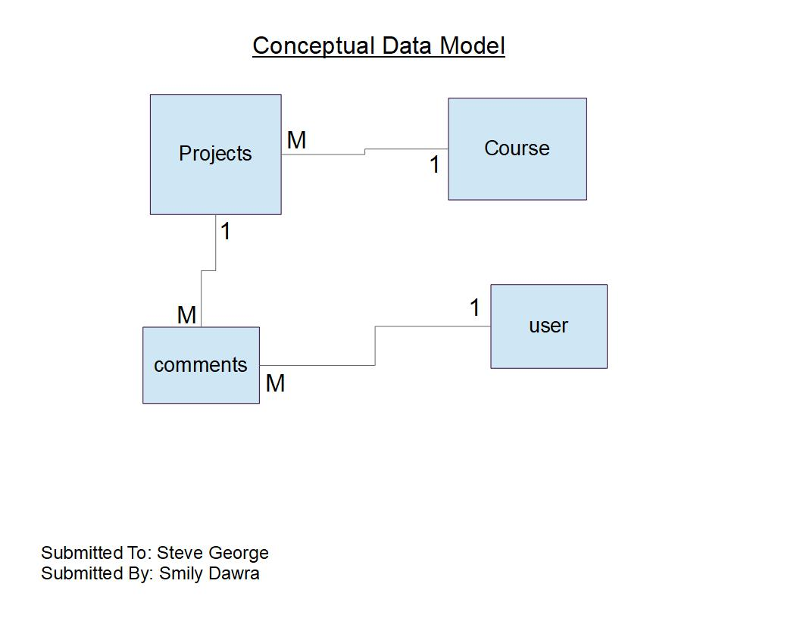

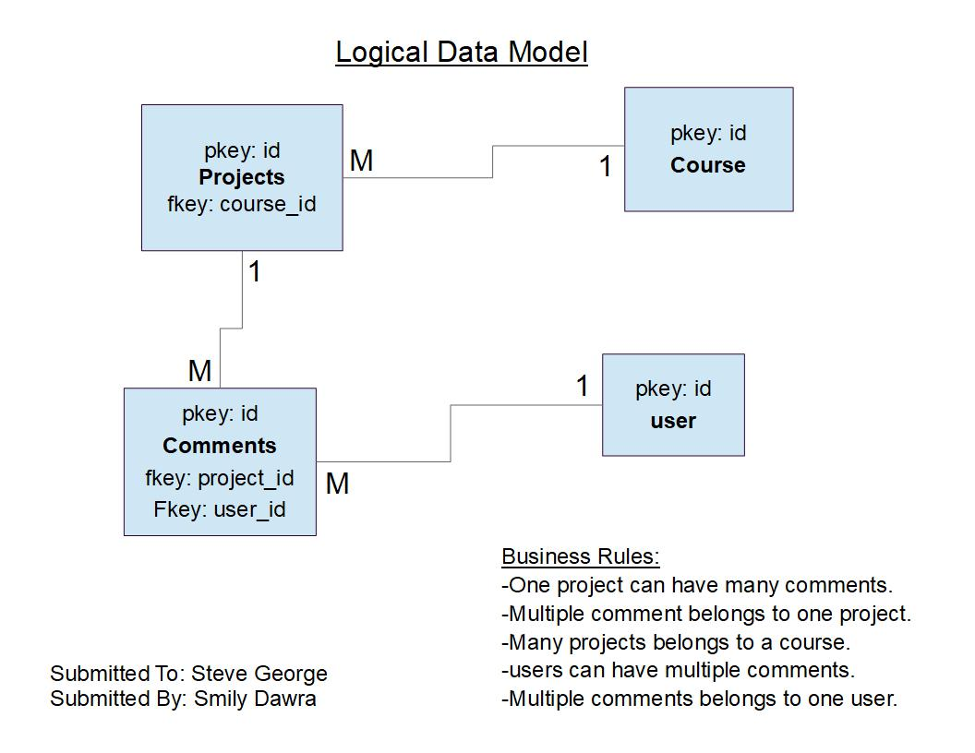

**ERD Diagram:**

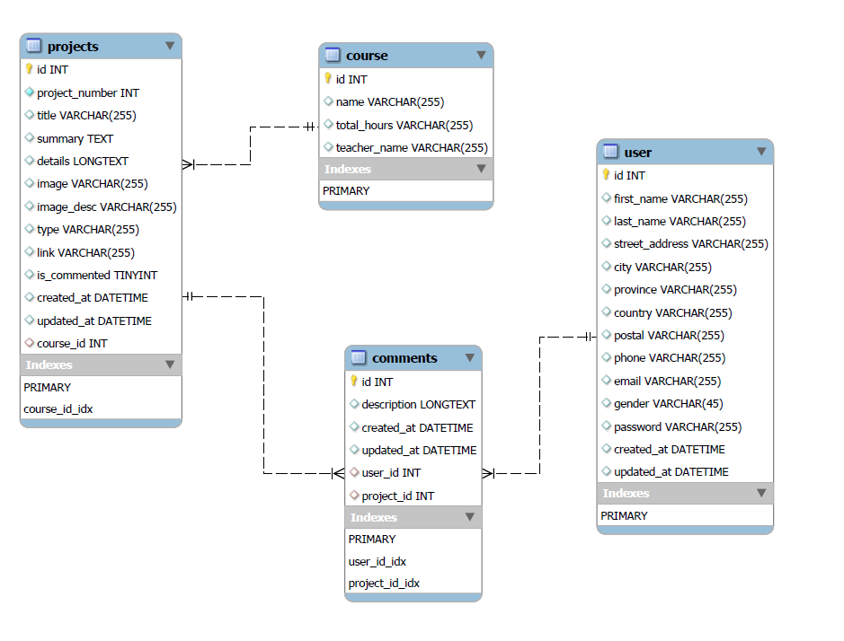

# **XXII. Front End Dynamic Pages Design/Screenshots**

**Register Page:**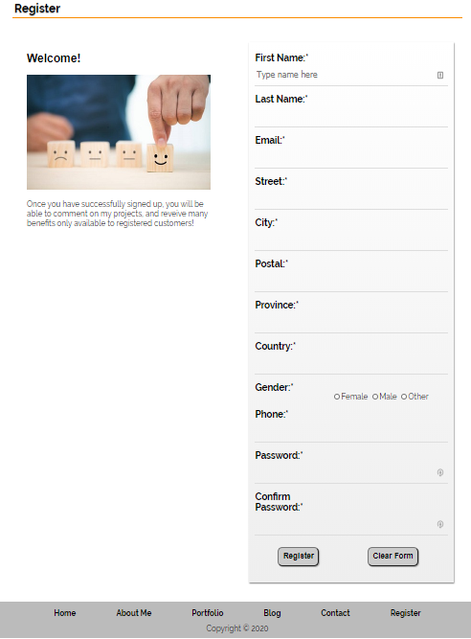

**Login Page:**

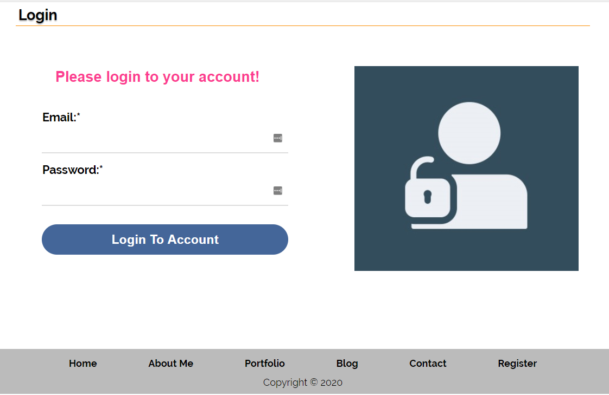

**Profile Page:**

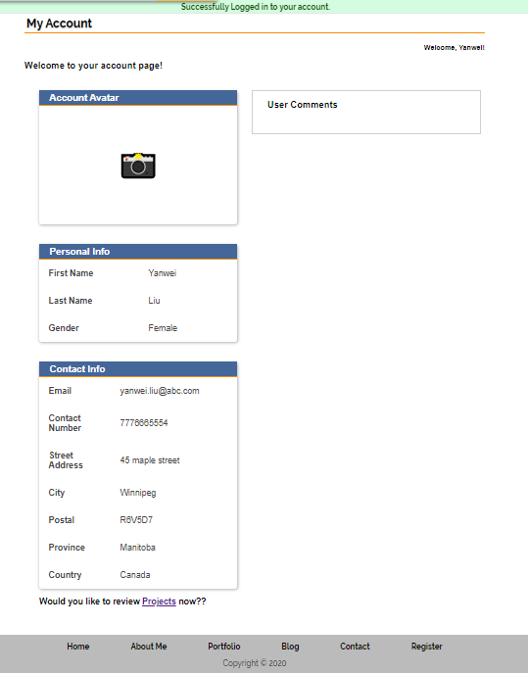

**List View Projects:**

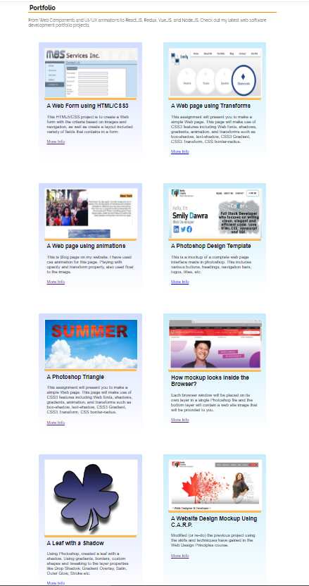

**Detail Project View:**

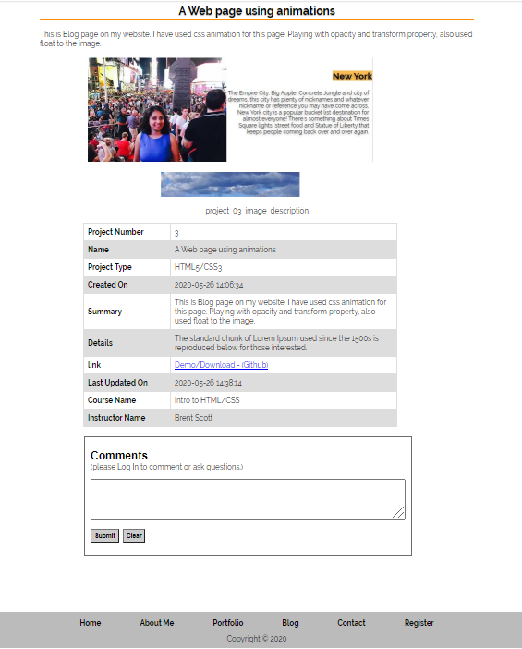

# **XXIII. Backend Design/Screenshots**

**Primary Entity List View: (Table - project)**

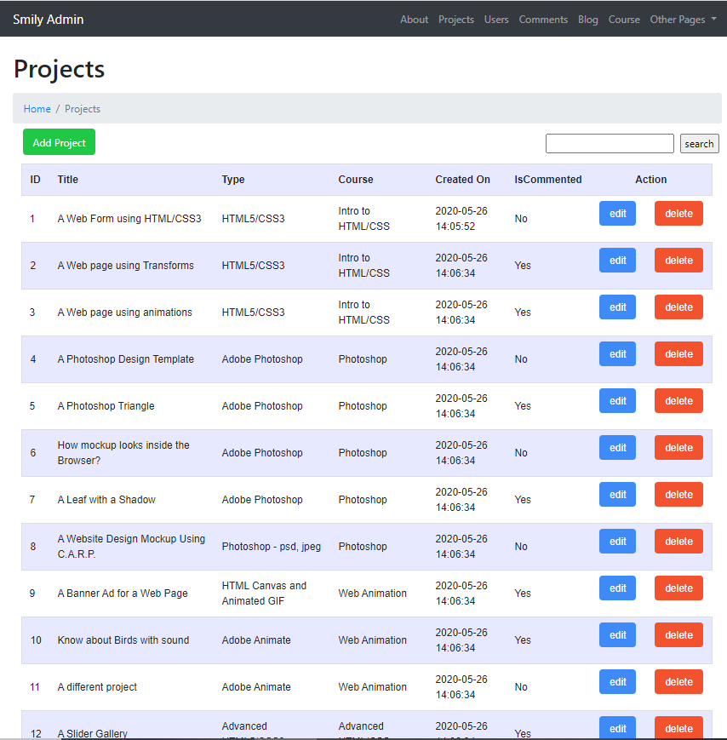

**Primary Entity Edit View: (Table - project)**

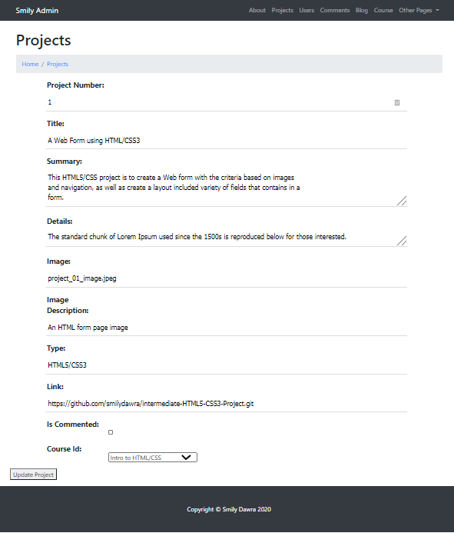

**List View: (Table - users)**

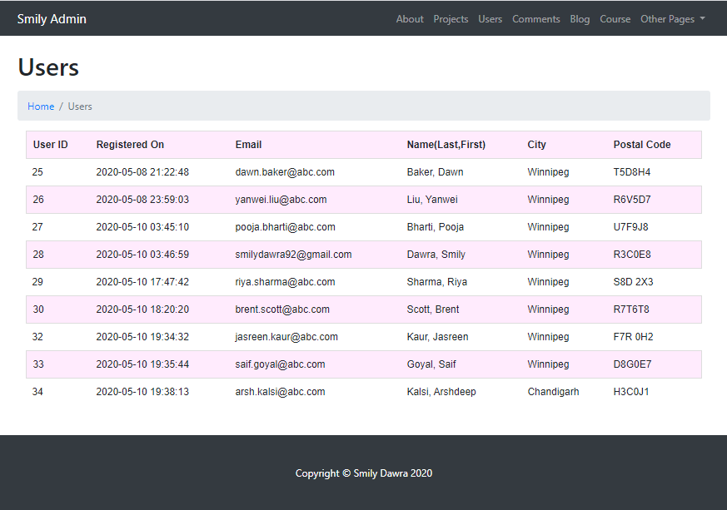

**List View: (Table - comments)**

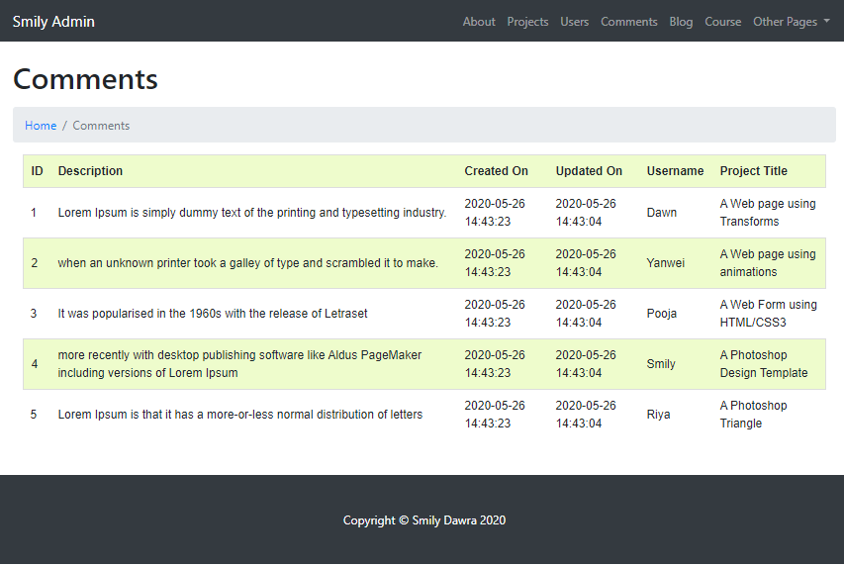

**List View: (Table - comments)**

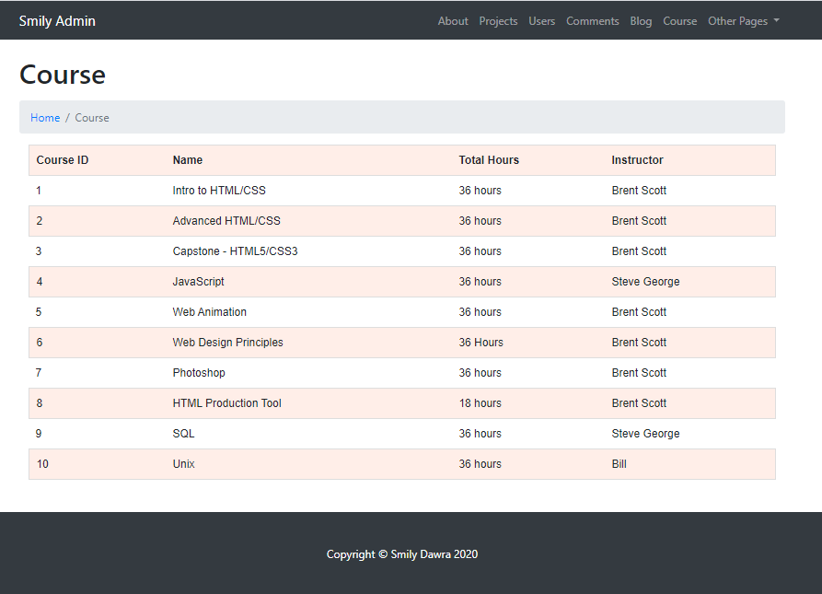

# **XXVI. Sitemaps**

**Frontend: Login/Logout**

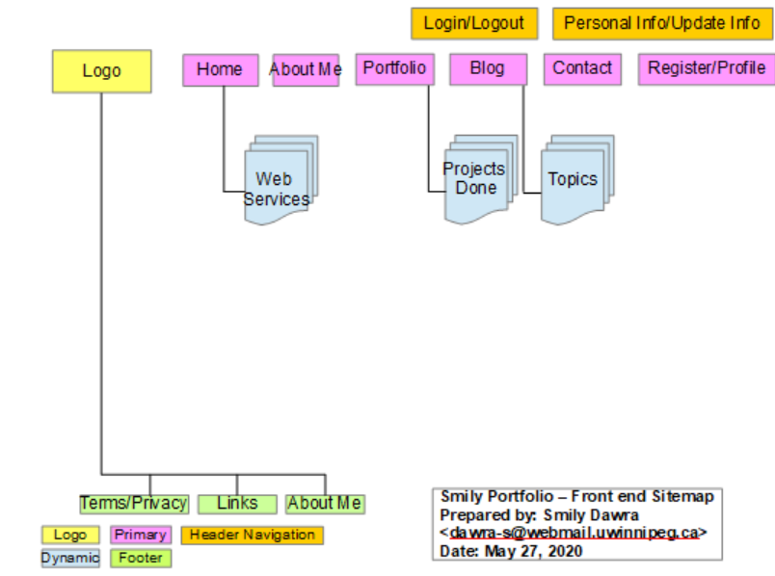

**Backend: Admin**

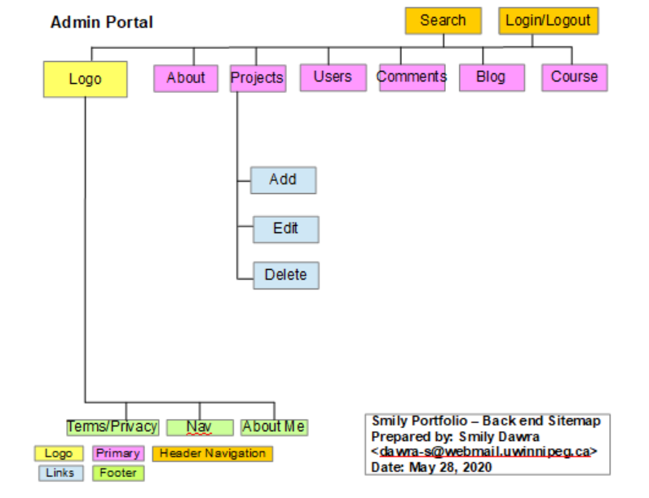

# **XXV. Conclusion**

To conclude, I would like to thank you for giving the opportunity to develop this project. This document has proposed research to redevelop the website of Portfolio Website - Smily Dawra as a detailed information on our approach to build newly, user friendly web platform which has database driven functionality.

# **XXVI. INVOICE: PHASE II**

