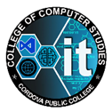
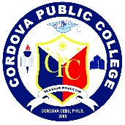
Republic of the Philippines
Province of Cebu
Municipality of Cordova
CORDOVA PUBLIC COLLEGE
Gabi, Cordova, Cebu 6017

TECHNOPRENEURSHIP
DOCUMENTATION

Submitted by:
Member 1
Member 2
Member 3

Submitted to:
Bernie Empaces
Course Instructor

Submitted in Partial Fulfillment
of the Requirements for the Subject
TECHNOPRENEURSHIP

Date Submitted:
May 2026

