

Practical File
of
Object Oriented Language
Course Code: CSEG1044
School of Computer Science

Submitted By Submitted To
Student Name: Suryansh Mishra Mr. Piyus Bagla
SAP ID: 590012069
Course: B.Tech CSE (Core)
Semester: 4
Batch: 4
Academic Year: 2025-26

  - Write a Java program to print “Hello World”’
- package experiment1;
- //write a program to display "Hello, World!" on the screen
- class First {
- public static void main(String[] args) {
- System.out.println("Suryansh Mishra 590012069");
- System.out.println("Hello, World!");
- }
- }
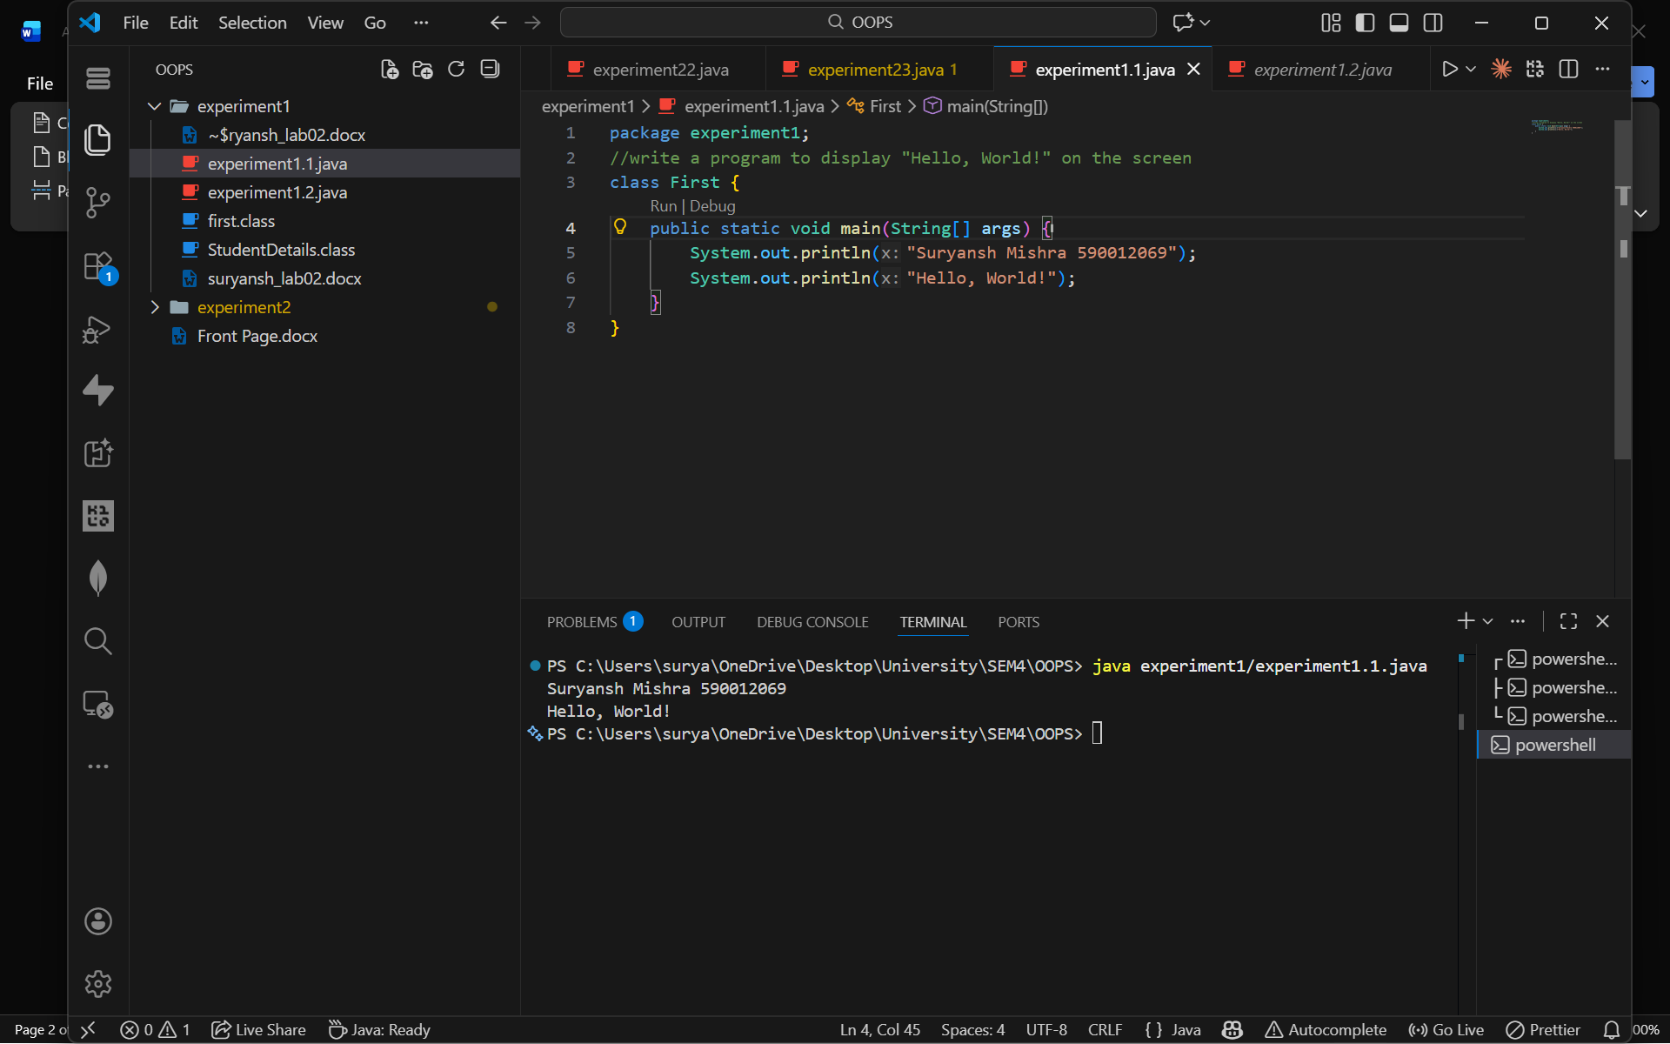

1.2. Write a Java program to print the details of a student.
package experiment1;
// write a program to display student details without taking input from user
class StudentDetails {
public static void main(String[] args) {
String name = "Suryansh Mishra";
int age = 19;
String course = "B.Tech in Computer Science";
String university = "UPES";
System.out.println("Student Details:");
System.out.println("Name: " + name);
System.out.println("Age: " + age);
System.out.println("Course: " + course);
System.out.println("University: " + university);
}
}

