

Practical File
of
Object Oriented Language
Course Code: CSEG1044
School of Computer Science

Submitted By Submitted To
Student Name: Suryansh Mishra Mr. PiyushBagla
SAP ID: 590012069
Course: B.Tech CSE (Core)
Semester: 4
Batch: 4
Academic Year: 2025-26

2.1. Write a Java program to input two numbers and perform four arithmetic operations using command line arguments.
//input two numbers as command line arguments and perform basic arithmetic operations
package experiment2;
public class experiment21 {
public static void main(String[] args) {
System.out.println("Suryansh Mishra 590012069");
int num1 = Integer.parseInt(args[0]);
int num2 = Integer.parseInt(args[1]);
System.out.println("Addition: " + (num1 + num2));
System.out.println("Subtraction: " + (num1 - num2));
System.out.println("Multiplication: " + (num1 * num2));
System.out.println("Division: " + (num1 / num2));
}
}
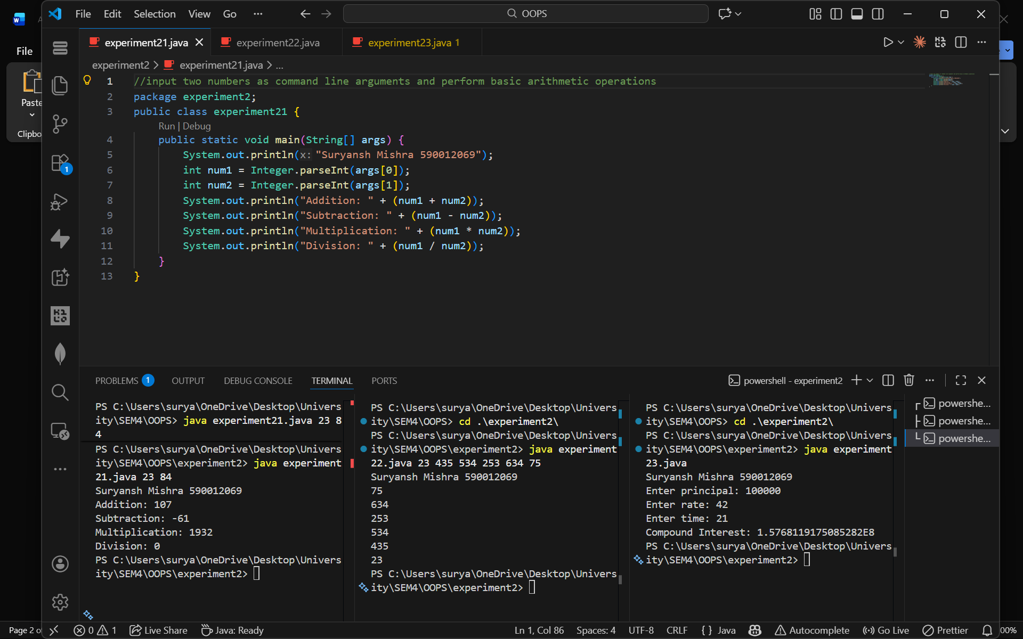
2.2. Write a Java program to input n numbers using command line arguments and print them in reverse order.
//input numbers and print reversal of them
package experiment2;
public class experiment22 {
public static void main(String[] args) {
System.out.println("Suryansh Mishra 590012069");
for (int i = args.length - 1; i >= 0; i--) {
System.out.println(args[i]);
}
}
}

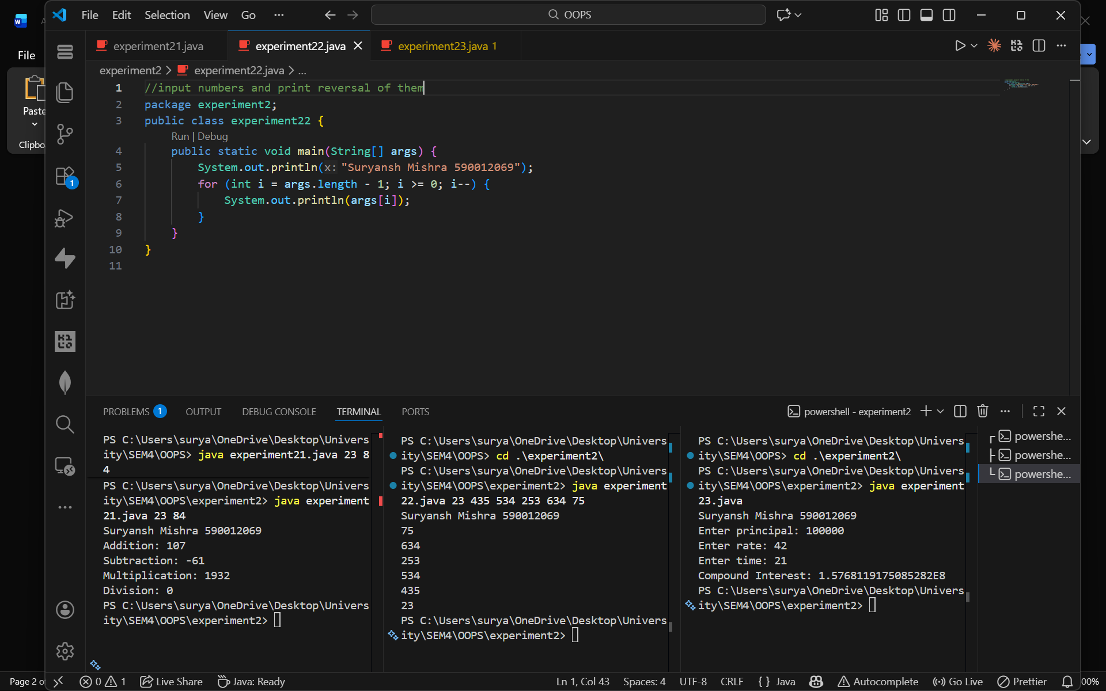
2.3. Write a java program to calculate compund intereset. Take required inputs using Scanner class.
//input principal, rate, time and print compound interest
package experiment2;
import java.util.Scanner;
public class experiment23 {
public static void main(String[] args) {
System.out.println("Suryansh Mishra 590012069");
Scanner sc = new Scanner(System.in);
System.out.print("Enter principal: ");
double p = sc.nextDouble();
System.out.print("Enter rate: ");
double r = sc.nextDouble();
System.out.print("Enter time: ");
double t = sc.nextDouble();
double ci = p * Math.pow(1 + r / 100, t) - p;
System.out.println("Compound Interest: " + ci);
}
}

