

Practical File
of
Object Oriented Language
Course Code: CSEG1044
School of Computer Science

Submitted By Submitted To
Student Name: Suryansh Mishra Mr. Piyush Bagla
SAP ID: 590012069
Course: B.Tech CSE Core
Semester: 4th
Batch: 4
Academic Year: 2025-26

3.1. Write a Java program to find the bionomial coefficient.
// 3.1. Write a Java program to find the binomial coefficient.
package experiment3;
import java.util.Scanner;
public class Experiment31 {
public static long factorial(int n) {
long fact = 1L;
for (int i = 1; i <= n; i++) {
fact = fact * i;
}
return fact;
}
public static long binomial(int n, int r) {
if (r < 0 || r > n) {
return 0L;
}
if (n > 20) {
return -1L;
}
long nFact = factorial(n);
long rFact = factorial(r);
long nrFact = factorial(n - r);
long denominator = rFact * nrFact;
return nFact / denominator;
}
public static boolean isNonNegativeInputs(int n, int r) {
return n >= 0 && r >= 0;
}
public static void main(String[] args) {
Scanner sc = new Scanner(System.in);
System.out.print("Enter n: ");
int n = sc.nextInt();
System.out.print("Enter r: ");
int r = sc.nextInt();
if (!isNonNegativeInputs(n, r)) {
System.out.println("Negative values are not allowed. Use n >= 0 and r >= 0.");
sc.close();
return;
}
long c = binomial(n, r);
if (c == -1L) {
System.out.println("n is too large for long-based factorials. Use n <= 20.");
} else {
System.out.println("Binomial Coefficient C(" + n + "," + r + ") = " + c);
}
sc.close();
}
}
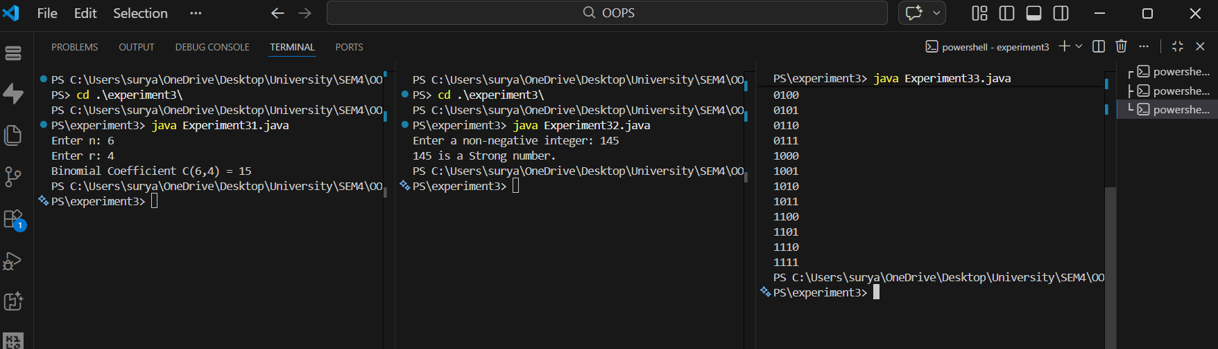

4.1. Write a Java program to check whether a number is strong or not. If the sum of factorial of the digits of the number is the number itself than it is a strong number.
// 4.1. Write a Java program to check whether a number is strong or not. If the sum of factorial of the digits of the number is the number itself than it is a strong number.
package experiment3;
import java.util.Scanner;
public class Experiment32 {
public static int factorial(int n) {
int fact = 1;
for (int i = 2; i <= n; i++) {
fact = fact * i;
}
return fact;
}
public static int sumOfFactorials(int num) {
int sum = 0;
int temp = num;
while (temp > 0) {
int digit = temp % 10;
sum = sum + factorial(digit);
temp = temp / 10;
}
return sum;
}
public static boolean isStrongNumber(int num) {
if (num < 0) {
return false;
}
return sumOfFactorials(num) == num;
}
public static void main(String[] args) {
Scanner sc = new Scanner(System.in);
System.out.print("Enter a non-negative integer: ");
if (!sc.hasNextInt()) {
System.out.println("Invalid input. Please enter an integer.");
sc.close();
return;
}
int number = sc.nextInt();
if (number < 0) {
System.out.println("Please enter a non-negative integer.");
sc.close();
return;
}
if (isStrongNumber(number)) {
System.out.println(number + " is a Strong number.");
} else {
System.out.println(number + " is not a Strong number.");
}
sc.close();
}
}

4.2. Write a java program to print the N bit binary counter in increasing order.
// 4.1. Write a Java program to check whether a number is strong or not. If the sum of factorial of the digits of the number is the number itself than it is a strong number.
package experiment3;
import java.util.Scanner;
public class Experiment32 {
public static int factorial(int n) {
int fact = 1;
for (int i = 2; i <= n; i++) {
fact = fact * i;
}
return fact;
}
public static int sumOfFactorials(int num) {
int sum = 0;
int temp = num;
while (temp > 0) {
int digit = temp % 10;
sum = sum + factorial(digit);
temp = temp / 10;
}
return sum;
}
public static boolean isStrongNumber(int num) {
if (num < 0) {
return false;
}
return sumOfFactorials(num) == num;
}
public static void main(String[] args) {
Scanner sc = new Scanner(System.in);
System.out.print("Enter a non-negative integer: ");
if (!sc.hasNextInt()) {
System.out.println("Invalid input. Please enter an integer.");
sc.close();
return;
}
int number = sc.nextInt();
if (number < 0) {
System.out.println("Please enter a non-negative integer.");
sc.close();
return;
}
if (isStrongNumber(number)) {
System.out.println(number + " is a Strong number.");
} else {
System.out.println(number + " is not a Strong number.");
}
sc.close();
}
}


