

Practical File
of
Object Oriented Language
Course Code: CSEG1044
School of Computer Science

Submitted By Submitted To
Student Name: Suryansh Mishra Mr. Piyush Bagla
SAP ID: 590012069
Course: B.Tech CSE Core
Semester: 4th
Batch: 4
Academic Year: 2025-26

/*5.1: Employee Performance Matrix Analyzer
Problem Statement
A company stores employee performance ratings in a 2D array, where each row represents an employee and each column represents performance scores in different quarters.
Write a Java program to:
- Store performance scores of N employees across M quarters.
- Find:
  - Employee with highest average performance
  - Quarter with maximum overall performance
  - Employees whose performance is consistently improving
- Display sorted employee list based on overall performance.
Hint:
Employee Name | Quarter 1 | Quarter 2 | Quarter 3 | Quarter 4
A | 70 | 80 | 55 | 60
B | 50 | 60 | 70 | 80
C | 70 | 60 | 90 | 30

Input Example
Enter number of employees: 3
Enter number of quarters: 4

Expected Output
Top Performer: Employee 2
Best Performing Quarter: Quarter 2
Improving Employees: Employee 2
Sorted Performance Ranking:
Employee 3
Employee 1
Employee 2
*/
Code :-
import java.util.*;
public class Experiment41 {
static Scanner sc;
static int n, m;
static String[] names;
static int[][] scores;
static int[] sum;
static double[] avg;
static int topIdx;
static int bestQuarter;
static List<Integer> improving;
static Integer[] idx;
public static void main(String[] args) {
sc = new Scanner(System.in);
input();
average();
output();
sc.close();
}
static void input() {
System.out.print("Enter number of employees: ");
n = sc.nextInt();
System.out.print("Enter number of quarters: ");
m = sc.nextInt();
sc.nextLine();
names = new String[n];
for (int i = 0; i < n; i++) {
System.out.print("Enter name of employee " + (i + 1) + " (or press Enter to use 'Employee " + (i + 1) + "'): ");
String line = sc.nextLine().trim();
names[i] = line.isEmpty() ? ("Employee " + (i + 1)) : line;
}
scores = new int[n][m];
for (int i = 0; i < n; i++) {
System.out.println("Enter " + m + " scores for " + names[i] + " (separated by spaces):");
for (int j = 0; j < m; j++) {
scores[i][j] = sc.nextInt();
}
sc.nextLine();
}
}
static void average() {
sum = new int[n];
for (int i = 0; i < n; i++) {
int s = 0;
for (int j = 0; j < m; j++) s += scores[i][j];
sum[i] = s;
}
avg = new double[n];
for (int i = 0; i < n; i++) avg[i] = (double) sum[i] / m;
topIdx = 0;
for (int i = 1; i < n; i++) if (avg[i] > avg[topIdx]) topIdx = i;
int[] quarterSum = new int[m];
bestQuarter = 0;
for (int j = 0; j < m; j++) {
int s = 0;
for (int i = 0; i < n; i++) s += scores[i][j];
quarterSum[j] = s;
}
for (int j = 1; j < m; j++) if (quarterSum[j] > quarterSum[bestQuarter]) bestQuarter = j;
improving = new ArrayList<>();
for (int i = 0; i < n; i++) {
boolean inc = true;
for (int j = 0; j < m - 1; j++) {
if (!(scores[i][j] < scores[i][j + 1])) {
inc = false;
break;
}
}
if (inc) improving.add(i);
}
idx = new Integer[n];
for (int i = 0; i < n; i++) idx[i] = i;
Arrays.sort(idx, (a, b) -> Integer.compare(sum[b], sum[a]));
}
static void output() {
System.out.println();
printInputTable();
System.out.println("Top Performer: " + names[topIdx]);
System.out.println("Best Performing Quarter: Quarter " + (bestQuarter + 1));
System.out.print("Improving Employees: ");
if (improving.isEmpty()) {
System.out.println("None");
} else {
for (int k = 0; k < improving.size(); k++) {
if (k > 0) System.out.print(", ");
System.out.print(names[improving.get(k)]);
}
System.out.println();
}
System.out.println();
System.out.println("Sorted Performance Ranking:");
for (int i = 0; i < n; i++) {
System.out.println(names[idx[i]]);
}
}

static void printInputTable() {
System.out.println();
System.out.println("Input Table:");
System.out.printf("%-16s", "Employee Name");
for (int j = 0; j < m; j++) {
System.out.printf("Q%-8d", j + 1);
}
System.out.println();
for (int i = 0; i < n; i++) {
System.out.printf("%-16s", names[i]);
for (int j = 0; j < m; j++) {
System.out.printf("%-9d", scores[i][j]);
}
System.out.println();
}
}
}

Output :-
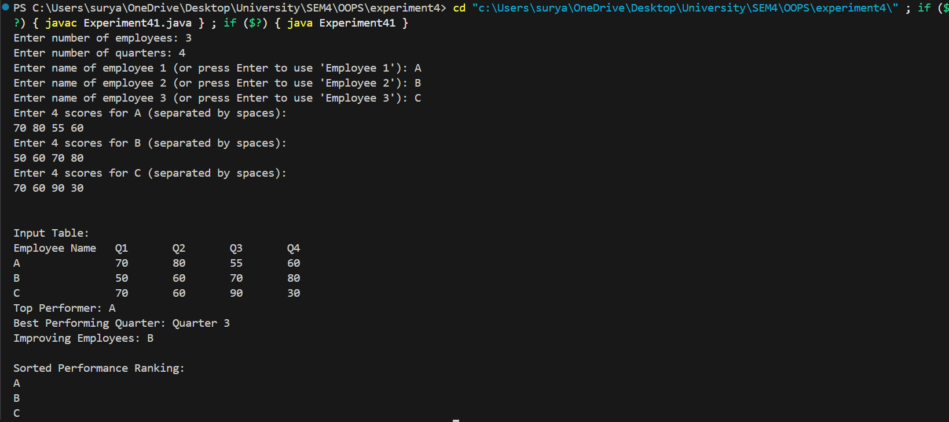

/*6.2. A company wants to analyze customer feedback text automatically.
Write a Java program to:
- Accept a paragraph from user.
- Perform the following operations using Java String methods:
  - Count total words and sentences
  - Identify most frequently used word
  - Replace all negative words from a given list with "***"
  - Check if feedback contains promotional keywords
  - Display reversed sentence order

Constraints
- Must use Java built-in String functions
- Case insensitive processing required

Input Example
Enter feedback:
The product quality is bad but delivery was fast.

Expected Output
Total Words: 8
Most Frequent Word: product
Filtered Feedback: The product quality is *** but delivery was fast.
Contains Promotion Keyword: No
Reversed Sentence: fast was delivery but *** is quality product The
*/
Code :-
import java.util.*;
import java.util.regex.*;
public class Experiment42 {
public static void main(String[] args) {
try (Scanner sc = new Scanner(System.in)) {
System.out.println("Enter feedback:");
String feedback = sc.nextLine().trim();
if (feedback.isEmpty()) {
System.out.println("No feedback provided.");
return;
}
String[] sentenceParts = feedback.split("[.!?]+\s*");
int sentenceCount = 0;
for (String s : sentenceParts) if (!s.trim().isEmpty()) sentenceCount++;
Pattern wordPattern = Pattern.compile("\\b[\\w']+\\b");
Matcher wm = wordPattern.matcher(feedback);
List<String> wordsInOrder = new ArrayList<>();
while (wm.find()) {
wordsInOrder.add(wm.group());
}
int wordCount = wordsInOrder.size();
Set<String> stopwords = new HashSet<>(Arrays.asList(
"the","is","a","an","and","but","or","was","were","in","on","at","by","for","to","of","with","this","that","these","those","it","its","as","are","be","have","has","had", "not","from","they","their","them","he","she","his","her","you","your","yours","we","our","ours","i","me","my","mine","do","does","did","so","if","then","there","when","where","who","whom"
));
Map<String, Integer> freq = new LinkedHashMap<>();
for (String w : wordsInOrder) {
String lw = w.toLowerCase();
freq.put(lw, freq.getOrDefault(lw, 0) + 1);
}
String mostFreq = null;
int best = 0;
for (String w : freq.keySet()) {
if (stopwords.contains(w)) continue;
int f = freq.get(w);
if (f > best) { best = f; mostFreq = w; }
}
if (mostFreq == null && !wordsInOrder.isEmpty()) {
mostFreq = wordsInOrder.get(0).toLowerCase();
}
String[] negatives = {"bad","poor","terrible","awful","disappointing","unsatisfactory","horrible", "worst","negative","dissatisfied","unhappy","subpar","lacking","deficient","flawed","inadequate", "unacceptable","regret","complain","complaint","issue","problem","frustrated","angry","upset","annoyed","displeased", "unfortunate","miserable","depressing","dreadful","abysmal","atrocious","appalling","ghastly","heinous","horrendous","nasty","offensive","repulsive","rotten","sickening","terrifying","tragic","vile", "wretched","worthless","unbearable","unpleasant","unspeakable","vicious","wicked","worse", "worst","abominable","adverse","atrocious","awful","dreadful","egregious","ghastly","heinous","horrendous","nasty","offensive","repulsive","rotten","sickening","terrifying","tragic","vile", "wretched","worthless","unbearable","unpleasant","unspeakable","vicious","wicked","worse", "worst"};
String filtered = feedback;
for (String neg : negatives) {
Pattern p = Pattern.compile("\\b" + Pattern.quote(neg) + "\\b", Pattern.CASE_INSENSITIVE);
Matcher m = p.matcher(filtered);
filtered = m.replaceAll("***");
}
String[] promos = {"sale","discount","offer","buy now","free","promo", "deal", "limited time", "exclusive", "save", "clearance", "bargain", "coupon", "special", "flash sale", "bundle", "gift with purchase", "last chance", "doorbuster", "price drop", "mark down", "clearance", "best price", "lowest price", "money back", "guarantee", "risk free", "no obligation", "try it now", "act now", "don't miss", "while supplies last", "limited stock", "exclusive offer", "vip", "members only", "early access", "pre-order", "new arrival", "hot deal"};
boolean hasPromo = false;
for (String pk : promos) {
Pattern p = Pattern.compile("\\b" + Pattern.quote(pk) + "\\b", Pattern.CASE_INSENSITIVE);
if (p.matcher(feedback).find()) { hasPromo = true; break; }
}
String[] tokens = filtered.split("\\s+");
List<String> cleanTokens = new ArrayList<>();
for (String t : tokens) {
String cleaned = t.replaceAll("^[^\\p{L}\\p{Nd}]+|[^\\p{L}\\p{Nd}]+$", "");
if (!cleaned.isEmpty()) cleanTokens.add(cleaned);
}
Collections.reverse(cleanTokens);
String reversed = String.join(" ", cleanTokens);
System.out.println();
System.out.println("Total Sentences: " + sentenceCount);
System.out.println();
System.out.println("Total Words: " + wordCount);
System.out.println();
System.out.println("Most Frequent Word: " + (mostFreq == null ? "" : mostFreq));
System.out.println();
System.out.println("Filtered Feedback: " + filtered);
System.out.println();
System.out.println("Contains Promotion Keyword: " + (hasPromo ? "Yes" : "No"));
System.out.println();
System.out.println("Reversed Sentence: " + reversed);
}
}
}

Output :-
