ОПИСАНИЕ СУЩНОСТЕЙ

Словесное описание сущностей

Игра

|  |  |  |  |
| --- | --- | --- | --- |
| Наименование | Тип | Диапазон | Длина |
| Id | INT | 0-9 | 11 |
| Name | VARCHAR | a-zA-Zа-яА-Я | 255 |

Видео

|  |  |  |  |
| --- | --- | --- | --- |
| Наименование | Тип | Диапазон | Длина |
| Id | INT | 0-9 | 11 |
| Link_video | VARCHAR | a-zA-Z | 255 |
| Id_game | INT | 0-9 | 11 |
| Id_user | INT | 0-9 | 11 |

Турниры

|  |  |  |  |
| --- | --- | --- | --- |
| Наименование | Тип | Диапазон | Длина |
| Id | INT | 0-9 | 11 |
| Date | VARCHAR | 1.01-31.12 | 11 |
| Organizer | VARCHAR | a-zA-Zа-яА-Я | 255 |
| Prize_fund | INT | 0-9 | 11 |
| Status | VACHAR | a-zA-Z | 255 |
| Id_game | INT | 0-9 | 11 |

Новости

|  |  |  |  |
| --- | --- | --- | --- |
| Наименование | Тип | Диапазон | Длина |
| Id | INT | 0-9 | 11 |
| Title | VACHAR | a-zA-Zа-яА-Я | 255 |
| Full_news | VACHAR | a-zA-Zа-яА-Я | 255 |
| Id_game | INT | 0-9 | 11 |

Пользователь

|  |  |  |  |
| --- | --- | --- | --- |
| Наименование | Тип | Диапазон | Длина |
| Id | INT | 0-9 | 11 |
| Email | VARCHAR | a-zA-Z | 255 |
| Password | VARCHAR | a-zA-Z | 255 |
| Role | INT | 0-9 | 1 |

Роль пользователя

|  |  |  |  |
| --- | --- | --- | --- |
| Наименование | Тип | Диапазон | Длина |
| Id | INT | 0-9 | 11 |
| Name | VARCHAR | a-zA-Z | 255 |

Информация о пользователе

|  |  |  |  |
| --- | --- | --- | --- |
| Наименование | Тип | Диапазон | Длина |
| Id | INT | 0-9 | 11 |
| Link_photo | VACHAR | a-zA-Z | 255 |
| About | VARCHAR | a-zA-Zа-яА-Я | 255 |

Сообщения

|  |  |  |  |
| --- | --- | --- | --- |
| Наименование | Тип | Диапазон | Длина |
| Id | INT | 0-9 | 11 |
| Id_user | INT | 0-9 | 11 |
| Text | VACHAR | a-zA-Zа-яА-Я | 255 |
| Date | VACHAR | 0-9 | 255 |

Друзья

|  |  |  |  |
| --- | --- | --- | --- |
| Наименование | Тип | Диапазон | Длина |
| Id | INT | 0-9 | 11 |
| Id_user | INT | 0-9 | 11 |
| Id_user_2 | INT | 0-9 | 11 |

Оценки

|  |  |  |  |
| --- | --- | --- | --- |
| Наименование | Тип | Диапазон | Длина |
| Id | INT | 0-9 | 11 |
| Id_user | INT | 0-9 | 11 |
| Id_video | INT | 0-9 | 11 |
| Assessment | VARCHAR | a-zA-Z | 255 |

Подробное описание сущностей в виде диаграмм классов

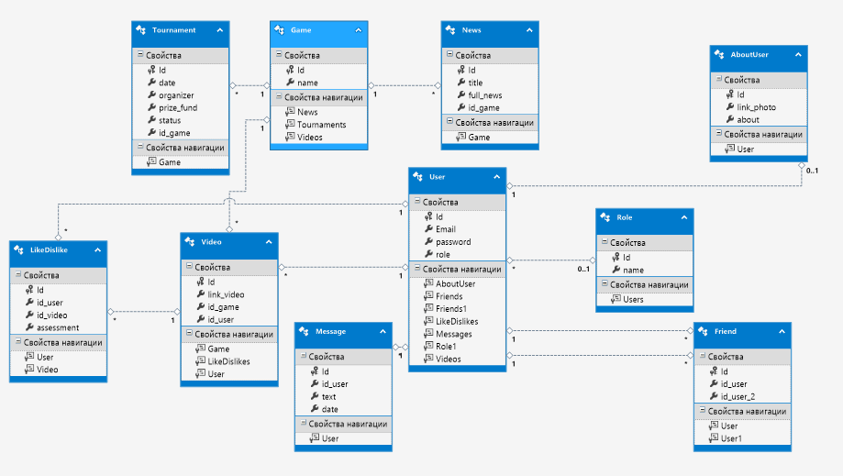

Диаграмма классов

Скрипты создания таблиц

Создание таблицы «Игра»

CREATE TABLE [dbo].[Game] (

[Id] INT NOT NULL,

[name] NVARCHAR (MAX) NOT NULL,

PRIMARY KEY CLUSTERED ([Id] ASC)

);

Создание таблицы «Видео»

CREATE TABLE [dbo].[Video] (

[Id] INT NOT NULL,

[link_video] NVARCHAR (MAX) NOT NULL,

[id_game] INT NOT NULL,

[id_user] INT NOT NULL,

PRIMARY KEY CLUSTERED ([Id] ASC),

CONSTRAINT [FK_Video_Game] FOREIGN KEY ([id_game]) REFERENCES [dbo].[Game] ([Id]) ON DELETE CASCADE ON UPDATE CASCADE,

CONSTRAINT [FK_Video] FOREIGN KEY ([id_user]) REFERENCES [dbo].[User] ([Id])

);

Создание таблицы «Турниры»

CREATE TABLE [dbo].[Tournament] (

[Id] INT NOT NULL,

[date] NVARCHAR (MAX) NOT NULL,

[organizer] NVARCHAR (MAX) NOT NULL,

[prize_fund] INT NOT NULL,

[status] NVARCHAR (MAX) NOT NULL,

[id_game] INT NOT NULL,

PRIMARY KEY CLUSTERED ([Id] ASC),

CONSTRAINT [FK_Tournament_Game] FOREIGN KEY ([id_game]) REFERENCES [dbo].[Game] ([Id]) ON DELETE CASCADE ON UPDATE CASCADE

);

Создание таблицы «Новости»

CREATE TABLE [dbo].[News] (

[Id] INT NOT NULL,

[title] NVARCHAR (MAX) NOT NULL,

[full_news] NVARCHAR (MAX) NOT NULL,

[id_game] INT NULL,

PRIMARY KEY CLUSTERED ([Id] ASC),

CONSTRAINT [FK_News_Game] FOREIGN KEY ([id_game]) REFERENCES [dbo].[Game] ([Id]) ON DELETE CASCADE ON UPDATE CASCADE

);

Создание таблицы «Пользователь»

CREATE TABLE [dbo].[User] (

[Id] INT NOT NULL,

[Email] NVARCHAR (MAX) NOT NULL,

[password] NVARCHAR (MAX) NOT NULL,

PRIMARY KEY CLUSTERED ([Id] ASC)

);

Создание таблицы «Роль пользователя»

CREATE TABLE [dbo].[Role] (

[Id] INT NOT NULL,

[name] NVARCHAR (MAX) NOT NULL,

PRIMARY KEY CLUSTERED ([Id] ASC)

);

Создание таблицы «Информация о пользователе»

CREATE TABLE [dbo].[AboutUser] (

[Id] INT NOT NULL,

[link_photo] NVARCHAR (MAX) NULL,

[about] NVARCHAR (MAX) NULL,

PRIMARY KEY CLUSTERED ([Id] ASC),

CONSTRAINT [FK_About_User] FOREIGN KEY ([Id]) REFERENCES [dbo].[User] ([Id]) ON DELETE CASCADE ON UPDATE CASCADE

);

Создание таблицы «Сообщения»

CREATE TABLE [dbo].[Message] (

[Id] INT NOT NULL,

[id_user] INT NOT NULL,

[text] NVARCHAR (MAX) NOT NULL,

[date] NVARCHAR (MAX) NOT NULL,

PRIMARY KEY CLUSTERED ([Id] ASC),

CONSTRAINT [FK_Message_User] FOREIGN KEY ([id_user]) REFERENCES [dbo].[User] ([Id]) ON DELETE CASCADE ON UPDATE CASCADE

);

Создание таблицы «Друзья»

CREATE TABLE [dbo].[Friend] (

[Id] INT NOT NULL,

[id_user] INT NOT NULL,

[id_user_2] INT NOT NULL,

PRIMARY KEY CLUSTERED ([Id] ASC),

CONSTRAINT [FK_Friend_User] FOREIGN KEY ([id_user]) REFERENCES [dbo].[User] ([Id]) ON DELETE CASCADE ON UPDATE CASCADE,

CONSTRAINT [FK_Friend_User_2] FOREIGN KEY ([id_user_2]) REFERENCES [dbo].[User] ([Id])

);

Создание таблицы «Оценка»

CREATE TABLE [dbo].[LikeDislike] (

[Id] INT NOT NULL,

[id_user] INT NOT NULL,

[id_video] INT NOT NULL,

[assessment] INT NOT NULL,

PRIMARY KEY CLUSTERED ([Id] ASC),

CONSTRAINT [FK_LikeDislike_User] FOREIGN KEY ([id_user]) REFERENCES [dbo].[User] ([Id]) ON DELETE CASCADE ON UPDATE CASCADE,

CONSTRAINT [FK_LikeDislike_Video] FOREIGN KEY ([id_video]) REFERENCES [dbo].[Video] ([Id]) ON DELETE CASCADE ON UPDATE CASCADE

);