Quatatative Management 1

Sumit Dutt Mishra

9/11/2021

###Q1: Data Source Our dataset **Medals** has been extracted from **KAGGLE** , is a collection of database and datasets used by Machine Learning community for the analysis of Machine Learning algorithms

###Q2: Importing Medal Dataset to R Studio

setwd("C:/Users/User/Downloads/archive (2)")  
Medals<- read.csv("C:/Users/User/Downloads/archive (2)/Tokyo Medals 2021.csv")  
head(Medals)

## Country Gold.Medal Silver.Medal Bronze.Medal Total  
## 1 United States of America 39 41 33 113  
## 2 People's Republic of China 38 32 18 88  
## 3 Japan 27 14 17 58  
## 4 Great Britain 22 21 22 65  
## 5 ROC 20 28 23 71  
## 6 Australia 17 7 22 46  
## Rank.By.Total  
## 1 1  
## 2 2  
## 3 5  
## 4 4  
## 5 3  
## 6 6

###Q3: Descriptive Analysis of Medals Dataset Inspecting Dataset

summary(Medals)

## Country Gold.Medal Silver.Medal Bronze.Medal   
## Length:93 Min. : 0.000 Min. : 0.000 Min. : 0.000   
## Class :character 1st Qu.: 0.000 1st Qu.: 0.000 1st Qu.: 1.000   
## Mode :character Median : 1.000 Median : 1.000 Median : 2.000   
## Mean : 3.656 Mean : 3.634 Mean : 4.323   
## 3rd Qu.: 3.000 3rd Qu.: 4.000 3rd Qu.: 5.000   
## Max. :39.000 Max. :41.000 Max. :33.000   
## Total Rank.By.Total   
## Min. : 1.00 Min. : 1.00   
## 1st Qu.: 2.00 1st Qu.:23.00   
## Median : 4.00 Median :47.00   
## Mean : 11.61 Mean :43.49   
## 3rd Qu.: 11.00 3rd Qu.:66.00   
## Max. :113.00 Max. :77.00

####Arithmetic Mean :AM of a set of observation is defined as a sum divided by number of observations

####Mean of overall Medals  
mean(Medals$Total)

## [1] 11.6129

**Median :** is the the middle value of the observation ####Rank of team with bronze

#### Median of Bronze  
median(sort(Medals$Bronze))

## [1] 2

**Mode:** refers to the value which occurs to the maximum frequency ####Which team got maximum Gold

sort(table(Medals$Gold),decreasing = TRUE)

##   
## 0 1 2 3 4 7 10 6 17 20 22 27 38 39   
## 28 22 11 11 5 4 4 2 1 1 1 1 1 1

###Q4: Transformation ####Applying log transformation on Silver Column

Silver_Medals<- log10(Medals$Silver)  
## Displaying first 10 values  
Silver_Medals[1:10]

## [1] 1.612784 1.505150 1.146128 1.322219 1.447158 0.845098 1.079181 1.079181  
## [9] 1.041393 1.000000

###Q5: Visualisation **Histogram Plot**

library(ggplot2)  
ggplot(Medals,aes(x=Gold.Medal))+ geom_histogram()+ggtitle('Histogram Graph')

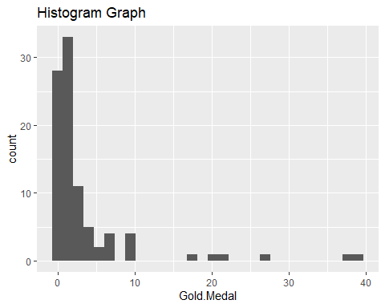 **Scatter Plot

ggplot(Medals,aes(x=Total, y= Rank.By.Total))+geom_point()+ggtitle('Scatter Plot')

