Please enter packet loss percentage0%
Time for which client executed: [18.72153]
Server received,sent ; Client recvd,sent in order [78, 78, 78, 78]
Total packets across network: 156
Throughput 8.332652299251182

Please enter packet loss percentage0%
Time for which client executed: [18.331692]
Server received,sent ; Client recvd,sent in order [79, 79, 79, 79]
Total packets across network: 158
Throughput 8.618953449577923

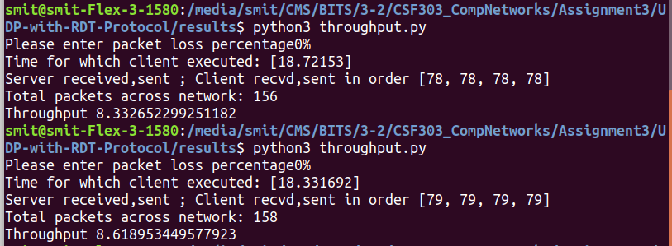

Packet loss :10%
[79.778282]
[63, 63, 59, 73]
Total packets across network: 122
1.5292382455666318

Time for which client executed: [87.408049]
[64, 64, 60, 75]
Total packets across network: 124
1.4186336546649152

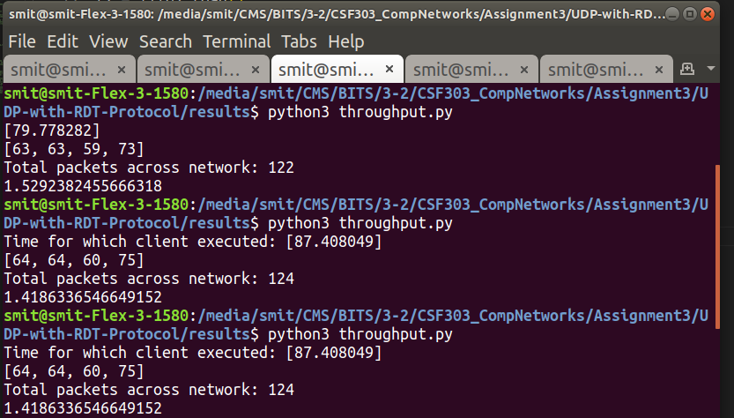

Packet loss : 30%

Please enter packet loss percentage30%
Time for which client executed: [105.855889]
[59, 59, 40, 74]
Total packets across network: 99
0.9352337497255349

Please enter packet loss percentage30%
Time for which client executed: [134.845197]
[69, 69, 50, 97]
Total packets across network: 119
0.8824934268886121

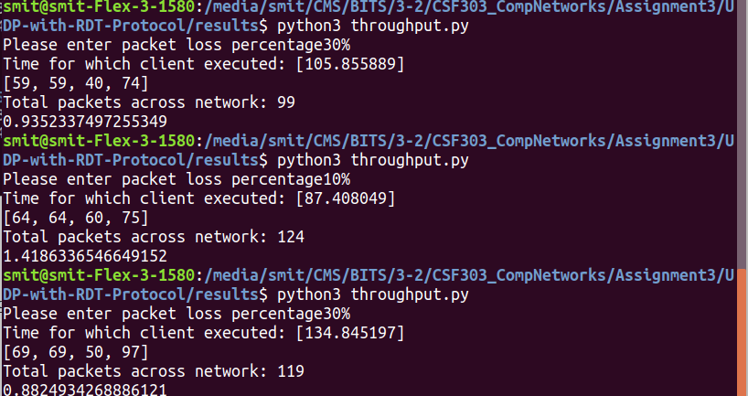

Packet Loss : 50%
Time for which client executed: [165.233292]
Server received,sent ; Client recvd,sent in order [48, 48, 23, 95]
Total packets across network: 71
Throughput 0.4296954877592102

Please enter packet loss percentage50%
Time for which client executed: [143.006938]
Server received,sent ; Client recvd,sent in order [43, 43, 20, 83]
Total packets across network: 63
Throughput 0.4405380667614882

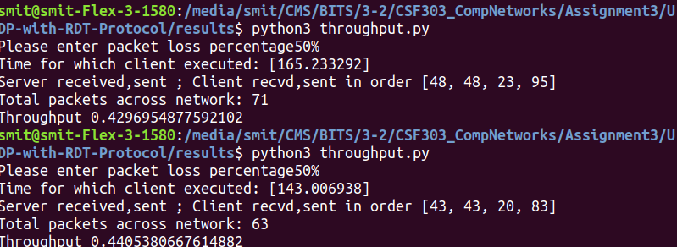

Packet Loss : 70%
Please enter packet loss percentage70%
Time for which client executed: [285.529816]
Server received,sent ; Client recvd,sent in order [52, 52, 17, 148]
Total packets across network: 69
Throughput 0.24165602376180567

Please enter packet loss percentage70%
Time for which client executed: [337.896712]
Server received,sent ; Client recvd,sent in order [47, 47, 13, 176]
Total packets across network: 60
Throughput 0.17756905548107257
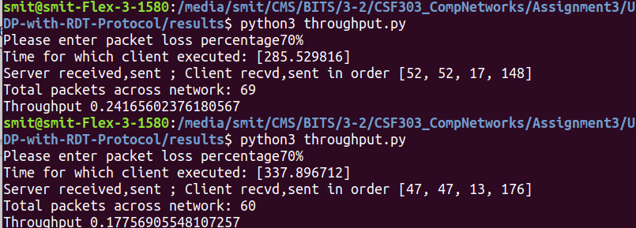

Packet Loss : 90%
Please enter packet loss percentage90%
Time for which client executed: [1063.260322]
Server received,sent ; Client recvd,sent in order [54, 54, 6, 529]
Total packets across network: 60
Throughput 0.05643020693854124

Please enter packet loss percentage90%
Time for which client executed: [679.694487]
Server received,sent ; Client recvd,sent in order [28, 28, 2, 337]
Total packets across network: 30
Throughput 0.044137477313391835

