

Assignment – 1

Enrollment No: MSCIT23B18

Roll No: 18

Smit Joshi | NoSQL | 29/07/2023

# Scenario: Online Bookstore Database

## Tasks:

## 1. *Create the Necessary Tables with Appropriate Data Types*

### Tables Creation Queries

#### Authors

create table authors(

author_id int primary key,

author_name varchar(100),

birth_date date,

country varchar(30)

);

#### Books

create table books(book_id int primary key,

title varchar(255),

author_id int references author(author_id),

price int,

publication_date date,

genre varchar(50)

);

#### Customers

create table customers(

customer_id int primary key,

first_name varchar(30),

last_name varchar(30),

email varchar(100),

address varchar(255),

city varchar(40),

zip_code int(6),

country varchar(50)

);

#### Orders

create table orders(

order_id int primary key,

customer_id int references customer(customer_id),

order_date date

);

#### Order_items

create table order_items(

order_item_id int primary key,

order_id int references orders(order_id),

book_id int references books(book_id),

quantity int,

subTotal int

);

### Insert Queries

## *2. Insert at least 5 books and 3 authors into their respective tables.*

#### Authers

insert into authors (author_id, author_name, birth_date, country) values

(1,'Javerchand Meghani','1856-08-12','India'),

(2,'Chetan Bhagat','1956-08-12','India'),

(3,'Smit Joshi','2002-11-15','India');

#### Books

insert into books(book_id,author_id,title,publication_date,genre,price) values

(1,1,'Saurast ni rasdhar','1880-11-18','xyz',1000),

(2,2,'Making India Awsome','1980-12-28','geographical',2000),

(3,1,'Jeevan Ni Vyatha','1910-12-19','Auto Bio graphy',4000),

(4,3,'Mysterious Tech','2019-01-20','Technology',1300),

(5,3,'A Life Long Story','2020-06-20','Phycology',2500);

## *3. Insert at least 3 customers into the customers table.*

#### Customers

insert into customers (customer_id, first_name, last_name, email, address, city, zip_code, country) values

(1,'Smit','Joshi’, ‘smitjoshi814@gmail.com','Ranpur Road deesa','Deesa',385535,'India'),

(2,'Tejasv','Modi’, ‘tejasvmodi420@gmail.com','Rony Streets Behind Anand Compex','Patan',384265,'Shri Lanka'),

(3,'Tanish','Modi’, ‘tanishmodi134@gmail.com','Neomi Houses near Kali Road burij','Patan',384265,'Caneda');

## 4.Create at least 2 orders, and for each order, add 2 or more books with their corresponding quantities into the order_items table.

#### Orders

insert into orders (order_id, customer_id, order_date) values

(1,1,'2023-07-25'),

(2,1,'2023-07-25');

#### order_items

insert into order_items(order_item_id,order_id,book_id,quantity,subTotal) values

(1,1,4,2,2600),

(2,2,5,1,2500);

## 5. Write a query to find all orders placed by a specific customer (you can choose any customer you've added).

#### Query

select * from orders where customer_id=1;

#### Output:

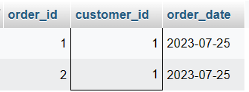

# Important Queries for SQL Practice Exercises

## How to create table with same structure with data?

### Ans: Create table temp_authors **as SELECT * FROM authors;**

## How to create table with same structure without data?

### Ans: Create table temp_authors as SELECT * FROM authors **WHERE 1<>1;**

## How to display last 10 records from student table.

### Ans: select * from student **order by student_id DESC LIMIT 10;**

## How to delete duplicate rows from the table

### Ans:

### Solution 1: if table has primary field, we can use the primary key field to delete the duplicate values.

### Solution 2: In Oracle There is hidden Column Named **rowid,** which has unique id for all the rows, we can use that to delete the duplicate rows.

### Solution3: In MySQL There is a Function Called **row_number() which can be used with over() function** which can be used to delete the duplicate rows from table. Here’s The Simple Query I’ve Found on MySQLTutorial.org

### 

## How to fetch all the student who took admission at 2016.

### Ans: SELECT * FROM STUDENTS WHERE **year(admission_date)=’2016’;**

## What is query to display odd records from student table.

### Ans: SELECT * FROM STUDENTS WHERE student_id in **(SELECT student_id FROM STUDENTS WHERE student_id%2 <> 0);**

Create table worker(

worker_id int primary key,

first_name varchar(50),

last_name varchar(50),

salary int,

joining_date datetime,

department varchar(10)

);

## insert into worker (worker_id,first_name,last_name,salary,joining_date,department) VALUES

## (1, 'Monika', 'Arora', 100000, '2014-02-20 9:00:00', 'HR'),

## (2, 'Niharika', 'Verma', 80000, '2014-06-11 9:00:00', 'Admin'),

## (3, 'Vishal', 'Singhal', 300000, '2014-02-20 9:00:00', 'HR'),

## (4, 'Amitabh', 'Singh', 5000000, '2014-02-20 9:00:00', 'Admin'),

## (5, 'Vivek', 'Bhati', 500000, '2014-06-11 9:00:00', 'Admin'),

## (6, 'Vipul', 'Diwan', 2000000, '2014-06-20 9:00:00', 'Account'),

## (7, 'Satish', 'Kumar', 75000, '2014-01-20 9:00:00', 'Account'),

## (8, 'Geetika', 'Chauhan', 90000, '2014-04-11 9:00:00', 'Admin');

create table bonus(

worker_ref_id int references worker(worker_id),

bonus_date datetime,

bonus_amount int

);

insert into bonus (worker_ref_id, bonus_date, bonus_amount) VALUES

(1, '2016-02-20 00:00:00', 5000),

(2, '2016-06-11 00:00:00', 3000),

(3, '2016-02-20 00:00:00', 4000),

(1, '2016-02-20 00:00:00', 4500),

(2, '2016-06-11 00:00:00', 3500);

create table title(

worker_ref_id int references worker(worker_ref_id),

worker_title varchar(20),

affectef_from datetime

);

insert into title (worker_ref_id, worker_title, affectef_from) VALUES

(1, 'Manager', '2016-02-20 00:00:00'),

(2, 'Executive', '2016-06-11 00:00:00'),

(8, 'Executive', '2016-06-11 00:00:00'),

(5, 'Manager', '2016-06-11 00:00:00'),

(4, 'Asst. Manager', '2016-06-11 00:00:00'),

(7, 'Executive', '2016-06-11 00:00:00'),

(6, 'Lead', '2016-06-11 00:00:00'),

(3, 'Lead', '2016-06-11 00:00:00');

## Q. Write an sql query to fetch “first_name” from the worker table using the alias name .

### Ans: select first_name as worker_name from worker;

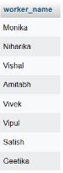

## Q-. Write an sql query to fetch unique values of department from the worker table.

### Ans: select distinct department from worker;

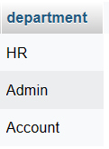

## Q-. Write an sql query to print all worker details from the worker table order by first_name ascending.

### Ans: select * from worker order by first_name asc;

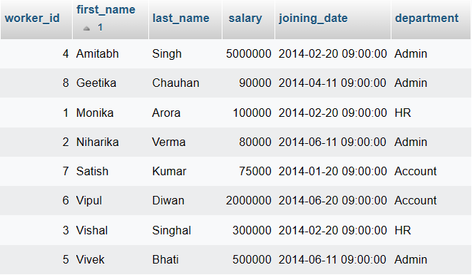

## Q-. Write an sql query to print details for workers with the first names “vipul” and “satish” from the worker table.

### Ans: select * from worker where first_name in (‘vishal’,’satish’);

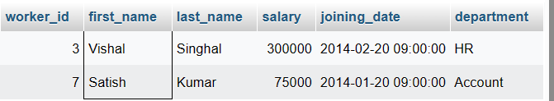

## Q-. Write an sql query to print details of workers with department name as “admin”.

### Ans: select * from worker where department=’Admin’;

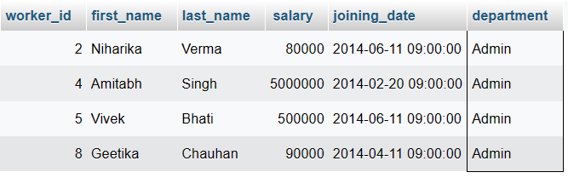

## Write an sql query to print details of the workers whose first_name ends with ‘a’.

### Ans: select * from worker where first_name=’%a’;



No rows

## Q-. Write an sql query to print details of the workers whose first_name ends with ‘h’ and contains six alphabets.

### Ans: select * from worker where first_name like ’%h’ and length(first_name)=6;

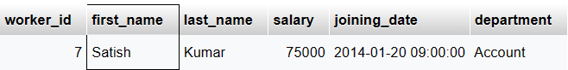

## Q-. Write an sql query to print details of the workers whose salary lies between 100000 and 500000.

### Ans: select * from workers where salary between 100000 and 500000;

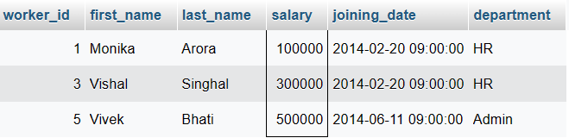

## Q-. Write an sql query to fetch the count of employees working in the department ‘admin’.

### Ans: select count(*) as employees from worker where department=’Admin’;

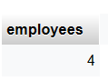

# Write a mysql statement to find the concatenated first_name, last_name where the age of the employee is greater than 30.

CREATE TABLE employee (

first_name VARCHAR(30),

last_name VARCHAR(30),

age INT(2),

dept VARCHAR(10)

);

insert into employee (first_name, last_name, age, dept) VALUES

('Mesa', 'Loop', 30, 'Acct'),

('Smith', 'Oak', 27, 'Dev1'),

('John', 'Jorz', 37, 'QA'),

('Hary', 'Gaga', 32, 'QA');

### Ans:

### solution 1:

### in this solution there will be no space between the name it will be like “SmitJoshi” but it shoud contain the space like “Smit Joshi”.

### **select concat(first_name,last_name) as name from employee where age>30;**

### solution 2: We can achive this by adding nested concat() in the query.

### **Select concat(first_name,concat(‘ ‘,last_name)) as name from employee where age>30;**

# Scenario: Student Database

## Tasks:

## 1. *Create the Necessary Tables with Appropriate Data Types*

### Tables Creation Queries

#### Student

create table student(

student_id int primary key,

first_name varchar(50),

last_name varchar(50),

date_of_birth date,

gender varchar(6),

email varchar(100),

phone varchar(10)

);

#### Note: phone is varchar because it is not going to be used in any mathematical calculation.

#### Cources

create table courses(

course_id int primary key,

course_name varchar(50),

instructor varchar(50),

credit_hours int

);

#### Enrollments

create table enrollments(

enrollment_id int primary key,

student_id int references student(student_id),

course_id int references courses(course_id),

enrollment_date date,

grade varchar(1)

);

### Insert Queries

## Insert at least 5 students' records into the students table.

insert into student (student_id, first_name, last_name, date_of_birth, gender, email, phone) VALUES

(1, 'smit', 'joshi', '2002/11/15', 'male', 'smitjoshi814@gmail.com ', '8140800864'),

(2, 'tejasv', 'modi', '2003-10-06', 'Male', 'tejasvmodi@gmail.com', '9876543210'),

(3, 'tanish', 'modi', '2002/04/28', 'male', 'tanishmodi@gmail.com', '0987654321'),

(4, 'switi', 'patel', '2002/03/30', 'Female', 'gothiswiti@gmail.com', '8866423301'),

(5, 'tabbssum', 'saji', '2003/7/20', 'female', 'tabbsaji@gmail.com', 9876543210);

## Insert at least 3 courses' records into the courses table.

Insert into courses (course_id, course_name, instructor, credit_hours) VALUES

(1, 'Mscit', 'Bhavesh Patel', 100),

(2, 'MCA', 'Smit Joshi', 90),

(3, 'BCA', 'Tejasv Modi', 80);

## Enroll some students in different courses by adding records to the enrollments table.

Insert into enrollments (enrollment_id, student_id, course_id, enrollment_date, grade) VALUES

(1,1,1, '2023-07-03', 'A'),

(2,2,1, '2023-07-03', 'B'),

(3,3,2, '2023-07-05', 'B'),

(4,4,2, '2023-07-05', 'A'),

(5,5,3, '2023-07-07', 'B');

### Select Queries

## Write a query to get the list of all students and their details.

### Ans: select * from student;

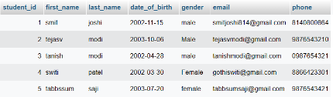

## Write a query to get the list of all courses and their details.

### Ans: select * from courses;

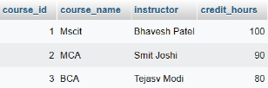

# (1)Create the following tables with appropriate constraints

## Customer_Master

Ans:

create table customer_master(

c_no int primary key,

c_name varchar(50),

gender varchar(6),

dob date,

contact_no varchar(10)

);

#### Note: concatc_no is varchar because it is not going to be used in any mathematical calculation.

insert into customer_master (c_no, c_name, gender, dob, contact_no) VALUES

(1, 'Tejasv', 'Male', '2002-08-24', '9988776655'),

(2, 'Tanish', 'Male', '2002-09-16', '7766885544'),

(3, 'Nisha', 'Female', '2003-07-16', '5599223311'),

(4, 'Vishva', 'Female', '2003-09-16', '1166228822'),

(5, 'switi', 'Female', '2003-04-30', '8833002299');

## Branch_Master

### Ans:

create table branch_master (

b_no int primary key,

b_name varchar(50),

location varchar(10)

);

insert into branch_master (b_no, b_name, location) VALUES

(1, 'pune branch', 'pune'),

(2, 'Ahmedabad Branch', 'ahmedabad'),

(3, 'Mumbai branch', 'mumbai'),

(4, 'patan branch', 'patan');

## Account_Master

### Ans:

Create table Account_Master (

a_no int primary key,

a_type varchar(10),

b_no int references branch_master(b_no),

c_no int references customer_master(c_no),

open_date date,

current_bal int

);

INSERT INTO account_master (a_no, a_type, b_no, c_no, open_date, current_bal) VALUES

(1, 'saving', '1', '1', '2016-08-17', 70000),

(2, 'current', '2', '2', '2016-08-17', 900);

# (2)Create the following tables with appropriate constraints:

## Person

### Ans:

Create table person(

pid int primary key,

name varchar(50),

address varchar(255),

city varchar(30)

);

INSERT INTO `person` (pid, name, address, city) VALUES

(11, 'Sakshi Modi', 'behind pomos pizza,abc soicty patan 384235', 'patan');

## Order_display

### Ans:

Create table order_display(

oid int primary key,

pid int references person(pid),

order_price int

);

INSERT INTO order_display (oid, pid, order_price) VALUES

(1, 11, 999);

## Employee

### Ans:

Create table employee(

e_id int primary key,

e_name varchar(50),

designation varchar(40),

salary int,

dob date

);

INSERT INTO employee (e_id, e_name, designation, salary, dob) VALUES

(1, 'smit', 'manager', 90000, '2002-11-15');

## Department

### Ans:

Create table department (

d_no int primary key,

d_name varchar(60),

e_id int references employee(e_id)

);

## Queries:

## List the name of the female customer only.

Ans: Select c_name from customer_master where gender=’female’;



## List the order price of the person having id 11.

Ans: select order_price from order_display where pid=11;

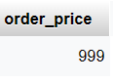

## Display account details where current balance is greater than 1000.

Ans: select * from account_master where current_bal > 1000;

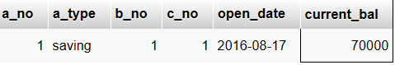

## Give the distinct set of all account type.

Ans: select distinct a_type from account_master group by a_type;

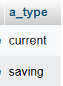

## Give hike of inr 5000 for salary where the designation is ‘manager’.

Ans: Update employee set salary=salary+5000 where designation=’manager’;



## List all customers numbers having saving bank account only.

Ans: select c_no from account_master where a_type=’saving’;

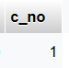

## List all customers whose name has three characters and middle character is ‘a’.

Ans: select * from customer_master where length(c_name)=3 and substr(c_name,2,1)=’a’;

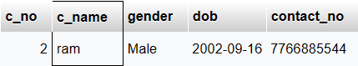

## List all customer name whose last character is ‘h’ and first character is ‘h’ .

Ans: select c_name from customer_master where c_name like ‘h%h’;

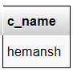

## List all records from account where account type is ‘fd’ .

Ans: select * from account_master where a_type=’fd’;

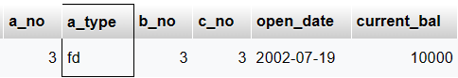

## Add a column customer_ type in customer master.

Ans: Alter table customer_master add customer_type varchar(10);

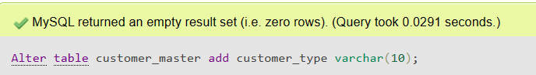

## Drop column customer_type from customer master.

Ans: Alter table customer_master drop column customer_type;

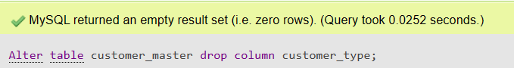

## Display all the details of account master for current balance ranging from 500 to 1000.

Ans: select * from account_master where current_bal between 100 and 500;

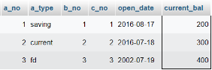

## Display the name of the customer whose name has total 4 characters and the second character is ‘a’.

Ans: select c_name from customer_master where length(c_name)=4 and substr(c_name,2,1)=’a’;

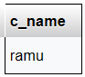

## Display only those branch details where the location is mumbai,pune,ahmedabad.

Ans:

select * from branch_master where location in(‘mumbai’,’pune’,’ahmedabad’);

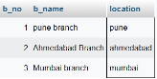

## Display only those loan default details where the reason starts with ‘no money’.

Ans: select * from loan_defaults where reason=’no money%’;

## Display the details of account where the current balance falls in the range of 10,000 to 20,000.

Ans: select * from account_master where current_bal between 10000 and 20000;

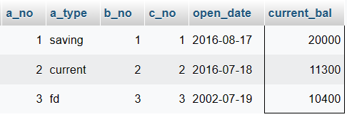

## Modify the city of customer in 11 to pune.

Ans: Update customers set city=’pune’ where c_no=11;

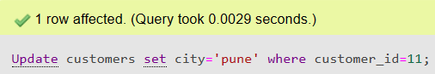

## Deduct 1500 rupees from account number 11 .

Ans: Update account_master set current_bal=current_bal-1500 where a_no=11;



## Change the city of the customer number 11 to ‘ahmedabad’ .

Ans: Update customers set city=’ahmedabad’ where customer_id =11;

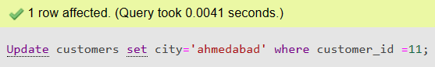

## Change the order_price to 1500 where oid is 11.

Ans: update order_display set order_price=1500 where oid=11;

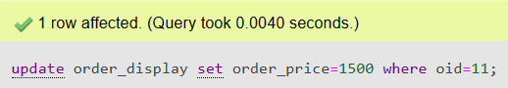

## Modify the location of branch to “ahmedabad” where the branch id is 101.

Ans: update branch_master set location=’ahmedabad’ where b_no=101;

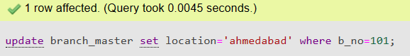

## Change the designation of employee to “officer” where e_name is “ram”.

Ans: update employee set designation=’officer’ where e_name=’ram’;

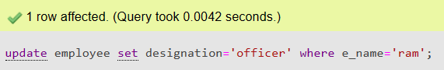

## Display only those columns from employee where designation is “manager”.

Ans: select * from employee where designation=’manager’;

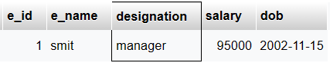

## Display only those columns from account_master where balance is either 10000 or 20000.

Ans: select * from account_master where current_bal=10000 or current_bal=20000;

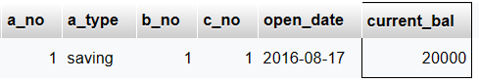

## Display only those columns from account_master where balance is 10000 and account type is “overdraft”.

Ans: select * from account_master where current_bal=10000 and a_type=’overdraft’;

