1)db.Movies.find()

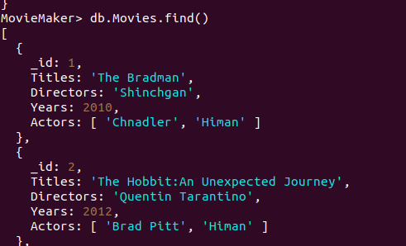

2)db.Movies.find({Directors:"Quentin Tarantino"});

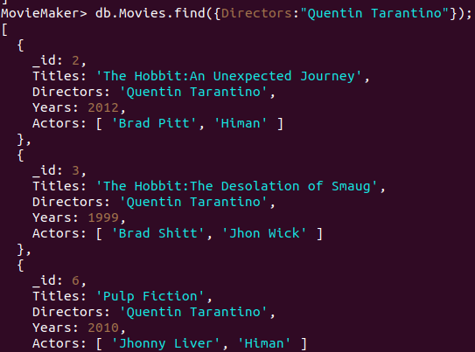

3)db.Movies.find({Actors:{$in:['Brad Pitt']}});

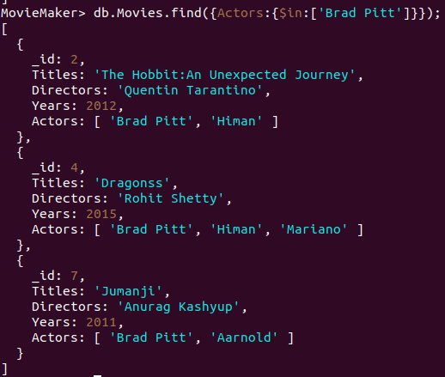

4)db.Movies.find({$or:[{Years:{$lt:2000}},{Years:{$gt:2010}}]});

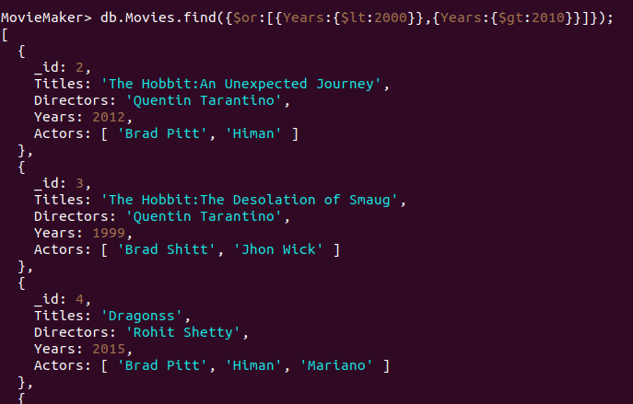

5)db.Movies.updateOne({_id:2},{$set:{Titles:'"The Hobbit:An Unexpected Journey":"A reluctant hobbit,Bilbo Baggins, sets out to the Lonely Mountain with a spirited group of dwarves to reclaim their mountain home - and the gold within it - from the dragon Smaug."'}});

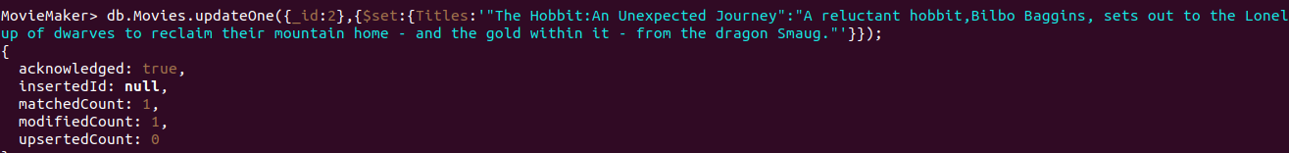

6)

7)db.Movies.updateOne({Titles:"Pulp Fiction"},{$push:{Actors:{$each:['Samuel L. Jackson']}}});

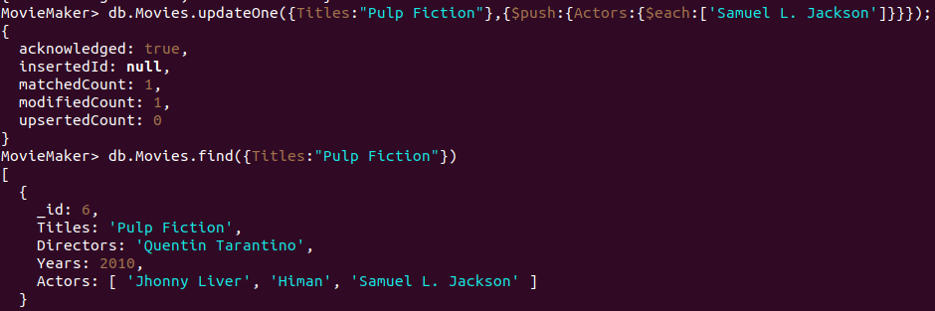

8)db.Movies.find({Titles:{$regex:"Bilbo"}});

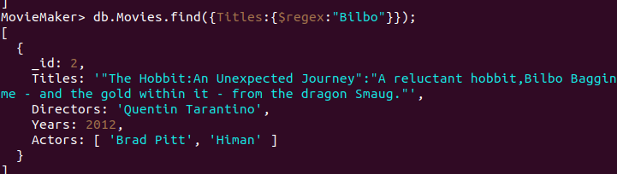

9)

10)

11)

12)

13)db.Movies.deleteOne({Titles:"Pee Wee Herman's Big Adventure"});



db.Movies.insertOne({_id:1,Titles:"The Bradman",Directors:"Shinchgan",Years:2010,Actors:["Chnadler","Himan"]});

db.Movies.insertMany([{_id:2,Titles:"The Hobbit:An Unexpected Journey",Directors:"Quentin Tarantino",Years:2012,Actors:["Brad Pitt","Himan"]},{_id:3,Titles:"The Hobbit:The Desolation of Smaug",Directors:"Quentin Tarantino",Years:1999,Actors:["Brad Shitt","Jhon Wick"]},{_id:4,Titles:"Dragonss",Directors:"Rohit Shetty",Years:2015,Actors:["Brad Pitt","Himan","Mariano"]},

{_id:5,Titles:"Cars",Directors:"Will Smith",Years:1990,Actors:["Tonyy Lee","Rick Flair","Ronda-rousy"]},

{_id:6,Titles:"Pulp Fiction",Directors:"Quentin Tarantino",Years:2010,Actors:["Jhonny Liver","Himan"]},

{_id:7,Titles:"Jumanji",Directors:"Anurag Kashyup",Years:2011,Actors:["Brad Pitt","Aarnold"]},{_id:8,Titles:"Zathura:Space-Adventure",Directors:"Quentin Tartos",Years:1995,Actors:["Hulk","Hogan"]},{_id:9,Titles:"Wanted",Directors:"Tarantino",Years:2005,Actors:["Seth","Rolins"]},{_id:10,Titles:"Kedarnath",Directors:"Abhijet Dalal",Years:2010,Actors:["Sushant","Sara"]}

]);