# HTML and CSS

To get started with HTML and CSS, please see following videos.

1. <https://www.youtube.com/watch?v=OZeoiotzPFg>
2. <https://www.youtube.com/watch?v=yyqvXhu-HOc>

## HTML Task

1. What is HTML? Give basic structure of the HTML page.

🡪HTML stands for(Hyper Text Markup Language). HTML defines the basic structure of web page. Its skeleton of the web page. Below is the basic structure of the HTML page.

<!DOCTYPE html>

<html>

<head>

<title></title>

</head>

<body>

</body>

</html>

1. Difference between inline and block level element.

🡪An inline element adjust the space based on the content it contains and can sit alongside other elements, whereas a block-level element occupies the entire width of its container, stacking vertically and taking up a full line.

1. Create an HTML page “index.htm” with following content

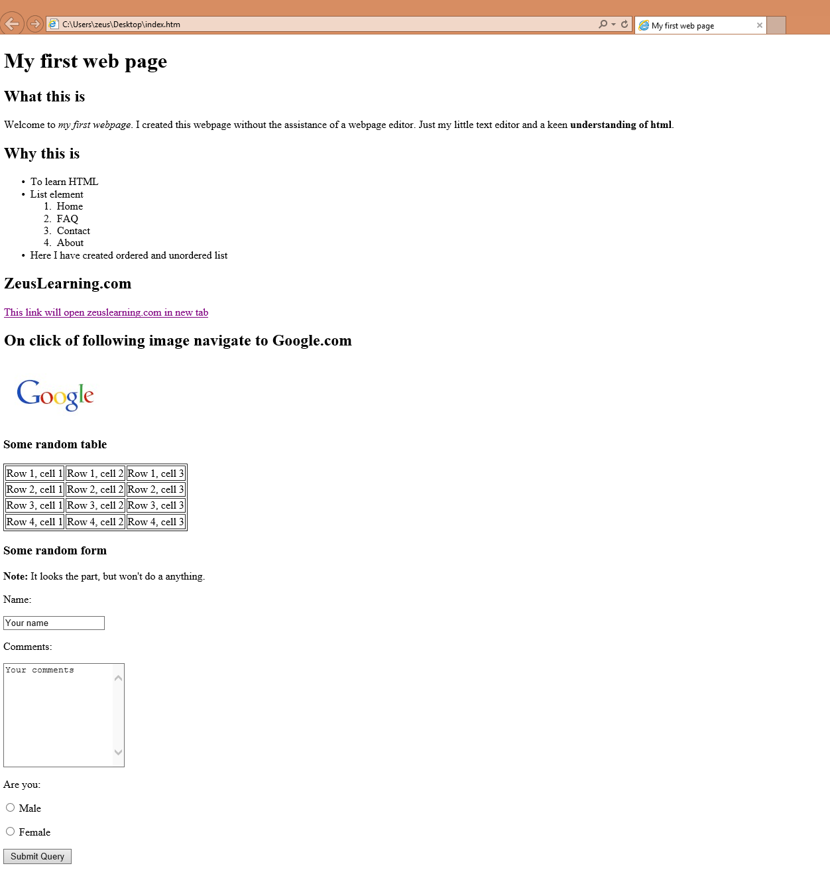

## CSS Task

1. Explain the different ways in which CSS can be applied to HTML, what is the preferred way and why.

🡪There are 3 different ways to apply CSS to HTML:

(1) inline CSS

(2) internal CSS

(3) external CSS

🡪External CSS is the preferred way to apply CSS to HTML. Because all the CSS lines are in the different file so its easy to manage code. If we want to apply same CSS to multiple files then external CSS is the only way which prevent repetitive writing of CSS.

1. What are different CSS selectors, with example explain Element, Class and Id selectors.

🡪Below are the different CSS selectors:

1. **CSS Element selector:**

The element selector selects HTML elements based on the element name

p{

---CSS Lines---

}

This way all the <p> tag will be affected

1. **CSS Id selector:**

The id selector use ‘id’ attribute of HTML element to select a specific element.

This id of the element is unique within the webpage, so the id selector is used to select one unique element.

To select an element with a specific id, write hash(#) character, followed by the id of the element

1. **CSS Class selector:**

The Class selector select HTML element with a specific class attribute.

To select elements with a specific class, write a period(.) character, followed by the class name.

1. **CSS Universal selector**
2. **CSS Grouping selector**
3. With the help of a diagram explain CSS Box Model.

Border

Padding

Content

Margin

1. To HTML page create in the task 1.a, apply following CSS

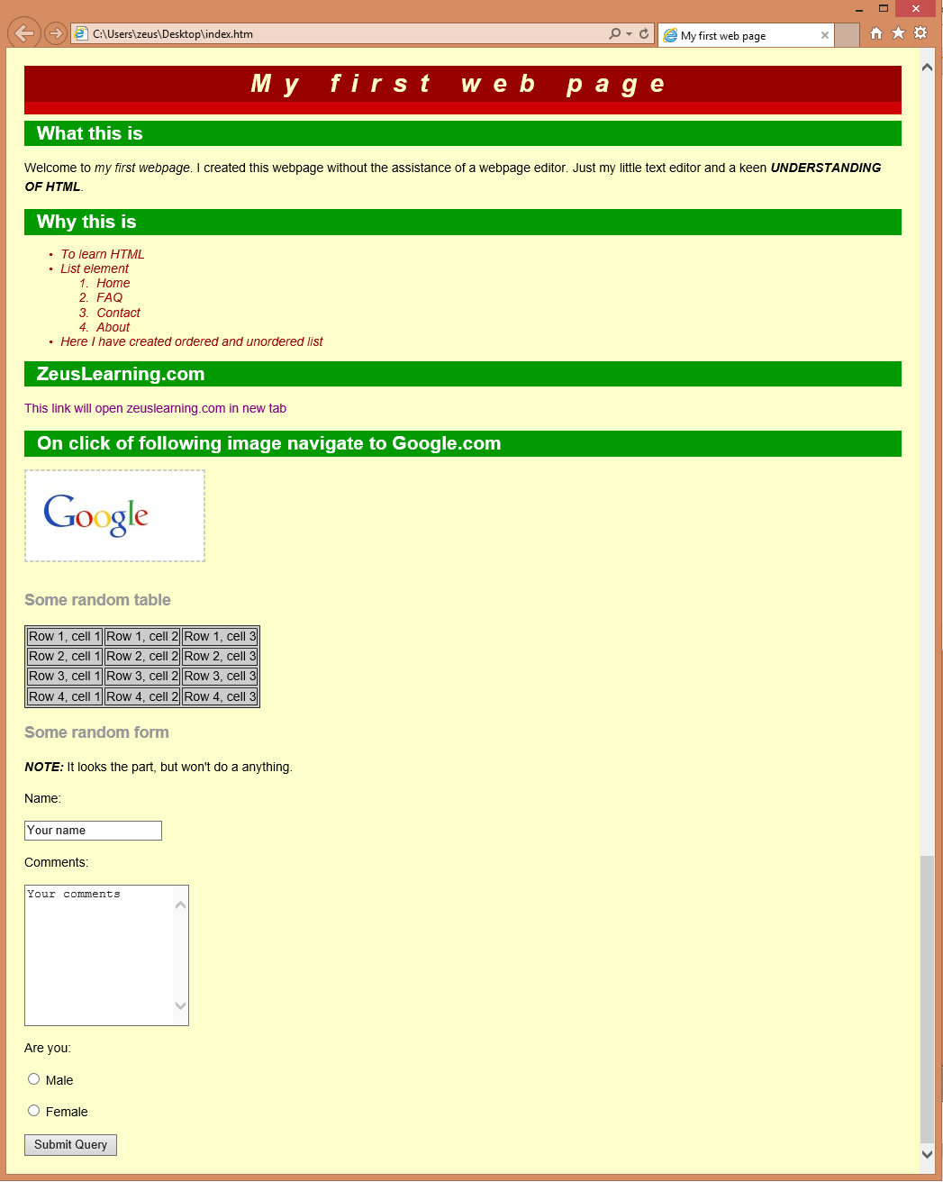

# JavaScript

1. List down ways in which JavaScript command can be added to a webpage, what is the preferred way.
2. To the webpage created in the task 2.d , on click of “Submit” button call JavaScript function to validate:
   1. Name and comments fields are not empty.
   2. User has selected one entry from male/female radio button
   3. In case user has not entered data for name and comment field or not selected anything from male/female radio button – show alert message “All fields are compulsory” and set focus to the first filed that is empty.