

**PROJECT REPORT**

**ON**

**FOOD POINT**

**AS A PARTIAL REQUIREMENT FOR THE DEGREE**

**OF**

**BACHELOR OF COMPUTER APPLICATION**

**(B.C.A.)**

**: SUBMITTED BY : : GUIDED BY :**

Ms. Priyanka Chauhan

|  |  |  |
| --- | --- | --- |
| 274 | 2922 | Dankhra Smit |
| 218 | 2952 | Sakhreliya poojan |
| 206 | 2869 | Padsala Dixit |
| 225 | 2705 | Kajavadra Rohit |

**ACKNOWLEDGEMET**

We would like to express our sincere gratitude to **Ms. Priyanka Chauhan** for her un-forgettable support and guidance without which the success of the project would not have been possible.

We would like to thank our head of the department prof. **Dr. Mukesh Goyani** for valuable guidance and direction. Our thanks and appreciation also go to our colleagues in developing the project and people who have willingly helped us with their abilities. Finally, we would also like to thank all the staff members, who have helped in one or another way to make this work a success.

INDEX

|  |  |
| --- | --- |
| **Chapter** | **Page No.** |
| 1. **Introduction**    1. College Profile    2. Project description    3. Project Profile 2. **Environment Description**    1. Hardware and Software Requirements    2. Technologies Used [Max 2 pages] 3. **System Analysis and Planning**    1. Existing System and its Drawbacks    2. Feasibility Study    3. Requirement Gathering and Analysis 4. **Proposed System**    1. Scope    2. Project modules (Module-wise objectives/functionalities Constraints)    3. Expected Advantages 5. **Detail Planning**    1. Data Flow Diagram    2. Process Specification    3. Data Dictionary    4. Entity-Relationship Diagram   **OR**   1. **Detail Planning**    1. UML    2. Activity Flow Diagram    3. Class Diagram 2. **System Design**    1. Database Design    2. Directory Structure    3. Input Layouts 3. **System Testing [Test Cases]** 4. **Limitations and Future Scope of Enhancements References** | 06  07  08  10  11  15  17  19  23  25  27  30  45  46  51  51  57  64  98 |

UNIT-1 INTRODUCTION

* 1. **College Profile**
  2. **Project Description**
  3. **Project Profile**
  4. COLLEGE PROFILE

Amroli village is now a part of the Suratmunicipal corporation. As it is a distance of only 10 minutes from tran Railway Station students can come easily from Kim, Sayan, Kosamba, and the places nearby. Moreover, Amroli College is accessible in 20-45 minutes from Surat Railway Station, Bus Depot, and Chowk.

prof.V.B.Shah Institute of Management, R.V.Patel College of Commerce(English Medium). V.L. Shah College of Commerce(Gujarati Medium), and Sutex Bank College of Computer Application & Science are self-financed colleges affiliated to Veer Narmad South Gujrat University, Surat.

* Prof.V.B.Shah Institute of Management-BBA College English Medium started in the year 1998
* R.V.Patel College of Commerce B.Com College English Medium started in the year 2001
* V.L.Shah College of Commerce B.Com College Gujrati Medium started in the year 2006
* The College also offers winter Admission (December-January)(BCA degree program)from the year 2021.
* Sutex Bank College of Computer Applications & Science, B.C.A. degree program

1.2 PROJECT DESCRIPTION

* The Online Food Delivery project aims to create a platform for customers to easily order food from local restaurants and have it delivered to their location.
* The platform will feature a user-friendly website and mobile app where customers can browse menus, place orders, and track the status of their delivery.
* It will also include a robust back-end system for managing orders, inventory, and payments. Additionally, the platform will provide restaurants with tools to manage their menu and fulfill orders in a timely and efficient manner.
* The goal of the project is to improve the convenience and accessibility of food delivery for customers and provide restaurants with a reliable and effective way to reach new customers.

1.3 PROJECT PROFILE

|  |  |
| --- | --- |
| **Name of Project** | Online Food Delivery |
| **Purpose** | The Online Food Delivery project aims to create a platform for customers to easily order food from local restaurants and have it delivered to their location. |
| **Development tools** | React js, Redux, JAVASCRIPT, Tailwind, Express js |
| **Backend** | MongoDB, NodeJS |
| **Hardware Specification** | Intel i3 onwards & min 2 GB RAM |
| **Operating System** | Microsoft Windows 7 |
| **Project Guide** | Priyanka Chauhan |
| **Submitted To** | SUTEX BANK COLLEGE OF COMPUTER APPLICATIONS & SCIENCE |
| **Developed By** | 1.Dixit Padsala  2.Smit Dankhra  3.Poojan Sakhreliya  4.Rohit Kajavadra |

UNIT-2 ENVIRONMENT DESCRIPTION

**2.1 Hardware and Software Requirements**

* 1. **Technologies Used**

2.1 Hardware and Software Requirements

* Intel i3 onwards & 2 GB RAM with Internet Connection

(Must Require)

* Web Browsers Like,
* Google Chrome
* Brave
* Safari
* Microsoft Edge

2.2 Technologies Used

* **MongoDB** :



MongoDB is a popular NoSQL database system that is designed to store and manage large amounts of data in a scalable, high-performance manner. It is an open-source document-oriented database that uses a flexible JSON-like data model that enables data to be stored in a structured or unstructured format. It was first released in 2009 and is maintained by MongoDB Inc.

* **React js :**



ReactJS is a popular open-source JavaScript library for building user interfaces. It was developed by Facebook and is widely used by developers around the world. React allows developers to build complex UIs using a simple and declarative syntax, making it easier to manage and maintain large codebases.

React follows a component-based architecture, where a UI is broken down into reusable components. Each component is responsible for rendering a specific part of the UI, and these components can be nested within each other to create complex UIs.

* **JavaScript** :



JavaScript is a high-level, dynamic, and interpreted programming language used for creating interactive web applications and web pages. It was first introduced in 1995 by Netscape and has since become one of the most widely used programming languages in the world. JavaScript is a client-side scripting language, which means that it runs in the browser and is used to add interactivity and functionality to web pages.

* **Tailwind :**



Tailwind CSS is a popular utility-first CSS framework that allows developers to quickly build responsive and customizable user interfaces. Unlike traditional CSS frameworks, Tailwind CSS provides a set of pre-defined CSS classes that can be used to style HTML elements directly, without the need to write custom CSS code.

* **Node js :**



Node.js is an open-source, cross-platform, back-end JavaScript runtime environment built on the V8 engine of Google Chrome. It is designed to allow developers to build scalable network applications using event-driven I/O, making it ideal for real-time applications that require high concurrency and low latency. Node.js provides an asynchronous, non-blocking I/O model that allows for efficient handling of a large number of connections, making it well-suited for building fast and scalable applications.

* **Express :**



Express.js is a web application framework for Node.js, which is designed for building web applications and APIs quickly and easily. It is a minimal and flexible framework that provides a set of robust features for web and mobile applications.

Express.js allows developers to create web applications with various HTTP methods, such as GET, POST, PUT, DELETE, and more. It supports various middleware functions, including body-parser, cookie-parser, and session, that can be used to add additional functionality to your application.

UNIT-3 SYSTEM ANALYSIS AND PLANNING

**3.1 Existing system and its drawbacks**

**3.2 Feasibility study**

**3.3 Requirement gathering and analysis**

3.1 Existing System and its Drawbacks

The existing system of food delivery apps has made it easier for people to order food from their favorite restaurants and have it delivered to their doorstep. However, there are some drawbacks to this system that are worth considering.

* **High Fees**:
* Food delivery apps charge restaurants a commission fee for every order placed through their platform. This fee can be as high as 30% of the total order value, which can significantly impact the restaurant's profit margins. For small businesses with low profit margins, this can make it difficult to justify participating in food delivery apps. Some restaurants have resorted to increasing their menu prices to offset the commission fees, which can make their food less competitive in the market.
* The high commission fees charged by food delivery apps have been a topic of controversy in the industry. While some restaurants see the value in the increased exposure and customer base that food delivery apps can provide, others feel that the fees are too high and eat into their profits. In addition, the high fees can be especially problematic for small, independent restaurants that may not have the resources to absorb them.
* **Delivery Time**:
* Food delivery apps rely on third-party delivery services to transport food from restaurants to customers. This can result in longer delivery times, especially during peak hours or in areas with heavy traffic. Longer delivery times can lead to dissatisfied customers, who may be less likely to order from the same restaurant in the future.
* Delivery time can be a major issue for food delivery apps, especially during peak hours or in areas with heavy traffic. Longer delivery times can result in cold or soggy food, which can impact the quality and taste of the meal. In addition, delays in delivery can lead to frustrated customers who may be less likely to order from the same restaurant in the future.
* **Quality Control**:
* Restaurants have little control over how their food is handled during the delivery process. Food may be mishandled or exposed to outside elements, which can impact its quality and presentation. Customers may be disappointed with the quality of their food, even if the restaurant prepared it perfectly. This can result in negative reviews and a loss of business.
* Restaurants have little control over how their food is handled during the delivery process, which can result in quality issues. Food may be mishandled, exposed to temperature changes, or contaminated during transport. These issues can impact the taste and presentation of the food, leading to dissatisfied customers and negative reviews.
* **Limited Menu Options**:
* Some restaurants may offer a limited menu for delivery, as certain menu items may not travel well or require specialized equipment. This can be frustrating for customers who are accustomed to a wider range of menu options when dining in. Limited menu options can also make it difficult for restaurants to showcase their full range of offerings.
* This can be disappointing for customers who may have been looking forward to a particular menu item, and can also limit the potential revenue for the restaurant.
* **Dependence on Technology:**
* Food delivery apps are dependent on technology, which can be prone to glitches and errors. This can result in issues with orders, payments, and other aspects of the service. Technical difficulties can lead to delays and dissatisfied customers, which can impact a restaurant's reputation.
* Food delivery apps rely heavily on technology to function, which can be problematic when there are glitches or technical issues. Technical difficulties can result in lost orders, incorrect orders, or delays in delivery, which can negatively impact the customer experience and the reputation of the restaurant.

Overall, while food delivery apps have provided a convenient and popular way for customers to order food, there are still challenges that need to be addressed in order to improve the system for both restaurants and customers. By addressing these challenges, food delivery apps can become more reliable, cost-effective, and efficient for restaurants, while providing customers with high-quality and convenient food delivery options.

3.2 Feasibility study

A feasibility study is an essential step before starting any new project or venture. Here are some key aspects to consider when conducting a feasibility study for an online food delivery website:

* **Market Analysis**:
* Conducting a thorough market analysis is crucial for determining the demand for an online food delivery website. This involves analyzing customer behavior, market trends, and competition to determine the potential customer base and revenue opportunities. Researching industry data and conducting surveys can help to identify customer preferences, needs, and expectations.
* **Technical Feasibility**:
* Building an online food delivery website requires technical expertise, infrastructure, and resources. It is important to evaluate the technical feasibility of the project, including the required hardware, software, and personnel to build, maintain, and operate the website. This may involve assessing the available technologies, web development platforms, and payment processing systems.
* **Financial Feasibility**:
* The financial feasibility of an online food delivery website depends on various factors such as development costs, operational expenses, revenue projections, and profitability analysis. It is important to evaluate the potential revenue streams and estimate the break-even point for the project. This may involve analyzing the costs of website development, marketing, and advertising, as well as the revenue potential from commission fees, delivery charges, and advertising.
* **Legal and Regulatory Compliance**:
* Complying with legal and regulatory requirements is critical for starting and operating an online food delivery website. This may involve obtaining licenses and permits, complying with tax obligations, and adhering to food safety regulations. It is important to research and understand the legal and regulatory framework governing the food industry and online businesses.
* **Marketing Strategy**:
* Developing a comprehensive marketing strategy is crucial for the success of an online food delivery website. This involves identifying the target audience, developing a brand image, and creating effective marketing and advertising campaigns to attract and retain customers. It is important to leverage various marketing channels such as social media, email marketing, and search engine optimization to reach potential customers.
* **Operational Strategy**:
* Developing an effective operational strategy is essential for the successful launch and smooth operation of an online food delivery website. This may involve developing standard operating procedures, identifying the required resources and personnel, and implementing effective logistics and delivery systems. It is important to ensure that the website is user-friendly and responsive, and that the delivery process is efficient and reliable.

Overall, a feasibility study is a critical step in the process of starting an online food delivery website. It helps to identify potential challenges and opportunities, and provides a roadmap for launching and operating a successful business. By conducting a thorough feasibility study, entrepreneurs can ensure that they have the necessary resources, expertise, and market demand to succeed in the highly competitive online food delivery industry.

3.3 Requirment gathering and analysis

Requirement gathering and analysis is a crucial step in the development of an online food delivery website. Here are some key aspects to consider during this process:

1. **User Requirements**:

Understanding user requirements is critical for the success of an online food delivery website. This involves gathering feedback from potential customers on their needs, preferences, and expectations. Some key areas to focus on during user requirements gathering include:

* **Ordering process**: Customers expect a seamless and easy-to-use ordering process, with the ability to browse menus, select items, customize orders, and add special instructions.
* **Delivery options**: Customers want flexibility in choosing their delivery options, including delivery time, location, and tracking.
* **Payment processing**: Customers expect a secure and convenient payment process, with the ability to pay using multiple payment methods such as credit cards, debit cards, and digital wallets.
* **User experience**: Customers expect a user-friendly and responsive website that is easy to navigate, with clear and concise information on menus, pricing, and delivery options.
* **Special features**: Customers may have specific needs such as dietary restrictions, allergens, and delivery instructions that need to be addressed by the website.

1. **Business Requirements**:

Defining the business requirements is essential for creating a successful online food delivery website. This involves understanding the goals, objectives, and strategies of the business, and defining the following aspects:

* **Revenue model**: The revenue model of the website may include commission fees, delivery charges, and advertising.
* **Target market**: Defining the target market is important for developing effective marketing strategies and tailoring the website to the needs of the target audience.
* **Competitive positioning**: Understanding the competitive landscape of the online food delivery industry is critical for positioning the website effectively and differentiating it from competitors.

1. **Technical Requirements**:

Identifying the technical requirements is essential for building and maintaining an online food delivery website. This involves evaluating the available technologies, platforms, and systems to determine the following:

* **Web development tools**: The website may be built using various web development tools such as HTML, CSS, and JavaScript, as well as content management systems like WordPress or Shopify.
* **Payment processing systems**: The website may integrate with various payment processing systems like PayPal, Stripe, or Square.
* **Logistics and delivery systems**: The website may need to integrate with various logistics and delivery systems like UberEats or Postmates.

1. **Functional Requirements**:

Defining the functional requirements is essential for building a website with the necessary features and functionalities. This may include the following:

* **Menu management**: The website should allow restaurant owners to add, edit, and delete menus, as well as customize items and pricing.
* **Ordering process**: The website should provide a seamless ordering process, allowing customers to browse menus, select items, customize orders, and add special instructions.
* **Payment processing**: The website should provide a secure and convenient payment process, allowing customers to pay using multiple payment methods.
* **Delivery management**: The website should allow restaurant owners to manage delivery logistics and track orders, as well as update delivery status and communicate with customers.

1. **Non-Functional Requirements**:

Defining the non-functional requirements is important for ensuring that the website meets the necessary performance, usability, and security standards. This may include the following:

* **Performance**: The website should be optimized for fast page load times, with minimal downtime and server errors.
* **Usability**: The website should provide a user-friendly and responsive user interface, with clear and concise information on menus, pricing, and delivery options.
* **Security**: The website should follow industry-standard security protocols, including data encryption, user authentication, and access control.

‘

UNIT-4 PROPOSED SYSTEM

**4.1 Scope**

**4.2 Project modules (Module-wise objective/functionalities constraints)**

**4.3 Expected advantages**

4.1 Scope

* **User registration and login**:

Allow users to create an account and log in to the website.

* **Menu and restaurant search:**

Allow users to search for restaurants and menu items based on location, cuisine, price, and other criteria.

* **Ordering system:**

Allow users to place orders online, including customizing their orders, choosing delivery or pickup, and selecting payment options.

* **Payment processing:**

Integrate a secure payment system to handle transactions and process payments from users.

* **Real-time order tracking:**

Allow users to track their order status in real-time, including estimated delivery or pickup time.

* **Customer service:**

Provide customer support through a chatbot, email, or phone to handle issues and complaints.

* **Restaurant management:**

Provide a dashboard for restaurant owners to manage their menus, update prices, and receive orders.

* **Delivery management:**

Allow delivery drivers to manage their schedules, track orders, and optimize routes.

* **Ratings and reviews:**

Allow users to rate and review restaurants and menu items, which can help other users make informed decisions.

* **Loyalty program:**

Offer rewards and discounts to repeat customers to encourage customer loyalty.

* **Analytics and reporting:**

Provide insights and reports to restaurant owners on their sales, order trends, and customer behavior.

* **Integration with third-party services:**

Allow integration with other services such as social media, marketing automation tools, and accounting software

4.2 Project modules (Module-wise objective/functionalities constraints)

* + - * + **Admin**

add category and sub category

manage user type

approve resturant and delivery boy

check all resturant

show all products

shwo all order

show all report

login

register

forgot password

* + - * + **User**

add product in cart

add address

edit user profile

change password

show all current and previous order

login

register

forgot password

* + - * + **Restaurant**

add resturant

accept order

add product

manage product

show all order

login

register

forgot password

* + - * + **Delivery boy**

login

register

forgot password

show all order

manage order status

change profile details

4.3 Expected advantages

* **Convenience:**

One of the main benefits of food delivery is the convenience it offers. Users can order food from the comfort of their homes or workplaces without having to go out and physically visit a restaurant.

* **Time-saving:**

Ordering food online can save time, especially for busy individuals who don't have time to cook or go out to eat. With a food delivery service, users can have their meals delivered directly to them, saving them time and effort.

* **Wide selection of restaurants and menu items:**

With food delivery, users can access a wide selection of restaurants and menu items, including cuisines that may not be available locally.

* **Customizable orders:**

Many food delivery services allow users to customize their orders, selecting ingredients or specifying cooking preferences. This can be especially useful for individuals with specific dietary restrictions or preferences.

* **Contactless delivery:**

During the COVID-19 pandemic, many food delivery services have implemented contactless delivery options to help prevent the spread of the virus. This has made food delivery a safer option for many people.

* **Increased business for restaurants:**

For restaurants, offering food delivery can increase their customer base and sales, which can help them stay in business and compete with other restaurants.

UNIT-5 Detail Planning

**5.1 Data Flow Diagram**

**5.2 Process Specification**

**5.3 Data Dictionary**

**5.4 Entity-Relationship Diagram**

* 1. Data Flow Diagrams
* **Database**
  + - * **Discription**

Database is huge collection of data. It is used for storage purpose.

* **Process** 
  + - * **Discription**

A process shows a transformation or manipulation of data flow within the system. A process transforms incoming data flow into outgoing data flow.

* **External Entity**

* + - * + **Discription**

External entity is outside the system, but they either supply input into the system or use system or use system output.

External entity is representing by a rectangle.

* **Dataflow** 
  + - * + **Discription**

A data flow shows flow of information from source to destination. A data flow is represented by a line with arrow head showing the direction.

**0-LEVEL DFD**

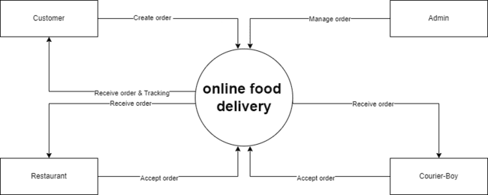

**1-LEVEL DFD(ADMIN)**

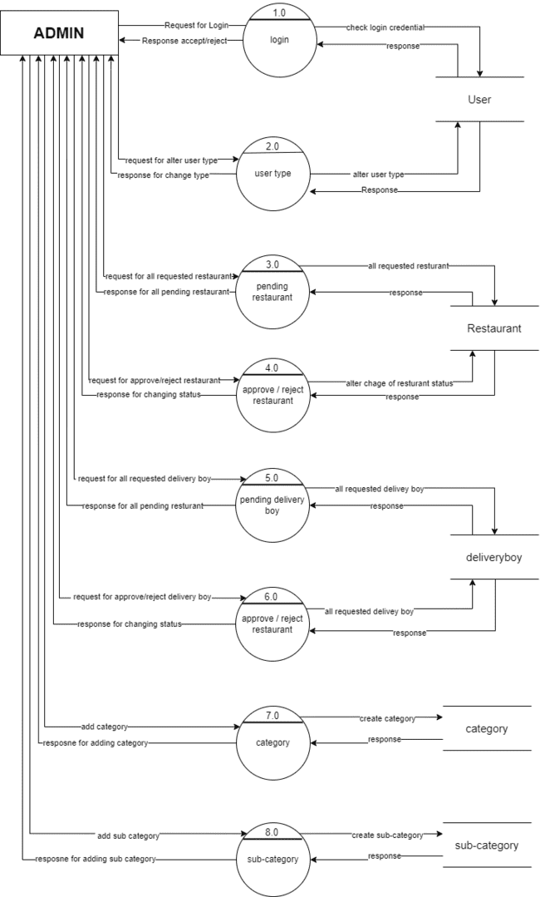

**1-LEVEL DFD(USER)**

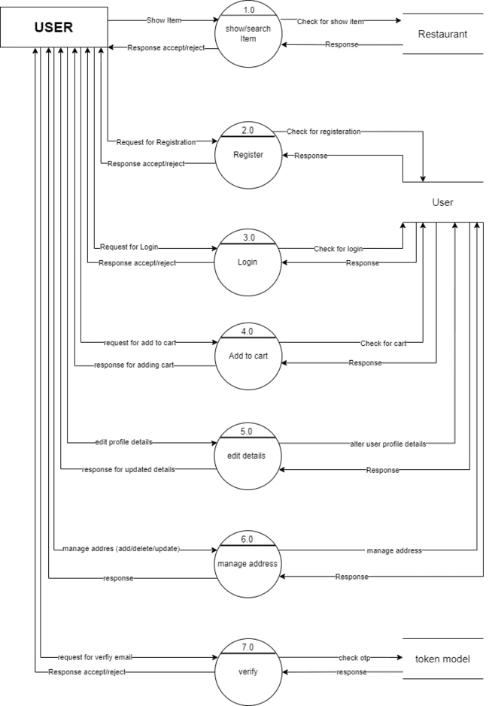

**1-LEVEL DFD(OWNER)**

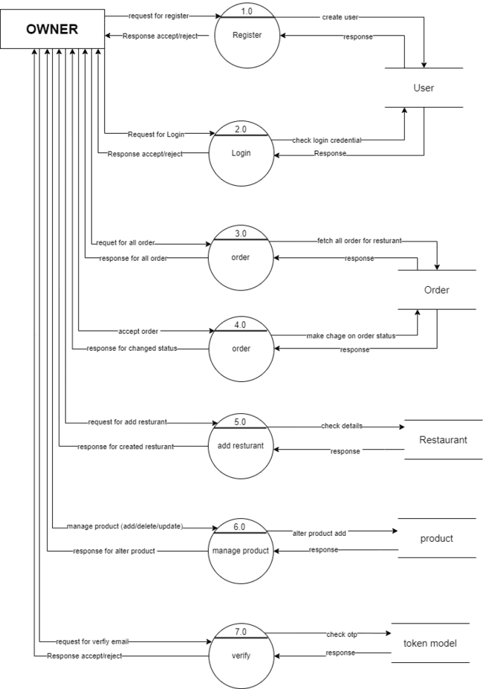

**1-LEVEL DFD(DELIVERY BOY)**

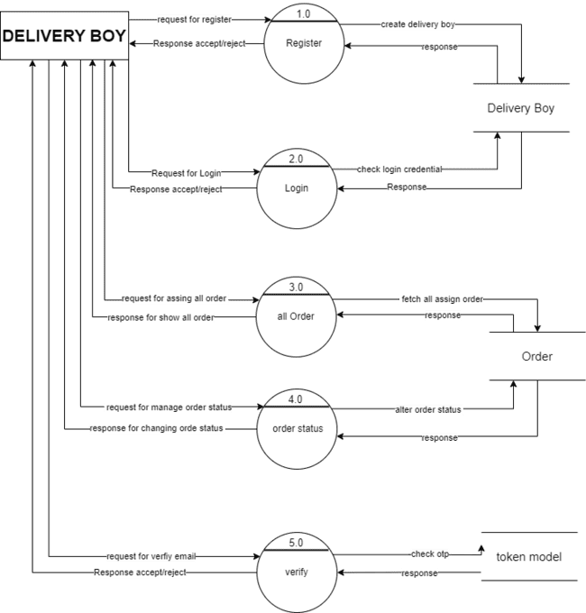

**2-LEVEL DFD(ADMIN)**

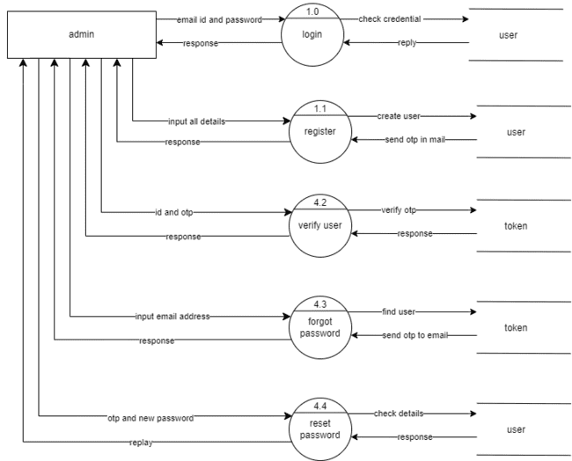

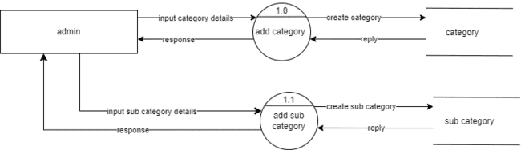

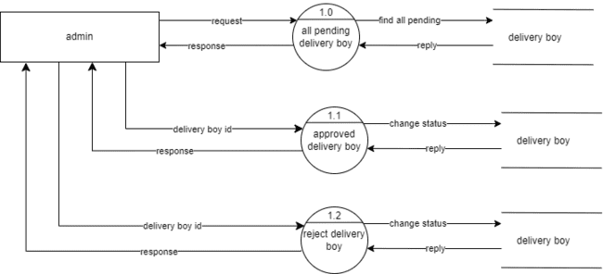

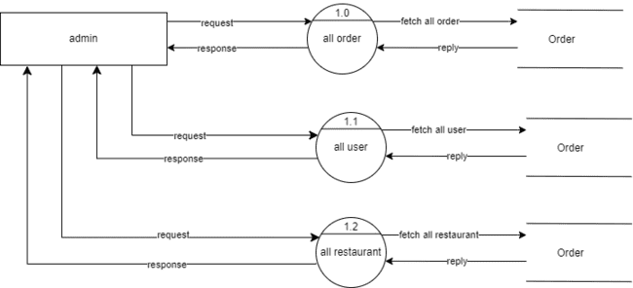

**2-LEVEL DFD(OWNER)**

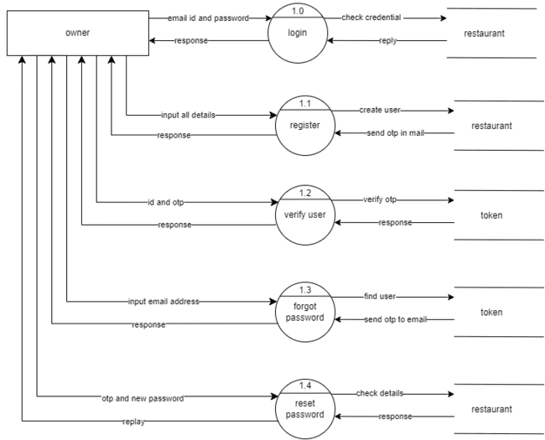

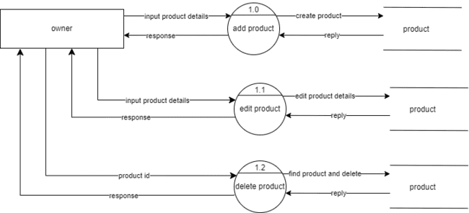

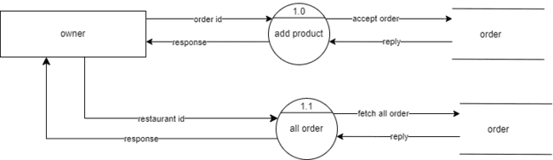

**2-LEVEL DFD(USER)**

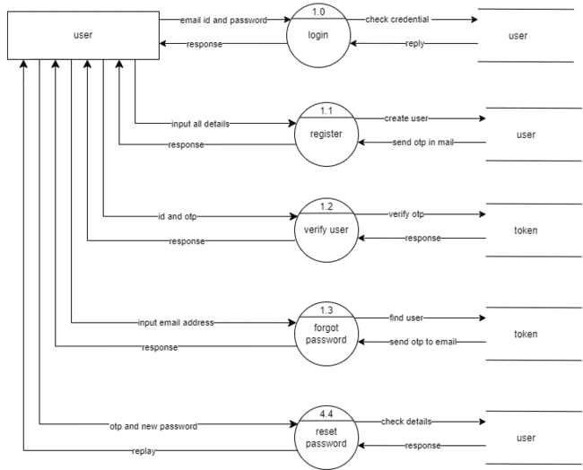

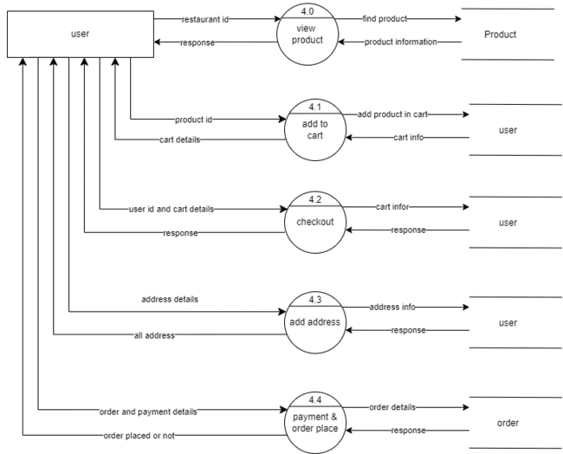

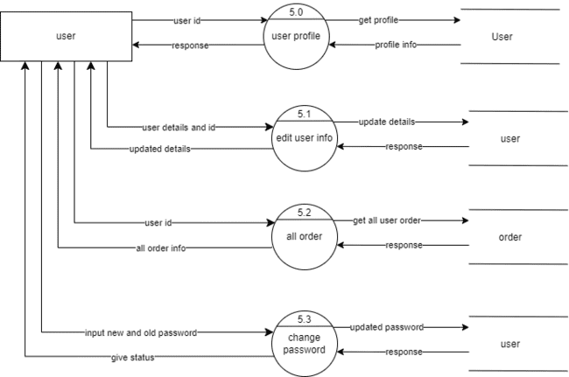

**2-LEVEL DFD(DELIVERY BOY)**

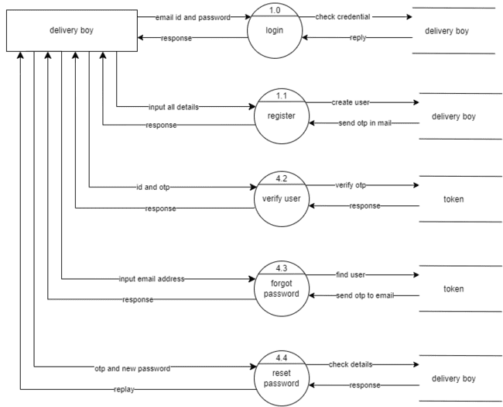

* 1. Process Specification

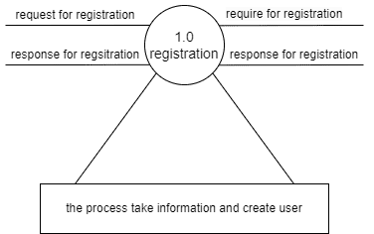

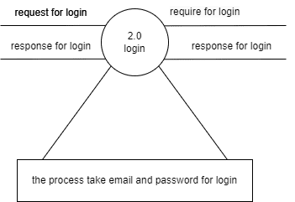

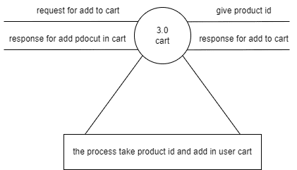

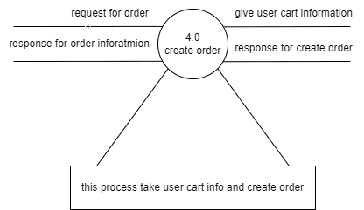

* 1. Data Dictionary

**User**

|  |  |
| --- | --- |
| **Name** | User |
| **Alias** | Null |
| **Where used? / how used?** | It stores all user details. |
| **Description** | _id + name + email + password + number + address + order + type + bankDetails + verified + createAt + cart + fcmToken |
| **Supplementary information** | _id must be primary key.  Order and bankDetails are reference id. |

**deliveryBoy**

|  |  |
| --- | --- |
| **Name** | deliveryBoy |
| **Alias** | Null |
| **Where used ?/how user?** | Its stores delivery boy information |
| **Description** | _id + Name + email + number + password + isApproved + isVerified + review + averageRating + isAvilable + registrationToken + socketId + orde + fcmToken |
| **Supplementary information** | _id must be primary key  Review and order are reference object id |

**Restaurant**

|  |  |
| --- | --- |
| **Name** | Restaurant |
| **Alias** | Null |
| **Where used? / how used?** | It stores all restaurant details. |
| **Description** | _id + name + ownerName + email + password + number + outletType + address + registerVerified + category + product + bankDetails + panCard + order + isApproved + pancardURL + bankURL + bgImageUrl + rating + review + fcmToken |
| **Supplementary information** | _id must be primary key.  Category , order ,product and review are reference id. |

**Product**

|  |  |
| --- | --- |
| **Name** | Product |
| **Alias** | Null |
| **Where used ? /how use ?** | It stores all product data |
| **Description** | _id + name + price + restaurnat + category + subCategory + info + imageUrl + review + description + isActive |
| **Supplementary information** | _id must be primary key  Restautarnt, category, subCategory and review are reference id. |

**Category**

|  |  |
| --- | --- |
| **Name** | Category |
| **Alias** | Null |
| **Where used? / how used?** | It stores product category details. |
| **Description** | _id + name + description + isActive + subCategory + product |
| **Supplementary information** | _id must be primary key.  subCategory and product are reference id. |

**subCategory**

|  |  |
| --- | --- |
| **Name** | subCategory |
| **Alias** | Null |
| **Where used? / how used?** | It stores all subCategory details. |
| **Description** | _id + name + description + mainCategory + isActive + product |
| **Supplementary information** | _id must be primary key.  mainCategory and product are reference id. |

**Order**

|  |  |
| --- | --- |
| **Name** | Order |
| **Alias** | Null |
| **Where used ?/how use?** | It stores order data |
| **Description** | _id + products + customer + payment + restaurant + status + deliveryBoy + address + courierBoyOtpNumber + customerOtpNumber + review + cratedAt + isreviewGiven |
| **Supplementary information** | _id must be priamry key  Proudct, customer and restaurant are reference object id |

**Review**

|  |  |
| --- | --- |
| **Name** | Review |
| **Alias** | Null |
| **Where used? / how used?** | It stores all customer review. |
| **Description** | _id + usreId + userName + restaurant + orderId + review + star |
| **Supplementary information** | _id must be primary key.  userId , restaurant and orderId are reference id. |

**Token**

|  |  |
| --- | --- |
| **Name** | Token |
| **Alias** | Null |
| **Where used? / how used?** | It stores all user OTP. |
| **Description** | _id + userID + token + createAt |
| **Supplementary information** | _id must be primary key.  userID is reference id. |

**ContactUs**

|  |  |
| --- | --- |
| **Name** | Contact |
| **Alias** | Null |
| **Where used? / how used?** | It stores contact us data. |
| **Description** | _id + name + email + number + message |
| **Supplementary information** | _id must be primary key. |

* 1. Entity-Relationship Diagram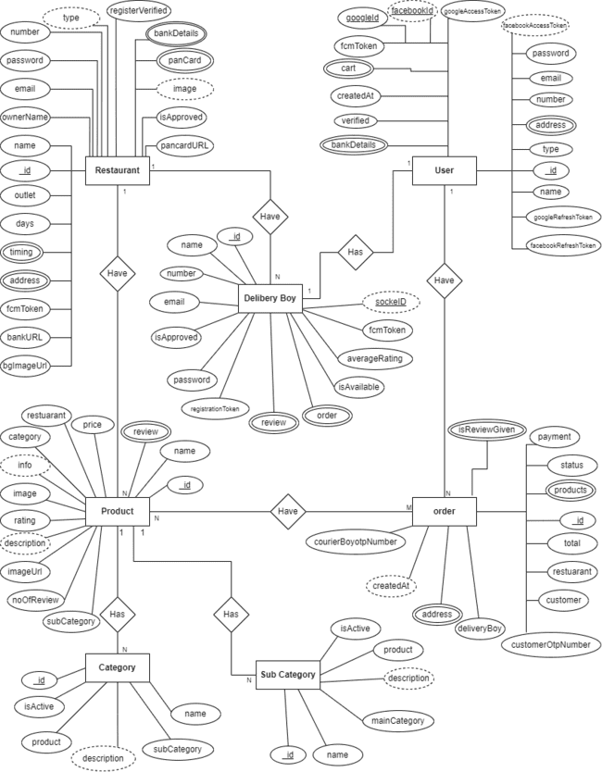

UNIT-6 System Design

**6.1 Database Design**

**6.2 Directory Structure**

* 1. **Input Layout**

6.1 Entity-Relationship Diagram

**User table**

|  |  |  |  |
| --- | --- | --- | --- |
| **field name** | **datatype** | **constraint** | **description** |
| name | string | - | user name |
| password | string | - | user password |
| email | string | unique | user email |
| number | string | - | user phone number |
| address | array | - | user address |
| order | reference | unique | order id |
| type | string | - | user type |
| verified | boolean | - | for user verification |
| createdAt | date | - | when user create |
| cart | array | - | user cart details |
| fcmToken | string | - | for user authentication |

|  |  |  |  |
| --- | --- | --- | --- |
| **Field Name** | **DataType** | **Constraint** | **Discription** |
| Name | String | - | Delivery boy name |
| Email | String | Unique | Delivery boy email |
| Number | Stirng | - | Delivery boy mobile number |
| Password | String | - | Delivery boy password |
| Isapproved | String | - | Admin can approved |
| isVerfiied | Boolean | - | Otp verification |
| Review | Array |  | Customer review |
| Order | Array | - | All assign order |
| FcmToken | String | - | For notification push |

**Delivery boy table**

**Restaurant table**

|  |  |  |  |
| --- | --- | --- | --- |
| **field name** | **datatype** | **constraint** | **description** |
| name | string | - | restaurant name |
| ownerName | string | - | restaurant owner name |
| email | string | - | owner email |
| password | string | - | owner password |
| number | string | - | owner phone number |
| restaurantType | string | - | restaurant type |
| outletType | string | - | restaurant outlet |
| address | array | - | restaurant full address |
| registerVerified | boolean | - | admin can accept restaurant registration |
| category | reference | unique | restaurant category id |
| product | reference | unique | restaurant listed product id |
| bankDetails | array | - | restaurant owner bank details |
| panCard | array | - | owner pancard details |
| order | reference | unique | customer ordered id |
| isApproved | string | - | Admin accept restaurant request |
| pancardURL | string | - | owner pan card image |
| bankURL | string | - | owner bank passbook image |
| bgImageUrl | array | - | some Restaurant images |
| rating | string | - | restaurant rating |
| review | reference | unique | restaurant review id |
| fcmToken | string | - | for authentication |

**Product table**

|  |  |  |  |
| --- | --- | --- | --- |
| **field name** | **datatype** | **constraint** | **description** |
| name | string | - | product name |
| price | string | - | product price |
| restaurant | reference | unique | belong to which restaurnat |
| category | reference | unique | belong to which category |
| subCategory | reference | unique | belong to which sub-category |
| info | string | - | product information |
| rating | string | - | product rating |
| noOfReview | string | - | product review |
| review | reference | unique | restaurant review |
| imageUrl | string | - | product image |
| description | string | - | product description |
| isActive | boolean | - | Admin can active |

**Outlet table**

|  |  |  |  |
| --- | --- | --- | --- |
| **Field Name** | **Datatype** | **Constraint** | **Description** |
| Name | string | - | outlet type |
| description | string | - | description about outlet |
| isActive | boolean | - | Admin can active |

**Category table**

|  |  |  |  |
| --- | --- | --- | --- |
| **Field name** | **Datatype** | **Constraint** | **description** |
| Name | String | - | Food category name |
| Description | String | - | Category description |
| isActive | Boolean | - | Admin can active category |
| subCategory | Array | - | Main category related subCategory |
| Product | Array | - | Product contain this category |

**Sub category table**

|  |  |  |  |
| --- | --- | --- | --- |
| **field name** | **datatype** | **constraint** | **description** |
| name | string | - | category name |
| description | string | - | category description |
| mainCategory | reference | unique | main category Id |
| isActive | boolean | - | admin can active |
| product | reference | - | product details |

**Order table**

|  |  |  |  |
| --- | --- | --- | --- |
| **Field name** | **Datatype** | **Constraint** | **Description** |
| Product | Array | - | Ordered product list |
| Customer | Reference | - | customer all details |
| Payment | String | - | Payment type |
| Total | String | - | ordered price |
| Restaurant | Reference | unique | Restaurant id |
| Status | String | - | Ordered product status |
| Delivery boy | Reference | unique | Delivery boy id |
| Address | Array | - | customer billing address |
| courierBoyOtpNumber | String | - | Courier boy otp |
| customerOtpNumber | String | - | Customer otp |
| Review | Reference | unique | Customer review |

**Review table**

|  |  |  |  |
| --- | --- | --- | --- |
| **field name** | **datatype** | **constraint** | **description** |
| userId | reference | unique | user id |
| userName | string | - | user name |
| restaurant | reference | unique | restaurant id |
| orderId | reference | unique | order id |
| review | string | - | user given review |
| star | string | - | user given star |

**Token model table**

|  |  |  |  |
| --- | --- | --- | --- |
| **field name** | **datatype** | **constraint** | **description** |
| userID | reference | unique | for authenticate user |
| token | string | - | token id |
| createdAt | date | - | token expired time |

**Contact us table**

|  |  |  |  |
| --- | --- | --- | --- |
| **field name** | **datatype** | **constraint** | **description** |
| Name | String | - | User name |
| Email | string | - | User email |
| Number | String | - | User phone number |
| Message | String | - | User message |

UNIT-7 System Testing

# Software Testing :

* Software testing is a critical element of software quality assurance and represents the ultimate review of specification design and coding. Testing is an exposure of a system to trial input to see whether software meets correct output. Testing cannot be determined whether software meets user’s needs, only whether it appears to confirm to requirements. Testing finds errors, it does not correct errors. Software success is a quality product, on time and within cost.

Through testing can reveal critical mistakes .testing should therefore,

* + Validate Performance
  + Detects Errors
  + Identify Inconsistencies
* **Test Objectives :**

There is strong evidence that effective requirement management leads to overall project cost savings. The three primary reasons for this are:

* + Errors in requirement typically cost over 10 times more to repair than other errors.
  + Requirement errors typically comprise over 40% of all error in a software project.

The testing procedure should care for all of these As well as in order to attain a flawless, error-free and efficient functioning system. Too software testing is an important phase of any Software Development Life Cycle. Various reports and data used for the same are the core of the system. The testing, therefore, becomes important in order to maintain the cost as well as improve performance and consistency. The testing procedure for the system has been divided in to various parts ranging for single unit testing to entire system testing.

### Testing Types :

#### Smoke Testing :

It is also known as “Build Verification Testing”, is a type of software testing that comprises of a non-exhaustive set of tests that aim at ensuring that the most important functions work.

#### Functional Testing :

Functional Testing is a type of software testing whereby the system is tested against the functional equirements/specifications.

#### Usability Testing :

It is a type of software testing done from an end-user’s perspectivto determine if the system is easily usable.

#### Security Testing :

It is a type of software testing that intends to uncover vulnerabilities of the system and determine that its data and resources are protected from possible intruders.

#### Performance Testing :

It is a type of software testing that intends to determine how a system performs in terms of responsiveness and stability under a certain load.

#### Regression Testing :

It is a type of software testing that intends to ensure that changes (enhancements or defect fixes) to the software have not adversely affected it.

* + **Compliance Testing :**

It is also known as conformance testing, regulation testing, standards testing is a type of testing to determine the compliance of a system with internal or external standards.

### Testing Methods :

##### Black Box Testing :

A software testing method in which the internal structure/design/implementation of the item being tested is not known to the tester. These tests can be functional or non-functional, though usually functional. Test design techniques include Equivalence partitioning, Boundary Value Analysis, Cause- Effect Graphing.

##### White Box Testing :

A software testing method in which the internal structure/design/implementation of the item being tested is known to the tester. Test design techniques include Control flow testing, Data flow testing, Branch testing, Path testing.

##### Grey Box Testing :

A software testing method which is a combination of Black Box Testing method and White Box Testing method.

##### Alige Testing:

A method of software testing that follows the principles of agile software development.

##### AD Hoc Testing:

A method of software testing without any planning and documentation.

### Test Case :

* + **Admin :**

##### Login :

|  |  |  |  |
| --- | --- | --- | --- |
| **Test-Field** | **Test-Data** | **Valid /**  **Invalid** | **Test -Result** |
| Email | Null | Invalid | Email is required. |
| admin.com | Invalid | This is not valid email format |
| [admin99@gmail.com](mailto:admin99@gmail.com) | Valid |  |
| Password | Null | Invalid | Password is  required. |
| S2s | Invalid | Password must be 4 character |
| Kduuiids` | Valid |  |

* + - **Forgot Password :**

|  |  |  |  |
| --- | --- | --- | --- |
| **Test-Field** | **Test-Data** | **Valid /**  **Invalid** | **Test -Result** |
| Current password | Null | Invalid | Current password is required. |
| Admin@12 | Valid |  |
| New password | Null | Invalid | New password is required. |
| 123d | Invalid | New password must be more than 4 character. |
| Admin@123 | Valid |  |
| Confirm Password | Null | Invalid | Confirm password is required. |
| Admin@12 | Invalid | The password and confirm password must be match. |
| Admin@123 | Valid |  |

* + - **category:**

|  |  |  |  |
| --- | --- | --- | --- |
| **Test-Field** | **Test-Data** | **Valid /**  **Invalid** | **Test -Result** |
| Category name | Null | Invalid | Category name must be required. |
| 34512 | Invalid | Please enter valid category name. |
| American | Valid |  |
| Description | Null | Invalid | Description must be required. |
| Very delicious food. | Valid |  |

* + - **Sub-category:**

|  |  |  |  |
| --- | --- | --- | --- |
| **Test-Field** | **Test-Data** | **Valid /**  **Invalid** | **Test -Result** |
| Sub-category name | Null | Invalid | Sub-category name must be required. |
| 34512 | Invalid | Please enter valid sub-category name. |
| Burger | Valid |  |
| Description | Null | Invalid | Description must be required. |
| Double Cheess burger. | Valid |  |
| Main category | Select any category | Valid |  |

* + **User:**

##### Login :

|  |  |  |  |
| --- | --- | --- | --- |
| **Test-Field** | **Test-Data** | **Valid /**  **Invalid** | **Test -Result** |
| Email | Null | Invalid | Email is required. |
| krishna.com | Invalid | This is not valid email format |
| [krishna206@gmail.com](mailto:krishna206@gmail.com) | Valid |  |
| Password | Null | Invalid | Password is  required. |
| S2s | Invalid | Password must be 4 character |
| KrishNa2o6 | Valid |  |

* + - **Forgot Password :**

|  |  |  |  |
| --- | --- | --- | --- |
| **Test-Field** | **Test-Data** | **Valid /**  **Invalid** | **Test -Result** |
| Email | Null | Invalid | Email is required. |
| krishna.com | Invalid | This is not valid email format |
| [krishna206@gmail.com](mailto:krishna206@gmail.com) | Valid |  |
| New password | Null | Invalid | New password is required. |
| 123d | Invalid | New password must be more than 8 character. |
| Krishna$123 | Valid |  |
| Confirm Password | Null | Invalid | Confirm password is required. |
| Krishna#12 | Invalid | The password and confirm password must be match. |
| Krishna$123 | Valid |  |
| Otp | Null | Invalid | Wrong otp |
| 3f344d3 | Invalid | Something went wrong |
| 242435 | Valid |  |

* + - **Register:**

|  |  |  |  |
| --- | --- | --- | --- |
| **Test-Field** | **Test-Data** | **Valid /**  **Invalid** | **Test -Result** |
| Name | Null | Invalid | Name is required |
| Jay45 | Invalid | Name is not valid |
| Jay | Valid |  |
| Mobile no | Null | Invalid | Mobile number is required. |
| 939394344dd | Invalid | Mobile number is not valid. |
| 9876543210 | Valid |  |
| Email | Null | Invalid | Email is required. |
| jay.com | Invalid | This is not valid email format |
| [jay206@gmail.com](mailto:jay206@gmail.com) | Valid |  |
| Password | Null | Invalid | Password must be required. |
| 453 | Invalid | Password must be more than 4 character. |
| Jay$23 | Valid |  |
| Confirm password | Null | Invalid | Confirm password must be required. |
| jay@23 | Invalid | Confirm password does not match. |
| Jay$23 | Valid |  |
| Privacy policy | Not checked | Invalid | Please agree with our privacy |
| checked | Valid |  |
| Otp | Null | Invalid | Wrong otp |
| 3f344d3 | Invalid | Something went wrong |
| 242435 | Valid |  |

##### Update profile:

|  |  |  |  |
| --- | --- | --- | --- |
| **Test-Field** | **Test-Data** | **Valid /**  **Invalid** | **Test -Result** |
| Name | Null | Invalid | Name is required |
| Jay45 | Invalid | Please enter valid Name |
| Jay | Valid |  |
| Mobile no | Null | Invalid | Mobile number is required. |
| 939394344dd | Invalid | Please enter valid number |
| 9876543210 | Valid |  |

* + - **Change password:**

|  |  |  |  |
| --- | --- | --- | --- |
| **Test-Field** | **Test-Data** | **Valid /**  **Invalid** | **Test -Result** |
| Old password | Null | Invalid | You not leave it empty |
| Admin@11 | Valid |  |
| New password | Null | Invalid | New password is required. |
| 123d | Invalid | New password must be 8 character. |
| Admin@123 | Valid |  |
| Confirm Password | Null | Invalid | Confirm password is required. |
| Admin@12 | Invalid | Enter same password. |
| Admin@123 | Valid |  |
| Otp | Null | Invalid | Wrong otp |
| 3f344d3 | Invalid | Something went wrong |
| 242435 | Valid |  |

* + - **Add new address:**

|  |  |  |  |
| --- | --- | --- | --- |
| **Test-Field** | **Test-Data** | **Valid /**  **Invalid** | **Test -Result** |
| Address | Null | Invalid | Please enter address |
| Krishan park soc. | Valid |  |
| City | Null | Invalid | Please enter city name |
| Surat | Valid |  |
| State | Null | Invalid | Please enter state name |
| Gujarat | Valid |  |
| Pincode | Null | Invalid | Please enter pincode |
| 3434dg | Invalid | Enter correct pincode |
| 395010 | Valid |  |

* + - **Edit address:**

|  |  |  |  |
| --- | --- | --- | --- |
| **Test-Field** | **Test-Data** | **Valid /**  **Invalid** | **Test -Result** |
| Address | Null | Invalid | Please enter address |
| Krishan park soc. | Valid |  |
| City | Null | Invalid | Please enter city name |
| Surat | Valid |  |
| State | Null | Invalid | Please enter state name |
| Gujarat | Valid |  |
| Pincode | Null | Invalid | Please enter pincode |
| 3434dg | Invalid | Enter correct pincode |
| 395010 | Valid |  |

* + - **Contact us:**

|  |  |  |  |
| --- | --- | --- | --- |
| **Test-Field** | **Test-Data** | **Valid /**  **Invalid** | **Test -Result** |
| Name | Null | Invalid | Please enter valid name |
|  | Ram3 | Invalid | Please enter valid name |
|  | Ram | Valid |  |
| Email | Null | Invalid | Please enter valid email. |
|  | Ram#gmail.com | Invalid | Please enter valid email. |
|  | [ram@gmail.com](mailto:ram@gmail.com) | Valid |  |
| Phone | Null | Invalid | Please enter valid number |
|  | 98765689df | Invalid | Please enter valid number |
|  | 8765432103 | Valid |  |
| Description | Null | Invalid | Please enter description |
|  | Something nice…. | Valid |  |

##### Add Review :

|  |  |  |  |
| --- | --- | --- | --- |
| **Test-Field** | **Test-Data** | **Valid /**  **Invalid** | **Test -Result** |
| Review | Null | Invalid | The review field is required. |
| Nice Product | Valid |  |
| Star | Not selected | Valid |  |
|  | Selected | Valid |  |

* + **Owner:**

##### Login :

|  |  |  |  |
| --- | --- | --- | --- |
| **Test-Field** | **Test-Data** | **Valid /**  **Invalid** | **Test -Result** |
| Email | Null | Invalid | Email is required. |
| krishna.com | Invalid | This is not valid email format |
| [krishna206@gmail.com](mailto:krishna206@gmail.com) | Valid |  |
| Password | Null | Invalid | Password is  required. |
| S2s | Invalid | Password must be 4 character |
| KrishNa2o6 | Valid |  |

* + - **Forgot Password :**

|  |  |  |  |
| --- | --- | --- | --- |
| **Test-Field** | **Test-Data** | **Valid /**  **Invalid** | **Test -Result** |
| Email | Null | Invalid | Email is required. |
| krishna.com | Invalid | This is not valid email format |
| [krishna206@gmail.com](mailto:krishna206@gmail.com) | Valid |  |
| New password | Null | Invalid | New password is required. |
| 123d | Invalid | New password must be more than 8 character. |
| Krishna$123 | Valid |  |
| Confirm Password | Null | Invalid | Confirm password is required. |
| Krishna#12 | Invalid | The password and confirm password must be match. |
| Krishna$123 | Valid |  |
| Otp | Null | Invalid | Wrong otp |
| 3f344d3 | Invalid | Something went wrong |
| 242435 | Valid |  |

* + - **Register:**

|  |  |  |  |
| --- | --- | --- | --- |
| **Test-Field** | **Test-Data** | **Valid /**  **Invalid** | **Test -Result** |
| Name | Null | Invalid | Name is required |
| Jay45 | Invalid | Name is not valid |
| Jay | Valid |  |
| Mobile no | Null | Invalid | Mobile number is required. |
| 939394344dd | Invalid | Mobile number is not valid. |
| 9876543210 | Valid |  |
| Email | Null | Invalid | Email is required. |
| jay.com | Invalid | This is not valid email format |
| [jay206@gmail.com](mailto:jay206@gmail.com) | Valid |  |
| Password | Null | Invalid | Password must be required. |
| 453 | Invalid | Password must be more than 4 character. |
| Jay$23 | Valid |  |
| Confirm password | Null | Invalid | Confirm password must be required. |
| jay@23 | Invalid | Confirm password does not match. |
| Jay$23 | Valid |  |
| Privacy policy | Not checked | Invalid | Please agree with our privacy |
| checked | Valid |  |
| Otp | Null | Invalid | Wrong otp |
| 3f344d3 | Invalid | Something went wrong |
| 242435 | Valid |  |

##### Update profile:

|  |  |  |  |
| --- | --- | --- | --- |
| **Test-Field** | **Test-Data** | **Valid /**  **Invalid** | **Test -Result** |
| Name | Null | Invalid | Name is required |
| Jay45 | Invalid | Please enter valid Name |
| Jay | Valid |  |
| Mobile no | Null | Invalid | Mobile number is required. |
| 939394344dd | Invalid | Please enter valid number |
| 9876543210 | Valid |  |

* + - **Change password:**

|  |  |  |  |
| --- | --- | --- | --- |
| **Test-Field** | **Test-Data** | **Valid /**  **Invalid** | **Test -Result** |
| Old password | Null | Invalid | You not leave it empty |
| Admin@11 | Valid |  |
| New password | Null | Invalid | New password is required. |
| 123d | Invalid | New password must be 8 character. |
| Admin@123 | Valid |  |
| Confirm Password | Null | Invalid | Confirm password is required. |
| Admin@12 | Invalid | Enter same password. |
| Admin@123 | Valid |  |
| Otp | Null | Invalid | Wrong otp |
| 3f344d3 | Invalid | Something went wrong |
| 242435 | Valid |  |

##### Add product:

|  |  |  |  |
| --- | --- | --- | --- |
| **Test-Field** | **Test-Data** | **Valid /**  **Invalid** | **Test -Result** |
| Name | Null | Invalid | Product name is required |
| Lemon tea 5534 | Invalid | Please enter valid Name |
| Lemon tea | Valid |  |
| Price | Null | Invalid | Please enter valid price |
| Rupe33 | Invalid | Please enter valid price |
| 399 | Valid |  |
| Description | Null | Invalid | Please enter description |
| Nice tea. | Valid |  |
| Main category | Select | Valid |  |
| Sub category | Select | Valid |  |
| Add image | Add | Valid |  |

##### Edit product:

|  |  |  |  |
| --- | --- | --- | --- |
| **Test-Field** | **Test-Data** | **Valid /**  **Invalid** | **Test -Result** |
| Name | Null | Invalid | Product name is required |
| Lemon tea 5534 | Invalid | Please enter valid Name |
| Lemon tea | Valid |  |
| Price | Null | Invalid | Please enter valid price |
| Rupe33 | Invalid | Please enter valid price |
| 399 | Valid |  |
| Description | Null | Invalid | Please enter description |
| Nice tea. | Valid |  |
| Main category | Select | Valid |  |
| Sub category | Select | Valid |  |
| Add image | Add | Valid |  |

* + - **Contact us:**

|  |  |  |  |
| --- | --- | --- | --- |
| **Test-Field** | **Test-Data** | **Valid /**  **Invalid** | **Test -Result** |
| Name | Null | Invalid | Please enter valid name |
| Ram3 | Invalid | Please enter valid name |
| Ram | Valid |  |
| Email | Null | Invalid | Please enter valid email. |
| Ram#gmail.com | Invalid | Please enter valid email. |
| [ram@gmail.com](mailto:ram@gmail.com) | Valid |  |
| Phone | Null | Invalid | Please enter valid number |
| 98765689df | Invalid | Please enter valid number |
| 8765432103 | Valid |  |
| Description | Null | Invalid | Please enter description |
| Something nice…. | Valid |  |

* + - **Restaurant registration:**

|  |  |  |  |
| --- | --- | --- | --- |
| **Test-Field** | **Test-Data** | **Valid /**  **Invalid** | **Test -Result** |
| Restaurant name | Null | Invalid | Please enter shop name |
|  | Delight restro | Valid |  |
| Restaurant address | Null | Invalid | Please enter shop address |
|  | 11-deluxe apt. | Valid |  |
| Area | Null | Invalid | Please enter area name |
|  | Setellite road | Valid |  |
| Pincode | Null | Invalid | Enter correct pincode |
|  | 654354 | Valid |  |
| City | Null | Invalid | Please enter city name |
|  | Surat | Valid |  |
| State | Null | Invalid | Please enter state name |
|  | Gujarat | Valid |  |
| Owner name | Null | Invalid | Enter your name |
|  | Ram | Valid |  |
| Bank account number | Null | Invalid | Please enter your account no. |
|  | Sdf2342332 | Invalid | Please enter valid account no. |
|  | 5432543454341 | Valid |  |
| Confirm account number | Null | Invalid | Please enter account no. |
|  | 5432543453333 | Invalid | Please enter same account number |
|  | 5432543454341 | Valid |  |
| Account type | Not selected | Invalid | Select account type |
|  | Select | Valid |  |
| IFSC | Null | Invalid | Please enter ifsc code |
|  | Lfsldfkdsfl | Invalid | Please enter valid ifsc code |
|  | SBIN00018700 | Valid |  |
| Passbook image | Null | Invalid | Please select your passbook image |
|  | Select | Valid |  |
| PAN number | Null | Invalid | Please enter pan number |
|  | 3s34sdfsd3 | Invalid | Please enter valid pan number |
|  | SDSFD3434D | Valid |  |
| PAN holder name | Null | Invalid | Please enter pan holder name |
|  | Ram44 | Invalid | Please enter valid holder name |
|  | Ram | Valid |  |
| PAN image | Null | Invalid | Please select pan image |
|  | Select | Valid |  |
| Restaurant image-1 | Null | Invalid | Please select restaurant image pic-1 |
|  | Select | Valid |  |
| Restaurant image-2 | Null | Invalid | Please select restaurant image pic-2 |
|  | Select | Valid |  |
| Restaurant image-3 | Null | Invalid | Please select restaurant image pic-3 |
|  | Select | valid |  |

* + **delivery:**

##### Login :

|  |  |  |  |
| --- | --- | --- | --- |
| **Test-Field** | **Test-Data** | **Valid /**  **Invalid** | **Test -Result** |
| Email | Null | Invalid | Email is required. |
| krishna.com | Invalid | This is not valid email format |
| [krishna206@gmail.com](mailto:krishna206@gmail.com) | Valid |  |
| Password | Null | Invalid | Password is  required. |
| S2s | Invalid | Password must be 4 character |
| KrishNa2o6 | Valid |  |

* + - **Forgot Password :**

|  |  |  |  |
| --- | --- | --- | --- |
| **Test-Field** | **Test-Data** | **Valid /**  **Invalid** | **Test -Result** |
| Email | Null | Invalid | Email is required. |
| krishna.com | Invalid | This is not valid email format |
| [krishna206@gmail.com](mailto:krishna206@gmail.com) | Valid |  |
| New password | Null | Invalid | New password is required. |
| 123d | Invalid | New password must be more than 8 character. |
| Krishna$123 | Valid |  |
| Confirm Password | Null | Invalid | Confirm password is required. |
| Krishna#12 | Invalid | The password and confirm password must be match. |
| Krishna$123 | Valid |  |
| Otp | Null | Invalid | Wrong otp |
| 3f344d3 | Invalid | Something went wrong |
| 242435 | Valid |  |

* + - **Register:**

|  |  |  |  |
| --- | --- | --- | --- |
| **Test-Field** | **Test-Data** | **Valid /**  **Invalid** | **Test -Result** |
| Name | Null | Invalid | Name is required |
| Jay45 | Invalid | Name is not valid |
| Jay | Valid |  |
| Mobile no | Null | Invalid | Mobile number is required. |
| 939394344dd | Invalid | Mobile number is not valid. |
| 9876543210 | Valid |  |
| Email | Null | Invalid | Email is required. |
| jay.com | Invalid | This is not valid email format |
| [jay206@gmail.com](mailto:jay206@gmail.com) | Valid |  |
| Password | Null | Invalid | Password must be required. |
| 453 | Invalid | Password must be more than 4 character. |
| Jay$23 | Valid |  |
| Confirm password | Null | Invalid | Confirm password must be required. |
| jay@23 | Invalid | Confirm password does not match. |
| Jay$23 | Valid |  |
| Privacy policy | Not checked | Invalid | Please agree with our privacy |
| checked | Valid |  |
| Otp | Null | Invalid | Wrong otp |
| 3f344d3 | Invalid | Something went wrong |
| 242435 | Valid |  |

##### Update profile:

|  |  |  |  |
| --- | --- | --- | --- |
| **Test-Field** | **Test-Data** | **Valid /**  **Invalid** | **Test -Result** |
| Name | Null | Invalid | Name is required |
| Jay45 | Invalid | Please enter valid Name |
| Jay | Valid |  |
| Mobile no | Null | Invalid | Mobile number is required. |
| 939394344dd | Invalid | Please enter valid number |
| 9876543210 | Valid |  |

* + - **Change password:**

|  |  |  |  |
| --- | --- | --- | --- |
| **Test-Field** | **Test-Data** | **Valid /**  **Invalid** | **Test -Result** |
| Old password | Null | Invalid | You not leave it empty |
| Admin@11 | Valid |  |
| New password | Null | Invalid | New password is required. |
| 123d | Invalid | New password must be 8 character. |
| Admin@123 | Valid |  |
| Confirm Password | Null | Invalid | Confirm password is required. |
| Admin@12 | Invalid | Enter same password. |
| Admin@123 | Valid |  |
| Otp | Null | Invalid | Wrong otp |
| 3f344d3 | Invalid | Something went wrong |
| 242435 | Valid |  |

* + - **Contact us:**

|  |  |  |  |
| --- | --- | --- | --- |
| **Test-Field** | **Test-Data** | **Valid /**  **Invalid** | **Test -Result** |
| Name | Null | Invalid | Please enter valid name |
| Ram3 | Invalid | Please enter valid name |
| Ram | Valid |  |
| Email | Null | Invalid | Please enter valid email. |
| Ram#gmail.com | Invalid | Please enter valid email. |
| [ram@gmail.com](mailto:ram@gmail.com) | Valid |  |
| Phone | Null | Invalid | Please enter valid number |
| 98765689df | Invalid | Please enter valid number |
| 8765432103 | Valid |  |
| Description | Null | Invalid | Please enter description |
| Something nice…. | Valid |  |

UNIT-8 Limitations and Future Scope of Enhancements References

* Add functionlity for real time order tracking
* restaurant can able to add discont for some days
* make payment system very powerful