Example 1 – SharePoint Fax Notification Email Analysis
Task 2: Phishing Email Detection & Awareness System
Example Number: 01
Email Category: Fake Fax / Document Notification
Classification: Phishing
Risk Level: High

1. Overview
This example is a suspicious email that presents itself as a fax notification. The message uses the appearance and branding of SharePoint and informs the recipient that a new fax has been received.
The email asks the recipient to click a "Print & Preview Here" link to view the document. The message also contains information about the fax, including the date received, document type, number of pages, and file size.
The combination of an unexpected document notification, brand impersonation, and a link requesting user interaction makes this email suspicious and suitable for phishing analysis.

2. Email Details
Field | Observation
Displayed Brand | SharePoint
Email Theme | New Fax Notification
Message Type | Document/Fax Notification
Recipient | Undisclosed recipients
Classification | Phishing
Overall Risk | High

3. Visual Analysis
The email is designed to resemble a legitimate business notification. It uses the SharePoint name and presents a structured fax notification containing details such as:
- Date received
- Document type
- Number of pages
- File size
- A "Print & Preview Here" link
- Company-style footer information
The professional appearance may make the recipient believe that the message is legitimate.
Important: A professional-looking design does not necessarily mean that an email is genuine.

4. Phishing Indicators Identified

4.1 Brand Impersonation
The email uses the SharePoint name and branding to create an appearance of legitimacy. Attackers commonly imitate trusted services because users are more likely to trust familiar brands.

4.2 Suspicious Link
The message contains a "Print & Preview Here" link that encourages the recipient to interact with the email.
Links in unexpected emails should be treated carefully. The destination should be verified before clicking.

4.3 Unexpected Fax Notification
The recipient is informed about a fax that they may not have been expecting. Unexpected notifications involving documents or attachments can be used as a lure to encourage users to interact with malicious content.

4.4 Generic Recipient
The email contains "Undisclosed recipients" rather than identifying a specific recipient. This can indicate that the same message was distributed to multiple recipients.

4.5 Document-Based Social Engineering
The email creates curiosity by claiming that an important fax document has been received. This encourages the recipient to click the provided link to find out what the document contains.

5. Suspicious Elements
The following elements should make the recipient cautious:
- Unexpected fax notification
- Use of a trusted brand name
- "Print & Preview Here" call-to-action
- Link-based document access
- Generic recipient information
- Request for immediate interaction with an unexpected message

6. Risk Assessment
Indicator | Risk
Brand impersonation | High
Suspicious link | High
Unexpected document notification | High
Generic recipient | Medium
Social engineering | High

Overall Risk: HIGH
The email should not be trusted without independently verifying the message and its source.

7. Potential Impact
If a recipient interacts with a malicious link or attachment associated with a phishing email, possible consequences may include:
- Credential theft
- Unauthorized account access
- Malware infection
- Exposure of sensitive information
- Compromise of organizational accounts
The exact impact depends on the destination of the link and the attacker's objective.

8. Recommended User Actions
Users receiving a similar email should:
- Do not click suspicious links.
- Verify the sender's email address carefully.
- Hover over links to inspect their destination before opening them.
- Access the relevant service through its official website rather than through an unexpected email link.
- Contact the organization's IT/security team if the message appears suspicious.
- Report the email as phishing according to the organization's reporting procedure.
- Delete the message after reporting it if it is confirmed to be malicious.

9. Security Awareness Lesson
This example demonstrates how attackers can use familiar brands and routine business activities to make phishing emails appear legitimate.
Users should not judge an email only by its appearance. The sender, links, context, and reason for receiving the message should all be considered before taking action.

10. Conclusion
Example 1 demonstrates a phishing email that uses a fake fax notification and trusted-brand appearance to encourage the recipient to interact with a link.
The presence of brand impersonation, an unexpected document notification, a suspicious call-to-action link, and generic recipient information makes the message suspicious.
Final Classification: PHISHING EMAIL
Risk Level: HIGH
Users should verify unexpected document notifications through trusted channels and avoid interacting with suspicious links or attachments.

11. Evidence
Evidence Screenshot: Example 1 email screenshot
File: Example_01.png
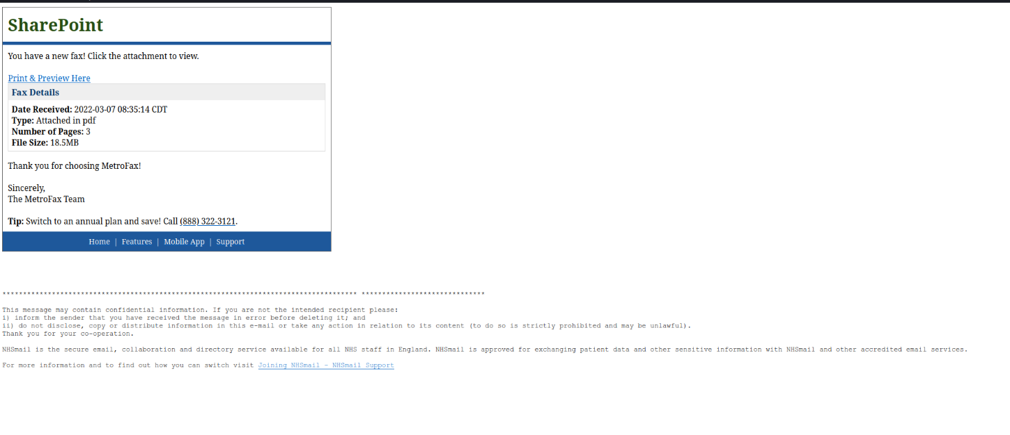

Example 1 – Phishing Email Analysis
1. Email Type
Phishing / social-engineering email impersonating a legitimate business service.
2. Key Observations
- The email claims that the recipient has received a new fax.
- It asks the recipient to click “Print & Preview Here.”
- The message presents itself as a SharePoint/MetroFax notification.
- It includes fax details such as the date received, file type, number of pages, and file size.
- The message uses legitimate-looking branding and formatting to appear trustworthy.
3. Suspicious Indicators
- The recipient is encouraged to click an unexpected link.
- The message creates curiosity by claiming that a new fax has arrived.
- The sender/return-path information shown in the underlying email data does not match a trustworthy official service domain.
- The link points to a suspicious external domain rather than an official Microsoft/SharePoint or MetroFax domain.
- The message contains business-style branding that could be used to make the email appear legitimate.
4. Risk Assessment
Risk Level: High
If the link or attachment were malicious, interacting with it could potentially expose the user to credential theft, malware, or a fraudulent website.
5. Recommended Action
- Do not click the link.
- Do not open unexpected attachments.
- Verify the message through the organization's official website or another trusted communication channel.
- Report the email as phishing.
- Delete the message after reporting it.
6. Conclusion
This example demonstrates how attackers can imitate familiar business services and use an unexpected document notification to encourage users to click a link. The combination of impersonation, an unsolicited fax notification, and a suspicious external link makes the message a strong phishing indicator.

