PHISHING EMAIL ANALYSIS – EXAMPLE 02

Email Theme
PayPal Account Notifications

Classification
Safe / Legitimate-looking based on available evidence

Risk Level
Low

1. Screenshot / Evidence
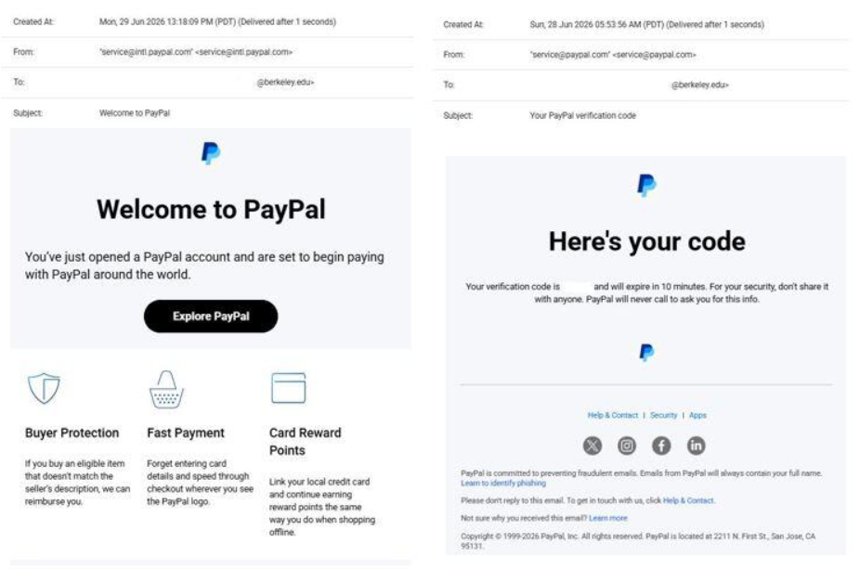
Evidence: The screenshot was collected as part of the phishing-email analysis exercise. It shows two PayPal-branded account notification emails.
The screenshot contains two PayPal-related emails:
- Email 1: “Welcome to PayPal”
- Email 2: “Your PayPal verification code”

2. Email Overview
The first email is a welcome message informing the recipient that a PayPal account has been opened.
The second email contains a verification-code notification. It states that the verification code will expire after a limited period and advises the recipient not to share the code.
Both emails use PayPal branding and appear to be account-related notifications.

3. Sender Analysis
The screenshot displays the following sender information:
Email 1:
service@intl.paypal.com
Email 2:
service@paypal.com
The visible domains are associated with PayPal and do not show an obvious misspelled or unrelated domain.

Finding:
No obvious sender-domain phishing indicator is visible in the screenshot.
Note: A complete email-header analysis would be required to verify the actual sending infrastructure.

4. Subject Analysis
The two subjects shown are:
- “Welcome to PayPal”
- “Your PayPal verification code”
These subjects are consistent with normal account-related notifications.
There is no obvious threatening or highly urgent language such as account suspension, immediate payment demands, or threats of account closure.

Finding:
No obvious suspicious subject-line indicator was identified.

5. Content Analysis
The visible content includes:
- PayPal branding
- A welcome message
- Account-related information
- A verification-code notification
- A warning not to share the verification code
- Standard PayPal-related footer information
The verification email specifically warns the recipient not to share the verification code.

Finding:
The visible content does not contain an obvious request for a password, payment, or sensitive personal information.

6. Phishing Indicators Checked
Indicator | Finding
Spoofed sender | No obvious evidence visible
Suspicious domain | No obvious evidence visible
Misspelled brand name | Not observed
Urgent/threatening language | Not observed
Request for password | Not observed
Request for payment | Not observed
Suspicious attachment | Not observed
Suspicious link | Cannot be fully verified from screenshot
Request for verification code | The email provides a code rather than asking the recipient to disclose it
Brand impersonation | Not clearly indicated

7. Risk Assessment

Overall Risk: LOW
Based on the information visible in the screenshots, the emails appear legitimate-looking rather than clearly phishing.
However, the screenshot does not provide enough information to completely verify authenticity. Email headers, authentication results such as SPF/DKIM/DMARC, and the actual destination of links would be required for a deeper investigation.

8. Recommended User Actions
Users receiving similar emails should:
- Verify that they actually created or accessed the PayPal account.
- Never share a verification or authentication code with another person.
- Avoid clicking unexpected links in emails.
- Check the actual destination of a link before opening it.
- If the email is unexpected, access PayPal through its official website or application instead of using links in the email.
- Report suspicious messages if they contain unexpected account activity or requests for sensitive information.

9. Final Conclusion
The two emails shown in Example 2 appear to be legitimate-looking PayPal account notifications based on the visible evidence. No clear phishing indicators such as a suspicious sender domain, threatening language, payment request, or request for a password were identified.
However, visual appearance and branding alone cannot guarantee that an email is authentic. A complete investigation should include email-header analysis, sender authentication checks, and examination of the actual URLs.

Final Classification:
SAFE / LEGITIMATE-LOOKING

Confidence:
Moderate — based only on the available screenshot evidence.

