PHISHING EMAIL ANALYSIS – EXAMPLE 03

Email Theme
Online Invitation / Event Notification

Classification
Suspicious / Potential Phishing

Risk Level
Medium

1. Screenshot / Evidence
The screenshot shows an email containing an online invitation and an “Open Invitation” button.
The button is the primary call-to-action in the email.
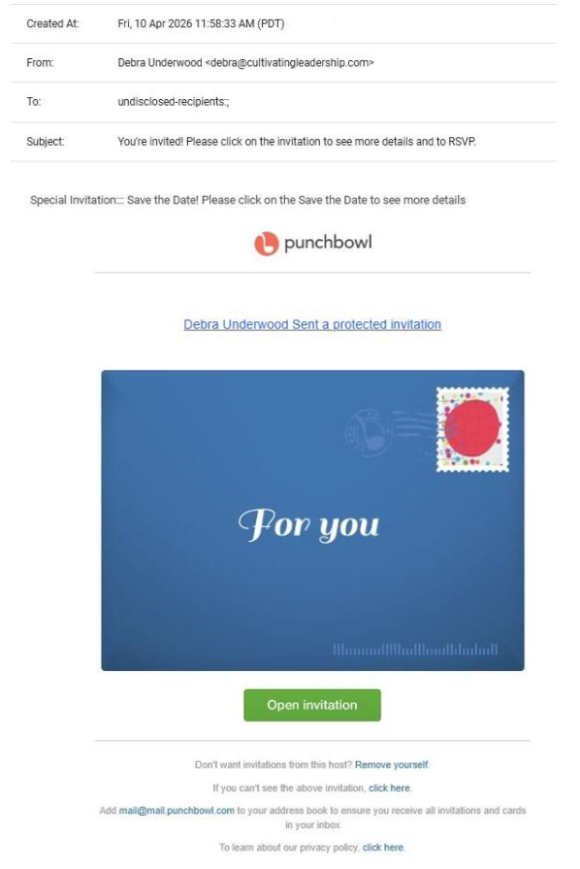

2. Email Overview
The email appears to notify the recipient about an invitation hosted through Punchbowl. It encourages the recipient to open the invitation using the provided button.
Unexpected invitations can be used as social-engineering lures because recipients may click the invitation simply because they are curious about who sent it or what event it contains.

3. Sender Analysis
The email displays a sender name associated with the invitation.
However, the screenshot alone does not provide enough technical information to verify the authenticity of the sender.
A complete investigation would require the original email headers and sender-authentication information.

Finding:
Sender authenticity cannot be completely verified from the screenshot alone.

4. Subject Analysis
The email uses an invitation-related subject that is designed to encourage the recipient to open the message.
The subject itself is not enough to confirm phishing, but an unexpected invitation should be treated cautiously.

Finding:
Potential social-engineering indicator: unexpected invitation.

5. Content Analysis
The email presents an invitation and provides an “Open Invitation” button.
This creates a clear call to action and encourages the recipient to follow an external link.
The recipient should verify whether they were actually expecting an invitation before interacting with the button.

6. Phishing Indicators Checked
Indicator | Finding
Unexpected invitation | Potential indicator
Suspicious sender | Cannot be confirmed from screenshot
Suspicious domain | Cannot be confirmed without checking the destination
External link/button | Present
Urgent language | Not clearly observed
Request for password | Not observed
Request for payment | Not observed
Attachment | Not observed
Social engineering | Possible

7. Risk Assessment

Overall Risk: MEDIUM
The email should be treated cautiously because it encourages the recipient to open an unexpected invitation through an embedded button.
However, the available screenshot does not provide enough technical evidence to conclusively classify the email as malicious.

8. Recommended User Actions
Users receiving an unexpected invitation should:
- Verify whether they know the sender.
- Check whether they were actually expecting an invitation.
- Avoid clicking the “Open Invitation” button if the message is unexpected.
- Verify the destination URL before opening it.
- Access the service independently through its official website when possible.
- Report the email if it appears suspicious.

9. Security Awareness Lesson
This example demonstrates how attackers can use ordinary activities such as event invitations as a social-engineering technique.
Users should not click a link simply because an email looks professional or familiar. The sender, context, and destination of the link should be verified before interacting with the message.

10. Conclusion
Example 3 demonstrates a potentially suspicious invitation email that uses an external call-to-action to encourage the recipient to open an invitation.
Based on the screenshot alone, there is insufficient evidence to confirm that the message is malicious. Therefore, it is classified as Suspicious / Potential Phishing rather than definitively phishing.

Final Classification:
SUSPICIOUS / POTENTIAL PHISHING

Risk Level:
MEDIUM

