PHISHING EMAIL ANALYSIS – EXAMPLE 04
Email Theme: Free Items / Logistics Fee
Classification: Phishing
Risk Level: High

1. Screenshot / Evidence
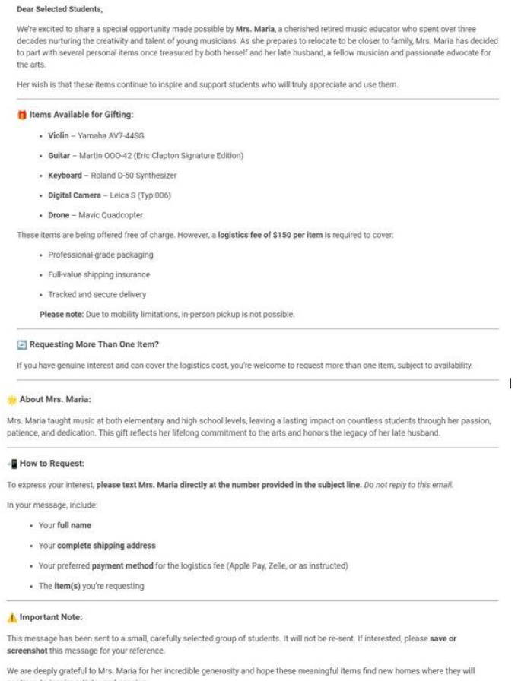

2. Email Overview
The email claims that selected students have been chosen to receive personal items donated by a retired music educator named “Mrs. Maria.” The message offers several expensive-looking items, including a violin, guitar, keyboard, digital camera, and drone.
Although the items are described as free of charge, the recipient is asked to pay a $150 logistics fee for each item. The email also requests personal information and a preferred payment method to arrange delivery.

3. Phishing Indicators

3.1 Unsolicited Offer
The recipient is told that they have been selected to receive valuable items even though there is no indication that they previously applied for or requested them.

3.2 Unrealistic Free-Gift Claim
The email offers several potentially valuable products for free. This type of unexpected reward can be used to attract the recipient's attention and encourage them to continue communicating with the sender.

3.3 Upfront Logistics Fee
The most significant warning sign is the request for a $150 logistics fee per item. A common scam pattern is to offer something valuable for free and then request an advance payment for shipping, processing, taxes, or other supposed expenses.

3.4 Request for Personal Information
The recipient is asked to provide information such as:
- Full name
- Complete shipping address
- Preferred payment method
- Item being requested
Providing such information to an unknown sender could create privacy and security risks.

3.5 Payment Request
The email specifically mentions payment methods such as Apple Pay and Zelle, which makes the financial aspect of the message particularly suspicious.

3.6 Pressure and Exclusivity
The message states that the offer is available only to a small, carefully selected group of students and will not be sent again. This can create urgency and encourage recipients to act without properly verifying the offer.

4. Risk Assessment
Risk Level: High
The email presents multiple indicators associated with phishing and advance-fee scams. The combination of an unexpected valuable offer, an upfront payment request, collection of personal information, and limited-availability language makes the message highly suspicious.

5. Recommended Action
Recipients should not provide personal information or make any payment based on this email.
They should independently verify the sender and the claimed organization before taking any action. If the offer cannot be independently confirmed, the email should be reported as suspicious and deleted.

6. Security Awareness Lesson
Users should be cautious of unexpected offers involving expensive gifts, prizes, donations, or free products when the sender later requests money or personal information.
A useful rule is:
If an unexpected “free” offer requires you to pay money first, treat it as suspicious and verify it independently.

