✅ TASK 2: High-Fidelity UI Design
Convert the wireframe into a high-fidelity UI design.
Add color palettes, typography, buttons, icons, and images.
Ensure the design follows UI/UX principles.

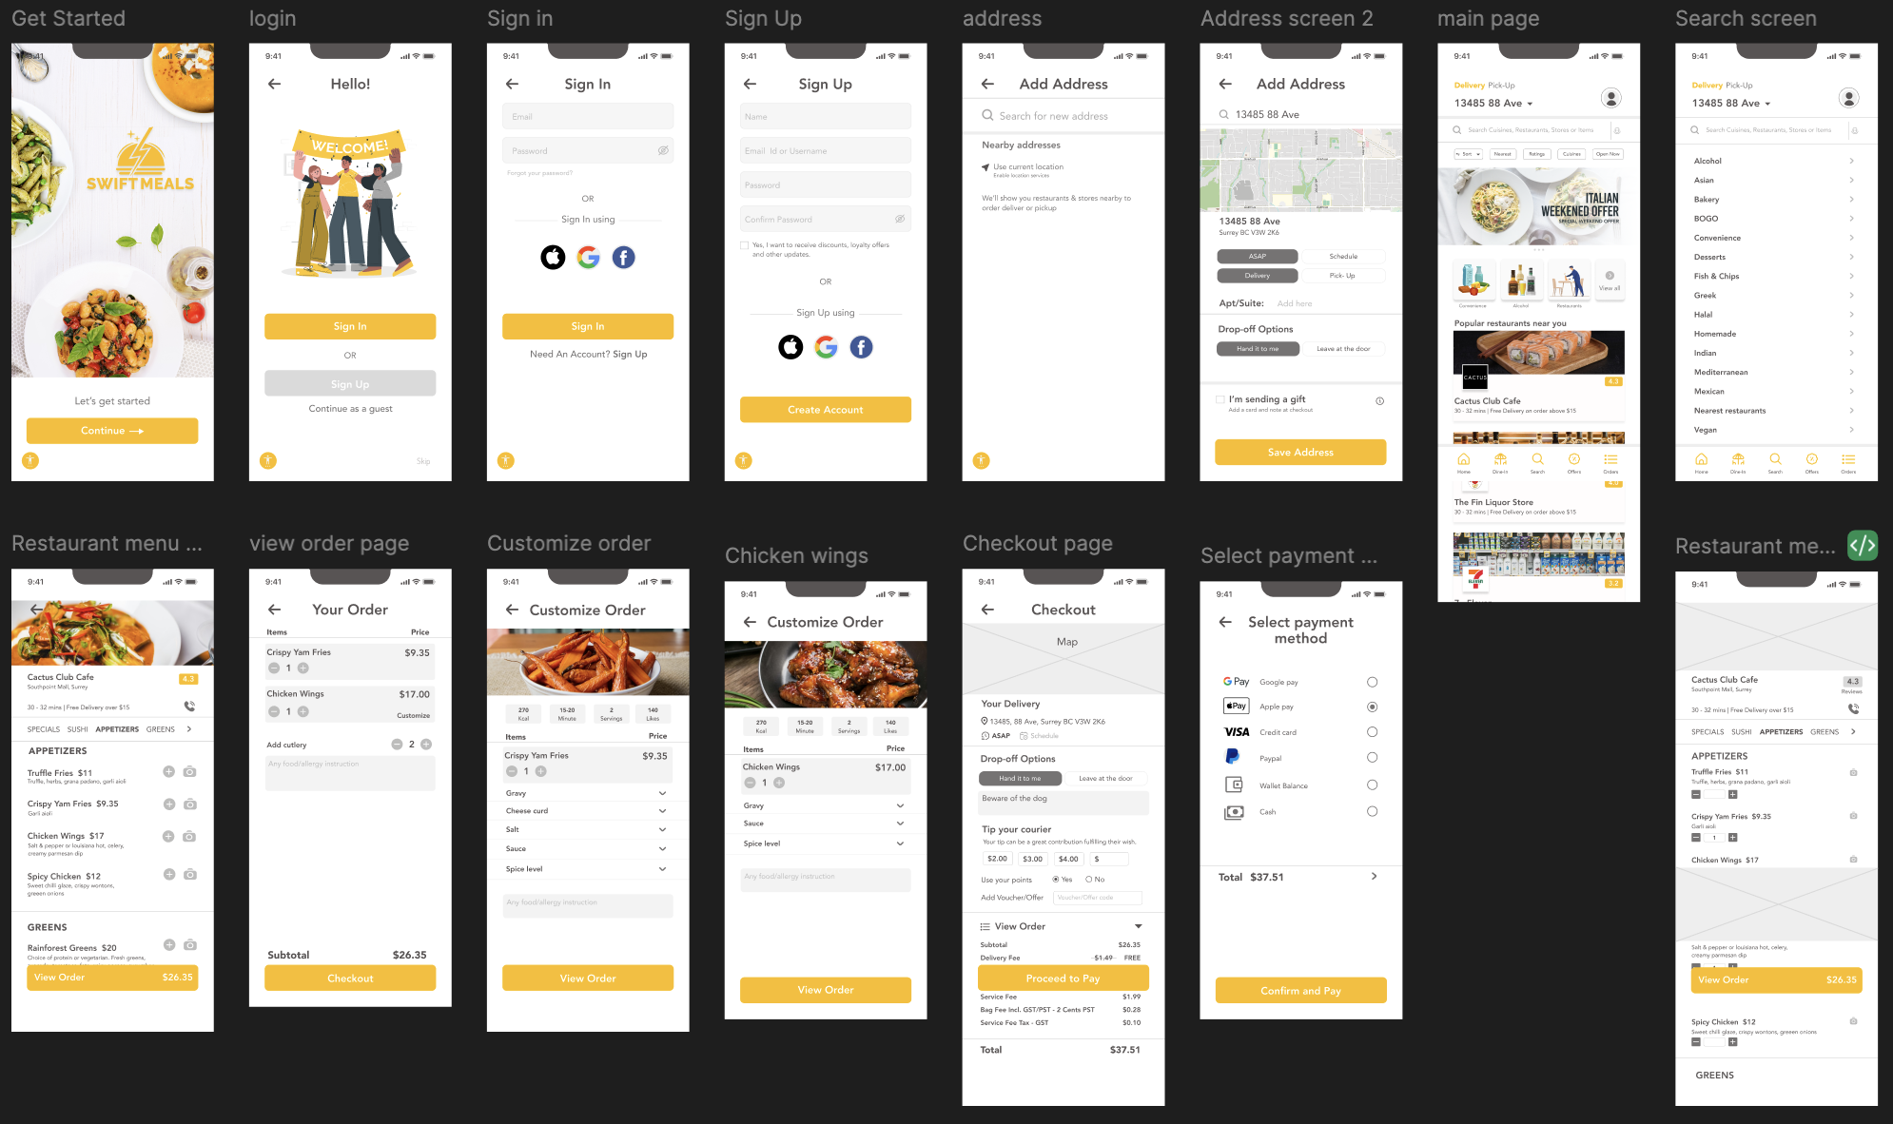

Description:
In this task, I converted the wireframes into high-fidelity UI designs by adding visual elements such as colors, images, typography, and icons.
Work Done:
- Applied a consistent color palette and typography
- Designed modern and user-friendly interfaces
- Added images, buttons, and icons to enhance visual appeal
- Maintained proper spacing, alignment, and layout consistency
Outcome:
This step resulted in a visually appealing and realistic mobile application design that follows modern UI/UX principles.
Figma link–
https://www.figma.com/proto/xnBFqdJU8PW2jSrVSsnL90/Food-Delivery-App-UI-UX-Design-%E2%80%93-Figma-Project?node-id=1-17880&p=f&viewport=201%2C57%2C0.18&t=c5NIUv8Dr7AMbi57-1&scaling=min-zoom&content-scaling=fixed&page-id=1%3A14781

