✅ TASK 4: Mini Project – Prototype Design
Create a clickable prototype of a complete app or website using Figma/Adobe XD.
Example Projects: Online Learning Platform, Travel Booking App, Personal Portfolio Website.
Submit prototype link + 2–3 page design explanation.
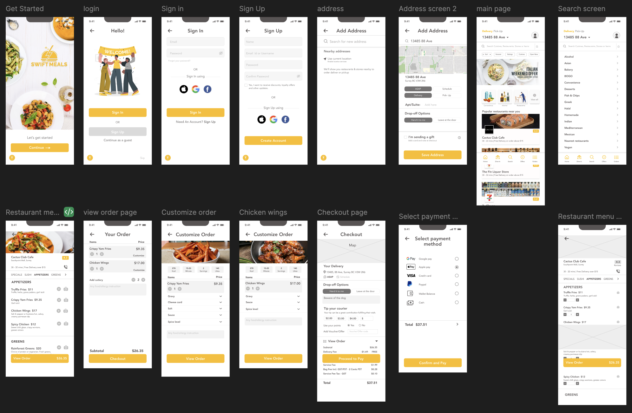
Description:
In this task, I created an interactive prototype of the food delivery application using Figma to simulate real user interactions and navigation flow.
Work Done:
- Connected multiple screens to create a clickable prototype
- Simulated user journey from login to order placement
- Ensured smooth transitions between screens
Prototype Link:
(Paste your Figma link here)
Outcome:
This prototype demonstrates the complete user flow and helps in understanding how users will interact with the application in real-world scenarios.
Figma link–
https://www.figma.com/proto/xnBFqdJU8PW2jSrVSsnL90/Food-Delivery-App-UI-UX-Design-%E2%80%93-Figma-Project?node-id=1-6933&p=f&viewport=45%2C-157%2C0.28&t=nkds5WwcMwecrsKU-1&scaling=min-zoom&content-scaling=fixed&page-id=1%3A2177

