TASK 1: Wireframing & Low-Fidelity Design
Create wireframes for a mobile app or website (e.g., food delivery, e-commerce or education platform).
Submit wireframes in Figma/Adobe XD.

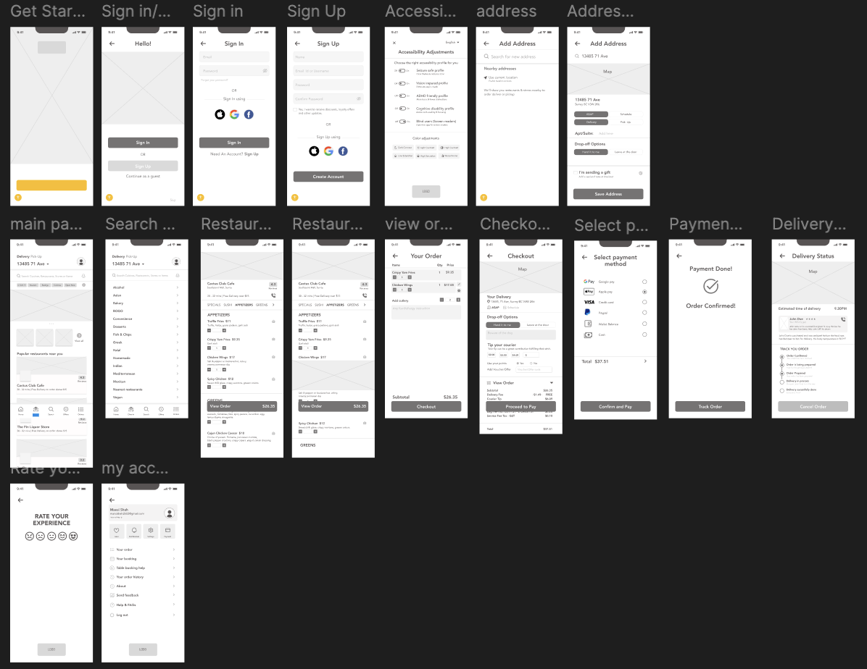

Description:
In this task, I created low-fidelity wireframes for a food delivery mobile application using Figma. The purpose of wireframing was to define the layout, structure, and user flow of the application before applying visual design elements.
Work Done:
- Designed basic layouts for key screens such as Login, Home, Menu, Cart, and Checkout
- Focused on user navigation and screen flow
- Used simple shapes and placeholders to represent UI elements
Outcome:
This step helped in planning the overall structure of the application and ensured a smooth user experience before moving to high-fide
Figma link–
https://www.figma.com/proto/xnBFqdJU8PW2jSrVSsnL90/Food-Delivery-App-UI-UX-Design-%E2%80%93-Figma-Project?node-id=1-744&p=f&viewport=258%2C106%2C0.16&t=cyyh1VaHXiNeWn2m-1&scaling=min-zoom&content-scaling=fixed&page-id=0%3A1

ffffflity design.

