Name: Smitkumar Patel

Student ID: 157308214

Course: PMC115

Section: NDE

Lab: 1

Hello Professor I have attached all the required files along with this submission. Reach me back if anything further needed.

Project 1 – Part 1

In this part as given in the instruction I go through selecting the required rows and added all required tasks that I needed to add and created the summary task where required and completed all the tasks and took a screenshot of the file to prove my work.

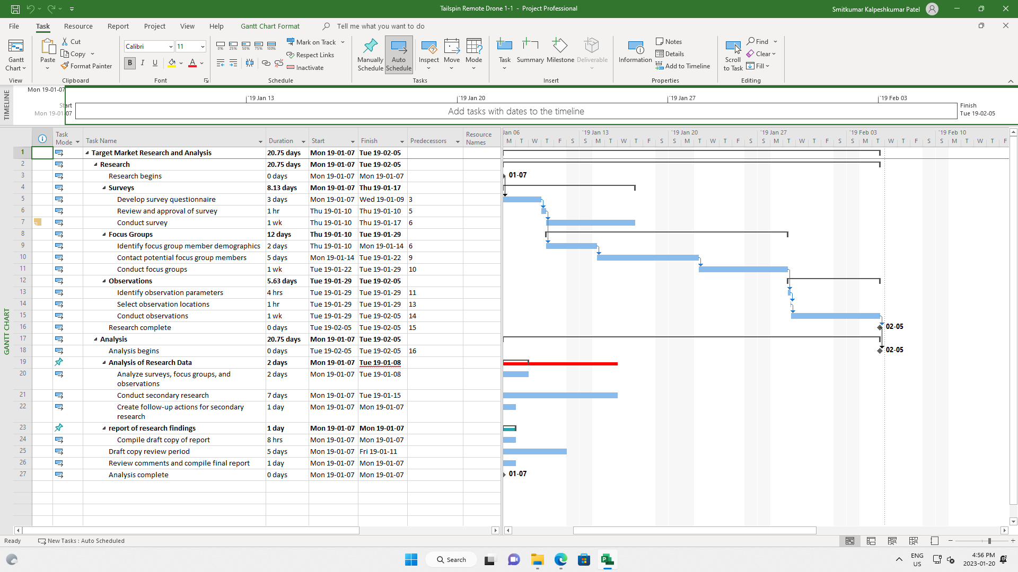

Project 1 – Part – 2

This task was also simple where in the particular task we left the notes so first I double clicked on the task and I saw one box open on screen. Then I went to the notes section where I left the note that was required to left in text area and I ended up doing this again with another task and completed this task too.

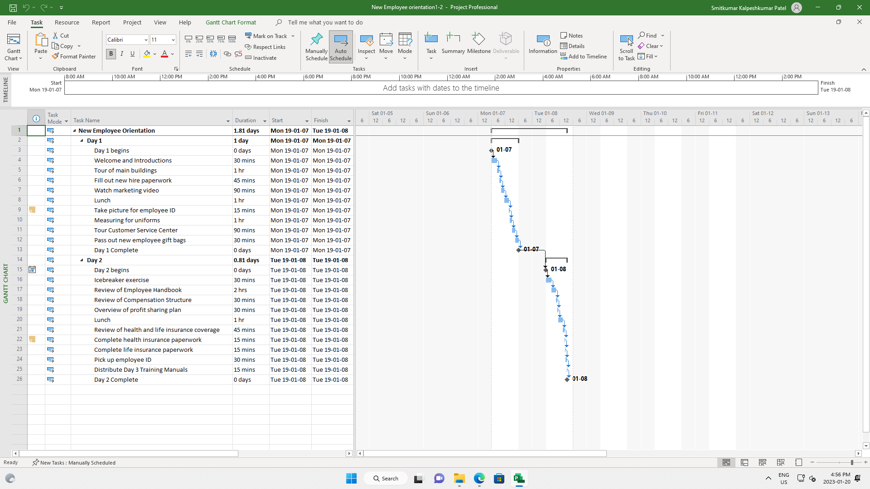

Project 1 – Part -3

This is the last module of the given lab where we need to create new project and there, we going to add three tasks that given in order to create the project. We can see given task below along with the deadline or duration of the project that’s given in the module has been added in the project.

