Name: Smitkumar Patel

Student ID – 157308214

Course: PMC115NDE

Lab: 2

Project 2-1: Adding People Resources for Hiring a New Employee

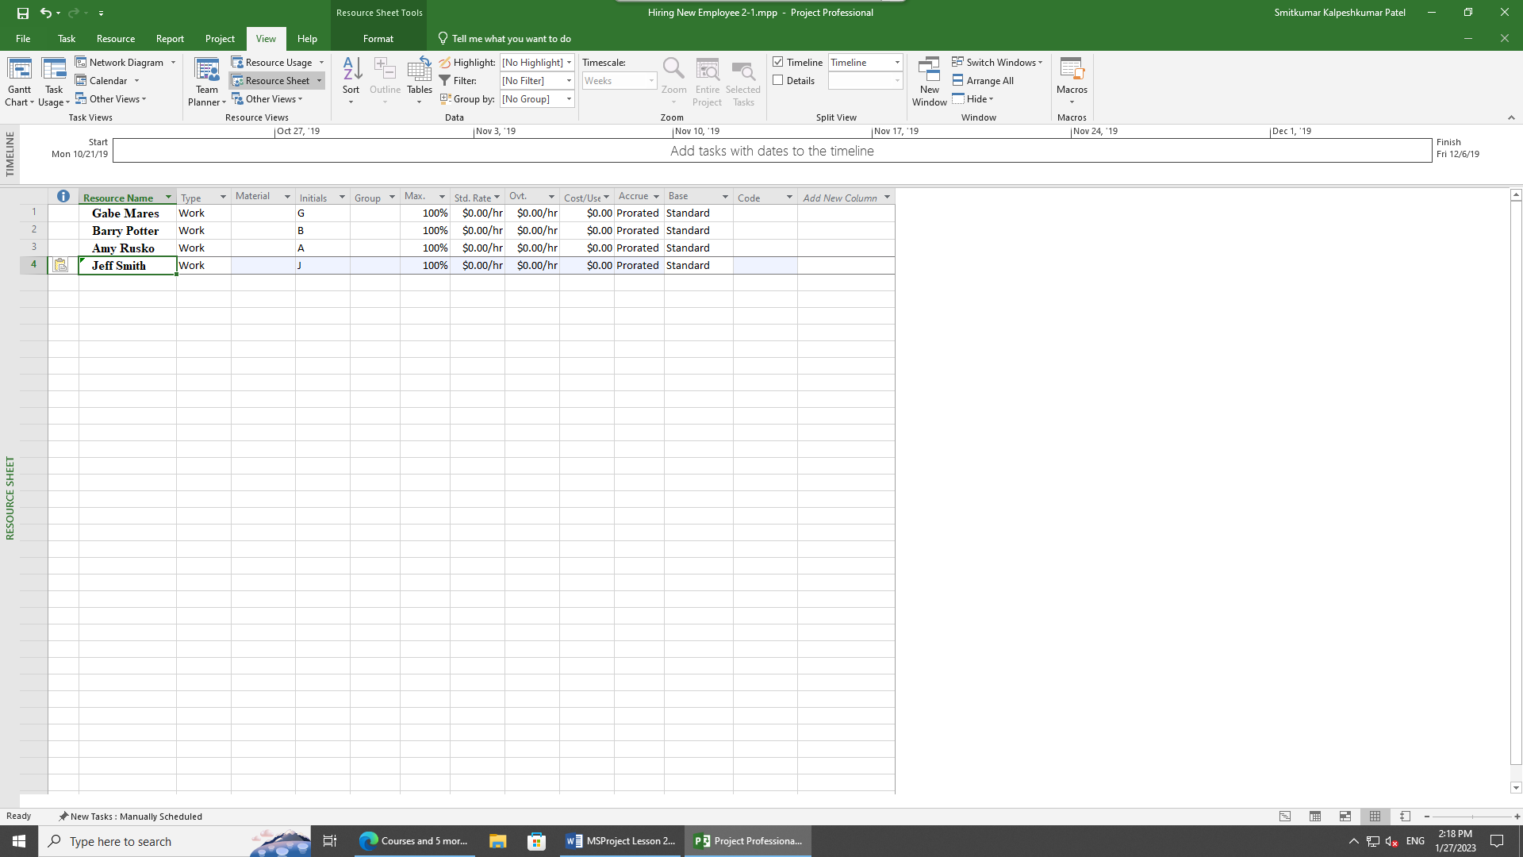

Here in this module we did in projects in order to Add People Resources for Hiring a New Employee. For that first I opened the file Hiring New Employee 2‐1. After that I clicked on view tab and then selected resource sheet option. Then I saw empty shell at bottom and added all the required information of employees and saved the file. This is what I did in order to complete this module. Screenshot is uploaded for your reference.

Project 2-2: Entering Pay Rates for an Office Remodel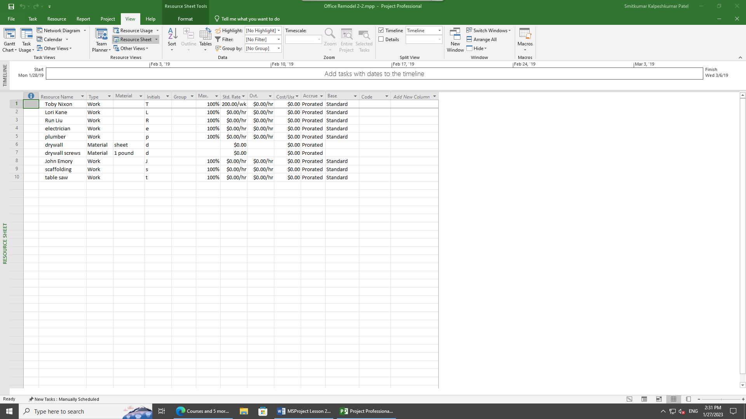

In order to complete this module, I opened the given file call Office Remodel 2‐2 and again went into the Resource Sheet view option and then I changed type from work to Material and then did the same thing with the tab given at the bottom call drywall screws, where I changed type to material. Then I went in Material tab and added sheet and 1-pound data respectively. At last, I changed pay rate of Toby Nixon by going in the STD PAY section and made it y 1200/w. that’s all we had to do in order to complete this lab. Screenshot is uploaded for your reference.