Name: Smitkumar Patel

Student ID – 157308214

Course: PMC115NDE

Lab: 3

Project 3-1: Assigning Resources for Hiring a New Employee

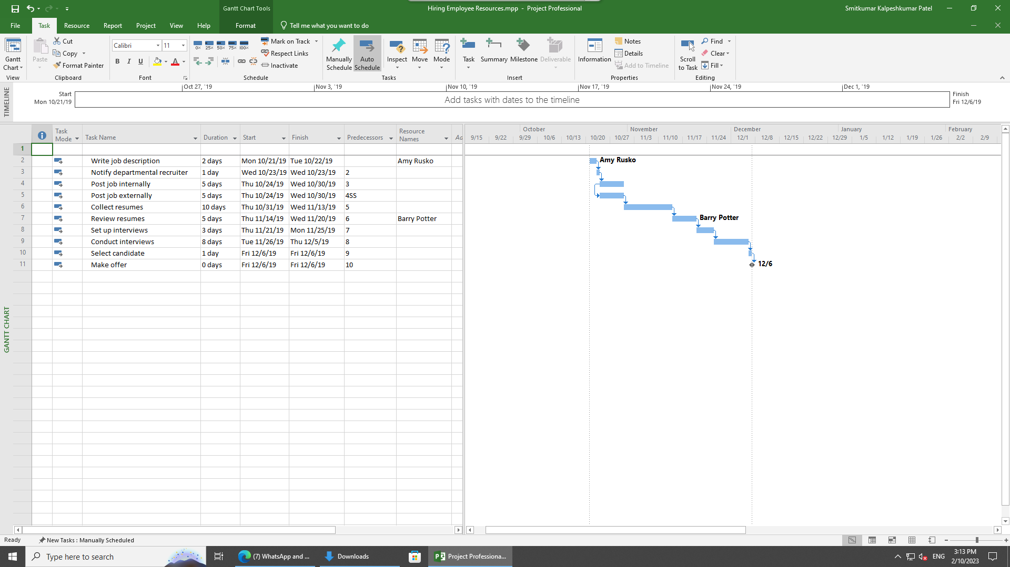

Here in this module we did in projects in order Assigning Resources for Hiring a New Employee.In the Task Name column, click the name of task 1, Write job description. In the Resource Name column of the Assign Resources dialog box, click Amy Rusko and then click Assign. In the Task Name column, click the name of task 6, Review resumes. In the Resource Name column of the Assign Resources dialog box, click Barry Potter and then click Assign.

Project 3-2Assigning Multiple Resources to an Office Remodel

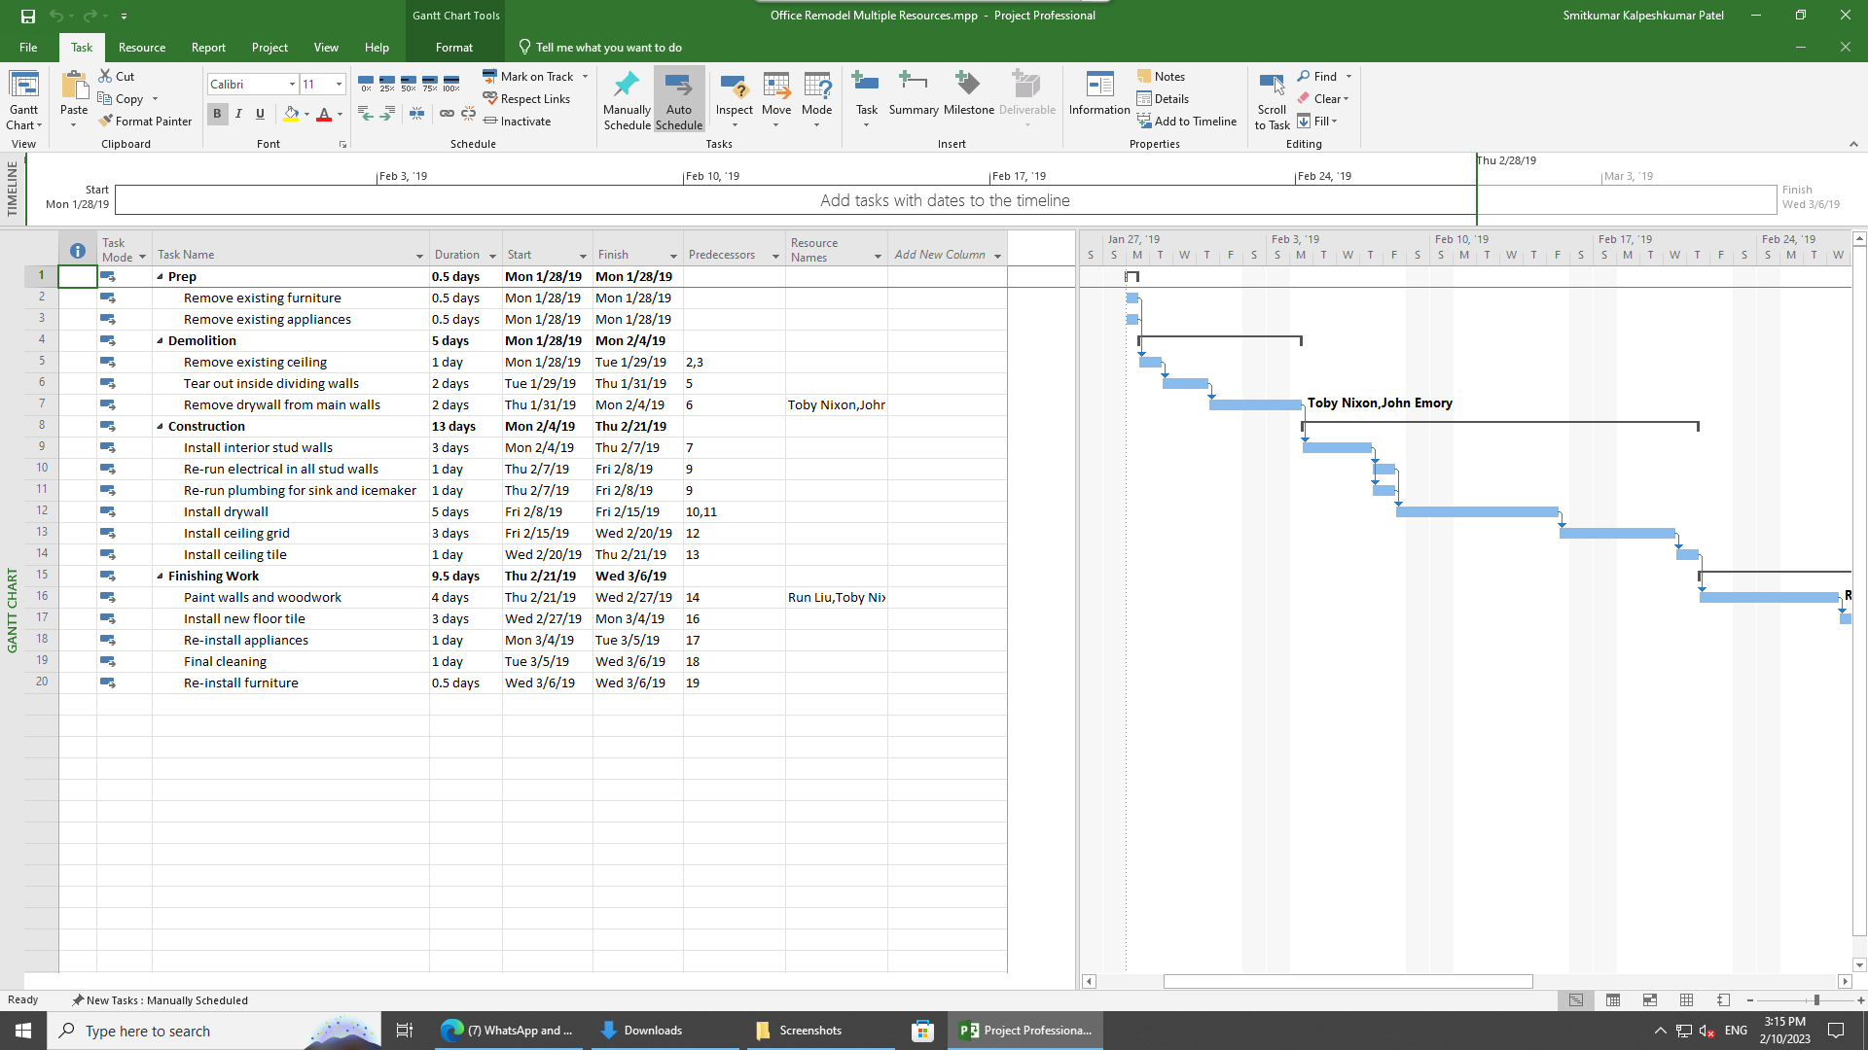

In order to complete this module, I opened the given file call Assigning Multiple Resources to an Office Remodel and again went into the Resource Sheet view option and then I changed the Assign Resources dialog box, select John Emory and Toby Nixon and then click Assign. In the Task Name column, click the name of task 16, Paint walls and woodwork. In the Assign Resources dialog box, select Run Liu and Toby Nixon and then click Assign.