Smitkumar Patel

PMC: Lab8 and Lab9

Student Number: 157308214

Project 8-1: Modifying the Tailspin Remote Drone Gantt Chart

In this we did basically how to format a Gantt chart in Microsoft Project. The instructions include selecting the "Summary" bar style and setting the color to purple, as well as configuring the display of task names on the chart. The tutorial also directs the user to select a specific task, scroll to it, and save the project schedule with a particular file name before closing the file.

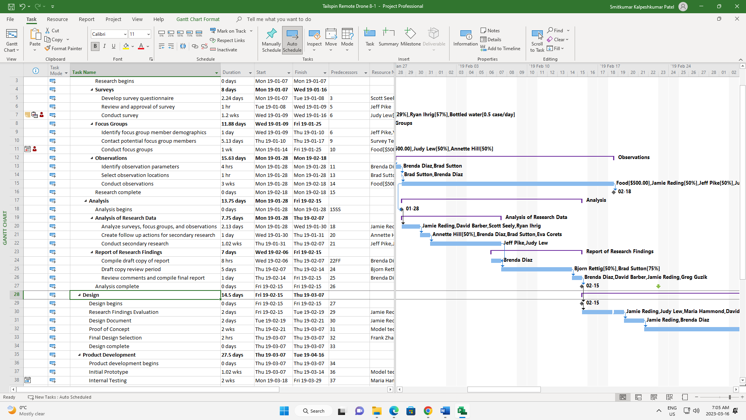

Project 8-2: Displaying the Interview Schedule Table

The provided instructions guide the user on how to create a new table in Microsoft Project to display task information. The tutorial walks the user through selecting the appropriate views and tables, customizing the table by adding or deleting specific fields, and modifying the date format. Finally, the tutorial instructs the user to save the project schedule with a specific name and close the file. The resulting file is named "HR Interview Schedule Table" and displays a customized table for task information.

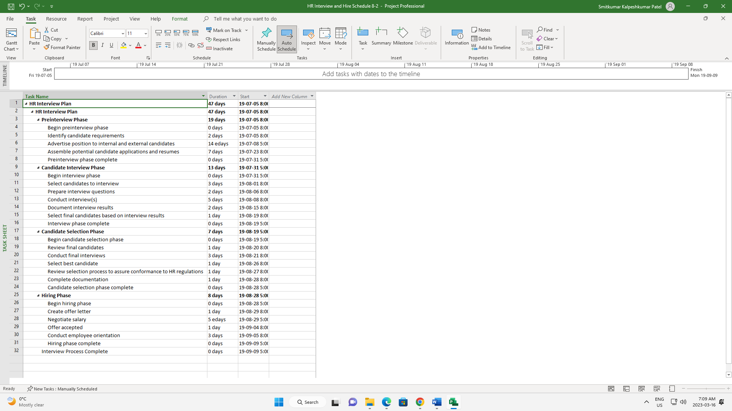

Project 8-3: Formatting the Office Remodel Contractor Tasks

Took guidance from the website and followed the steps in order to complete the below module.

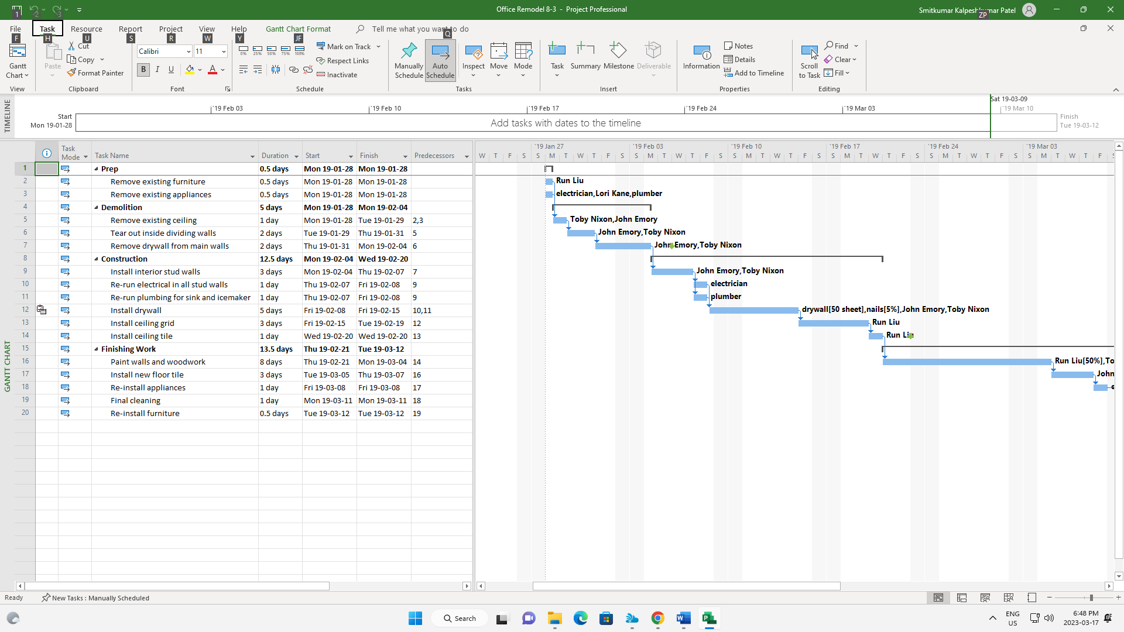

Project 8-4: Creating a Custom View for the Interviewing Schedule

In this module we did how to create a new view in Microsoft Project to display a summary of interview schedules. The tutorial walks the user through selecting the appropriate view type, naming the new view, and selecting the desired settings, including the task sheet, table, filter, and group. Finally, the tutorial instructs the user to save the project schedule with a specific name and close the file. The resulting file is named "HR Summary Interview Schedule" and displays a customized summary view of interview schedules.

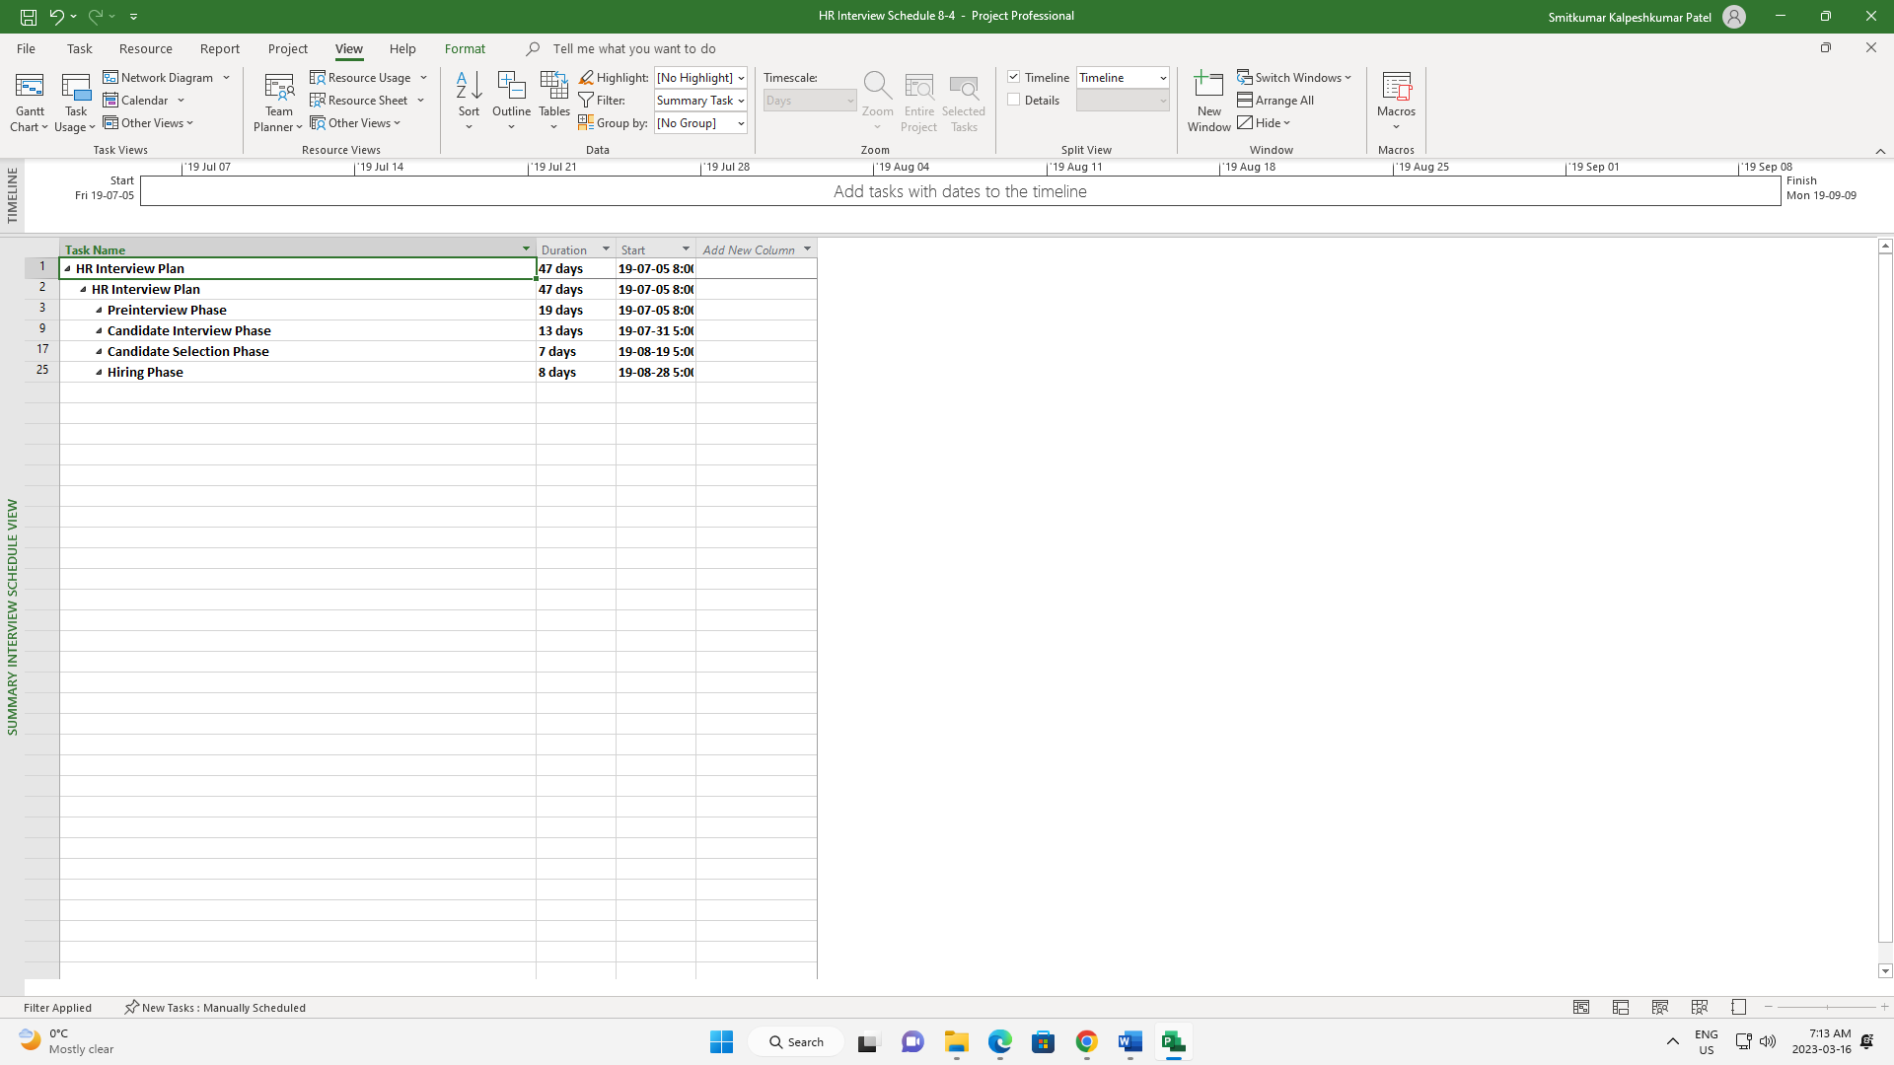

Project 8-5: Formatting the Tailspin Remote Drone Critical Path

In this we did how to create a custom view of the Gantt Chart in Microsoft Project. The tutorial instructs the user to make a copy of the Gantt Chart view, name the new view "Custom Gantt 8-5," and apply the custom view. The tutorial then directs the user to activate the Gantt Chart Tools - Format ribbon, select a dark blue Gantt bar style for presentation, and select Critical Path as the type of information to display. Finally, the tutorial instructs the user to save the project schedule with a specific name and close the file. The resulting file is named "Remote Drone Critical Path" and displays a customized Gantt Chart view with a dark blue Gantt bar style and Critical Path information.

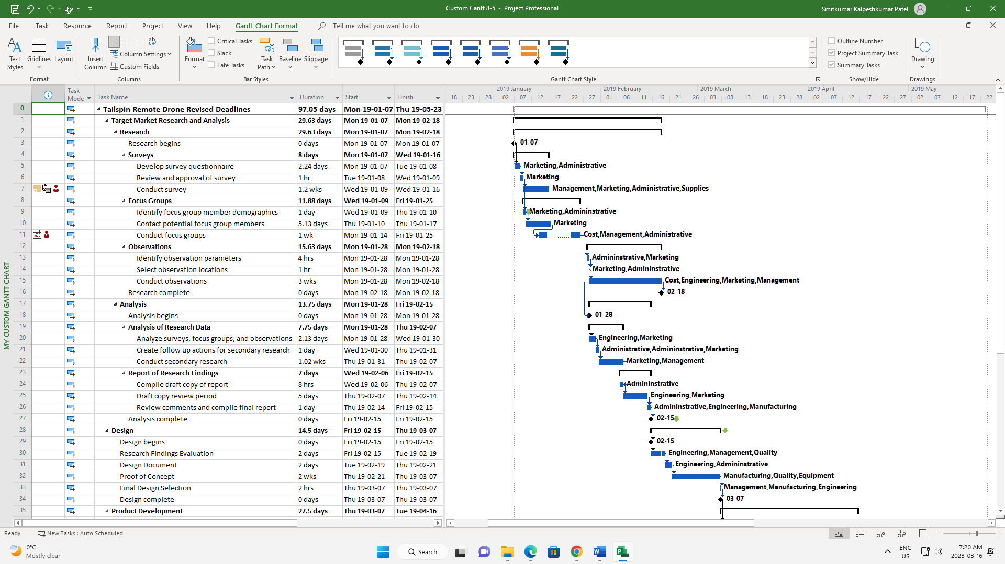

Project 8-6: Adding a Custom Field to the Home Office Project Schedule

In this task we created a custom text field in Microsoft Project. The tutorial instructs the user to open the Custom Fields dialog box, create a custom text field named "Supplier," insert the new field between the Task Name column and the Duration column, and key in supplier information for specific tasks. The user is instructed to save the project schedule with a specific name and close the file. The resulting file is named "Home Office Custom Field Info" and includes a custom text field displaying supplier information for various tasks.

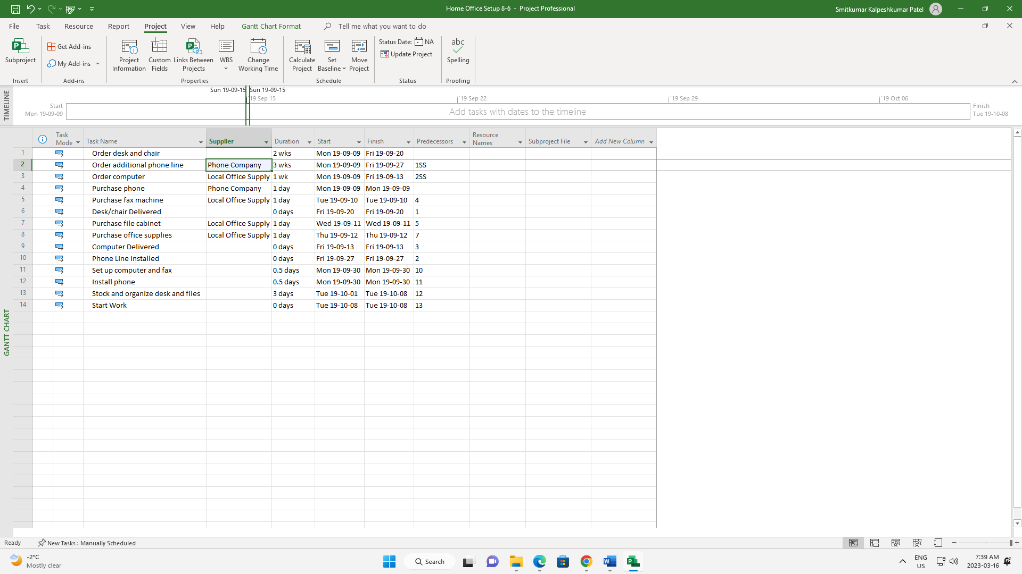

Project 9-1: Creating a Baseline

We basically did how to set a baseline for a project schedule in Microsoft Project. The tutorial instructs the user to click the Set Baseline button on the Project tab and select Set Baseline. The user is then instructed to click OK in the Set Baseline dialog box and saved the project.

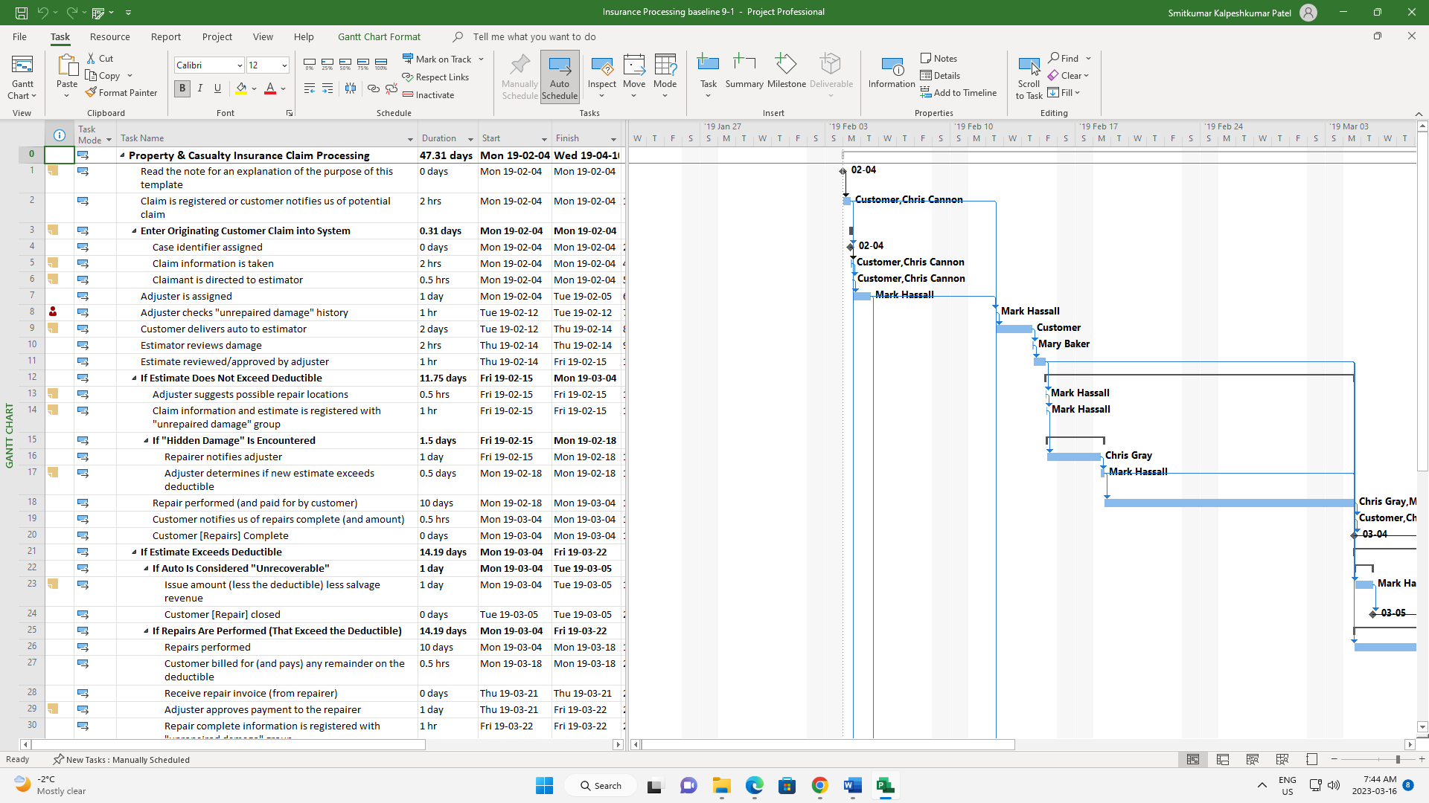

Project 9-2: Tracking a Project as Scheduled

Basically, we followed how to update the project schedule status and mark tasks as on-track in Microsoft Project. The tutorial instructs the user to set the status date as 3/7/19 in the Project Information dialog box and click OK. The user is then instructed to select tasks 1 through 53, click the Mark on Track button in the Schedule group of the Task tab, and save the updated project schedule with a specific name before closing the file. The resulting file is named "Insurance Processing Schedule Tracked" and includes the updated project status and marked on-track tasks.

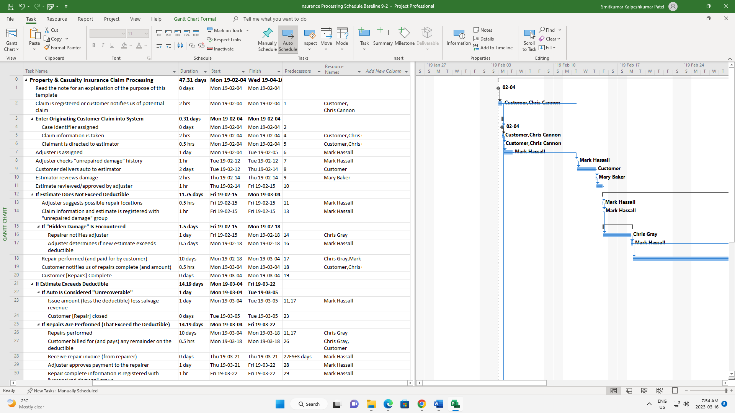

Project 9-3: Recording Completion Percentages

Adjusted the Gantt chart in Work table to display Work and % Work Complete columns. Entered percentages to indicate 100% completion through task 10 and 25% completion for task 11 (including subtasks). Saved the project schedule as HR Interview Schedule Percentages and then closed the file.

*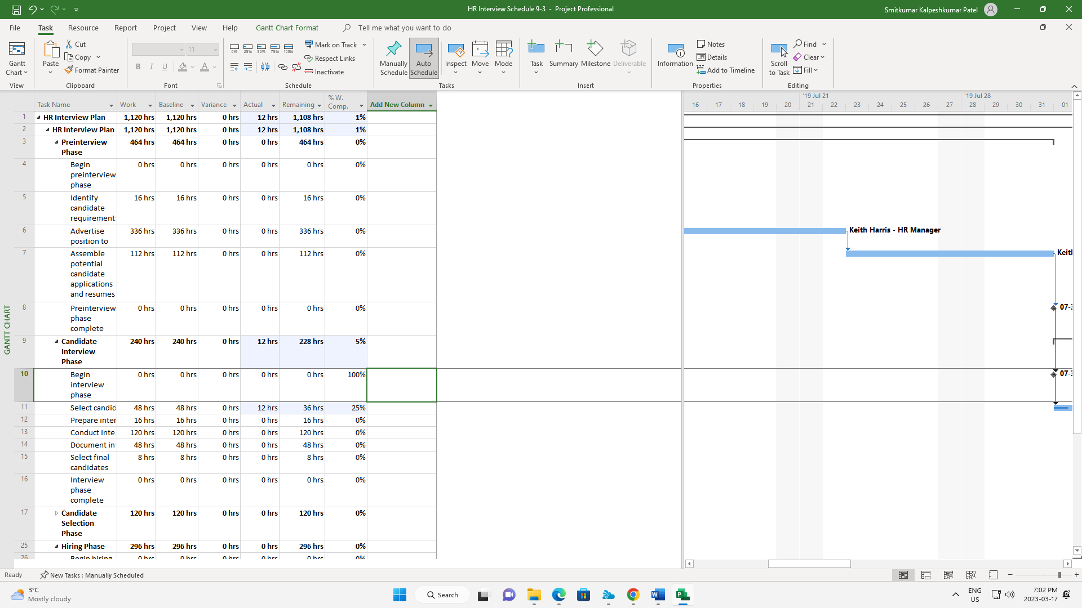*

Project 9-4: Determining Overbudget Tasks

he task requires you to open the Project Statistics dialog box and view the project costs. Then, display the Cost table and filter tasks that are over budget. Finally, collapse all summary tasks except the one with the greatest cost variance. Once done, save the project schedule as Remote Drone Overbudget and then close the file.

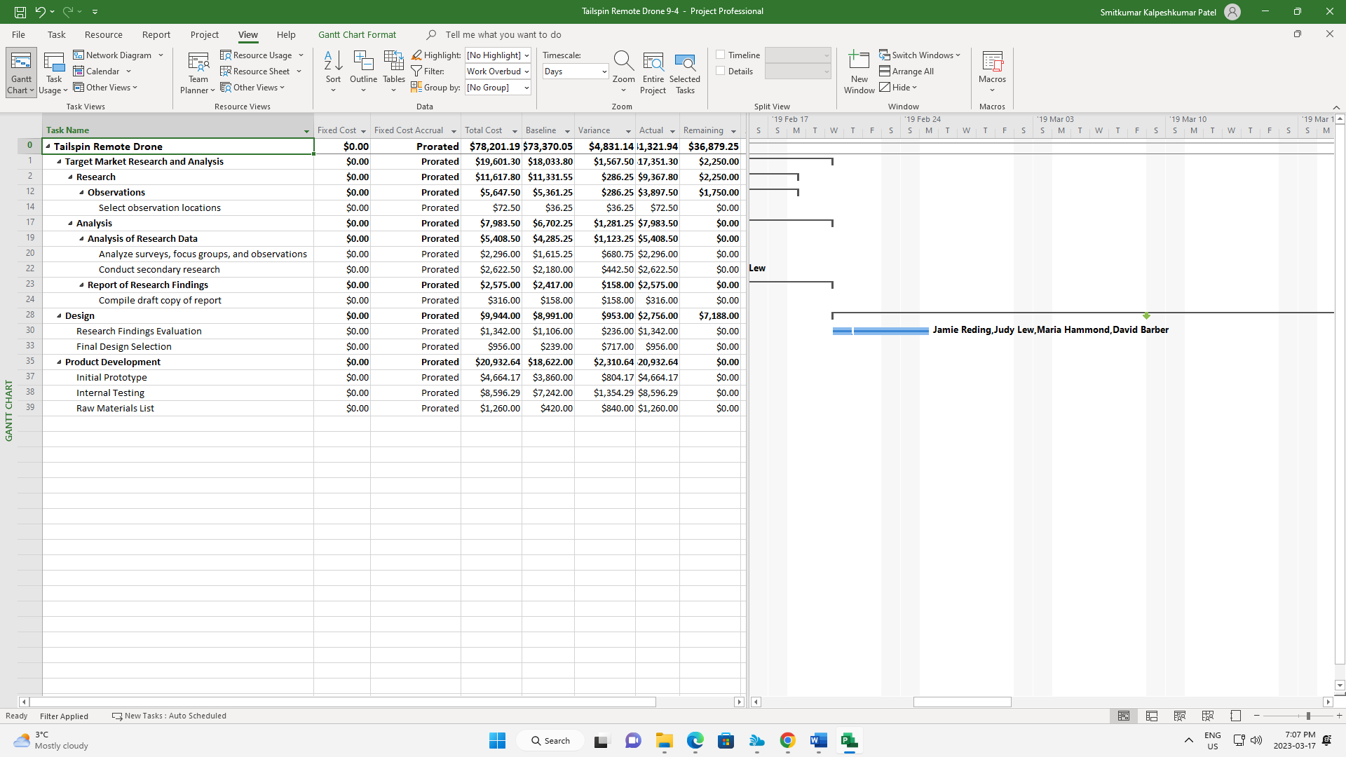

Project 9-5: Creating a Task Delay

Reschedule uncompleted work in the project to start after Friday, February 15, 2019 using the Update Project dialog box. Save the updated project schedule as Office Remodel Reschedule and then close the file.

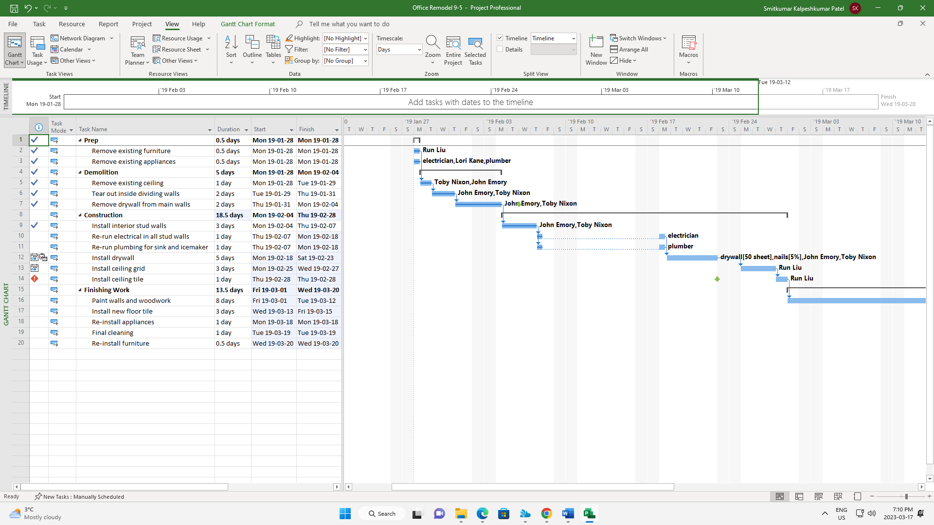

Project 9-6: Tracking the Tailspin Remote Drone as Scheduled

Basically, I updated the project progress to reflect completion through May 17, 2019 by activating the Update Project dialog box. Then, scroll the Gantt Chart bars to view the task and progress bars for the week of May 17, 2019 and saved the project.

